**RESUME**

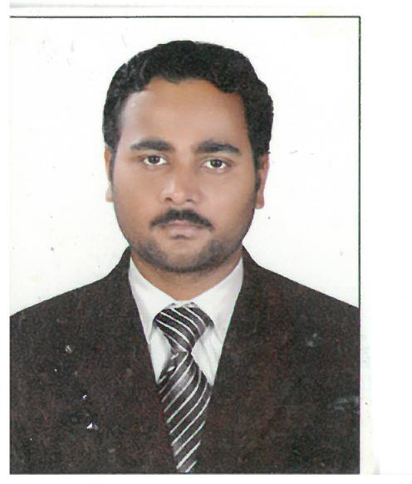

|  |  |  |
| --- | --- | --- |
| **Post Applied For** | : | Pipe Fabricator |
| **Qualification** | : | 12th Pass |
| **Languages Known** | : | Hindi,English |
| **Experience(India+Gulf)** | : | 9 Years |

**PARTICULARS AS PASSPORT**

|  |  |
| --- | --- |
| Name | Mr. Munna Yadav |
| Father Name | Shree Bhisham Yadav |
| Date of Birth & Place | 22/7/1991 Hempur Ismail U.S. Nagar |
| Passport No. | J-2521790 |
| Issue Place | Dehradun |
| Date of Issue | 22-10-2010 |
| Date of Expiry | 20-10-2020 |

|  |  |
| --- | --- |
| Present & Permanent | Bhisham Yadav  Vill.Hempur Ismail Bengali Colony  PO & P.S Kashipur,Udham Singh Nagar,  UK-244713,  Mob.+919661895097,+917983573189  E-mail id:yadav.munna49@gmail.com |

**JOB DESCRIPTION IN INDIA & GULF**

|  |  |  |
| --- | --- | --- |
| **Name of Company** | **Site of Work** | **Period of Service** |
| **Gourav Contractor** | HNG Float Glass Ltd., Halol | 8-10-2008 to 28-8-2009 |
| **Plus Tech Fabricators**  **PVT.Ltd** | IOCL, Gujarat Refinery Baroda | 2-10-2009 to 13-8-2010 |
| **Asianic Engineering Corporation** | GGSR Bhatinda | 25-9-2010 to 17-12-2010 |
| **Offshore Infrastructure Ltd** | N.P.L. Kalyan Mumbai | 22-01-2011 to 28-06-2011 |
| **Asianic Engineering Corporation** | OMPL Mangalore | 8-8-2011 to 20-3-2012 |
| **Chicago Maintenance & Const.** | Gems Education Dubai | 25-04-2012 to 06-10-2016 |
| **J&H Projects pvt limited.** | Alidac pharma myanmar | 13-05-2017 to 15-10-2017 |