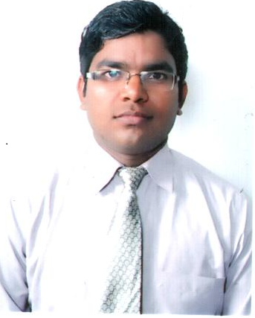**PARVEEN KUMAR**

H-110/15

Vill-Chaura Sec-22

Noida –G.B Nagar UP- 201301

MOB. : +91 9818799101EMAIL ID: [parveenkumar232@gmail.com](mailto:parveenkumar232@gmail.com)

**Brief Profile**

To get a responsible and professionally challenging position, where

I can make Contribution of my knowledge & skills for the growth and development of the organization.

**A professional with 5 years of experience in sales, customer relationship management & back office operations**

**Professional Qualification**

**MBA (Marketing & HR)** from **(G. B. Technical University, Lucknow in 2011)**

**Career Highlights**

**Company**: **Self Employed**

**Delhi Ncr**

**Profile**  : **Management**

**DURATION:** Sep 2014 Till date....

**Company**: **Serai Shipping Services**

**Dubai, UAE**.

**Profile**  : **Operations Executive**

**DURATION:** Feb 2012 to July 2014.

**Areas of Exposure:-**

**Customer Relationship Management:**

* Building and maintaining healthy business relationships with corporate clients, ensuring customer satisfaction by achieving delivery & service quality norms.
* Supervising customer service operations for rendering and achieving quality services, facilitating first line customer support by answering quarries & resolving issues.
* An effective communicator with excellent relationship building & interpersonal skills, strong analytical, problem solving & organizational abilities.

**Back Office Operations:-**

* Ensure effective liaison with agents and coordinated arrangement of shipments.
* Comprehensive understanding of export and import documentation be able to issue documents that comply with the shipping declaration requirements.
* Negotiate with Forwarder to the lowest best price with comprehensive payment terms.
* Approve bookings for container and freight pick up, and ensure coordination for shipments.
* Take responsibility for the shipment from its origin country until the shipment is delivered to the Warehouse.
* Review and sign off shipping documents while ensuring completeness and accuracy.
* Assist to prepare Authorization letter and send to forwarder together with shipping documents for clearance of the goods from the port.
* Seek innovative ways to improve service and cost, which will include both technological and process improvements.
* Ensure compliance with import/export regulations for all equipment and materials.
* Review and approve and follow up the documents, processes and controls of freight payment and audit system and ensure all documents, processes and controls are updated.
* Support the supply chain process through planning, on line allocation, pick release and invoicing to ensure customer’s requirements are met.
* Manage archiving of completed shipment files and maintain record keeping.

**Past Company: VIDEOCOND2H**

**DESIGNATION:** Operation Executive, Delhi NCR, India.

**DURATION:** 22-Jan 2011 to 19 -Nov 2011.

**Brief of Job:**

* Valuable experience in customer support and services in the sales and marketing sectors.
* Developed a good customer relationship of both existing and building new clients.
* Continually engaged in building clear and complete knowledge of products, workflow and procedures to enhance the quality of services.
* Assisted the sales functions in locating and introducing new corporate clients.
* Ensured timely processing of products and delivery to clients.
* Providing products information to customers.
* Attending to customers queries & complains.

**Academic Credentials**

MBA (Marketing & HR) from G.B. Tech. University, Lucknow, India) in 2011.

Bachelor Degree in Arts from V.V.S University U.P/ (India) in 2008.

XII from U.P. Board (V.M.K. Inter College, Allahabad) (Science Stream) in 2004.

X from U.P. Board (V.M.K. Inter College, Allahabad) (Science Stream) in 2001.

**Technical Skills**

Diploma In Computer Hardware Maintenance ‘O’ Level In Doeacc Society.

Diploma In Computer Application (DCA)

Operating System : Window xp Window Vista

Spreadsheet : MS- excel

Presentation : MS- PowerPoint

Word processor : MS- word

Internet operations : Internet Explorer, Net Surfing, MS Outlook

**Strong Traits**

Ability to quickly learn and implement

Patience & cooperation in team

People management skills

Always willing to learn new things

Multi-tasking.

**Personal Details**

Date of birth : July 1st 1986  
 Father’s name : Mr. Laxmi Shanker  
 Mother’s name : Smt. Gayatri devi

Permanent add : Vill. Kishora, Post Handia,

: Dist-Allahabad, U.P. India-221503   
 Passport No. : H0764700

Language Known : English, Hindi

**References on Request**

I hereby solemnly declare that the above particulars are true to the best of my knowledge.

**Place : Noida**

**Date : (Parveen Kumar)**