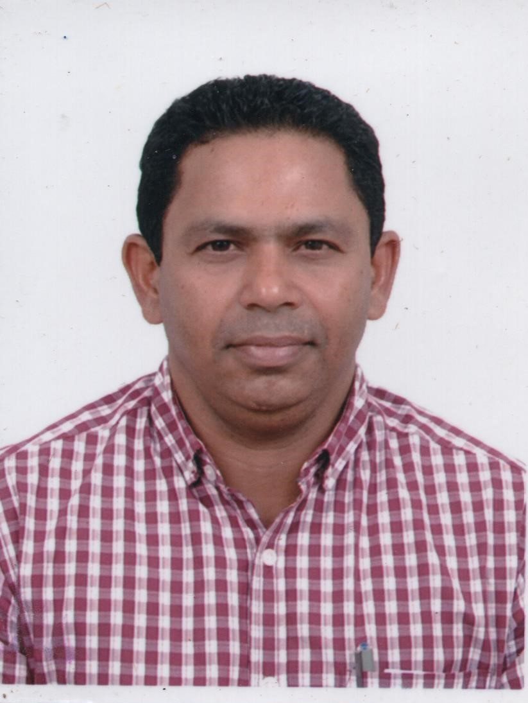

*Email:* [*sureshchari1973@gmail.com*](mailto:sureshchari1973@gmail.com)

*sureshchari­­­­_1973@yahoo.co.in*

*Mobile: 00 91 7667046671/ 9626085070*

*00 91 4222322261*

*Address: FlatNo.B-8, Gajananam Apartments,*

*Susela Nagar, Ramanathapuram,*

*Olympus, Coimbatore. Tamil Nadu.*

*India.Pin-641036.*

*Suresh T.N.*

|  |  |
| --- | --- |
| ***Objective***  ***Work Experience*** | ***Aiming to be associated with a progressive organization that gives me the scope to share my knowledge and skills in accordance with the* latest *technologies and be a part of the team that dynamically works towards the growth of organization and gives satisfaction and thereof.***  ***Construction Manager***  ***Feb 2016 To Oct 2017***  ***Ghantoot Transport General contracting L.L.C***  ***Client:- Tammeer Investments***  ***Consultant:- Keo Consultancy***  ***Project:-The Wave Plaza Hotel (4Star At Al Mouj-Muscat)***  ***Basement-1,G.Floor,F.Floor,Typical 2-6Floor’s Seventh Floor & Roof***  *Incharge Of all Civil Activities ,Co-Ordinating With All M.E.P Contractor’s ,190 Guest Room’s, 12 Junior Suite Room’s,6 Senior Suite Room’s,Swimming Pool & Kid’s Pool At Terrace,Upper & Lower Dining Room.*   * *Providing direction to the Construction site team so that all project activities will be performed are as per program.* * *Managing effectively the construction activities so that project will be completed on time and within budget.* * *Planning for all resource requirements (both men & material) in conjunction with Project Manager(s).* * *.**Device and implement optimum construction methods in co-ordination with Planning & Cost Control Dept.* * *Ensuring that timely inputs are provided to the Project Manager so that timely billing activities can be completed.* * *Providing support and direction to construction teams so as to retain competent Human Resources.* * *Learning & implementing various improvement in construction industry to help reduce cost and improve efficiency.* * *Providing performance update to the Project Manager(s).* * *Ensuring that all construction related activities set for the year is met / exceeded.*   ***Construction Manager***  ***May 2015 – Jan 2016.***  ***H.B.K Contracting Co. W.L.L Doha-Qatar.***  ***(AN I S O - 9001, ISO –14001COMPANY)***  ***GTC-626 Package- B Mega Reservoir Umm Salal***  ***Client:-Kharama.***  ***Consultant:-Hyder Consultancy.***   * ***In charge of Reservoir-5 No’s(300mx150mx12mt’s)*** * *Excellent leadership skills and ability to build teams, resolve conflict, motivate and develop subordinates* * *Ability to plan, organize, monitor and if necessary take corrective action on projects.* * *A comprehensive knowledge and understanding of related company management systems.* * *Able to react quickly and effectively when dealing with challenging situations.* * *Can control multiple construction projects simultaneously.* * *Excellent decision-making skills and the ability to prioritize and plan effectively.* * *Proven problem solving abilities, able to identify, assess, evaluate and resolve complex issues.* * *Ability to co-ordinate, control and monitor all sub-contractors' activities on site.* * *Recommending ways of improving the use of staff, materials, equipment and other resources.* * *Extensive knowledge of building legislation and regulations.* * *Up to date with the latest developments and technologies in the construction industry.* * *Practical construction knowledge and be able to work from drawings* |
|  | ***Construction Manager***  ***November 2010-April2015.***  ***Unicorp International Contracting Company Ltd. Jeddah, Saudiarabia..***  ***Project’s Handled: PP-12 Combined Cycle Project &Quarrayah***  ***Combined Cycle Power Plant.***  ***Client: Saudi Electricity Company.***  ***Contractor:-Arabian-Bemco Contracting Company Ltd.***   * ***Incharge Of FuelGasCompressor Area,H.R.S.G & S.T.G Electrical Building’s,A.C.C PipeRack,DuctSupport & PipeSupportFoundation’s,DieselGenerator Building,WatertreatmentBuilding,A.S.L.TreatmentBuilding,S.T.G FinFanCoolerFoundation,Security Building&MainAdministrationBuilding.(PP-12 Project).*** * ***Incharge of H.R.S.G(15Unit’s),BoilerFeedPump,ChemicalFeedSystem, M.V/L.VBuilding,AircompressorBuilding,DieselGeneratorBuilding, HydrogenBuilding,Mechanical Trenche’s,Underground Utilities,Electrical&StormwaterManhole’s.(Qurrayah Project)*** * *Responsible for field construction operations within assigned area and receives technical & operational directions from the Senior Management.* * *Provides operational directions to Asst. Engineers, Craft Supervisor and General Foremen’s.* * *Analyses man power, material, equipment requirements. Ensures that Asst. Engineers, Craft Supervisor and General Foremen are adequately supplied with Technical information, Materials, Tools and Construction Equipments.* * *Review schedules,* c*onstruction methods and procedures.* * *Prepares weekly Quantity reports including summary of construction progress, reviews with Cost engineer & understand details**of the same**and keeps supervisors informed on progress of overall assigned area activities.* * *Monitors the activities of subcontractors to ensure compliance with specifications and schedules.* * *Coordinates activities with other disciplines in the particular area as instructed by construction management.* * *Ensures that all State and Federal safety codes, requirements and standards are being reviewed, implemented and adhered to by craftsmen and others when in the operational area, tools & equipment are in safe condition and operated safely.*   ***Project Engineer***  ***January 2008 – September 2010. H.B.K Contracting Co. W.L.L Doha-Qatar.***  ***(AN I S O - 9001, ISO –14001COMPANY)***  ***Project:-Domestic Solid Waste Management Centre*.*Meassaied.***  ***Structures Executed: Bio-Reactor Tank(04No’s)&Inlet Work’s***  ***Project:-Sewerage Treatment Plant,Doha-North.***  ***Contractor:-Keppel Seghers Singapore Pte Ltd.***  ***Consultant:-Stanley Consultants.***   * ***In charge of all Civil activities including R.D.F Bunker,Ash Bunker,Waste Bunker,ReceptionHall, AircompressorRoom,SlaughterHouse,TurbineHall,WaterTreatmentPlant,BulkyWasteArea,Danodrum..Etc*** * *Executing the work within Time frame.* * *Preparation of Shop drawings and Bar bending schedule* * *Estimation of quantities.* * *Material Submittals to Consultant.* * *Preparation of Labour Rate Analysis.* * *Preparation of Daily Reports to Client & check Request for Activities going on at site.* * *Formwork done by Doka For Slab & Wall.*   ***Project Engineer***  ***May 2007 - Dec 2007 , L.M.S.Engineers &Builders Pvt Ltd,***  ***Coimbatore,India.***   * ***Project****: Shriram Apartments.* * *Constuction of Individual Villas..* * *Executing the work within Time frame.* * *Liasing with Client's & Consultants.*   ***Project Engineer***  ***July 2004 - April 2007***  ***Al Fara'a Gen Cont. Co. LLC Abu Dhabi, UAE.***  ***(AN I S O - 9001, ISO –14001COMPANY)***  ***Project****: -* ***Commercial Building for H.H SH. Mansoor Bin Zayed Al Nahyan at C-44, Abu Dhabi. U.A.E (Basement-3,-2&-1Level,Ground floor, MezzanineFloor, Typical office (1-3) Floors, Typical Residential (1-18) Floors, Lower & Upper Roof.)***   * *In charge of all Civil activities including Diaphram Wall & Piling* * *Executing the work within Time frame.* * *Preparation of Shop drawings and Bar bending schedule* * *Estimation of quantities* * *Material Submittals to Consultant.* * *Preparation of Monthly Reports, Submission of Monthly Running Bills.* * *Preparation of Labour Rate Analysis.* * *Preparation of Daily Reports to Client & check Request for Activities going on at site.* * *Coordinating with M.E.P Engineers regarding services openings & sleeves for efficient Quality at job in the building.Preparation of Material Schedule for the smooth progress of work* * *Coordinating with Site Managers, Foremen, and Site Engineers on day-to-day basis to achieve the Work in Target Period of the Project.*   ***Project Engineer December 2002 to January 2004***  ***AL Nahdah AL Omania Co LLC, Oman (AN I S O - 9001 COMPANY)***  ***- Al Mawellah Water Supply Project - Al Khoudh Reservoir site (Client: Ministry of Housing,Electricity & Water) Capacity of reservoir - 18,000 m3 (2 Nos.) + 9,000 m3 (1 No.)***   * *Identify material sources and ensure conformity with drawings.* * *Quality of material ensurement.* * *Preparing Shop drawing & Bar bending Schedule.* * *Executing the work within Time frame.*   ***Project Engineer***  ***June 2002 - November 2002.***  ***Shankar & Associates, Coimbatore, India (Jute Plant Construction at Kolkatta)***   * *In charge of all civil activities.* * *Includes raw material godown, sizing, warping & calendaring foundations, generator foundations, air -compressor foundations, under ground water tank, administration building, and chimney foundations.* * *Flooring done by Tremix De-vacuum Process.*   ***Senior Engineer***  ***December 1995 - May 2002***  ***Build Met Limited, Bangalore, India***  ***(Construction of Cement Silos, Blending Silo, Unloading Hopper, Crusher Foundations, Chimney Supporting Structures Upto a height of 90.00 mtrs)***  ***- (Project Client: Vasavadatta Cements, ACC Cements, Birla Cements, Gujarat Ambuja Cements)******Consultants: -Bhagwathi Designs (Private) Limited, Mumbai .***  ***Fitchner Consultants International Limited, Chennai.***  ***(For 15 M.W Coal Based Captive Power Plant)***   * *Execution of the project with time bound schedule.* * *Interaction with client & documentation.* * *Completion estimation & billing of the entire project.* * *Construction of Silos by Slip form Technology.* * *In charge of 15 M.W Coal Based Power Plant includes Steam turbine generator buildings, boiler and bunker foundations, electrostatic precipitators, raw water & fire water reservoirs, dump hopper, crusher foundations, fly ash silos and bed ash silos, chimney supporting structure up to height of 90 mtrs by Slip Form Technology.* * *Complete estimation & Billing of the entire project.*   ***Academic***  *1990-1994,Annamalai University, India*  ***Qualification***  *Bachelor of Civil & Structural Engineering*   * + - * *First Class / 69%.*   ***Computer Literacy***   * + - * *M.S.Office,Word,Excel.*       * *Autocad-Release-14.*       * *Primavera-P3 (Level-1 &Level-2).*   ***Languages Known***   * + - * *English & Indian Language’s(Hindi,Tamil,Kannada &*   *Malayalam)*  ***Personal Data***   * *Nationality : - Indian.* * *Age/Date of Birth:- 44 Yr’s/24.06.1973* * *Marital Status : - Married* * *Religion : - Hindu*   ***Passport Details:***   * *Passport No : - R 1760006* * *Place Of Issue :- COIMBATORE* * *Date Of Issue : - 03.07.2017* * *Date Of Expiry : - 02.07.2027* * *********************************************************************************** |
|  |  |