**RESUME**

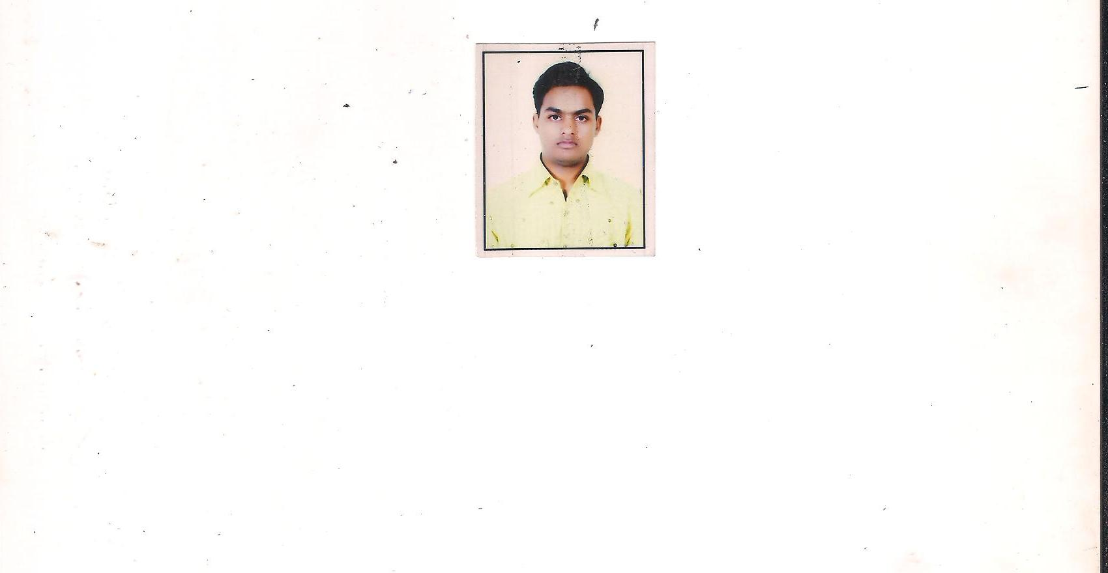

**Ashish Gujrati**

Email Id: [gujrati.ashish1@gmail.com](mailto:gujrati.ashish1@gmail.com)

Mob no: 09760207737

***Career Objective:***

To join an organization that will recognize and utilize my skills fully and offer me a position requiring innovative and creative ideas where continuous growth and learning are way of life.

***Educational Qualifications:***

|  |  |  |  |  |
| --- | --- | --- | --- | --- |
| **Year** | **Degree** | **Institution** | **Subjects/Specialization** | **%** |
| 2012-2014 | POST GRADUATION  (MBA) | GURUKUL KANGRI UNIVERSITY | BUSINESS FINANCE | 68.00% |
| 2008-2011 | GRADUATION  (BBA) | SGRRITS , DEHRADUN | BUSINESS FINANCE | 67.00% |
| 2008 | INTERMEDIATE | A B V M I COLLEGE | ENGLISH, HINDI, GEOGRAPHY | 52.00% |
| 2006 | HIGH  SCHOOL | B G R M I COLLEGE | ENGLISH, HINDI,MATHEMATICS, SCIENCE, SOCIAL SCIENCE | 55.00% |

***Additional Qualifications:***

* I have done Computer application software from Prime computers Institute (Dehradun).
* I have done Hindi Typing from Nice institute (Dehradun).

***Skills Sets:***

**Personal Skills:** Leadership, Team-Building, Professional, Public speaking.

**Technical SKILLS:** MS Word, Excel, PowerPoint, Access, Internet use, etc.

***Project and Training Undertaken:***

* Successfully completed Eight weeks summer training in “**ING VYSYA BANK”** from Dehradun under BBA.
* Successfully completed Six weeks summer training in “**LOHIA CORP LIMITED**” From Kanpur under MBA.

* I have completed “Skills University” Project under Dr. Pankaj Madan (Prof. in Gurukul Kangri University).

***Extra & Co-Curricular Activities:***

* Participated in the **“5th FIESTA QUIZ-2013”** held by GURUKUL KANGRI VISHWAVIDYALA, HARIDWAR.
* Participated in the **“POSTER COMPITION”** held by GURUKUL KANGRI VISHWAVIDYALA, HARIDWAR.

***Current working:***

* Presently working in **“Uttarakhand Sanskrit Academy”** As a Account Assistant.

***Personal Details:***

***Date of Birth*** : 08-07-1991

***Father’s Name*** :Mr. Santosh Kumar Gujrati

***Address*** :Mo-Khatrana, Post-Bilgram,

Dist-Hardoi, Uttar Pradesh.

***Marital status*** : Unmarried

***Nationality***  : Indian

***Language Known*** : English, Hindi

**DATE NAME**

**(ASHISH GUJRATI)**