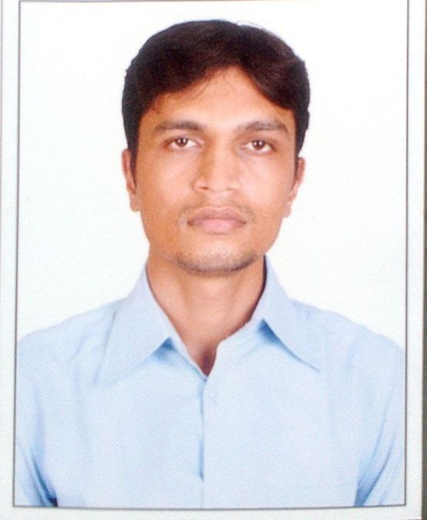BHARGAV MOHABATBHAI MER

**FABRICATOR cum WELDER**

D.O.B.: 13-nov-1988

Nationality: India

Location: Bhavnagar,Gujarat

Mobile: +91 9824060867-9722935445

Email: bhargav.mer@gmail.com

Indian Passport no: S4449298

# PROFILE

BHARGAV MER is an accomplished FITTER with 8 years of experience as a FABRICATOR. He has proven success in organizing task.

# OBJECTIVE

Seeking new challenges, which effectively utilize my expertise and provide opportunities for knowledge enhancement and career growth to develop skills in every field with extensive response and reception to on the job learning.

# EDUCATION

1. **I.T.I (NCVT) FITTER-2006**
2. **S.S.C- GSEB-2004**

# LANGUAGES

**English –** Excellent reading, writing

**Hindi –** Excellent reading, writing and speaking

**Gujarati--**Excellent reading, writing and speaking

**SPECIALIZED SKILLS & Responsibilities and Role details:**

Engineering Drawing and measuring instrument.

* Manufacturing Material use for stainless steel 304,316L
* Marking of Layouts Like Plate Cutting Layout, Nozzle Marking Layout Dished End Layout, Marking of Internals & Externals
* Measurements & Calculations of all such work Drawing Reading & Interpretation for their work.
* Setup Like Shell Setup, LS & CS Seam Setup, Nozzle Setup, and Setup of Internal & External Fittings
* All type of hand power tools operating &tacking, Grinding, Finishing. Cutting.
* Workshop crane operating .lifting vessel-Tank-heavy metal parts,
* Setup and operate fabricating machines, such as brakes, rolls, shears,cutters and drill presses.Hammer, chip and grind work piece to cut, bend and straighten metal
* Manufacturing –Stainless steel machinery for food Beverages,pharma and Dairy
* Practical experience in ARC and TIG argon SS welding knowledge,

**PROFESSIONAL EXPERIENCE:-**

**JR TECHNICIAN(FABRICATOR)2006-2014 at I.D.M.C LIMITED V.U.NAGAR**

**ANAND-388121.**

**Personal Profile:-**

**Father Name: Mohabatbhai Mer**

**Gender: Male**

**Marital Status:Married**

**Passport No: S4449298**

**Date of Expiry:28/06/2028**

**Permanent Address:**

**Siddhi residency-1,**

**401/4th floor,**

**Opp: vidhyavihar school,**

**Desainagar,**

**Bhavnagar-364003**

**Gujarat**

# OTHER INTERESTS

Bike Riding, watching movie, internet surfing

**THANKS**

**BHARGAV MER**