AI CUSTOMER REQUEST CENTER
From incoming emails to structured, actionable customer requests
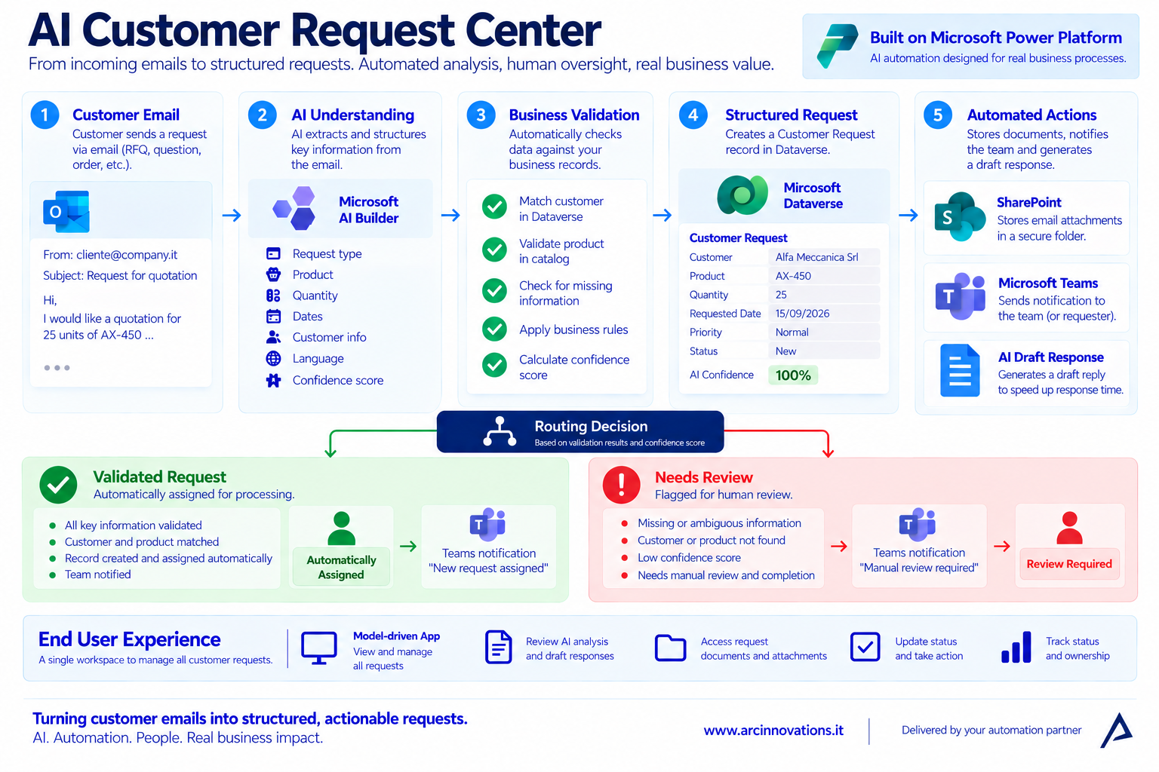
A Microsoft Power Platform automation case study by Arc Innovations
www.arcinnovations.it

Executive Summary
Customer-facing teams often receive RFQs, product questions, orders and support requests through email. The work that follows is repetitive but business-critical: understand the message, identify the customer and product, capture the request, organize attachments, route the work and prepare a response.
Arc Innovations built the AI Customer Request Center to automate that workflow while keeping people in control. The solution uses AI to understand incoming emails, validates the extracted information against business data, creates a structured Dataverse request, stores documents in SharePoint, drafts a reply and notifies the right team in Microsoft Teams.
Core design principle
Automate predictable work. Route uncertain, incomplete or invalid requests to a human instead of letting AI make unsupported business decisions.

The Business Challenge
- Requests arrive as unstructured email text and attachments.
- Employees manually re-enter the same information into CRM or tracking systems.
- Customer and product references can be missing, inconsistent or invalid.
- Attachments are scattered across inboxes and local folders.
- Fast responses matter, but fully automatic replies can create commercial risk.
- Exceptions need clear context so employees know why human review is required.
What the Solution Does
- Extracts request type, customer, product, quantity, date, priority, language and confidence.
- Matches customers in Dataverse and validates product codes against trusted master data.
- Creates a structured Customer Request with status, owner, AI summary and notes.
- Creates SharePoint folders only when attachments exist and stores documents by request.
- Generates a safe draft reply in the customer's language.
- Routes validated requests automatically and flags uncertain or invalid requests for review.
- Notifies users in Teams with a direct link to the supporting documents.
- Provides a model-driven app for day-to-day request management.

How the Automation Works
End-to-end architecture of the AI Customer Request Center.
1. Understand the email — A custom AI prompt converts the message into structured data. Missing values remain empty rather than being invented.
2. Validate against business data — The flow matches the customer, validates product codes and combines deterministic business rules with the AI confidence score.
3. Create the request — Dataverse stores the request, priority, status, owner, AI summary and review notes.
4. Organize documents and prepare a response — Attachments are stored in a request-specific SharePoint folder and a second AI prompt prepares a customer reply without confirming price, availability or delivery.
5. Route the work — Validated requests are assigned. Unknown, ambiguous or invalid requests are marked Needs Review and surfaced to a person with the reason for review.

A Single Workspace for Customer Requests
The model-driven app gives the team one place to see what arrived, what AI understood, which requests were assigned automatically and which ones need attention.
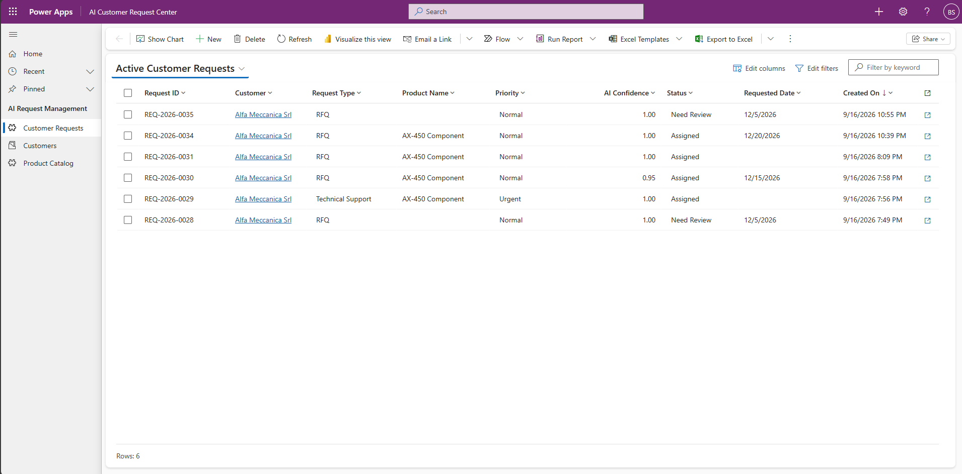
Customer Requests view: request type, product, priority, confidence and status in one operational queue.
Operational simplicity
Users work with business records, not flow runs. They can search, assign, review and complete requests without opening Power Automate.

Validated Request: Automatic Processing
When the customer is known, the request is sufficiently confident and the relevant business validation succeeds, the request can be routed automatically to the responsible owner.
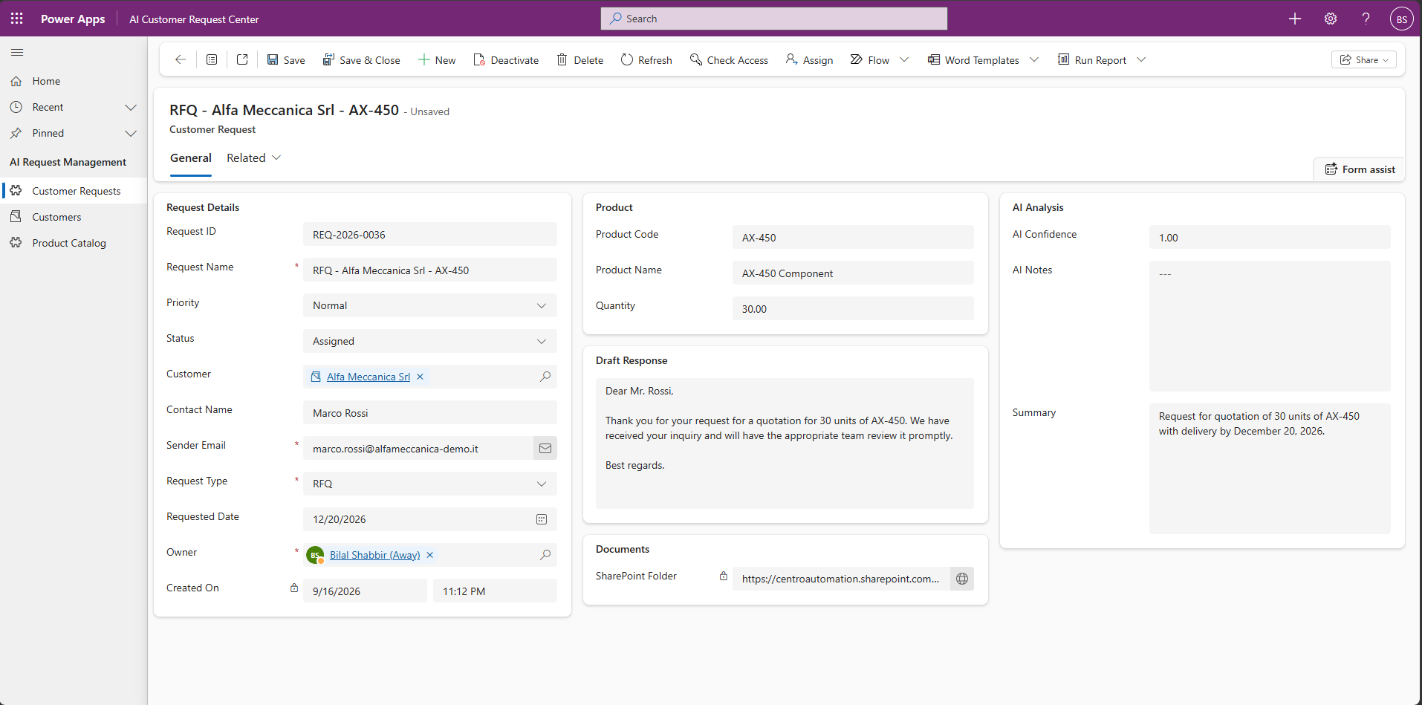
Assigned RFQ: customer, product, quantity, AI analysis, draft response, documents and owner are available on one record.
What happened automatically
- The email was classified as an RFQ.
- Alfa Meccanica Srl was matched to the customer record.
- AX-450 was validated against the Product Catalog.
- The request was created and assigned to the account owner.
- The attached document was stored in SharePoint.
- A draft response was generated for employee review.
- A Teams notification surfaced the new request and document link.

Human-in-the-Loop: Needs Review
AI confidence alone does not decide whether a request is safe to automate. The workflow also checks trusted business data. In this example, AI correctly understands the RFQ, but product ZZ-999 does not exist in the Product Catalog. The request is therefore routed to a person.
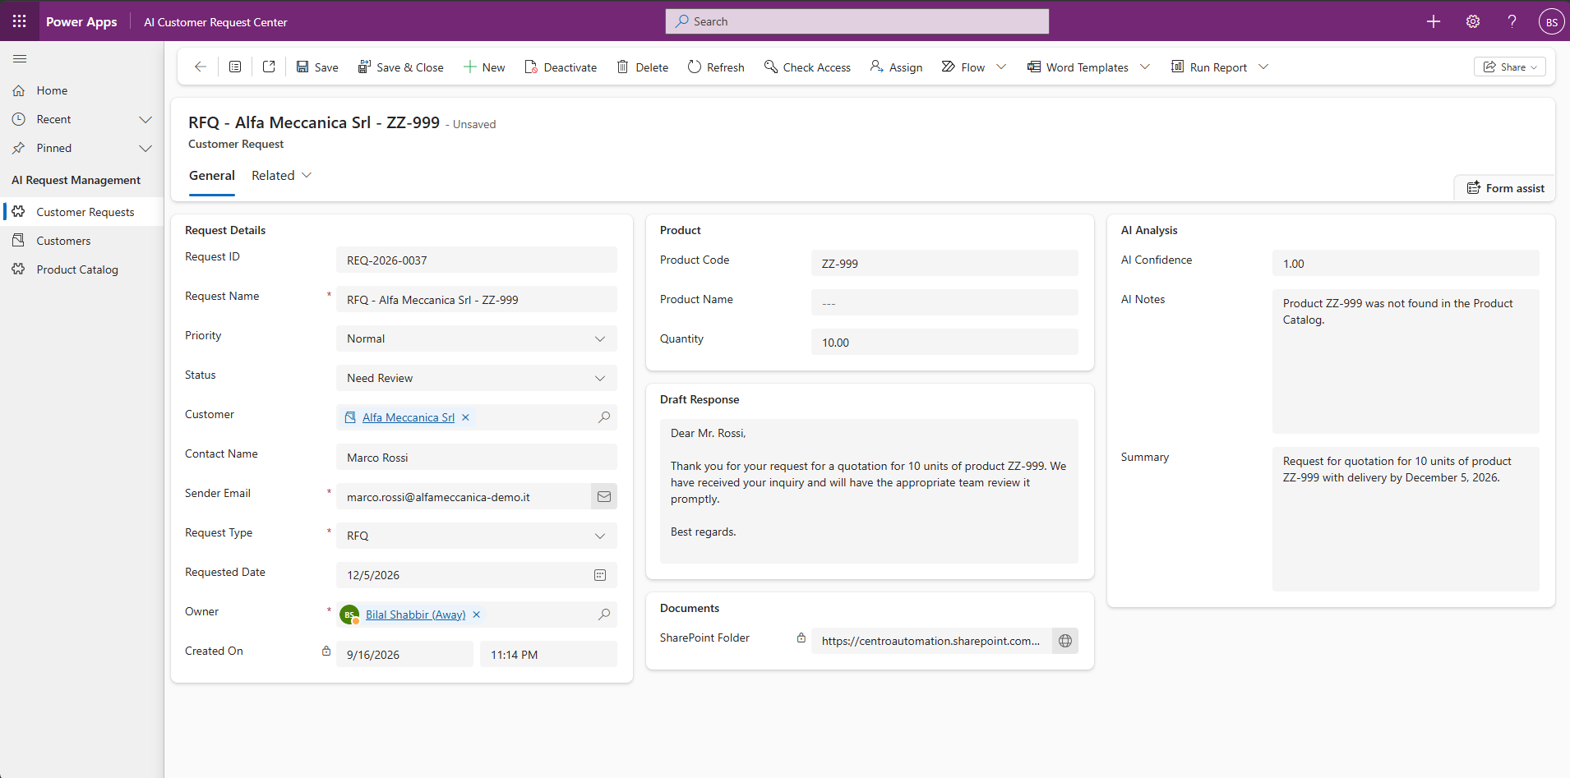
Needs Review example: AI confidence is high, but a deterministic product-validation rule prevents automatic processing.
Controlled AI, not blind automation
The reason for review is stored directly on the request: “Product ZZ-999 was not found in the Product Catalog.” The reviewer gets immediate context instead of having to investigate why the automation stopped.

Teams Notifications and Document Collaboration
Teams notifications surface the information needed to act. Validated requests and review-required requests use different cards, while SharePoint keeps the supporting documents organized by customer and request.
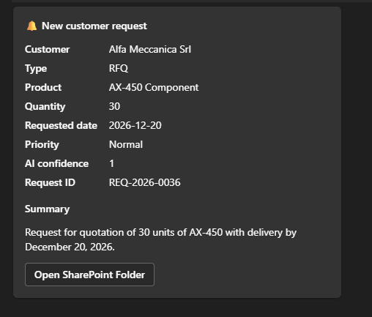  Validated request | 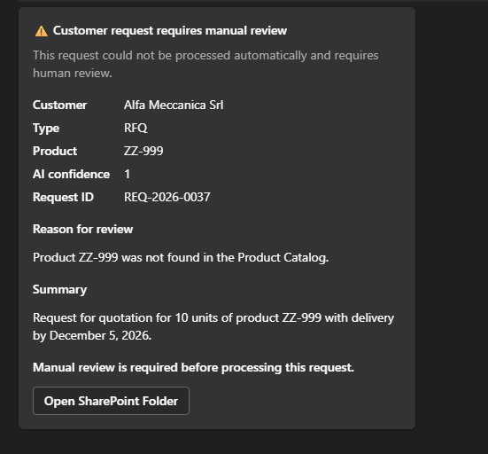  Needs Review

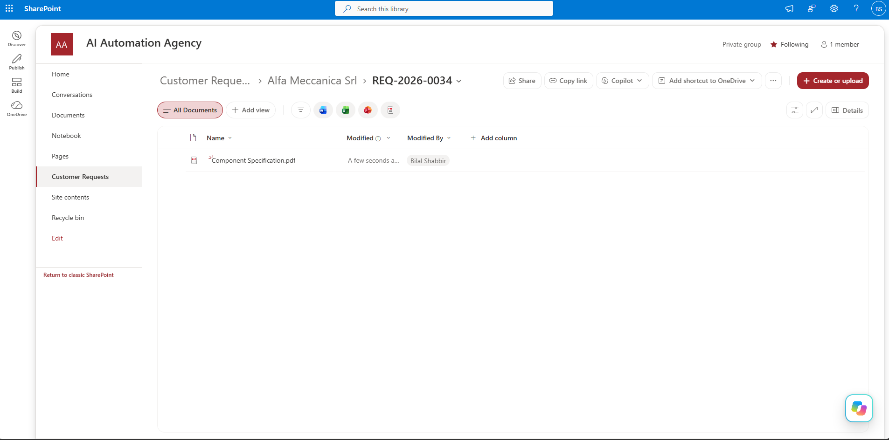
SharePoint stores request documents in a predictable customer/request folder structure.

Business Value
This prototype demonstrates how AI can be embedded inside a controlled business process rather than used as a standalone chat experience. The value comes from combining AI understanding with trusted data, deterministic rules, workflow automation and human oversight.
- Less manual email triage and data entry.
- Faster routing of RFQs, inquiries and support requests.
- More consistent customer and product data in the operational system.
- Automatic organization of request documents.
- Clear exception handling instead of silent automation failures.
- Human review for uncertain or invalid requests.
- Reusable architecture that can be adapted to sales, service, procurement and back-office workflows.
Technology
Power Automate  Workflow orchestration | Dataverse  Business data & requests | AI Builder  Email understanding & drafting | Power Apps  Operational workspace
SharePoint  Document storage | Microsoft Teams  Notifications | Outlook  Email intake | Solutions & Environment Variables  ALM / deployment readiness
Where This Pattern Can Be Applied
- Sales inquiries and RFQs
- Customer service and support intake
- Supplier or procurement requests
- Shared mailbox triage
- Document-heavy approval processes
- Internal service requests and case management
Have a similar email-driven process?
Arc Innovations designs AI and automation solutions on Microsoft Power Platform that turn repetitive business processes into structured, traceable workflows.

www.arcinnovations.it

