

Website and mobile application geolocation feature implementation

Supervisor: Peter Sherar

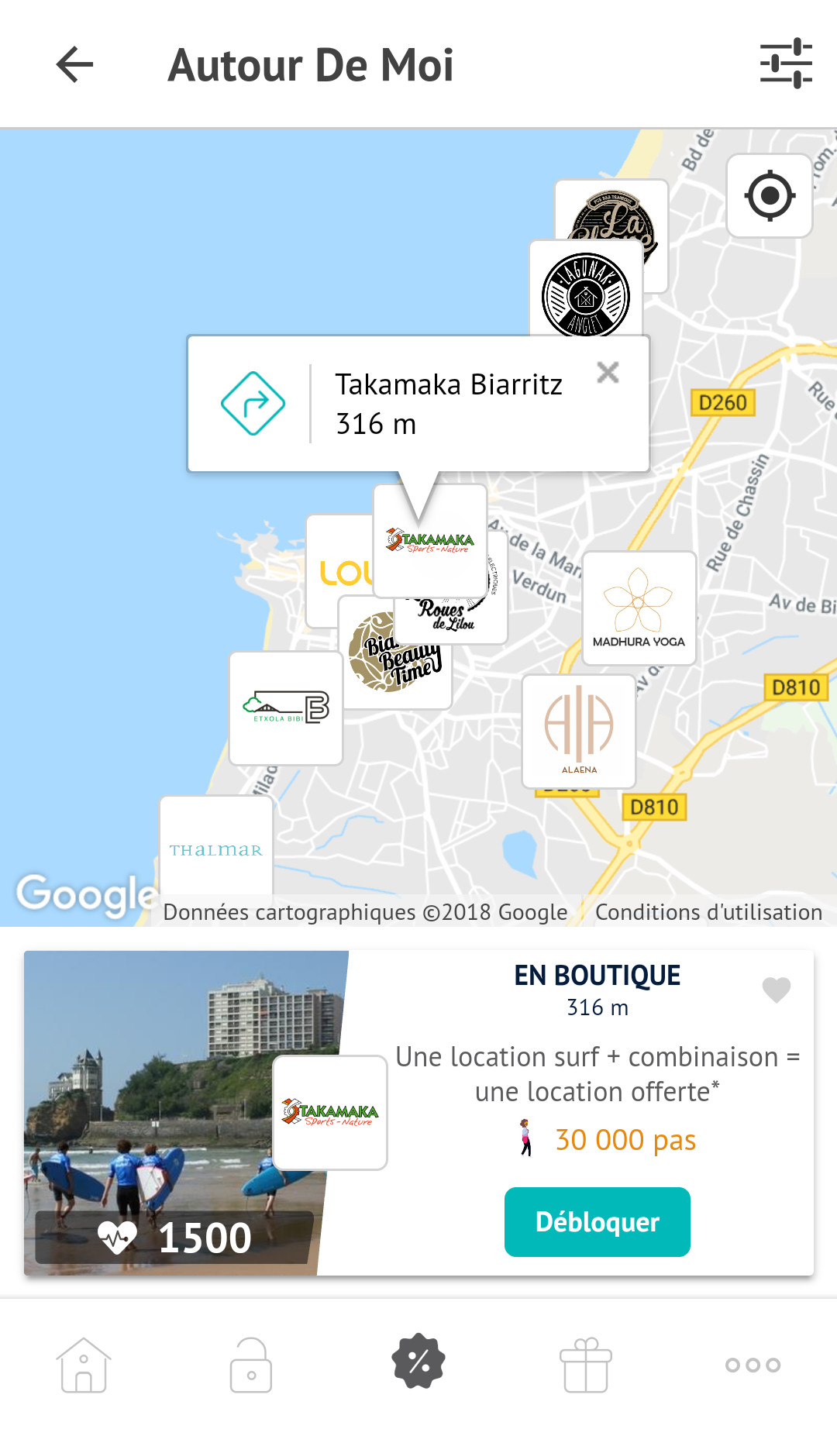

Context

Xendera is a French startup which rewards its users’ physical activities with discount vouchers from their commercial partners.  
The application is developed following agile methodology and targets both  
Android and iOS platforms

Work environment

* Angular framework
* Ionic Framework
* Kanban methodology
* Git
* Postman





Augustin Reille

MSC Software Engineering and Technical Computing

Academic year 2017 - 2018

a.reille@cranfield.ac.uk

Main results

* web component for partners brand geolocation adding and editing
* new “Around me” page in Android mobile app

Conclusion

Feature on both website and mobile app is live, and both users and partners are happy with it.

Further work

Developing a web application using Facebook’s ReactJS framework

50 avenue du lac Marion

64200 Biarritz