CS4331/CS5342 Network Security
Homework 3 (100 points)

Name:
RNo:

Q.1. How many ways to achieve key distribution? (6.5 points)
Ans:
- A key could be selected by A and physically delivered to B.
- A third party could select the key and physically deliver it to A and B.
- If A and B have previously and recently used a key, one party could transmit the new key to the other, using the old key to encrypt the new key.
- If A and B each have an encrypted connection to a third-party C, C could deliver a key on the encrypted links to A and B.

Q.2. What are the requirements of many-to-many authentication? (8.5 points)
Ans:
Security
- against attacks by eavesdroppers and malicious users.
Transparency
- users shouldn't notice authentication taking place.
- entering password is ok, if done rarely.
Scalability
- Large number of users and servers.

Q.3. What are advantages & weaknesses of this protocol? (8.5 points)

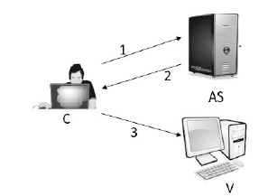

Ans:
1.C->AS: IDC||PC||IDV
2. AS->C: Ticket = E(KV, [IDC||ADC||IDV])
3. C->V: IDC || Ticket

Advantage

- Client and malicious attacker cannot alter IDC (impersonate), ADC (change of address), IDV
- server V can verify the user is authenticated through IDC, and grants service to C

- guarantee the ticket is valid only if it is transmitted from the same client that initially requested the ticket.
Weakness: Insecure: password is transmitted openly and frequently
Solution: no password transmitted by involving ticket-granting server (TGS)

Q.4. What are advantages & weaknesses of secure authentication?
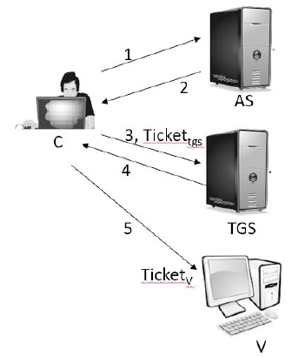

Ans:
Once per user logon session
- C->AS: IDC|| IDtgS
- AS->C: E(KC, Tickettgs)
Once per type of service:
(3) C->TGS: IDC |||IDv|| Tickettgs
(4) TGS->C: TicketV
Once per service session:
(5) C->V: IDC || TicketV
Advantage:
- No password transmitted in plaintext.
- Ticket is reusable. Timestamp is added to prevent reuse of ticket by an attacker.
Weakness:
- Ticket hijacking
- Malicious user may steal the service ticket of another user on the same workstation and try to use it.
- Network address verification does not help.
- Servers must verify that the user who is presenting the ticket is the same user to whom the ticket was issued.
No server authentication
- Attacker may misconfigure the network so that he receives messages addressed to a legitimate server-man in the middle attack.
- Capture private information from users and/or deny service.
- Servers must prove their identity to users
Solution: section key
Q.5.Draw & describe the sequence diagram of Kerberos_V4
Ans:

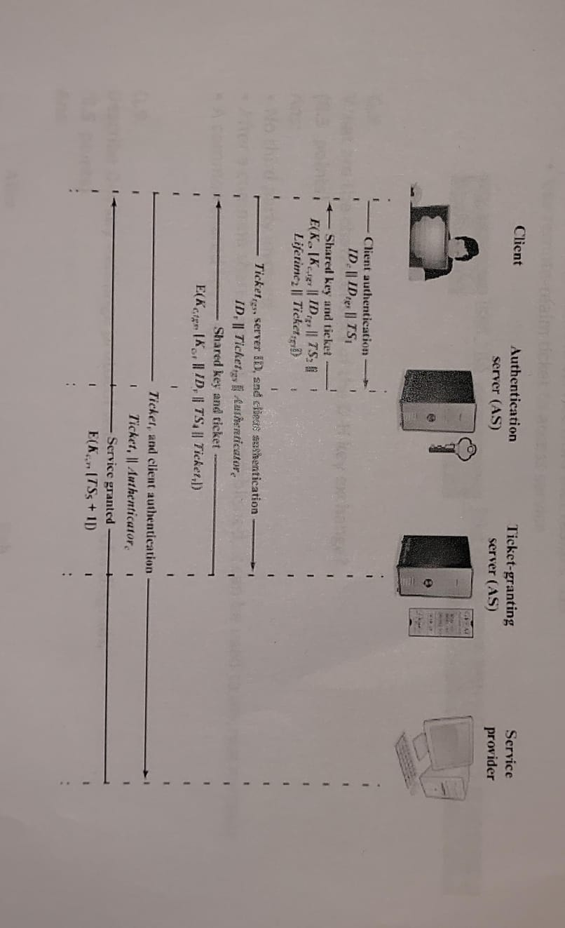

Q.6.
What are the important ideas in Kerberos? (8.5 points)
Ans:
- Short-term session keys
• Long-term secrets used only to derive short-term keys
• Separate session key for each user-server pair.
• Re-used by multiple sessions between same user and server-
lifetime.
- Proofs of identity based on authenticators
• Client encrypts his identity, addr, time with session key; knowledge of key
proves client has authenticated to KDC.
• Also prevents replays (if clocks are globally synchronized)
• Server learns this key separately (via encrypted ticket that client can't
decrypt), then verifies client's authenticator
• Symmetric cryptography only

Q.7. Write a sequence to access the service in the remote realms to get the service ticket. (8.5 points)
Ans:
To access a service in another realm, users must...
- Get ticket for home-realm TGS from home-realm KDC.
- Get ticket for remote-realm TGS from home-realm TGS.
• As if remote-realm TGS were just another network service
- Get ticket for remote service from that realm's TGS.
- Use remote-realm ticket to access service.


.
Q.8. What are the characteristics of the D-H key exchange? (8.5 points)
Ans:
- No third party involved.
- After a common shared key, αXAXB is established, it can be used to encrypt message.
- A common shared key is symmetric.

Q.9.
Describe D-H key exchange protocol with the help of a diagram. (8.5 points)
Ans:
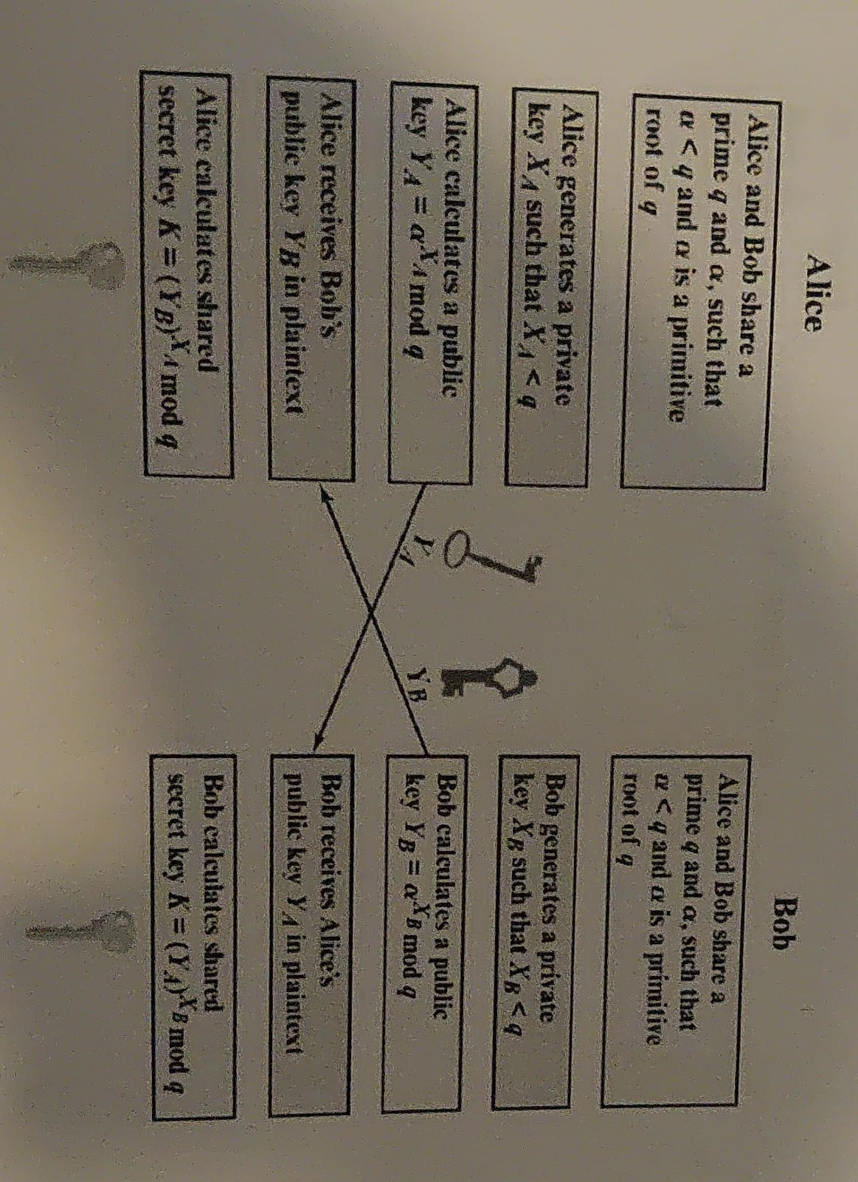

Q.10. What are the assumptions in D-H key exchange protocol? (8.5 points)
Ans:
Two cryptographic assumptions:
- Discrete logarithm problem (discrete log problem): Given α, q, α^XA mod q for random XA, it is computationally hard to find XA.
- Diffie-Hellman assumption: Given α, q, α ^XA mod q, and α^XB mod q for random ХA, Хв, no polynomial time attacker can distinguish between a random value R and α^{XAXB} mod q.
• Intuition: The best-known algorithm is to first calculate XA and then
compute (α^{XB})^{XA} mod q, but this requires solving the discrete log problem,
which is hard!
• Note: Multiplying the values doesn't work, since you get
α^{XA+XB} mod p≠ α^{XAXB} mod p

Q.11.What attack is D-H key exchange suffer? (8.5 points)
Ans:
- David can alter messages, block messages, and send her own messages
- DH is not secure against a MITM attacker: David can just do a DH with both sides!

Q.12. Consider a Diffie-Hellman key exchange scheme with a common prime q = 11 and a primitive root α = 3. If User A has the public key Y_{A} = 5, and User B has both the private key Y_{B} = 4 and the private key X_{B} = 4, what is the shared secret key K? (8.5 points)
Ans: K = (YA)^{XB} mod q = (5)⁴ mod e 11=9

