Network Security Tutor & Quiz Agent

Name: Anusha Triveni Maddina R#: R11979105
This project features an interactive Q&A and Quiz Bot designed to support users in learning essential topics in network security. The entire system runs locally, using a Next.js frontend (port 55263) and a backend (port 55268). When a user submits a question in the Tutor interface, the backend fetches related information from a Chroma vector database and sends it to the Llama 3.2 model hosted through Ollama. The model then generates a response, which is returned and displayed on the front end.
All processing happens on localhost (127.0.0.1). This means that every step of communication—including user queries, database searches, and model inference—takes place within the system itself, without any external network requests or third-party data transmissions.
Wireshark packet captures collected during testing clearly demonstrate the internal data flow: the browser sends the request to the backend, the backend queries the vector database, interacts with the Llama model, and finally returns the generated answer back to the user interface. The captured packets verify that the communication remains entirely local, confirming the isolated and secure architecture of the system.

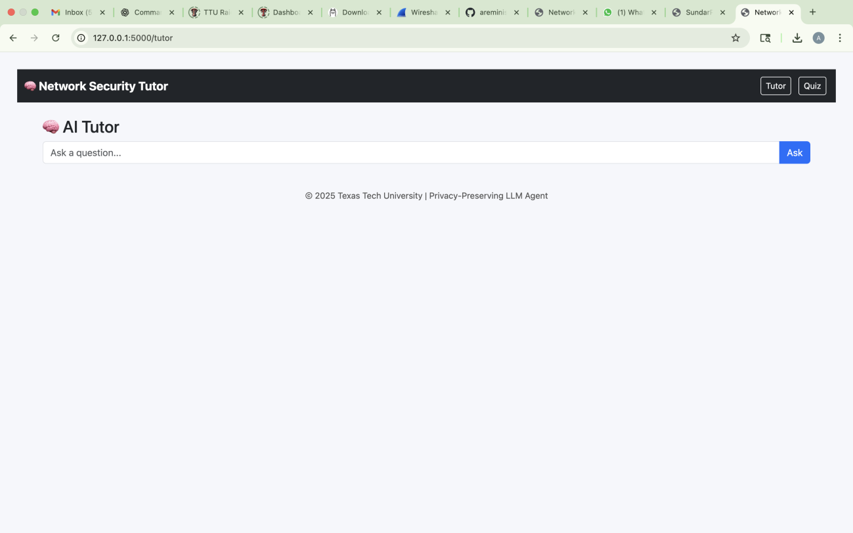

Prompt 1: What is a security policy and why is it critical for organizations? Procedure:
In the Tutor interface, the user enters the question “What is a security policy and why is it critical for organizations?” into the input field and submit it. The request is sent from the
browser running on 127.0.0.1 to the backend server, which processes the query and returns the explanation to the user.
The backend retrieves relevant information from the local vector database and forwards it to the locally hosted language model. The generated answer is then returned to the frontend and displayed in the Tutor UI, as shown in the screenshot below.

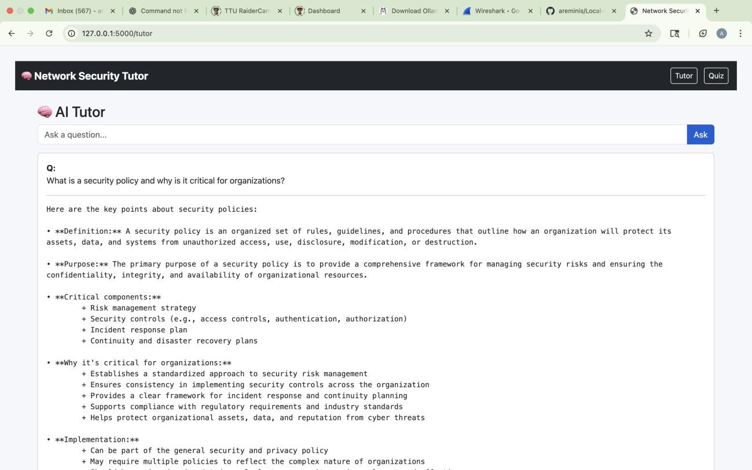

Wireshark Observation:
- Source IP: 127.0.0.1
- Destination IP: 127.0.0.1
This confirms that there is no external network communication involved.
- Protocol: TCP
- Source Port: 55263
- Destination Port: 55278

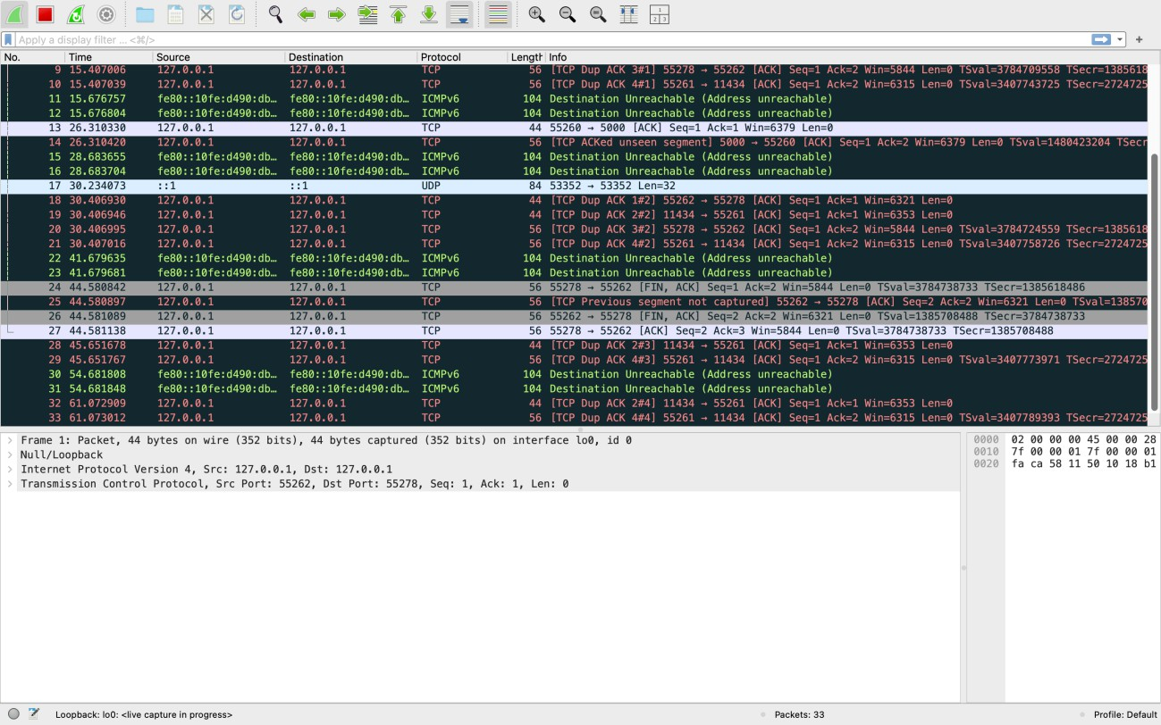
The connection begins with the standard TCP three-way handshake:
SYN → SYN/ACK → ACK

Once the connection is established, the browser sends an HTTP POST request containing the
user’s question in JSON format.
Wireshark clearly shows the transmitted message, including the question text. After receiving the request:
- The Django backend queries the Chroma vector database for relevant context.
- The backend forwards the retrieved information along with the user’s question to the
Llama model running locally via Ollama.
- The model generates the answer and returns it to the backend.
- The backend sends the final response back to the frontend via HTTP.

prompt 2: Explain the steps involved in risk assessment and management Procedure:
In the Tutor interface, the user enters the question “Explain the steps involved in risk

assessment and management” and submits it. This request is sent from the web browser to the backend server running locally on the same system. The backend retrieves relevant information and generates a structured explanation using the locally hosted language model. The response is then returned to the front end and displayed to the user, as shown in the screenshot.
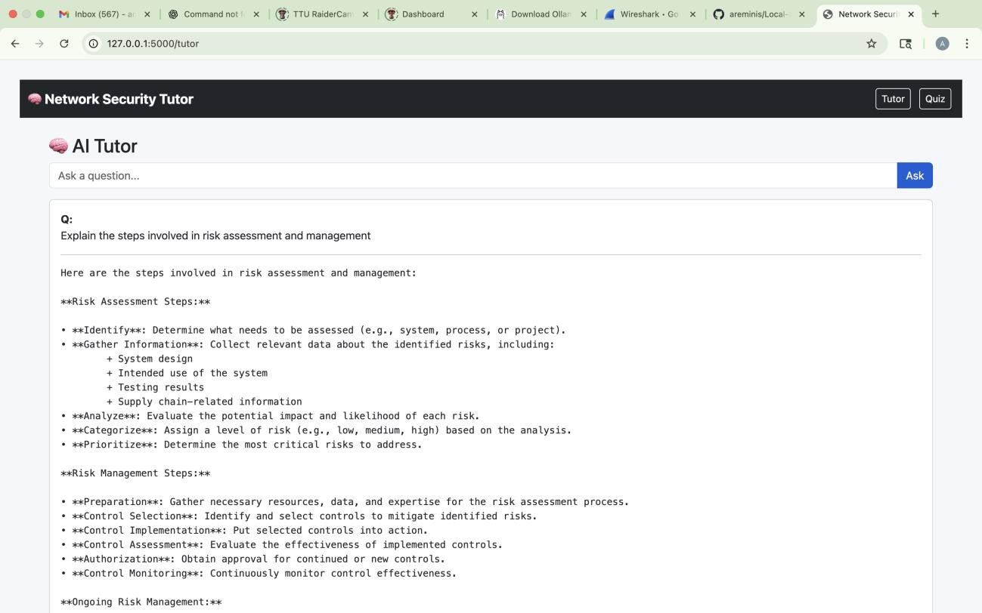

Wireshark Observation:
Wireshark was used to capture communication during this interaction. The packet trace confirms that the communication takes place entirely on the local machine through the loopback interface.
- Source IP: 127.0.0.1
- Destination IP: 127.0.0.1
- Protocol: TCP / HTTP
- Source Port: 55262
- Destination Port: 55278
The communication begins with the standard TCP three-way handshake:
SYN → SYN/ACK → ACK
After the connection is established, the browser sends an HTTP POST request containing the question of text. Wireshark clearly shows the request payload including the question:

“Explain the steps involved in risk assessment and management.”
Once received:
- The Django backend retrieves relevant context from the Chroma vector database.
- The backend forwards the query and retrieves data to the Llama model running locally through Ollama.
- The model generates a structured explanation and returns it to the backend.
- The backend sends the completed answer back to the frontend as an HTTP/1.1 200 OK response.
The Wireshark capture confirms a successful response and shows no external network traffic, demonstrating that the system operates completely locally.
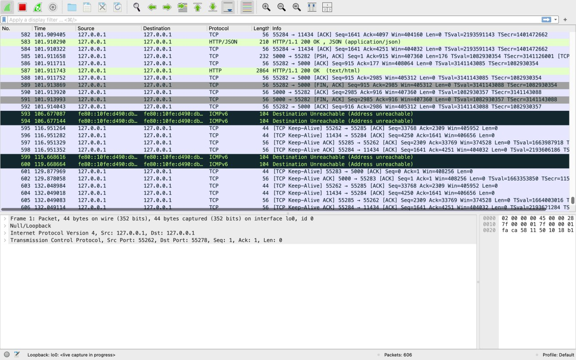

Prompt 3: What are NIST and ISO security frameworks used for? Procedure:
In the Tutor interface, the user enters the question “What are NIST and ISO security
frameworks used for” and submits it. The request is sent from the browser to the backend server, both running locally on the same system. The backend processes the query, retrieves supporting information from the Chroma vector database, and generates an answer using the

locally hosted Llama model. The final explanation is then returned to the frontend and displayed in the Tutor interface, as shown in the screenshot.
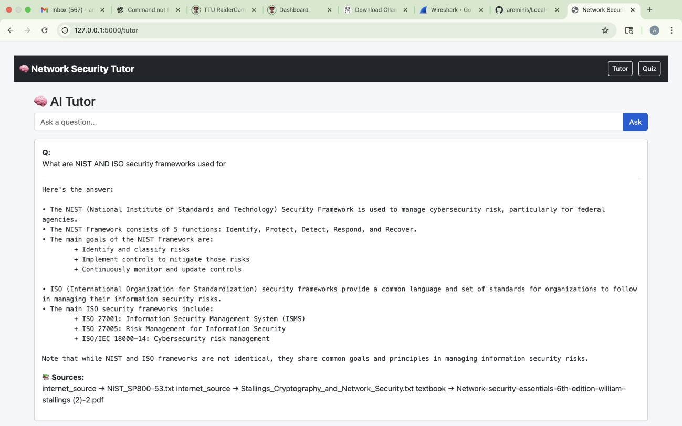

Wireshark Observation:
Wireshark was used to capture the network activity during this request. The packet trace confirms that the entire interaction occurs locally through the loopback interface.
- Source IP: 127.0.0.1
- Destination IP: 127.0.0.1
- Protocol: TCP / HTTP
- Source Port: 55262
- Destination Port: 55278
The communication begins with the standard TCP three-way handshake:
SYN → SYN/ACK → ACK

After the connection is established, the browser sends an HTTP POST request containing the
text of the user’s question. In the Wireshark packet details, the request body clearly includes:

“What are NIST and ISO security frameworks used for.”
Once the backend receives the request:
- The Django server retrieves relevant context from the Chroma vector database.
- The backend forwards both the context and the question to the local Llama model through Ollama.
- The model generates the final explanation.
- The backend returns the answer to the frontend as an HTTP/1.1 200 OK response.
The Wireshark capture shows this successful HTTP response and confirms that no external network communication occurred, demonstrating that the system operates fully offline and on- device.
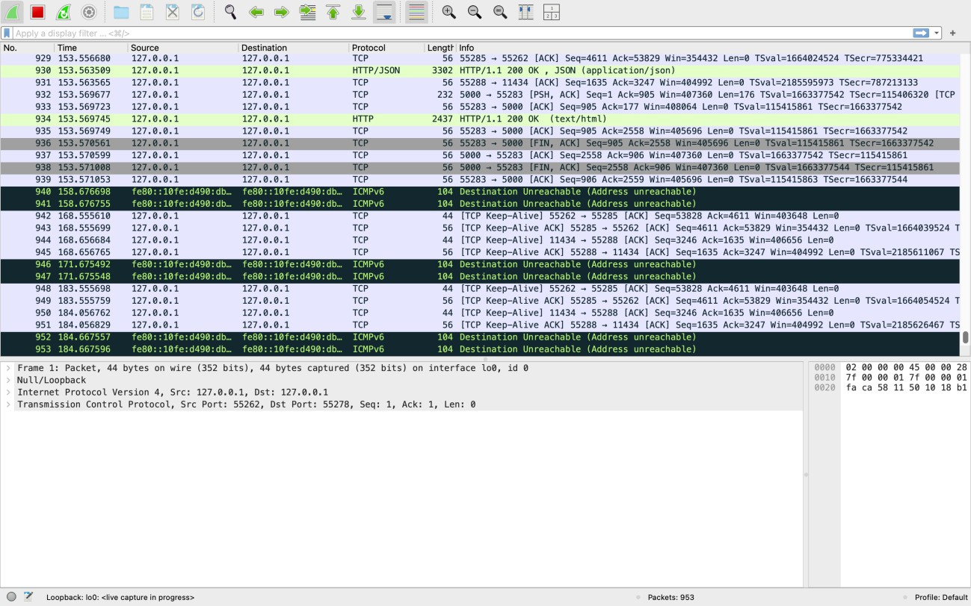

Prompt 4: Describe the concept of compliance and its importance in cybersecurity? Procedure:
In the Tutor interface, the user enters the question “Describe the concept of compliance and its importance in cybersecurity” and submits it. The browser sends this request to the backend server running locally on the same system. The backend processes the query, retrieves relevant context from the Chroma vector database, and uses the locally hosted Llama model to generate

the explanation. The final answer is then returned to the front end and displayed clearly in the Tutor interface, as shown in the screenshot.
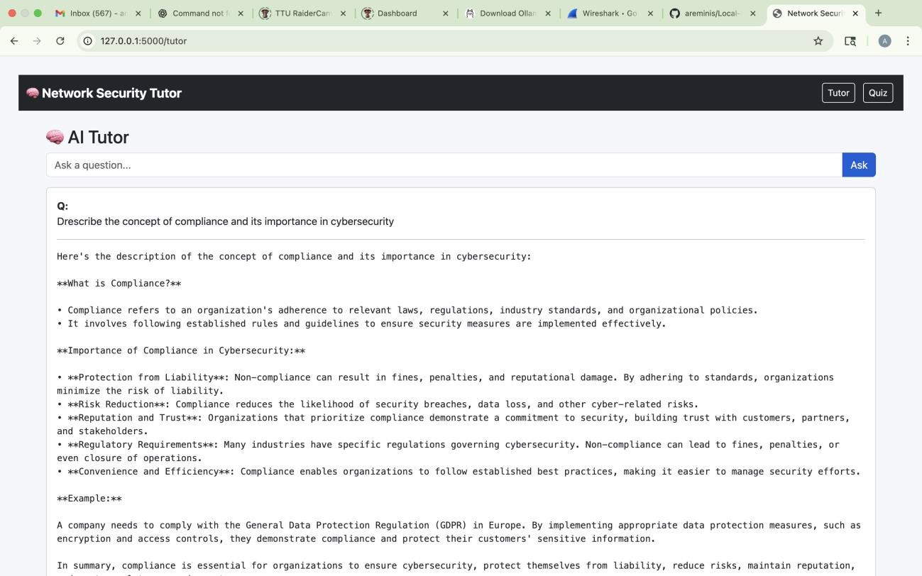

Wireshark Observation:
Wireshark was used during this process to analyze network traffic. The captured packets confirm that the communication occurs entirely over the loopback interface, meaning everything runs locally without external network interaction.
- Source IP: 127.0.0.1
- Destination IP: 127.0.0.1
- Protocol: TCP / HTTP
- Source Port: 55262
- Destination Port: 55278
The communication session begins with the standard TCP three-way handshake:
SYN → SYN/ACK → ACK
After the connection is established, the browser sends an HTTP POST request containing the text of the question. In Wireshark, the payload clearly shows the request content:
“Describe the concept of compliance and its importance in cybersecurity.”

Once the backend receives the request:
- The Django backend fetches relevant information from the Chroma vector database.
- The system forwards the retrieved data and the question to the Llama model running locally through Ollama.
- The model generates responses.
- The backend sends the explanation back to the frontend in an HTTP/1.1 200 OK response.
The Wireshark capture verifies the successful response and confirms that no external network traffic occurs throughout the interaction.
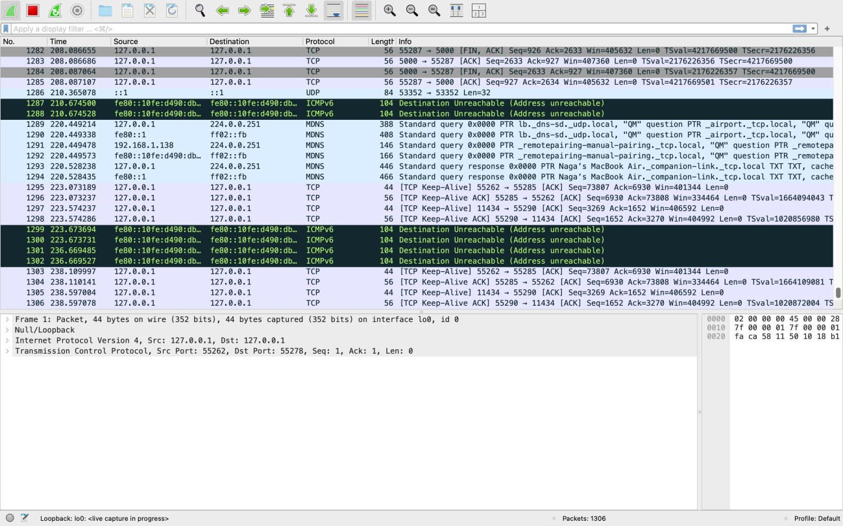

Prompt 5: Quiz Lab
When the user opens the Quiz Lab interface, they begin by entering their quiz preferences such as the number of questions, difficulty level, and topic of interest. In this case, the user selected the topic “Encryption Algorithms” with 5 questions and pressed the Generate Quiz button.

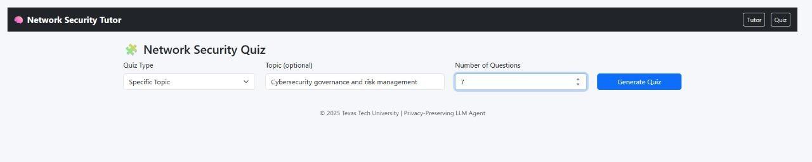
The backend retrieves relevant instructional materials and reference content stored in the Chroma vector database, including textbook excerpts, lecture notes, and supplemental documents. This context, along with the quiz configuration settings, is then forwarded to the Llama model running locally using Ollama. The model generates quiz questions and answer choices, which are returned to the frontend and rendered as an interactive quiz for the user, as shown in the screenshots.
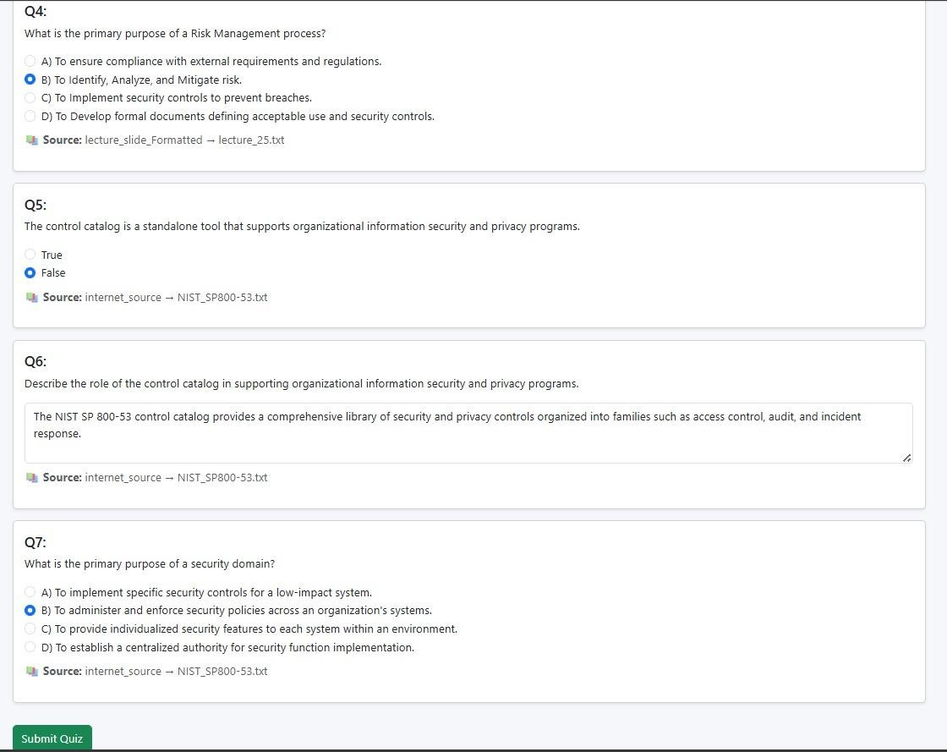

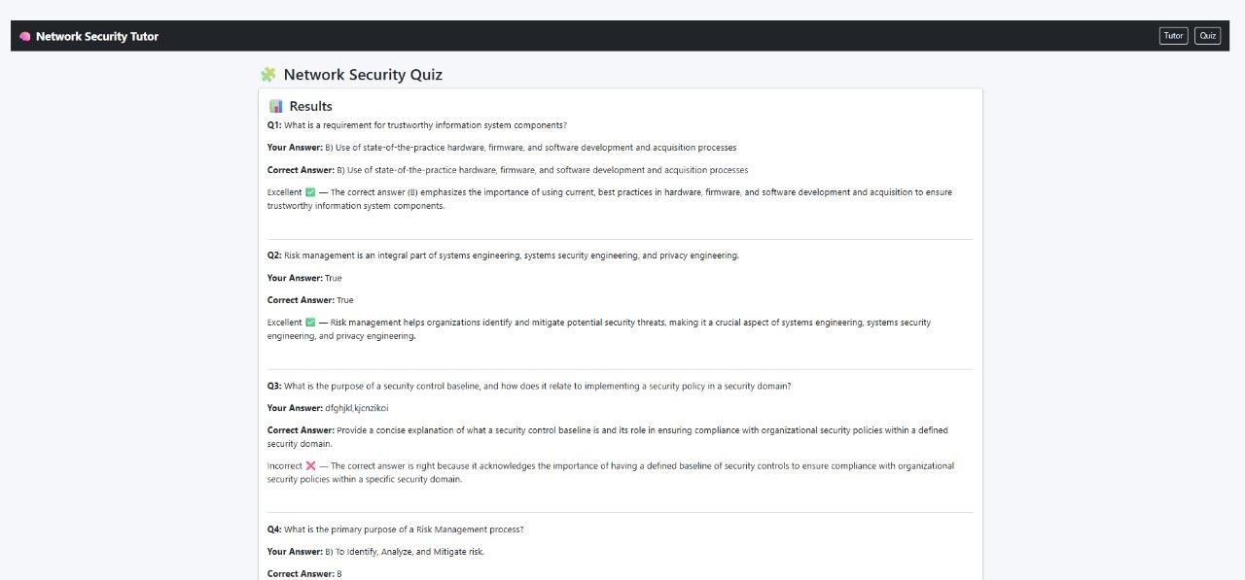

Wireshark Observation:
During quiz generation and submission, Wireshark was used to capture network traffic. The trace confirms that all communication occurs locally, with no external servers involved.
- Source IP: 127.0.0.1
- Destination IP: 127.0.0.1
This verifies that the browser, Django backend, vector database, and Llama model are all communicating on the same machine.
- Source Port: 49938
- Destination Port: 49951
- Protocol: TCP and HTTP
The packet exchange begins with the TCP handshake:
SYN → SYN/ACK → ACK

Once connected, the frontend sends:
HTTP GET /quiz HTTP/1.1
to retrieve and load the Quiz interface. The backend responds with:
HTTP/1.1 200 OK

confirming successful page delivery.
When the user submits a quiz request or quiz answers, HTTP POST requests are recorded in Wireshark. These requests contain the quiz configuration and the user’s responses. Multiple TCP ACK packets are exchanged as part of normal data acknowledgment between the endpoints.

Additionally, occasional IGMP packets may appear in the trace; these are standard local network multicast maintenance packets and are not related to quiz processing.
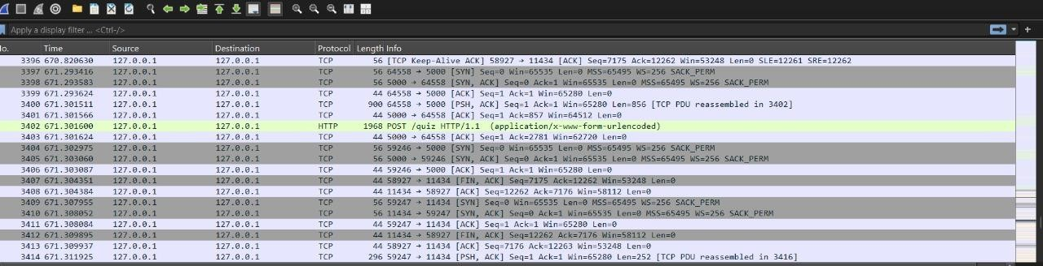

Summary of Observations:
- All traffic remains within 127.0.0.1, confirming that the system operates entirely offline.
- The HTTP responses show 200 OK, indicating that quiz creation, delivery, and scoring were completed successfully.
- No external network communication occurs, demonstrating strong privacy and local execution control.

