***Q-2-c:***

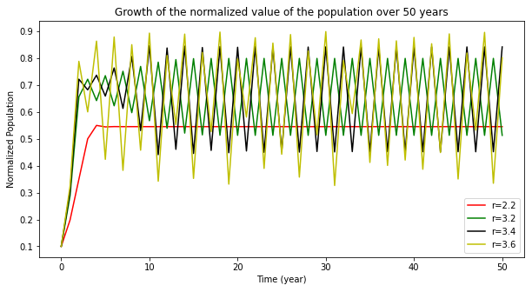

**Comments:** As the value of r grows, the fluctuations in the graph become higher (growing from no fluctuations to several), as well as the maximum amplitude of the fluctuation along an inccrease in the diversity of amplitudes (subpatterns). For example, in r=3.2, the graph repeats between two values and for r=3.6 between 6 values.

***Q-2-d:***

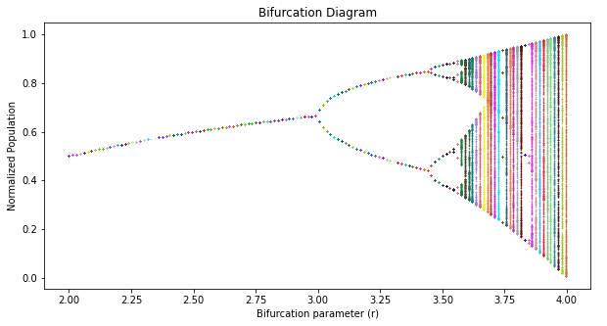

**Connection to graph in part c:** The period doubling happens when a forking happens in the diagram. For example, after r~3.45, a forking happens and results in an oscillation between 4 values this time, which increases the period (doubles it) between similar peaks and troughs. This pattern will continue as more forking happens. On the other hand, the bifurcation demonstrates chaotic behaviour as “solid vertical lines”. These lines indicate that the population is oscilling between a very large number of value. This could be in the thousands as the diagram demonstrates! The system can be considered chaotic after r~3.6, since that would be when solid lines start to emerge in the bifurcation diagram.

***Q-2-e:***

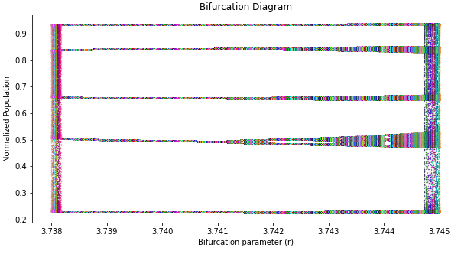

**Comments:** The forking process continues, but this time, the period between forkings is much less. Also, the openning of the forks is much smaller than the bifurcation diagram in part d. In addition, It seems that a transition period (similar to the [0,3] period in the graph in part d)) is happening shortly after r = 3.738, before leading to more forking. Overall, it seems that the plot repeats its behaviour when it is observed in a “magnified” state.

***Q-2-f:***

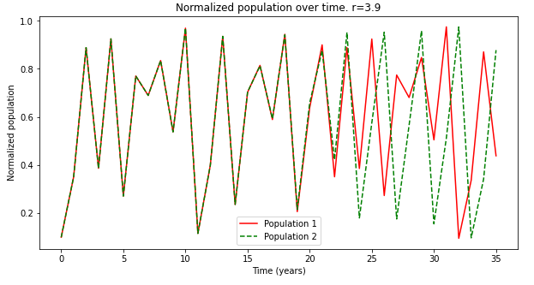

**Comment**: I chose p_max to be 35 years, since it is a sufficient range to demonstrate how the two populations initially match and diverge over time. I also chose r=3.9, since visually speaking from the Bifurcation diagram, a solid line is reached so it means the behaviour is chaotic at this point and it is the right choice for r.

***Q-2-g:***

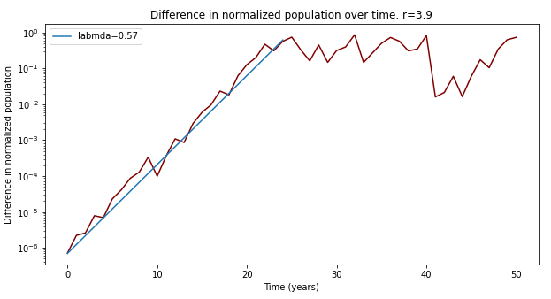

***λ-Lyapunov exponent ~- 0.57 (visually calculated)***