PHY407 Lab 9 Report

Andrey did question 3. Arya did questions 1, 2.

**Question 3:**

**Author: Andrey Remorov**

**Part (a)**

First, I had to obtain a way to generate nonuniform random numbers in accordance with the provided normalized weighting function p(x) = 1/(2 $\sqrt{x}$). From Newman pages 458, 459, by equation (10.7), I get that the integral of p(x) is $\sqrt{x}$ which equals the random number z, so x=z2. This means that to get the nonuniform random numbers for this specific weighting function, I had to generate a random number z, and then square it, and feed this result into the importance sampling expression.

I used code provided in the lecture notes (related to mean value).

To understand how both methods worked, I printed out the result of applying the mean value and importance value techniques:

Part (a) Mean value integral: 0.8690614831664905

Part (a) Importance sampling integral: 0.8408481012936195

Wolfram alpha says that this integral is around 0.838932960. Although the above outputs suggest that importance sampling is more accurate, 1 sample is not enough to be sure about this. So, I ran both techniques 100 times, and plotted histograms of the resulting values, with a fixed range of [0.8,0.88]. These are shown in figures 1,2. The mean value histogram is significantly more spread out than the importance sampling histogram, and both are centered about the exact value mentioned above, which means the importance sampling method is significantly more accurate in this situation, since it has a much lower variance.

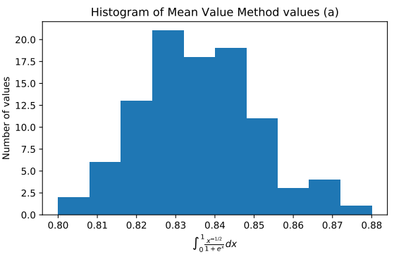

Figure 1: Histogram of values of the integral in part a obtained with the mean value technique.

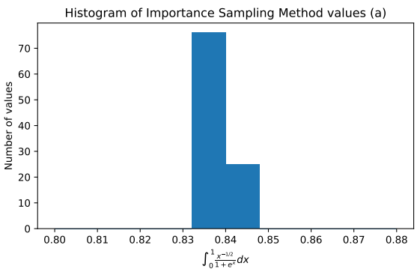

Figure 2:Histogram of values of the integral in part a obtained with the importance sampling technique.

**Part (b)**

I had to repeat the above analysis, but using an integral of a different function. This time, the normalized weighting function p(x) was a gaussian centered about x=5 with standard deviation of 1, and I could choose the nonuniform random number using np.random.normal(loc=5). I printed out the result of applying the mean value and importance value techniques:

Part (b) Mean value integral: 1.0226554758886042

Part (b) Importance sampling integral: 0.9947517361533385

Wolfram alpha says that this integral is around 0.99995. Although the above outputs suggest that importance sampling is more accurate, 1 sample is not enough to be sure about this. So, I ran both techniques 100 times, and plotted histograms of the resulting values, with a fixed range of [0.9,1.1]. These are shown in figures 3,4. The mean value histogram is significantly more spread out than the importance sampling histogram, and both are centered about the exact value mentioned above, which means the importance sampling method is significantly more accurate in this situation, since it has a much lower variance.

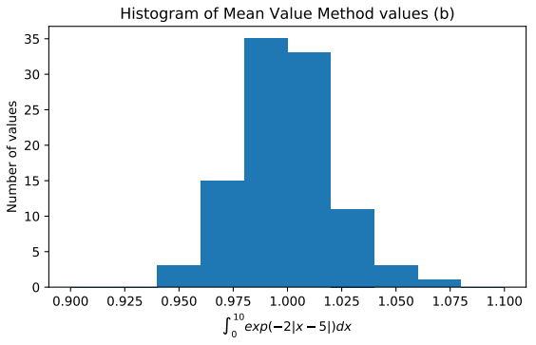

Figure 3: Histogram of values of the integral in part b obtained with the mean value technique.

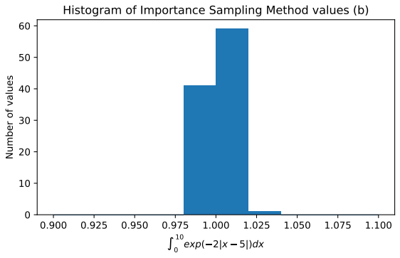

Figure 4: Histogram of values of the integral in part b obtained with the importance sampling technique.