Q-3:

**Outline:**

In this problem, we will explore the Monte Carlo and Markov Chain/Metropolis method for a 2-d protein folding problem.

This involves:

1. Choosing a random monomer on the protein chain.
2. Randomly choose and adjacent position near that monomer.
3. Check if the move brings no “stretches”, i.e. increase in connection length.
4. Calculate the energy of the new bond and see if the energy increases of decreases.
5. If it does increase, choose this move if the Boltzman factor of it is larger than a a random number between zero and one that you generate.
6. If the energy decreases, make the transition to the new position and save the new configuration.

After a lot of Monte Carlo steps, the energy of the protein will decrease. This rate will be different since the individual Monte Carlo steps are random.

**Part-a:**

For the case of N = 30, T = 0.5, ε = -5 and n = 105, a Monte Carlo simulation produces the following:

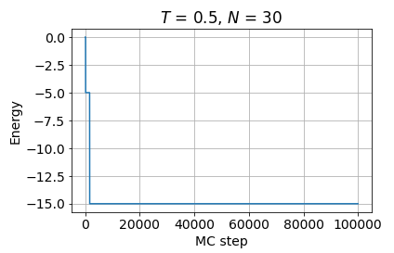

Figure-1: The energy diagram over Monte Carlo steps for T = 0.5 .

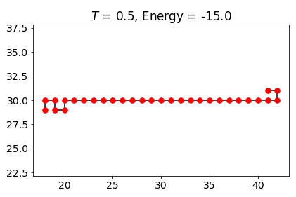

Figure-2: The Protein chain configuration after 105 Monte Carlo steps at T = 0.5 .

For the case of N = 30, T = 5, ε = -5 and n = 105, a Monte Carlo simulation produces the following:

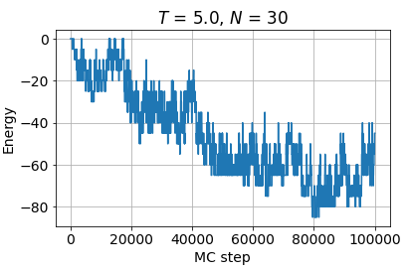

Figure-3: The energy diagram over Monte Carlo steps for T = 5 .

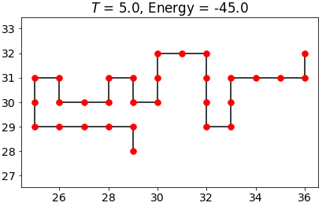

Figure-4: The Protein chain configuration after 105 Monte Carlo steps at T = 5.

Observation:

We can observe that in the low temperature range, the drop in energy over Monte Carlo steps is very rapid, as strong as a vertical drop. The configuration of the protein also did not change significantly from its original form.

For the higher temperature simulation, the drop in the energy over Monte Carlo steps has a significant degree of fluctuations. In addition, the energy of the protein is lower for this case in comparison to the lower temperature case. Which physically does not make sense. The reason for this is that the higher temperatures allows for more “constructive updates” (i.e. passes) on the protein. This allows for more varriation and this is why the fluctuations are more significant compared to T = 0.5 .

**Part-b:**

For *T* = 0.5 and a million MC steps, we get the following for the energy and protein configuration:

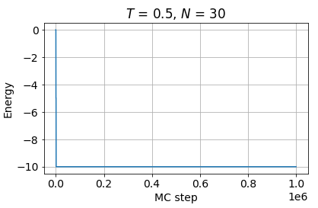

Figure-5: The energy diagram over a million Monte Carlo steps for T = 0.5 .

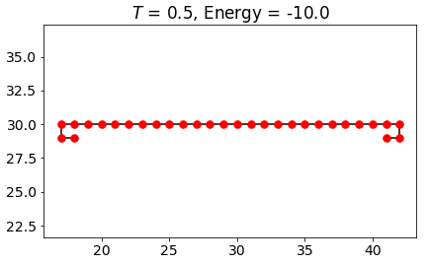

Figure-6: The Protein chain configuration after 106 Monte Carlo steps at T = 0.5 .

For *T* = 1.5 and a million MC steps, we get the following for the energy and protein configuration:

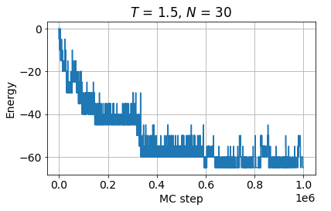

Figure-7: The energy diagram over a million Monte Carlo steps for T = 1.5 .

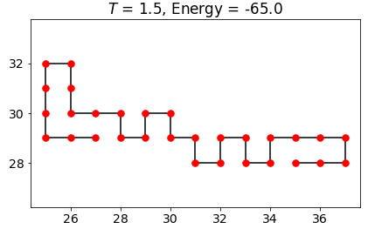

Figure-8: The Protein chain configuration after 106 Monte Carlo steps at T = 1.5 .

Observation:

In the low temperature scenario, we see that the energy of the ground state is higher than the energy of an excited state (higher temperature T = 1.5), which does not make logical sense. The reason for this is stated in part-a. The reason why the number of iterations did not help is the lack of annealing just like part-a of this question. This is because when the process doesn’t start from a higher temperature (first stage of annealing), the Markov chain Monte Carlo process gets stuck in a local minimum while lowring the energy from zero. A slower annealing process would avoid this by letting the first changes to go through faster by decreasing the component of the Boltsman factor. In the next parts of the problem, we will introduce staircase annealing find a closer approximation of the global minimum of the energy.

Part-c:

The result for T= 0.5 and stepwise annealing, we reach the following ground state energy and configuration for the protein polymer:

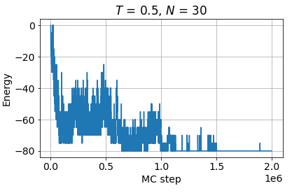

Figure-9: The energy diagram for the Monte Carlo steps for T = 0.5 using annealing .

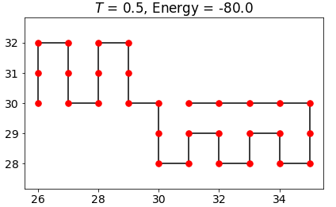

Figure-10: The Protein chain configuration after a stepwise annealing of temperature.

Observation:

We see that the stepwise annealing in this case has changed the configuration of the protein significantly compared to part-b and also lowered the energy of the final state significantly from -10 to -80. This is directly related to our annealing of the temperature. The drop in energy over the Monte Carlo steps has been smoother than the non-annealed version. In the non-annealed version, the drop was instantenaous and very sharp and bottomed out at a local minimum. This made almost all the monte carlo steps useless for that process, which is resolved here.

**Part-d:**

Now we test a more gradual annealing with 9.5 million Monte Carlo steps. We observe the following for the Energy and configuration for T = 0.5 :

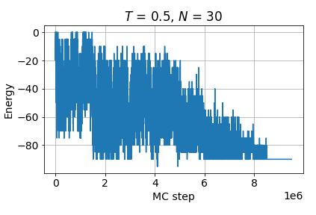

Figure-11: The energy diagram for the Monte Carlo steps for T = 0.5 using more gradual annealing .

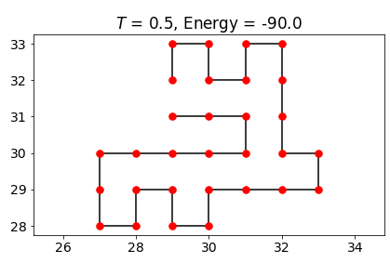

Figure-12: The Protein chain configuration after a smoother stepwise annealing of temperature.

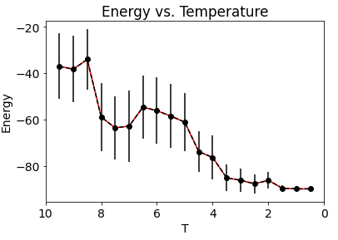

Figure-13: The energy vs. Temperature graph. The vertical lines represent uncertainty in energy.

In this case, a smoother annealing has resulted in a lower ground state energy, which means that we got closer to the global minimum for the energy of the protein. The configuration of the protein is much more curled compared to part-a,b and even part-c. The energy graph displays a drop in energy for the most part, which is a good sign that our process works. In addition, an evidence of a phase transition is seen in the energy versus temperature graph. At a temperature very close to T = 8, over a very small temperature interval, there is a significant drop in energy, which is the largest in the graph.