**Question-1:**

Part-a) Nothing to submit.

Part-b) The numerically calculated integrals and their errors are as follows:

|  |  |
| --- | --- |
| Numerical value of the Derivative (Forward Diff. ) | Error Relative to Analytical Value |
| -1.1102230246251565 | 0.33142224155375166 |
| -0.7771561172376095 | 0.0016446658337954112 |
| -0.7771561172376096 | 0.0016446658337953002 |
| -0.7793765632868599 | 0.0005757802154550129 |
| -0.7788214517745473 | 2.066870314243463e-05 |
| -0.7787992473140548 | 1.5357573500685007e-06 |
| -0.7788003575370794 | 4.2553432544334413e-07 |
| -0.7788008016262893 | 1.8554884406718486e-08 |
| -0.778800790524059 | 7.45265416046692e-09 |
| -0.7788008216103037 | 3.8538898849971304e-08 |
| -0.7788011724407795 | 3.8936937463152077e-07 |
| -0.7788046770040856 | 3.893932680743006e-06 |
| -0.7788397166208494 | 3.8933549444508664e-05 |
| -0.7791895344301247 | 0.0003887513587198521 |
| -0.782629857128947 | 0.00382907405754207 |
| -0.8112445700037385 | 0.03244378693233363 |
| -0.6734015585095405 | 0.10539922456186435 |

Part-c)

When h is small, the first term in eq 5.91 dominates the error, that being the rounding error of the computer. This is because h approaches the scale of C (~10^-16). However in the large h values, the second term in eq 5.91 dominates, that being, the error due to truncation. Note that we get the second term of the equation by estimating the function as the second order Taylor series of itself. This explains why the graph grows at each extreme, once for one type of error.

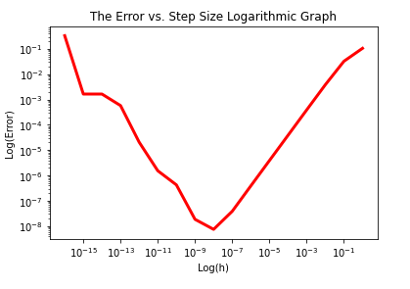

Part-d)

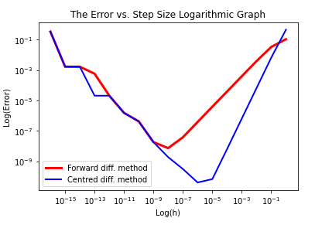

**Comments:** It can be observed that the forward and centred difference method are almost (with the exception of 10^-13 to 10^-11, in which the centred method becomes superior) the same in accuracy up to the 10^-9 mark. However from 10^-9 to 10^-1, the centred method beats the forward method by a large margine. It should also be noted that the lowest error of the centred method is reached at h = 10^-6.

**Question-3:**

Part-a)

Nothing to submit.

Part-b)

Nothing to submit.

Part-c)

For the integration method, I chose the Simpson’s rule, since it is in general more accurate than the trapazoidal method for a fixed partition.

Normally, the number of sample points is either approximated with equation 5.25 (especially for the cases where we have the analytical expression of the function), or estimated through the produced error and the acceptability of the error, with trial and error. However, in this case, the inner function is a complex valued function and thus its integral is a complex number. Thus determining the error through both eq. 5.25 and the acceptability criterion for error can be tricky. Thus, I resorted to the visual effects of error in the diffraction pattern. I started from N=10 and doubled it at a time to see how the diffraction pattern graph changes. Once little change between the steps was observed, it was realized that N is sufficiently large. Note that N is an argument of the integral_calc function so it can be changed without changing the main code.

Part-d)

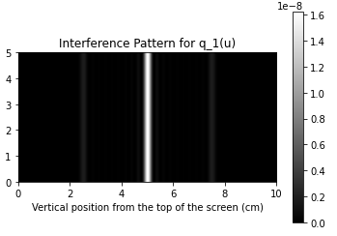

*the figure above is an interference pattern for the transmission function mentioned in part a of the problem on a gray scale. Bright areas represent higher intensities.

Part-e)

i)

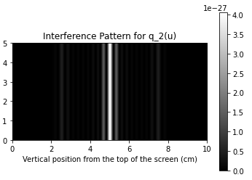

* the figure above is an interference pattern for the transmission function mentioned in part e-(i) of the problem on a gray scale. Bright areas represent higher intensities.

ii)

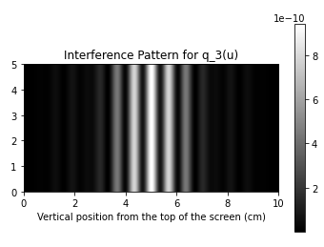

* the figure above is an interference pattern for the transmission function mentioned in part e-(ii) of the problem on a gray scale. Bright areas represent higher intensities.