**Question-2:**

***Part-a)***

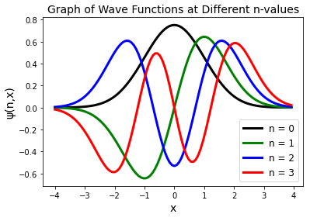

Figure-1: graph of wave functions at different values of n.

Observation: it looks like that as we increese the value of ***n*** the number of oscilations also rises. In the graph of n=0 we have a single peak/trough, in n=1 we have two peak and trough, in n=2 we have three peak and trough and so on.

***Part-b)***

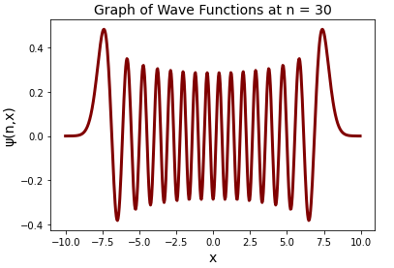

Figure-2: Graph of the wave function at n=30

Observation: our observation in part a) is confirmed! We observe a dramatic increase in the number of oscillations for this case.

Part-b)

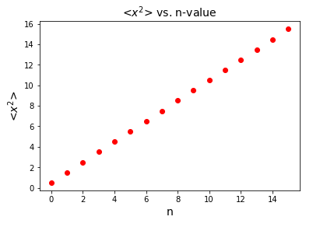

Figure-3: the expectation of over different values of n.

**Observation:** the expectation value increases linearly over n.

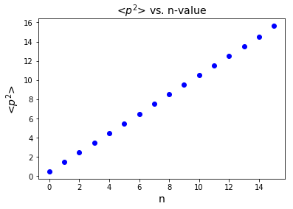

Figure-4: the expectation of over different values of n.

**Observation:** the expectation value increases linearly over n.

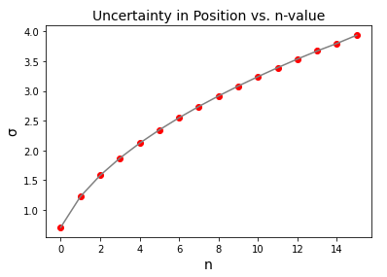

Figure-5: The uncertainty in position in respect to the value of n.

**Observation:** The uncertainty in position increases as we go to higher and more excited states of the system. It also seems that this growth in uncertainty is a *square root growth*, which matches the theoretical evaluation of uncertainty in position for the harmonic oscillator.

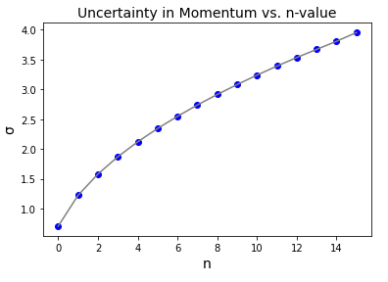

Figure-6: The uncertainty in momentum in respect to the value of n

**Observation:** The uncertainty in momentum increases as we go to higher and more excited states of the system. Similar to the case of position, it also seems that this growth in uncertainty is a *square root growth*, which matches the theoretical evaluation of uncertainty in momentum for the harmonic oscillator.

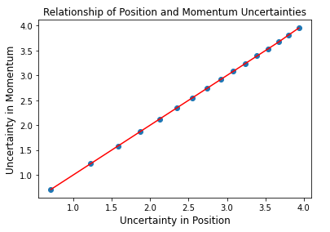

Figure-6: The uncertainty in momentum vs uncertainty in position in respect to varying value of n.

**Observation:** Its seems that the relationship of these two quantities is fully linear and it can be interpreted that they are almost equal to each other at all values of n (as it can be seen in the graph). In other words:

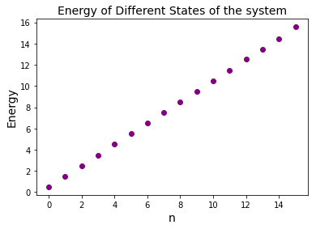

Figure-7: Energy of the system in respect to varying value of n.

**Observation**: it is clearly seen that the relationship of the Energy and the n is fully linear (at least in range 0 to 15). However, for a closer analysis of a general rule we need to look at the values themselves.

|  |  |
| --- | --- |
| ***n-value*** | ***Numerically Calculated Energies*** |
| 0 | 0.49999999999998673 |
| 1 | 1.50000000000361 |
| 2 | 2.500000000059724 |
| 3 | 3.499999999329178 |
| 4 | 4.499999986345655 |
| 5 | 5.49999999844032 |
| 6 | 6.500000839948109 |
| 7 | 7.500002775286729 |
| 8 | 8.499980879868207 |
| 9 | 9.499887536514807 |
| 10 | 10.500125202013185 |
| 11 | 11.50190580604222 |
| 12 | 12.501629150524174 |
| 13 | 13.48384468996272 |
| 14 | 14.465493989165884 |
| 15 | 15.56418429862556 |

It is clearly observable that the energy value obay the following rule:

Which matches the theoretical expression for the energy in a harmonic oscillator (considering that ).