Question-1:

Part-b)

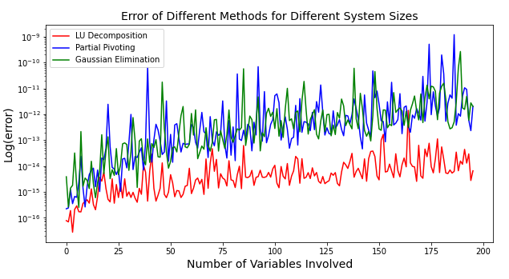

The error of the LU decomposition method is clearly 10-100 times more accurate than the partial pivoting and Gaussian elimination. Note that the algorithm of Gaussian elimination and partial pivoting are almost identical and this is reflected in the graph, their errors are almost always on the same scale.

For the processing time, the LU method showed a surprising result. It almost took no time for the computer to process. In fact, the abundance of 0s in the time data made us unable to graph the times on a logarithmic scale (we did it anyway for the purpose of demonstration). On the other hand, it appears that the processing time for Partial pivoting and Gaussian elimination grows parabolic and on a similar pace.

*Note that the large amount of fluctuations is due to the constaints on computer memory that performs several non related tasks at the same time.*

***Figure-1: Error of different methods over different system sizes***

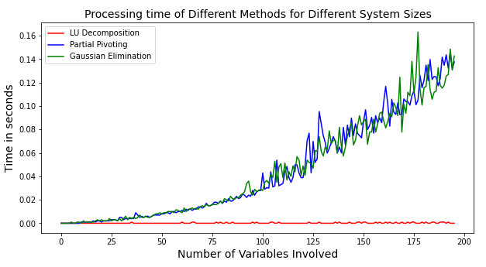

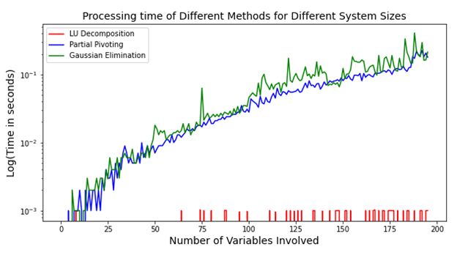

***Figure-2: Processing time vs. system size for different methods.***

Part-c)

The values below are the solution to the vector X = (x1,x2,x3) for the first set of factors:



The values below are the phases and amplitudes of V1, V2,V3 at time=0s:



The following graphs are the graphs for two different set of resistors, capasitance (or) inductors:

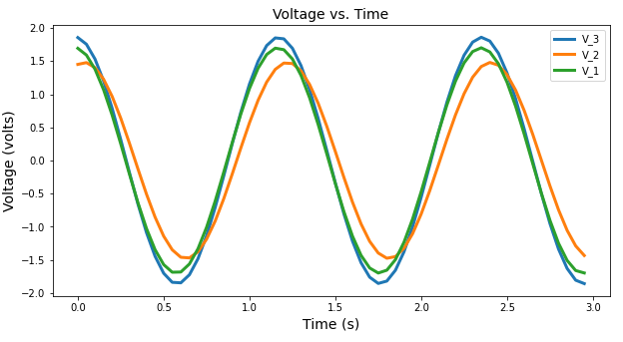

***Figure-3: Voltage vs. Time for different set of voltages for the first set of factors.***

The introduction of an inductor or setting R6 as іR6 in the system of equation has resulted in a mild change in the amplitude of V1 and V2, however, in the case of V3, the amplitdue has been increased dramatically. The phase difference of V1 and V2 has also largened. However, the largest shift happened for V3.

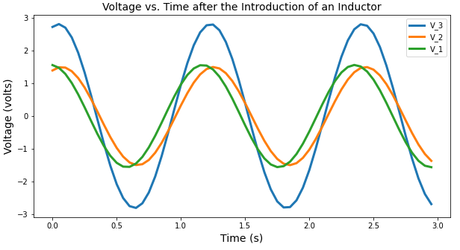

***Figure-4: Voltage vs. time graph after the introduction of an inductor instead of the sixth resistor.***



Question-2:

Part-c)

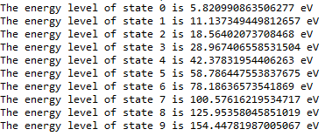

The following are the energy levels (in electron volts) of the first ten eigenstates (i.e. stationary states), computed for the 10x10 Hamiltonian operator.

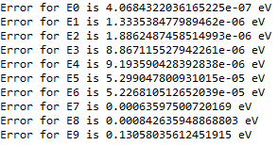

The following are the errors of finding the first ten energy levels through the 100-dimensional Hamiltonian matrix and the 10-dimensional Hamiltonian matrix. The magnitude of the error increases as we move to higher (more excited) states. It seems that the rate at which the error grows is significantly faster that the rate at wich the energy grows.

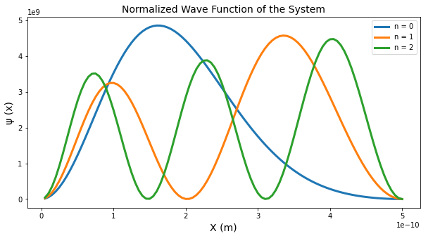

***Figure-5: Graph of the normalized wave functions of the first three levels***

A plot of normalized wave functions of the first three stationary states. The ground state has a higher probability amplitude near the low-potential region (left-leaning curve), which was a criterion in choosing the columns of the eigenvector matrix returned by the ***numpy.linalg*** package.

*Note: At first, the graphs were not normalized. A separate normalization process was performed on the data.*