PHY407 Lab 6 Report

Andrey did question 3. Arya did questions 1,2.

**Question 3:**

**Author: Andrey Remorov**

(a)

Updated Pseudocode:

1. Write a function for the second time derivative of the separation distance based on the Leonard_Jones Equation, to determine the acceleration on a particle from its relation with another particle. For each particle, add up all these acceleration contributions to get the total acceleration vector. Make sure to not overcount by a factor of 2. Output the acceleration list as a 2nx1 array, for n particles (the output is in the form of [ax1, ay1, ax2, ay2,…, axn, ayn])
2. Now write a function to update the position list, which is stored in a single 2nx1 vector: [x1, y1, x2, y2,…, xn, yn]. Write a function that does the following:
   1. Generate trajectory list, timestep, v(t+h/2) value, set initial position to be the inputted 2nx1 position vector
   2. Run a for loop for 1000 timesteps, inside which the positions and velocities are updated with the Verlet method:
      1. Append position vector to trajectory list
      2. Update position vector and velocities of each particle (the velocities are also stored in a 2nx1 velocity vector in the form [vx1, vy1, vx2, vy2,…, vxn, vyn]) according to the Verlet method. So r changes by h*v and v changes by k.
   3. Output the trajectory list
3. Define a grid of particles using the code provided in the lab instructions, and apply the above function to get the trajectories over 1000 timesteps. Plot these trajectories and save the figure.

END.

I implemented this pseudocode into python, and got the trajectories plot shown in Figure 1. I made the axes equal to make the plot more realistic. One can see that the trajectory lines are reflectively symmetric with respect to y=2 and x=2, due to the initial symmetric positions and opposite pairwise forces of equal magnitude between any two particles due to the Lennard Jones potential. Unfortunately, the trajectory lines overlap each other so it is hard to see what is happening, but it appears that the particles diverge from each other in four directions. In each of the directions, there is a group of particles travelling together, (for example in the top right corner, one can see the purple, and orange lines are always close to the light and dark brown lines, since they are bound together by the potential).

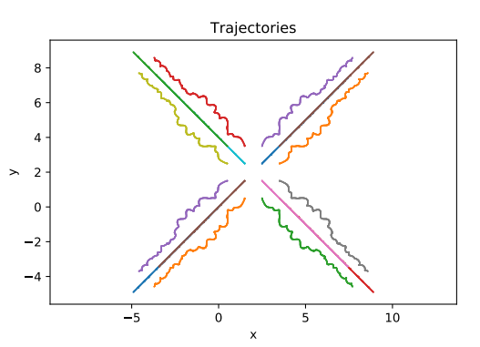

Figure 1: The trajectories of the 16 particles. Different colors represent different particles. The trajectories overlap over each other, so it is difficult to visualize what they are doing at any given moment.

b) I recorded the energy at each step by using equation 10 in the lab instructions to determine v for the same moments as x, and then determined the potential and kinetic energies using these values. I assumed m and the constants in the Lennard Jones potential were one. The plot of total energy vs time (in timesteps) is shown in Figure 2. The deviation of total energy is within 1% of the mean, so energy is conserved. It is also nice that the energy does not have a gradual average uptrend or downtrend, which would lead to considerable error for longer simulations.

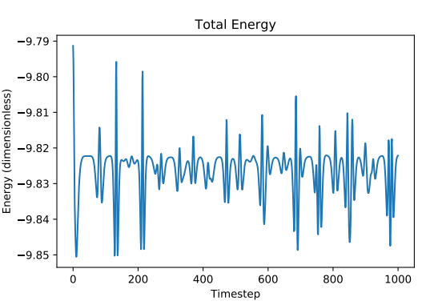

Figure 2: Total energy with respect to time plot. The deviation of total energy is within 1% of the mean, so energy is conserved.

c) I added periodic boundary conditions. I had to change the force function (that outputted accelerations for each particle) by creating 8 sets of image particles (as shown in Figure 1 of the lab instructions), and the trajectory obtaining function by making the particles reappear on the other side of the domain if they crossed it. I outputted trajectory plot in Figures 3.

We can see that each particle exhibits almost the same trajectory now (just rotated versions of each other with some small deviations). Let’s focus on the 4 particles on the top right, located at 2<x<4, 2<y<4. If we rotate the brown particle trajectory 90 degrees clockwise about (3,3), we almost get the trajectory of the orange particle. We can rotate this again 90 degrees to get a similar trajectory to the dark blue particle, and 90 degrees again to get a trajectory close to the purple particle. Also, we can take this whole block of 4 particles, and shift it down, shift it left, or shift it down and left, to produce very similar trajectories to the other blocks of 4 particles! These curious similarities between the trajectories of the particles is due to the periodic conditions. The periodic conditions make it seem that the 16 particles are not in free space, but are surrounded everywhere by the same particles (that are exhibiting the same trajectories). The attractive/repulsive aspects of the Lennard-Jones potential makes sure these molecules stay within a small range in coordinate space. Their small perturbations in this range affect the pairwise distances from other particles, which causes certain perturbations in the other particles. When accounting for all of these perturbations, each particle ends up moving in a manner similar to each other particle. Overall, the molecules all move synchronously together in trajectories that are very similar to each other when rotated the right way.

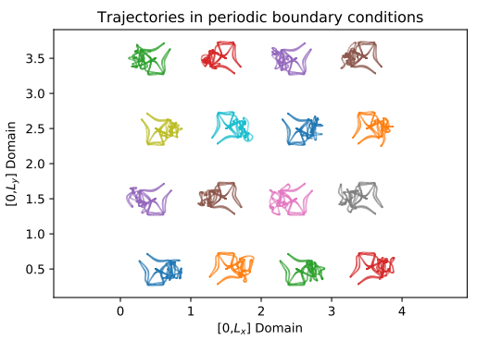

Figure 3: Trajectory plots of particles under periodic boundary conditions. All the trajectories are very similar to each other when the proper rotation is performed.