Q:1

**Outline:**

This problem explores the orbital motion of a ball bearing around a rod (along the z axis) of finite length and mass in the outerspace. The ball is assumed to orbit the rod around its center of mass. It is also assumed that the rod does not move due to the gravitational pull of the ball bearing and it is fixed in space.

**Results:**

Given the initial conditions of (x,y)t = 0 = (1,0) and (vx , vy) = (0,1), we can obtain the coordinates of the orbiting motion of the ball over t:[0 sec,10 sec], using the RK4 method for differential equations. The graph of the trajectory is the following:

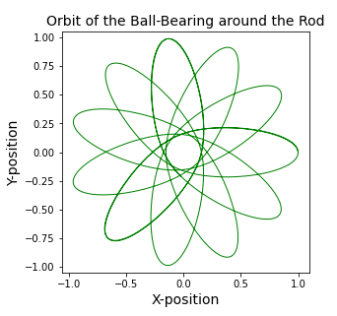

Figure-1: Trajectory of the ball bearing around the rod for a 10s period Considering initial conditions.

The trajectory is precessing because the force equations are not simply proportional to the inverse square of the separation distance, as it is for planets and the Sun for example.

Q:2

**Outline**:

In this problem, the trajectories of two interacting particles will be found. These two particles will represent molecules that obey the Lenoard-Jones Potential, and thus, the governing forces are based on this potential. The expression for the LJ potential is the following:

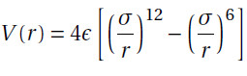

Where σ and ε are equal to 1 on our case and r is the separation distance between the two particles.

A plot of this potential could be very useful in future analyses:

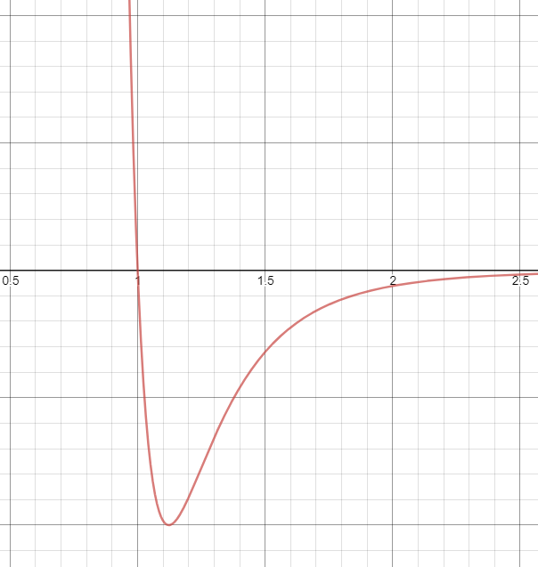

Figure-2: Leonard-Jones Potential vs. Seperation distance

This potential yields an ODE that can be split into four ODEs byt breaking down *r* into expressions in terms of x1,y1,x2,y2, so that, these coordinates can be solved together at the same time as a 1x4 vector r = [x1,y1,x2,y2].

Here is a pseudocode for how we will plan this out:

"""

*##Pseudocode:*

*1- Write a function for the second time derivative of the x1,y1,x2 and y2 coordiates*

*,based on the Leonard_Jones Equation, that returns [x2'',y2'',x1'',y1'']*

*(i.e. the right side of our differential equation).*

*2- Write a function that does the following:*

*a) Recieve initial positions for both particles from keyboard.*

*b) Makes the initial condition to a single 1x4 array*

*of the coordinates of both particle 1 and 2, and set if to an updatable*

*variable r.*

*c) set the initial first time derivative of x1,y1,x2 and y2 to zero (i.e. v).*

*d) update v (i.e. first time derivative of the separation distance) and*

*itterate using the Velret algorithm until done.*

*e) return all x and y coordinates (i.e. trajectories of both particles).*

*"""*

**Part-b)**

Now let’s graph the trajectories of a particle pair for different sets of initial conditions in position over t:[0,1] with dt = 0.01s.

The initial conditions of interest are:

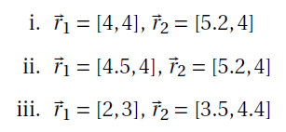

For (i) we have:

Particle-1 & Particle-2:

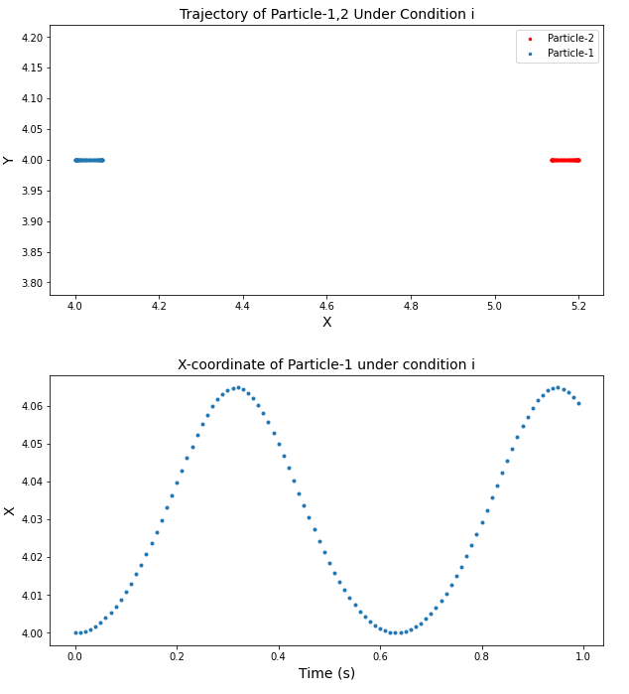

As we see, the pair under this initial condition exhibits an oscillatory motion, since the domain of motion seems to be fixed over time and the dotted graphs of their trajectories seems to be complimentary to each other.

For (ii) we have:

Particle-1 & 2:

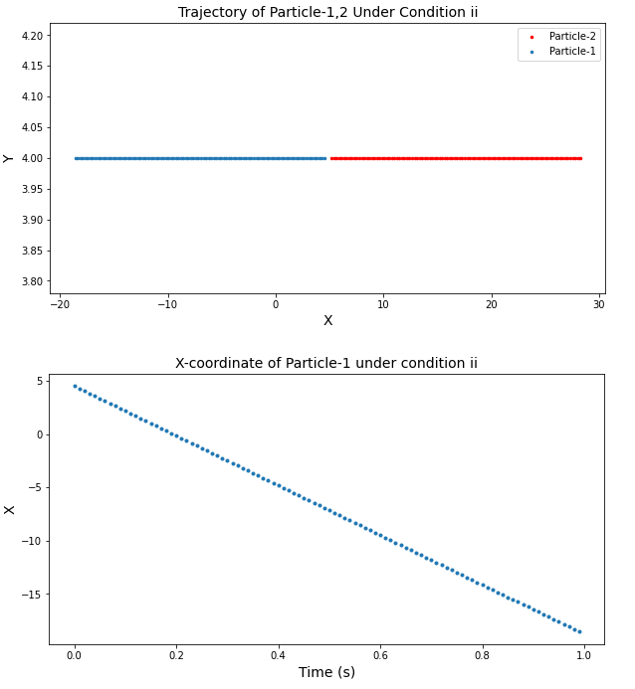

It is easily oberved that the particles are escaping from each other for the whole time. This is due to the initial seperation distanc of the two particles (0.7) which is less than σ = 1. This makes the particles reppel each other so much that they exceed their escape velocity and move apart for ever.

For (iii) we have:

Particle-1 & 2:

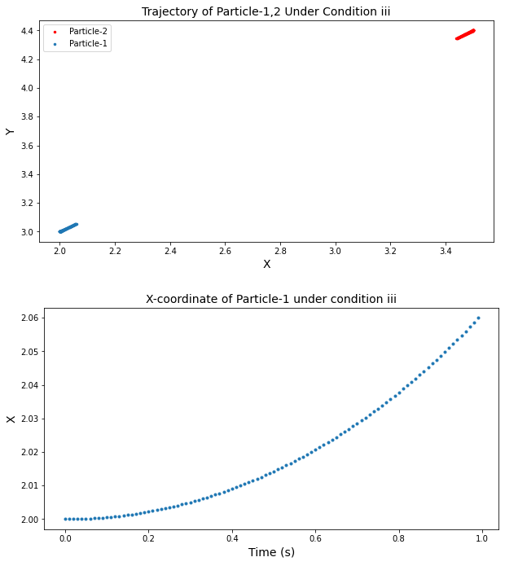

It seems that the particles are attracting each other. This should be the case since their initial separation is r ~ 2.05 and this is on the right side of the dip of the potential well (rdip ~ 1.12), which means forces are attractive.

**Part-c)**

The oscillatory behaviour is seen under condition (i), because the initial separation distance is very close to rdip and this causes the particles to be trapped in the potential well and never escape. (The particles under condition (i) start slighly on the right side of the dip). This fact will lead to an oscillatory behaviour as the particles try to espace their domain of distance and fail to do so, in other words, neither the attraction nor the repulsive phases are strong enough for any escape of the two particles, causing a back and forth between repulsive and attractive phases.