**Question-2:**

Outline:

In this question, we will explore the Bulirsch-Stoher Method as a replacement and alternative to the Verlet Method.

The context of the problem is very simple. We will analyse the trajectory of two astronomical bodies in the solar system, namely, Earth and Pluto, knowing some initial conditions regarding their position and velocity.

We need to solve 4 simultaneous first order ODEs for each planet. For this, we use a code that solves these through the Bulirsch-Stoher method. The resulting trajectory for Earth is demonstrated below:

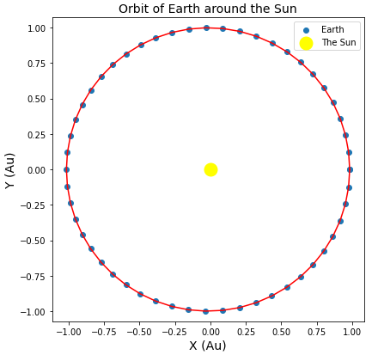

***Figure-1: The trajectory of planet Earth over a year long time period.***

The orbit is slightly elibtical and to have a better sense of how much eliptic it is, we calculated the difference in max and min x-distance from the Sun to be ~ 0.033Au.

Similarly for Pluto we have:

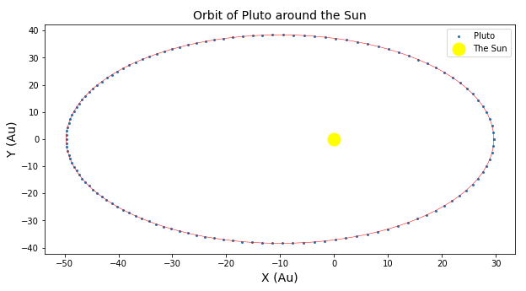

***Figure-2: Pluto’s orbit around the Sun for a full cycle of 285 years***.

As it can be observed, Pluto moves slower in farther distances and we see this fact with the increase in the density of the calculated positions. Pluto’s orbit is far more elliptical than that of Earth’s. In Pluto’s case, the difference in distance becomes ~ 20Au, which is compared to the scale of its orbit, it would be close to 0.5 of the half horizontal width. This ratio was close to 0.033 in Earth’s case. The difference between Earth and Pluto is stagering and clear.

**Question-1:**

**Part-a** :

Outline:

In this problem, we revisit our space junk problem from lab06 and re-do it using the *Adaptive Midpoint Method*. The adaptive method in this case helps us to allocate our computational resources to where it is needed, rather than blindly increasing the accuracy for all points involved. In this case, we want to have more data points when the particle (ball bearing) is moving faster to better capture the nature of the motion and less points where it is not necessary and the particle is moving slow such as the points at large radial distances.

*IMPORTANT OBSERVATION:* As it can be seen in the figure, the Adaptive method generated more points when there was a sharp change in position (i.e. high velocity moments) and that is why the center is looks more condensed/pact and the outer points look more sparse. This benefits our overall processing time.

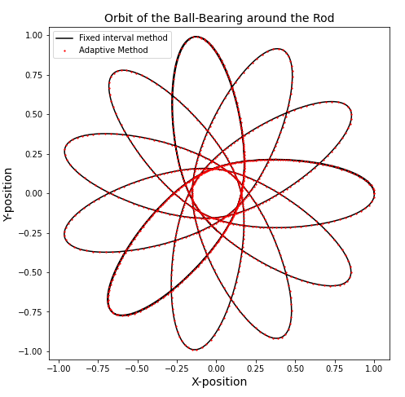

***Figure-3: The orbit of the ball bearing around the rod calculated by the Adaptive Midpoint Method.***

**Part-b**:

The results for the processing times are shown below (time values are in seconds):



This means that for problems that involve sharp changes in values of functions, the Adaptive Midpoint Method works faster than the simple RK4 method (non-adaptive).

**Part-c**:

To see how the adaption plays out, we can graph the timestep length vs. time graph of the process. The graph below shows the latter:

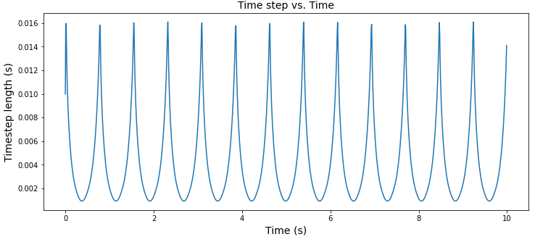

***Figure-4: The Time step vs. time graph for the adaptive RK4 method of solving the ODE of an orbiting ball bearing.***

As it can be seen, the calues sharply decrease for some values of time and increase for others. We suspect that the values sharply decrease when the particle moves faster (lower radial positions) and sharply increases while the particle is reaching low velocities (larger radial positions). Thus for understanding it better, we graph the radial distance of the ball bearning and superpose it over the timestep graph. The result is shown bellow:

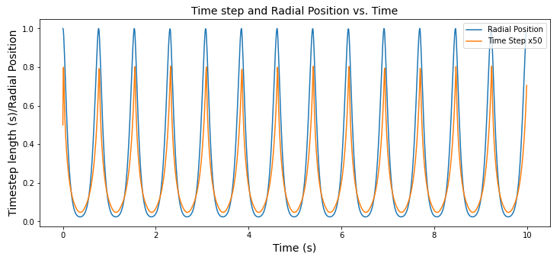

***Figure-5: The Radial Position of the Particle and the magnified (for the sake of vizualization) radial position of the ball bearing.***

As it can be observed, there seems to be a direct and positive correlation between distance and step size. Meaning that, if distance increases, time step also increases and if distance decreases then the timestep decreases, as expected in our previous analogy.