Question-1:

*Outline*:

**Part-a:**

This problem relates to a very basic case of a capacitor, where, we have two linear nodes one with a +1V and -1V potential. This potential difference will result in an electric field in the space.

To calculate the values of potential at points other than the nodes, we employ the Gauss-Seidel method os numerically solving PDEs. In this case, our PDE is simply a Laplacian in Cartesian coordinates with x and y dependencies.

The streamline graph of the electric field in this scenario is the following:

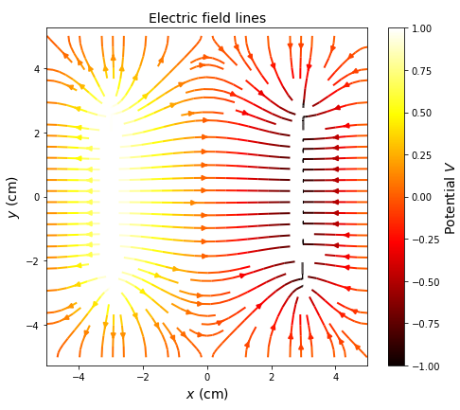 Figure-1: stream line plot of the electric field in space marked with their respective local potential values. The location of the nodes are evident.

Meanwhile, a contour plot of the potential values is the following:

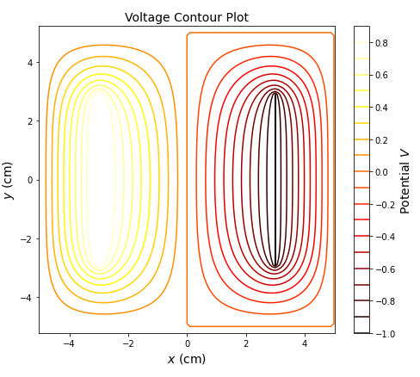

Figure-2: Voltage contour plot of the capacitor at descreate levels of potential.

Note that the contour line at V = 0 is looping around one of the nodes. This shouldn’t be the case in an ideal scenario since the zero mark should be a straight vertical line that passes in between the nodes. However, when generating a range of contour values, python does not mark the potential at exactly zero. It reads zero as a number on the scale of ~10-16 . This is why the contour at V = 0 also goes around the node because it is not exactly V = 0 and it is still non zero.

**Part-b:**

After implementing the overrelaxation method, it was observed that the case for ω = 0.1 ran almost as slow as the non-adapted method. However, after increasing the value to ω = 0.5, the code run much faster (almost half the time needed for the previous case). Other values such as ω = 0.7,0.8,0.9 was also tried. As we increased the values of ω to numbers very close to 1, the code ran even faster.

Question-3:

*Outline:*

In this problem, we explore a different numerical method of solving PDEs in the context of water waves and a mini-tsunami on a bounded spatial domain. We replace the FTCS approach with the two step Lax-Wendroff scheme.

**Part-a:**

Using the same set-up as question 2, we obtain the following wave forms for time = 0s, 1s, 4s:

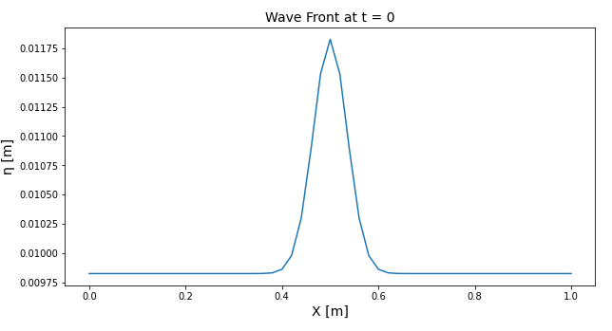

Figure-3: Wave cross section at t = 0, which is a Gaussian.

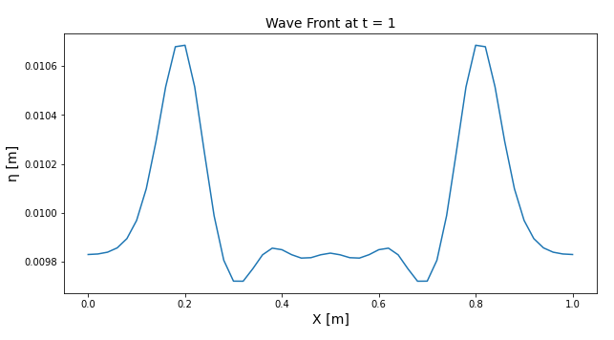

Figure-4: Wave cross section at t = 1 with a clear symmetry.

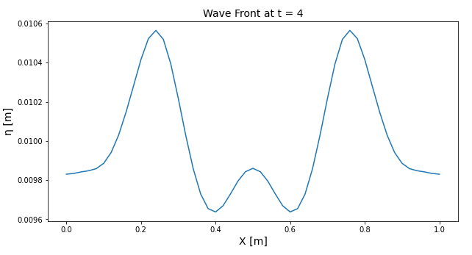

Figure-5: Wave cross section at t = 4. Notice that the reflection off of the walls has created a difference in the middle part of the wave.

Part-b:

*Outline:*

In this part of the problem, we will model a mini tsunami approaching shallow waters.

A tsunami is caused by a massive shift in the bottom topography in the ocean. This will cause the body of water to take a pulse-like shape. This pulse will grow in height when encoutering shallower bottoms (as we will see).

We use the same boundary conditions as question 2 and set the start of the wave form to be a half Gaussian starting from our X = 0m point.

The following graph shows the bottom topography used for the simulation:

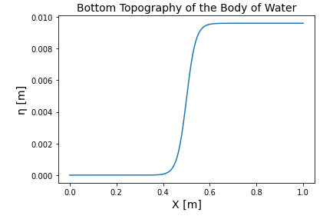

Figure-6: The bottom topography of our simulated body of water. The heigh of the shallow waters is H = 0.01m.

The following graphs are the wave for at times: 0s, 1s, 2s, 4s:

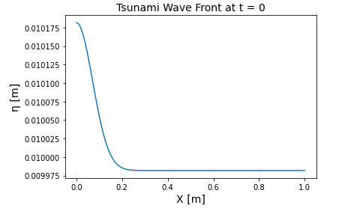

Figure-7: Water wave form at t = 0s. This is the half Gaussian that we start with.

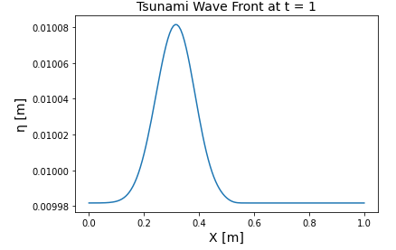 Figure-8: Water wave form at t = 1s. Notice that there is no significant change in the smoothness of the wave profile just yet.

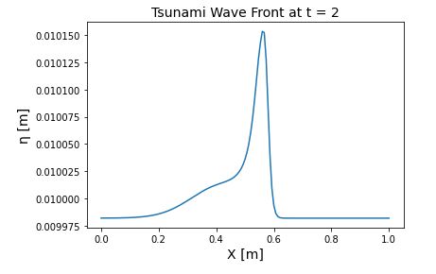

Figure -9: Water wave form at t = 2s. Notice that the wave profile is narrowing and becoming taller after passing the X = 0.5m mark.

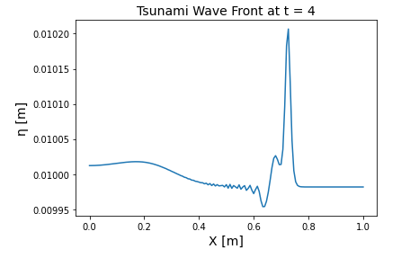

Figure-10: Water wave form at t = 4s.

Some trends are easily noticable. Just like a string wave (a rope with varrying thickness for example), the speed of the pulse increases as the pulse travels from a high density region to a low density region. Here is the same case. The thickness (depth) of the body of water decreases thus the speed of the wave front increases as it closes up to the shore.

This is clearly observable in the wave speed graphs. For instance let’s compare t = 1 to t = 4 seconds:

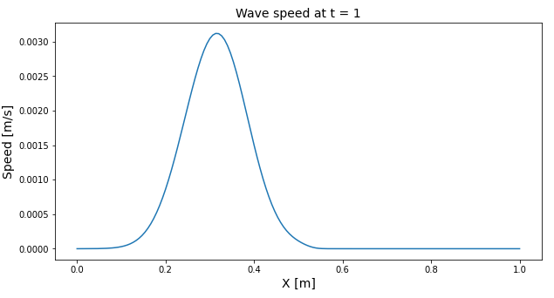

Figure-11: Wave speed profile at t = 1s.

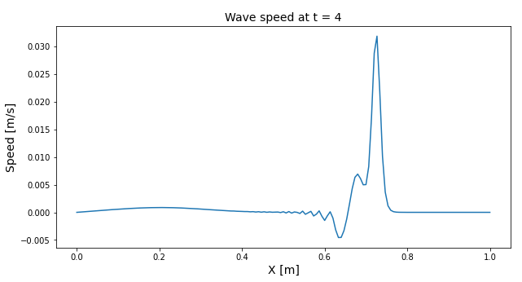

Figure-12: Wave speed profile at t = 4s. The maximum speed has almost increased by 10 times from ~0.003 m/s to ~0.03 m/s.

Another observable trend is the heigh and width of the wave front or the tsunami. The height of the wave front increases in size as it enters shallow waters and also, the width of the wave front decreases in size and becomes more pointy. In addition, a local dip in the depth of water is seen right before the major peak of the tsunami. This is typical of the development of a tsunami and its shape in the real world.