PHY407 Lab 9 Report

Andrey did question 1. Arya did question 2.

**Question 1:**

**Author: Andrey Remorov**

**Part (a)**

In this part, I had to analyze the behaviour of a Gaussian wave packet in a square well potential, by applying the Crank-Nicolson scheme to the Schrodinger wave equation.

When initializing everything, I had to determine the value of ψ0, the normalization parameter. I obtained this analytically, by computing ψ(x)ψ*(x) at t=0, and integrating that from negative infinity to infinity. The complex part eikx was cancelled out because of the conjugate multiplied by it, so the integrand was the real valued gaussian function: ψ(x)ψ*(x) = ψ02exp(-(x-x0)2/(2σ2)), and when integrated from negative infinity to infinity, equals: ψ02σ. For the wavefunction to be normalized (<ψ|ψ> = 1), we must have ψ02σ, so ψ0 = 1/ is the normalization parameter. I used code from the top of page 7 of the lab instructions when making the discrete Hamiltonian matrix.

Once all the functions and parameters were created, I ran the Crank-Nicolson scheme. As requested in the lab instructions, I calculated the diagnostics of energy, normalization, and expected position at each time step, and plotted them with time. I obtained these values using equations 3,4 from the lab instructions. These plots are shown in Figures 1,2,3. The energy and normalization were supposed to be constant in time, and they were, which implies that the time evolution of the wavefunction is behaving normally. However, we can see that the normalization value in Figure 2 is slightly less than 1. This is because the analytic value of ψ0 is computed by integrating the wavefunction from negative infinity to infinity, while when this is implemented computationally, the domain is [-L/2,L/2], which is finite, so the integral of |ψ(x)|^2 should be slightly less than ψ02σ, so ψ0 should be slightly greater than 1/ $\sqrt{σ\sqrt{2π}}$. Since the analytic value of ψ0 is used instead the computational value, <ψ|ψ> is slightly less than 1.

The expected position <X>(t) changes linearly with time, except at the inflection points (approximately t = 6x10-16 s, 2.3x10-15 s) where the slope becomes negative of what it was before the inflection. This is expected of a free particle in a square well potential, as it moves with no acceleration when inside the domain, but reflects off the boundaries at x=-L/2 and x=L/2. This even agrees with the classical result (assuming elastic collisions at the boundaries). In the beginning, the particle is moving towards the x=L/2 boundary because the wavenumber k is positive.

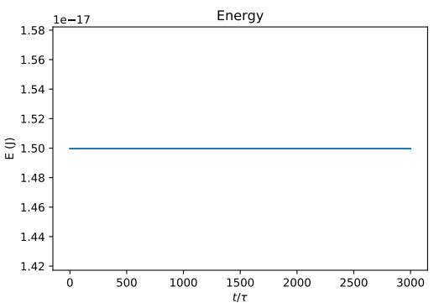

Figure : Plotting the energy of the particle with time.

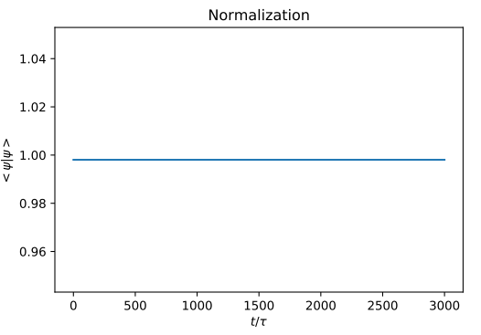

Figure : Plotting the normalization of the particle with time.

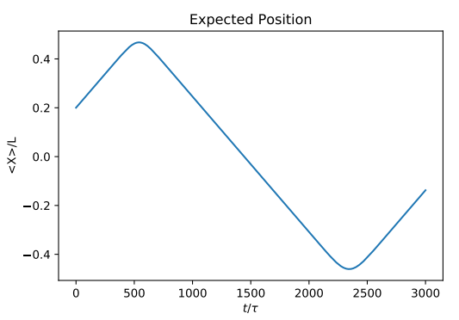

Figure : Plotting the expectation of the particle with time, for the square well.

**Part (b)**

To understand the behaviour of the system better, I plotted |ψ|^2 = ψψ* at the times t = 0, T/4, T/2, 3T/4, T. I know the question didn’t ask for t=3T/4, but I provided it because then the plots are separated by equal intervals of time and easier to comprehend. This plots are shown in Figures 4, 5, 6, 7. The wavepacket starts traveling towards the right boundary x=L/2, and when it reaches this boundary, starts interfering with itself, as seen in Figure 5 with t=T/4. This interference allows it to “reflect” completely off the boundary and travel to the left, towards the x=-L/2 boundary. It starts interfering with itself again when it hits this boundary, as seen in Figure 7. After reflecting off this boundary, it starts travelling back to the right at a uniform speed. The initial Gaussian shape of ψψ*(t=0) is preserved when the particle is not too close to the boundaries. These plots and analysis is in agreement with the position expectation plot in Figure 3.

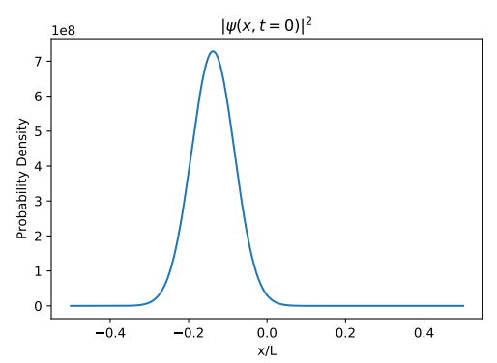

Figure : Plot of ψψ* at t=0, for the square potential.

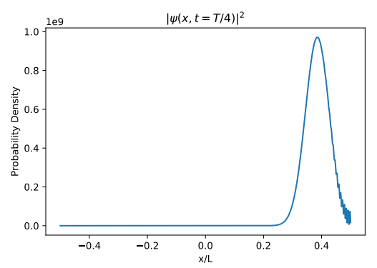

Figure : Plot of ψψ* at t=T/4.

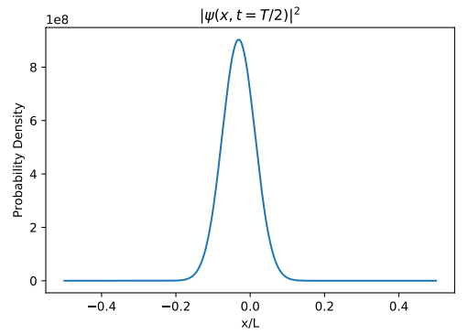

Figure : Plot of ψψ* at t=T/2.

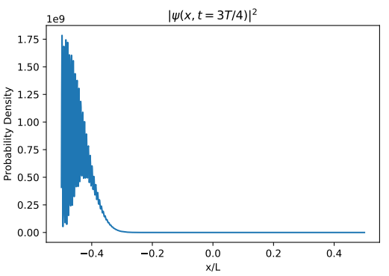

Figure : Plot of ψψ* at t=3T/4.

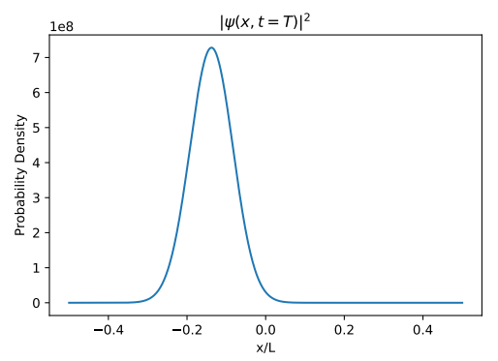

Figure : Plot of ψψ* at t=T.

**Part (c)**

In this part, I had to use a harmonic oscillator potential instead of a square well, defined in equation 5b of lab instructions. I also had to run the simulation for N=4000 timesteps instead of the 3000 timesteps used for the previous scenario. Then, I outputted plots showing the position expectation <X>(t) and plots of |ψ|^2 = ψψ* at the times t = 0, T/4, T/2, 3T/4, T. I know the question did not require showing <X>(t) but I think visualizing it allows for a better understanding of what is going on. These plots are shown in Figures 9, 10, 11, 12, 13, 14.

From the <X>(t) plot, we can see that the expected position of the particle oscillates sinusoidally in position space, with a period of approximate 2300 timesteps (by looking at the two lowest points at around N = 1300, 3600 timesteps). This is expected of a particle in a harmonic potential, and even agrees with the classical result.

The ψψ* plots show that the wavepacket becomes asymmetric as it travels back and forth. It starts as a Gaussian at t=0, but when it moves towards the left at t=T/4, the left part of ψψ* is steeper than the right. This is because the potential is currently greater on the left side than on the right side, so the left side wavepacket finds it “harder” to travel left than the right side, and becomes compressed horizontally. From the t=T/2, 3T/4 plots, we can see that eventually ψψ* becomes more steep in the lower potential zone, with a very steep side in the direction that the wavepacket is travelling, with a small tail on the other side. The creation of this tail is seen in the t=T plot, where the wavepacket just changed direction from left to right. This t=T plot looks like a pressure profile of a shock wave.

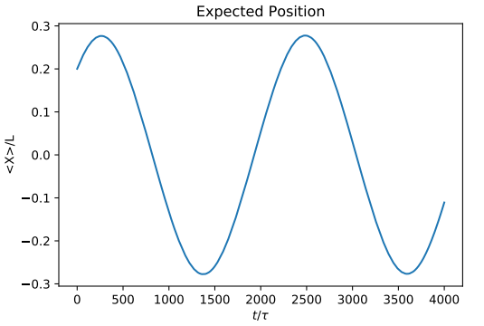

Figure : Plotting the expectation of the particle with time, for the harmonic oscillator potential.

Figure : Plot of ψψ* at t=0, for the harmonic oscillator potential.

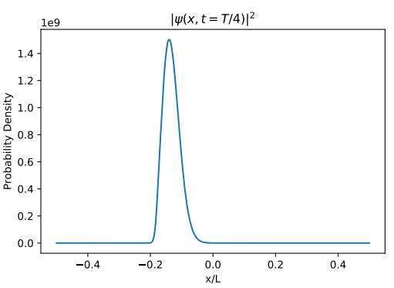

Figure : Plot of ψψ* at t=T/4, for the harmonic oscillator potential.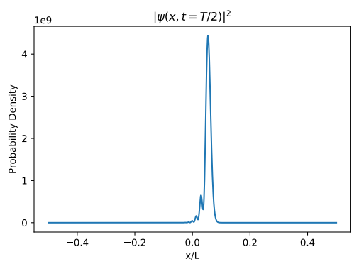

Figure : Plot of ψψ* at t=T/2, for the harmonic oscillator potential.

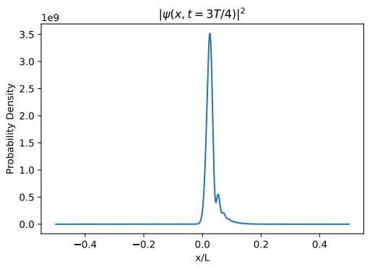

Figure : Plot of ψψ* at t=3T/4, for the harmonic oscillator potential.

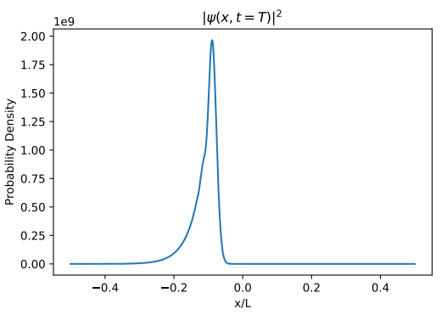

Figure : Plot of ψψ* at t=T, for the harmonic oscillator potential.

**Part (d)**

In this part, I had to use a double well potential, defined in equation 5c of lab instructions. I also had to run the simulation for N=6000 timesteps. Then, I outputted plots showing the position expectation <X>(t) and plots of |ψ|^2 = ψψ* at the times t = 0, T/4, T/2, 3T/4, T. These plots are shown in Figures 15, 16, 17, 18, 19, 20.

The expected position looks like that of a dampened harmonic oscillator with complex perturbations, with a period of around 2000 timesteps. We will better understand why this is occurring by looking at the ψψ* plots.

The ψψ* plots show that the wavepacket quickly splits up and part of it travels to the potential at x=-L/4, where it localizes for some time, as shown in the t=T/4, T/2 plots. Then, this part of the wavepacket travels to the right and interacts with the part of the wavepacket localized about x=L/4. At t=T, the wavepacket is mainly localized about x=L/4, but “attracted” by the potential well at x=-L/4 as seen by the large tail in ψψ* on the left of the peak. The reason for the rough oscillation with complex perturbations in <X>(t) is due to the wavepacket moving between the potentials, losing its Gaussian profile, and having a lot of seemingly chaotic sharp peaks.

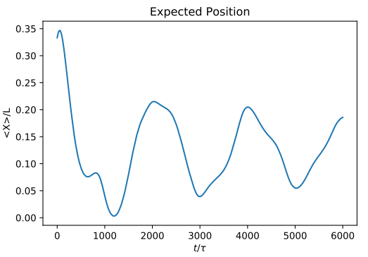

Figure : Plotting the expectation of the particle with time, for the double well potential. 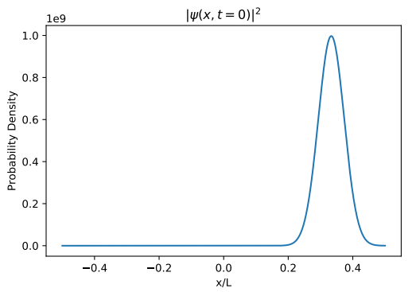

Figure : Plot of ψψ* at t=0, for the double well potential.

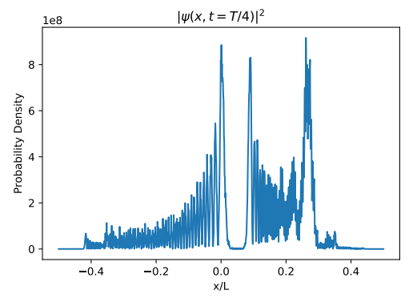

Figure : Plot of ψψ* at t=T/4, for the double well potential. 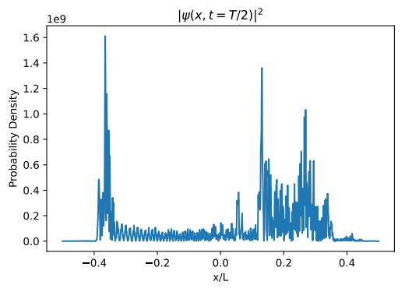

Figure : Plot of ψψ* at t=T/2, for the double well potential.

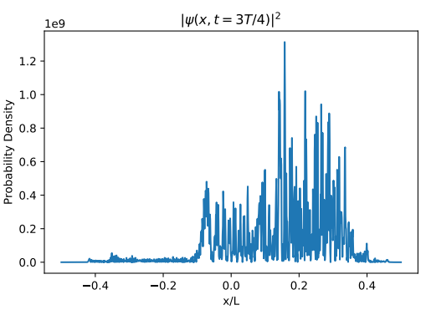

Figure : Plot of ψψ* at t=3T/4, for the double well potential.

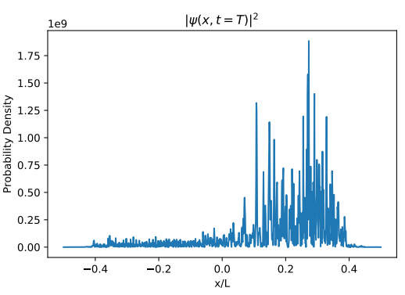

Figure : Plot of ψψ* at t=T, for the double well potential.