Q-2:

Outline:

In this problem, we analyze the electric and magnetic field in a cavity that contains electric flux. To accelerate the computational process, we use Sine and Cosine transforms (Fourier transforms in effect) and update them through the Crank-Nickelson method for solving PDE’s. Thus, instead of updating the field values over time, we update their fourier coefficients over time and then recapture the actual values for a desired time through an inverse fourier transform, that can vary in type based on the quantity of interest.

In this problem, we work with alternating electric flux (current density) and analyze different oscillation frequencies in respect to the dimensions and physical factors of our cavity.

Part-a:

Equation 10a satisfies the boundary condition since for any p or q that is either equal to 0 or P, since pluggin p,q = 0 or P will result in all the sine terms to vanish and we get zero for the boundaries. This is expected as it was for the electric field on the boundaries.

Equation 10b satisfies the boundary condition that it should be zero at x = 0 or Lx. This does happen through the sine transformation in the fourier breakdown. Plugging in x = 0 (i.e. p = 0) or x = Lx (i.e. p = P) will result in the sine part to vanish and make the whole sum zero as a result. In addition, the y derivative, (i.e. the derivative in respect to q) of the expression of Hx becomes zero for the same reason; the presence of the p-dependent sine term that comes out of the derivative unaffected.

Equation 10c satisfies the boundary condition that it should be zero at y = 0 or Ly. This does happen through the sine transformation in the fourier breakdown. Plugging in y = 0 (i.e. q = 0) or y = Ly (i.e. q = P) will result in the sine part to vanish and make the whole sum zero as a result. In addition, the x derivative, (i.e. the derivative in respect to p) of the expression of Hy becomes zero for the same reason; the presence of the q-dependent sine term that comes out of the derivative unaffected.

Equation 10d satisfies the boundary condition since for any p or q that is either equal to 0 or P, since pluggin p,q = 0 or P will result in all the sine terms to vanish and we get zero for the boundaries. This is expected for the flux at the boundary.

Part-b,c:

It is clearly observed that the x-magnetic field and y-magnetic field oscillates over time with a frequency associated to w = 3.75. However, another patternt that is even more prominent is that the amplitude also changes as well, going from zero to a maximum value and then going back to zero. The change in amplitude is directly associated with the change of current strength.

In addition, the Hx and the Hy graphs seem to be an x-reflection version of each other.

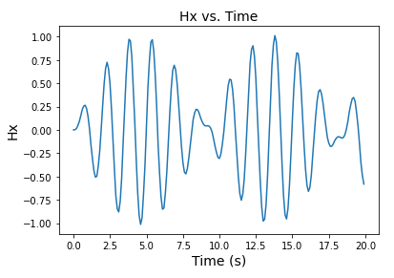

Figure-1: Hx (proportional to magnetic field) vs. Time graph.

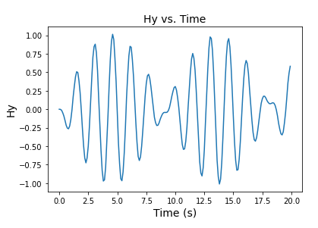

Figure-2: Hy (proportional to magnetic field) vs. Time graph.

In particular for the E field, we can see that the direction and strength of the field switches periodicly. This indeed the definition of an alternating current (a.k.a AC current).

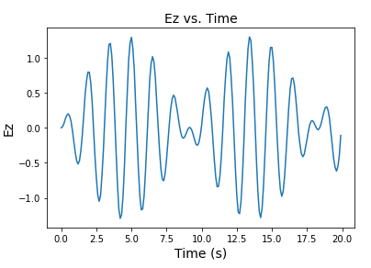

Figure-3: Ez (proportional to magnetic field) vs. Time graph.

Part-d:

It can be seen that the amplitude peaks at around ω ~ 0.4 to 0.45.

If we compare this with the expression of the normal frequency of the system:



Plugging in our values (i.e. m=n=c=Lx=Ly=1) we get that ω1,1 =

This perfectly matches our numerical result earlier. The graph clearly demonstrates this fact.

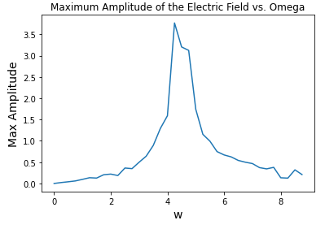

Figure-3: Ez (proportional to magnetic field) vs. Time graph.

Part-e:

Here are the graphs of the magnetic field components (x and y) as well as the electric field along the z direction. As it can be seen, if the fields are driven by the inherent normal frequency of the system, which depended on the dimensions and mode of the cavity, the magnitude of the fields grow over time and blow up. The logic behind this is similar to a harmonic oscillator. If a driving force has the same frequency as the normal (inherent) frequency of the system, the oscillation will blow up over time, i.e. the magnitude of the amplitude never stops growing. We observe the same pattern here. The pattern is seen in all the fields since all of them depend on the electric flux.

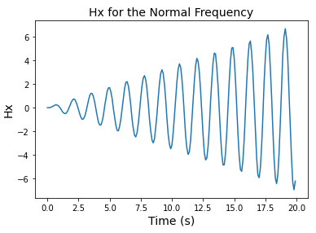

Figure-4: Hx under the normal frequency of the cavity.

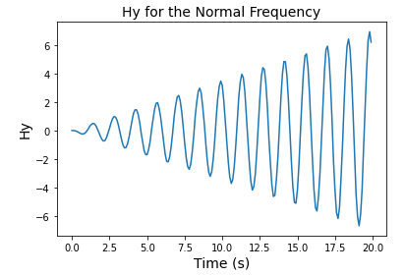

Figure-5: Hy under the normal frequency of the cavity.

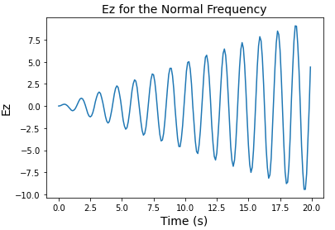

Figure-6: Ez under the normal frequency of the cavity.

In addition, the energy density in the cavity can be calculated by the following expression:



This expression tells us that the energy density in the cavity also goes up as the electric and magnetic field go up in magnitude over time.