Reference: <http://www.thecrazyprogrammer.com/2016/05/jsp-pagination-example-using-jquery-ajax-json-mysql.html>

JSP Pagination Example Using jQuery, AJAX, JSON and MySQL

In this tutorial you will learn how to implement pagination in JSP.

Pagination is a technique of dividing the content into several pages. Fetching all the data at a time is time consuming and it also results in poor user experience as the user has to scroll down to view data. So, pagination is used to speed up data fetching because only selected amount of data is fetched form server by user request.

Below I have shared JSP pagination example. It is created using Eclipse IDE and the technologies I have used are JSP, jQuery, AJAX, JSON and MySQL.

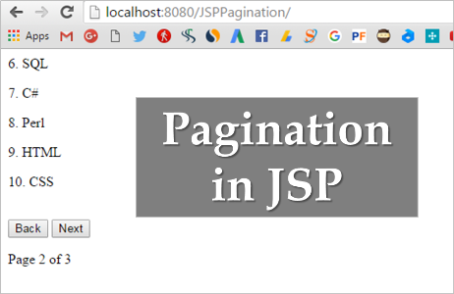

## JSP Pagination Example

**Note:** To use jQuery you have to add the jQuery library. You can download it from [**here**](https://jquery.com/download/). To use JSON here I have used **json.simple** library. You can download it from [**here**](http://www.java2s.com/Code/Jar/j/Downloadjsonsimple11jar.htm). Make sure you include both of these libraries in your project.

Create a dynamic web project in Eclipse and add following code in respective files.

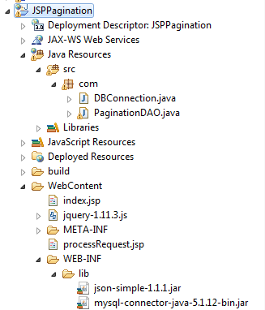

### index.jsp

This page displays the data to user. All pagination logic is written here.

<html>

    <head>

        <title>JSP Pagination Example</title>

        <script src="jquery-1.11.3.js"></script>

    </head>

    <body>

        <script type="text/javascript">

        $(document).ready(function(){

            var totalRecords;

            var recordsPerPage=5;

            var recordsToFetch=recordsPerPage;

            var totalPages;

            var currentPage=1;

            var currentIndex=0;

            $.get("processRequest.jsp?requestType=countRecords",function(data){

                var JSONData=JSON.parse(data);

                totalRecords=JSONData.count;

                totalPages=Math.floor(totalRecords/recordsPerPage);

                if(totalRecords%recordsPerPage!=0){

                    totalPages++;

                }

                if(totalRecords<recordsPerPage){

                    recordsToFetch=totalRecords%recordsPerPage;

                }

                else{

                    recordsToFetch=recordsPerPage;

                }

                $("#page").html("Page "+currentPage+" of "+totalPages);

            });

            $.get("processRequest.jsp?requestType=getRecords&currentIndex="+currentIndex+"&recordsToFetch="+recordsToFetch,function(data){

                var JSONData=JSON.parse(data);

                for(i=0;i<recordsToFetch;++i){

                    $("#div1").append("<p>"+(currentIndex+1)+". "+JSONData.record[i]+"</p>");

                    currentIndex++;

                }

                if(currentPage==totalPages){

                    $("#next").hide();

                }

                else{

                    $("#next").show();

                }

                if(currentPage==1){

                    $("#back").hide();

                }

                else{

                    $("#back").show();

                }

            });

            $("#next").click(function(){

                $("#div1").html("");

                currentPage++;

                if(currentPage==totalPages){

                    $("#next").hide();

                    if(totalRecords%recordsPerPage!=0){

                        recordsToFetch=totalRecords%recordsPerPage;

                    }

                    else{

                        recordsToFetch=recordsPerPage;

                    }

                }

                else{

                    $("#next").show();

                    recordsToFetch=recordsPerPage;

                }

                if(currentPage==1){

                    $("#back").hide();

                }

                else{

                    $("#back").show();

                }

                $.get("processRequest.jsp?requestType=getRecords&currentIndex="+currentIndex+"&recordsToFetch="+recordsToFetch,function(data){

                    var JSONData=JSON.parse(data);

                    for(i=0;i<recordsToFetch;++i){

                        $("#div1").append("<p>"+(currentIndex+1)+". "+JSONData.record[i]+"</p>");

                        currentIndex++;

                    }

                });

                $("#page").html("Page "+currentPage+" of "+totalPages);

            });

            $("#back").click(function(){

                $("#div1").html("");

                currentPage--;

                currentIndex=currentIndex-recordsToFetch-recordsPerPage;

                if(currentPage==totalPages){

                    $("#next").hide();

                    recordsToFetch=totalRecords%recordsPerPage;

                }

                else{

                    $("#next").show();

                    recordsToFetch=recordsPerPage;

                }

                if(currentPage==1){

                    $("#back").hide();

                }

                else{

                    $("#back").show();

                }

                $.get("processRequest.jsp?requestType=getRecords&currentIndex="+currentIndex+"&recordsToFetch="+recordsToFetch,function(data){

                    var JSONData=JSON.parse(data);

                    for(i=0;i<recordsToFetch;++i){

                        $("#div1").append("<p>"+(currentIndex+1)+". "+JSONData.record[i]+"</p>");

                        currentIndex++;

                    }

                });

                $("#page").html("Page "+currentPage+" of "+totalPages);

            });

        });

        </script>

        <div id="div1"></div><br/>

        <button id="back">Back</button>

        <button id="next">Next</button>

        <p id="page"></p>

    </body>

</html>

### processRequest.jsp

This page process request by fetching data.

<%@page import="com.PaginationDAO"%>

<%

String req=request.getParameter("requestType");

String data="";

if(req.equals("countRecords")){

    data=PaginationDAO.countRecords();

}

if(req.equals("getRecords")){

    String start=request.getParameter("currentIndex");

    String total=request.getParameter("recordsToFetch");

    data=PaginationDAO.getRecords(start, total);

}

out.print(data);

%>

### DBConnection.java

Contains code for database connection.

package com;

import java.sql.Connection;

import java.sql.DriverManager;

public class DBConnection {

    final static String URL="localhost:3306/";

    final static String DATABASE="pagination";

    final static String USER="root";

    final static String PASS="root";

    final static String DATA_TABLE="data";

    final static String ID_COL="id";

    final static String NAME_COL="name";

    public static Connection getCon(){

        Connection con=null;

        try{

            Class.forName("com.mysql.jdbc.Driver");

            con=DriverManager.getConnection("jdbc:mysql://"+URL+DATABASE,USER,PASS);

        }catch(Exception e){

            e.printStackTrace();

        }

        return con;

    }

}

### PaginationDAO.java

Fetch data from database and convert it into JSON format.

package com;

import java.sql.Connection;

import java.sql.PreparedStatement;

import java.sql.ResultSet;

import org.json.simple.JSONArray;

import org.json.simple.JSONObject;

public class PaginationDAO {

    public static String countRecords(){

        String query="select count(*) from "+DBConnection.DATA_TABLE;

        int count=0;

        JSONObject obj=new JSONObject();

        try{

            Connection con=DBConnection.getCon();

            PreparedStatement ps=con.prepareStatement(query);

            ResultSet rs=ps.executeQuery();

            if(rs.next()){

                count=rs.getInt(1);

                obj.put("count",count);

            }

        }catch(Exception e){

            e.printStackTrace();

        }

        return obj.toString();

    }

    public static String getRecords(String start,String total){

        String query="select * from "+DBConnection.DATA_TABLE+" limit "+start+","+total;

        JSONObject obj=new JSONObject();

        JSONArray arr=new JSONArray();

        try{

            Connection con=DBConnection.getCon();

            PreparedStatement ps=con.prepareStatement(query);

            ResultSet rs=ps.executeQuery();

            while(rs.next()){

                arr.add(rs.getString(DBConnection.NAME_COL));

            }

            obj.put("record",arr);

        }catch(Exception e){

            e.printStackTrace();

        }

        return obj.toString();

    }

}

### Database

The database table that I have used has following structure.

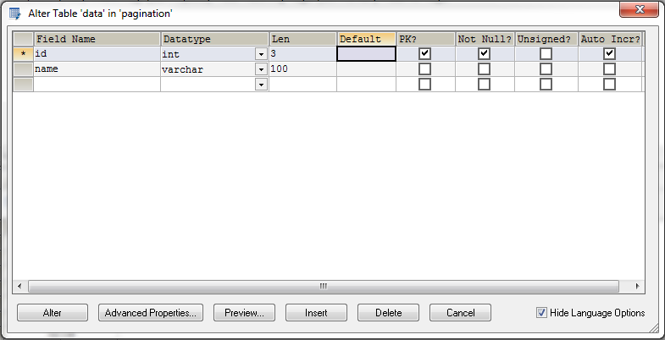

In this example I am fetching only 5 records at a time from the database and then displaying them. You can change the number of records per page according to you.

Download the project from below link. It also contains the database backup file.