Team Number: 011-5
Team Name: Studious Planners
Team Members:
Arenas Rasul, arra6697@colorado.edu, arenas-r
Jennifer Alex, jeal3201@colorado.edu, jenniferalex657
Rhea Rajashekhar, rhra5014@colorado.edu, rhear02
Burke Lowrey, bulo3629@colorado.edu, igotsomesalt
Farooq Ahmed, faah1403@colorado.edu farooq1-web
Brendan Johnson, brjo1654@colorado.edu, bjbuddyboy
Application Name: Tally
Application Description: Tally is a coursework and assignment tracking application designed to help students manage their academic responsibilities in one organized location. Students will be able to create an account, log in, add their courses, and enter assignments associated with each course. Assignments can include information such as the assignment name, course, due date, priority level, etc. This information will be displayed through a dashboard and calendar so students can easily understand what work they have coming up.
The main dashboard will focus on helping students evaluate their workload for the current day and week. Assignments will be organized according to factors such as due date, priority, and estimated time required. Tally will also include a study-path feature that uses a node-style structure to help students visualize which assignments should be completed first. The purpose of this feature is to turn a large number of assignments into a more manageable sequence of tasks.
Students will have the option to either automatically import their assignments with Canvas or manually enter assignments. Course and assignment information will be stored in a database and accessed through the application's server. The overall goal of Tally is to provide students with a simple, centralized system for understanding deadlines, organizing coursework, and planning their study time.
Audience: The primary audience for Tally is students at all grade levels who need help managing coursework, assignments, and deadlines. Students often have several assignments from different classes due within the same day or week, making it difficult to determine which tasks should receive the most attention. Tally is intended to reduce this problem by organizing assignments in a calendar and dashboard and helping students determine what work should be completed first.
The ideal user is a student who regularly manages multiple classes and wants a simple way to keep track of upcoming academic responsibilities. Users should not need advanced technical knowledge to use the application. The interface will prioritize simple navigation, clearly labeled controls, readable text, and visual indicators for due dates and assignment priorities. The goal is to make the application intuitive and convenient for students with different levels of technical experience.
The application will also consider general usability and accessibility principles. Important information such as deadlines, course names, and priority levels will be clearly displayed rather than relying only on color. The calendar and dashboard will be designed so students can quickly understand their workload without navigating through unnecessary pages.
Vision Statement: To empower students to take control of their academic success by simplifying coursework management, prioritizing deadlines, and turning overwhelming schedules into achievable goals.
Github Repo: https://github.com/arenas-r/Tally
Development Methodology: Agile style with a Kanban board (Jira)
Communication Plan: Plan to use Discord to keep team members updated on progress and communicate if problems arise.
Meeting Plan: Wednesdays 1:15-2 in person at Engineering Center
Case Diagram:
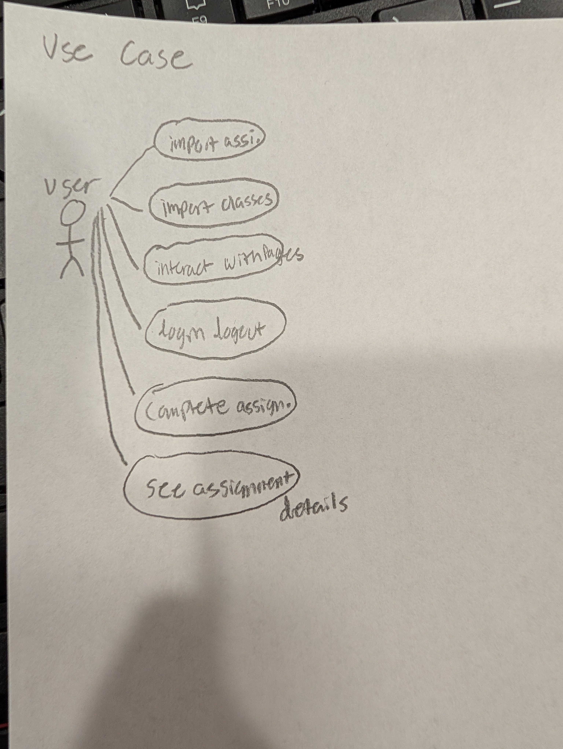

Wireframes:
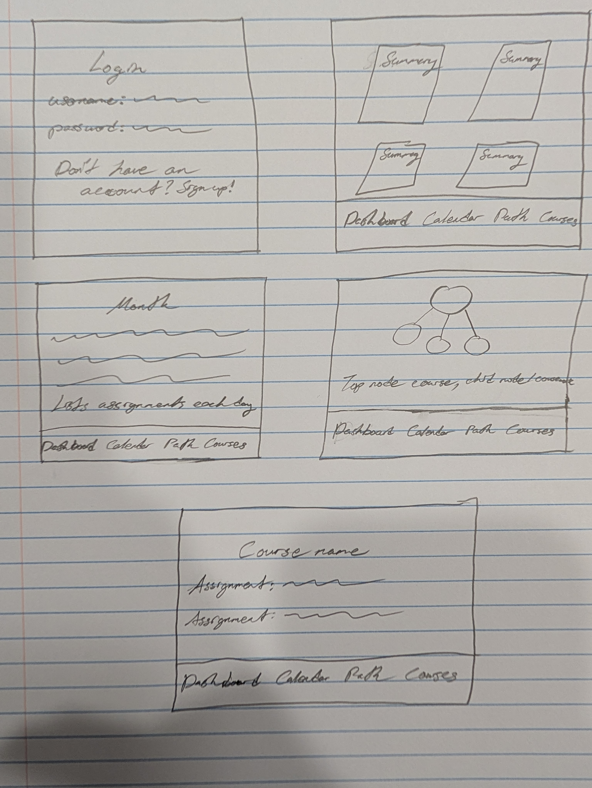
Extra Credit:
Risk 1 – Scope Creep (Medium): There could be a chance where too many features are added, which could make it difficult to finish the project on time. To reduce this risk, we will complete the main features first and only add optional features if there is enough time.
Risk 2 – Team Member Availability (Low): Team members may have other classes, exams, work, or unexpected conflicts that affect their availability. To reduce this risk, tasks will be divided clearly and reassigned if someone is unable to complete their work.
Risk 3 – Integration Problems (High): The front end, back end, and database may not work correctly together when features are combined. To reduce this risk, we will test each feature as it is developed instead of waiting until the end of the project.
Risk 4 – Security with User Accounts (High): Since Tally will include user accounts, poor password or login handling could create security problems. To reduce this risk, passwords will be securely hashed and users will only be allowed to access their own information.
Risk 5 – Merge Conflicts (Medium): Multiple team members may work on the same files and create merge conflicts or accidentally overwrite changes. To reduce this risk, we will use separate branches when needed, communicate about shared files, and regularly pull the latest changes before working.

