1. Intro
   * 1. Working memory theories
        + 1. -PT
          2. -STG
          3. -Broca
     2. 2. ECoG and BLOD-fMRI: measure brain activity during working memory delay periods:
        1. ECoG amplitude positively correlated with fMRI response, negative correlated for theta band.  Theta band chanaged were higher for eelctrodes located away from fMRI activation
        2. Relation persists after disappearance of visual stimuli while info maintained in memory [cite]
2. Methods
   1. Event locked HG
   2. Phase Locking Value
   3. Phase Amplitude Coupling
3. Figures/Results  
    Fig 1. Electrode Placement/Stimulaton site for all patients

EC22

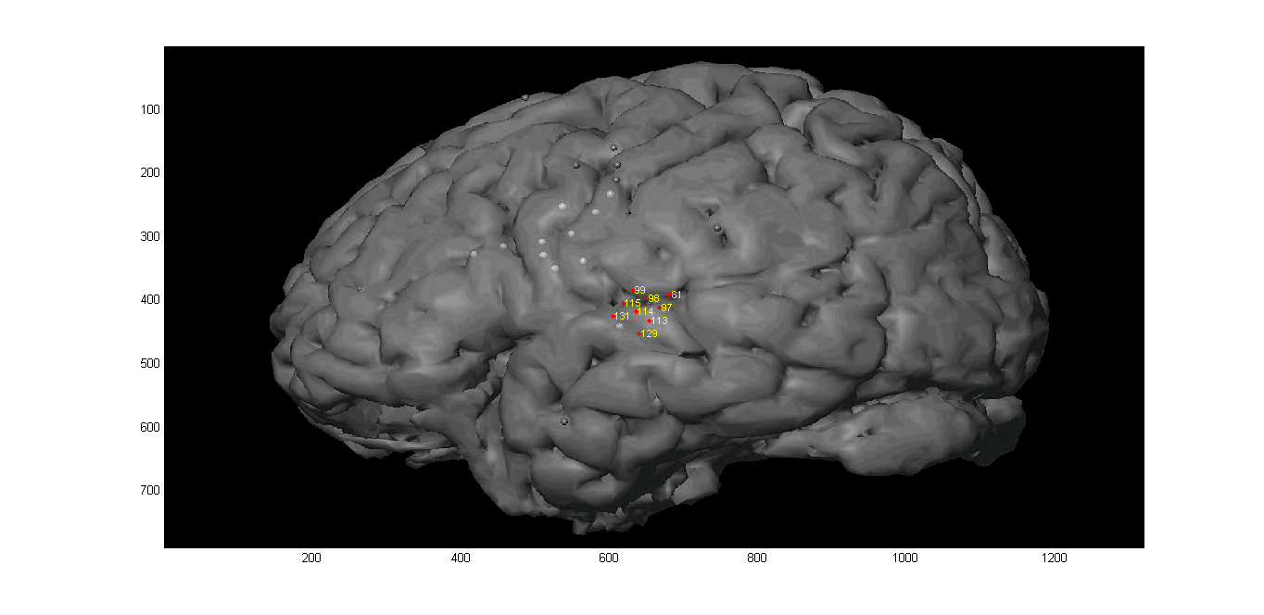

SuppFig EC22 Auditory Channels responding to any sound

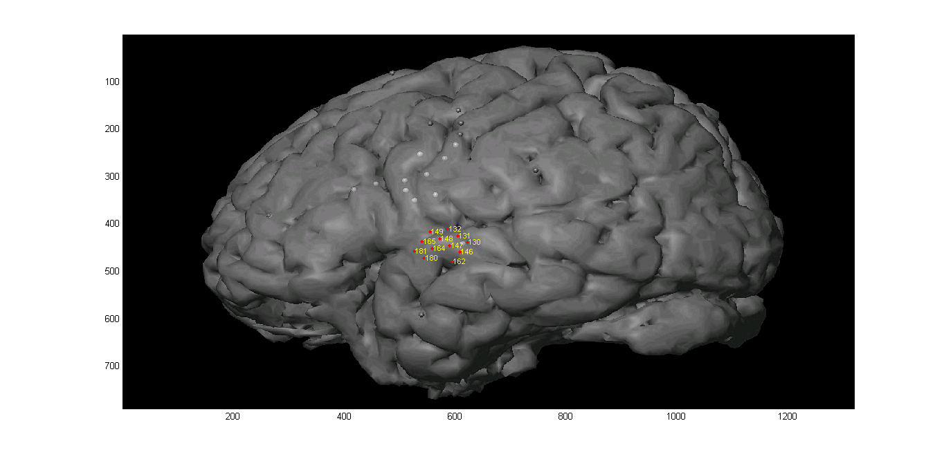

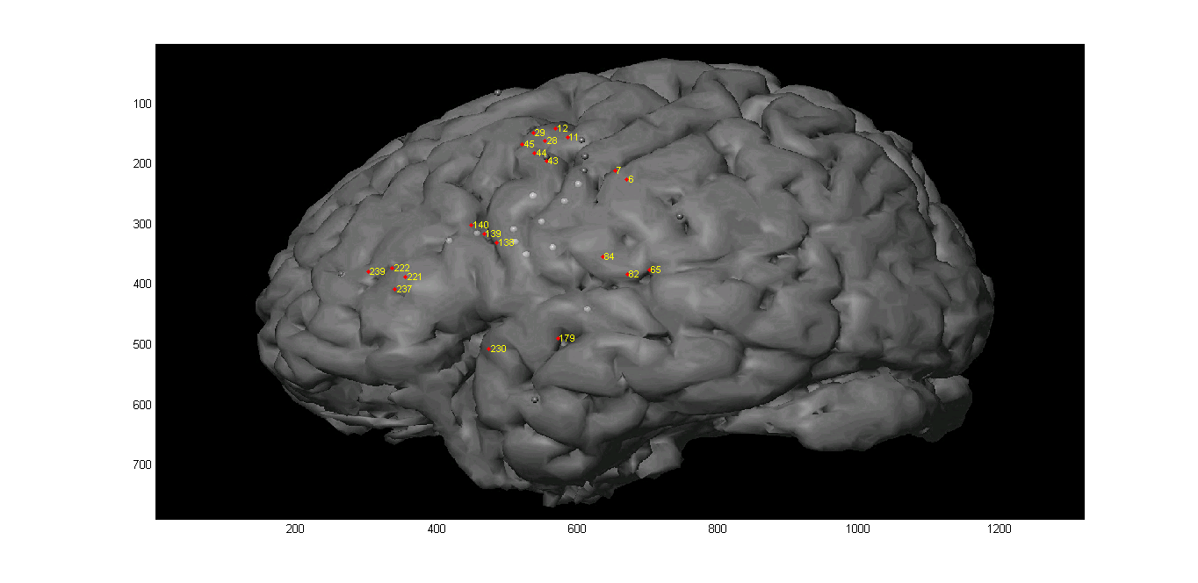

SuppFig EC22 Channels responding to words only

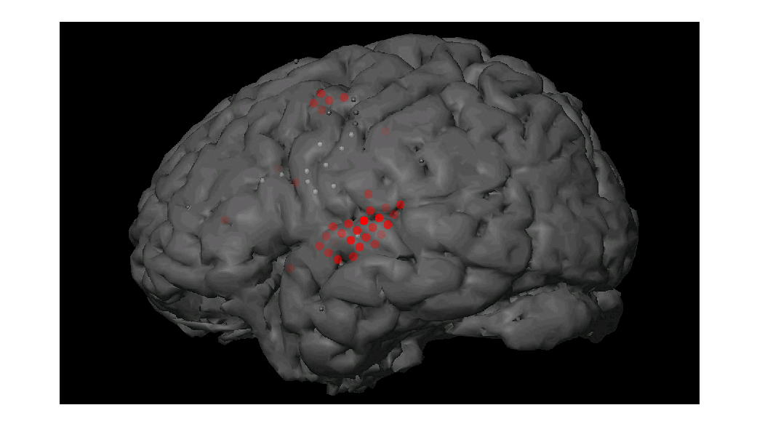

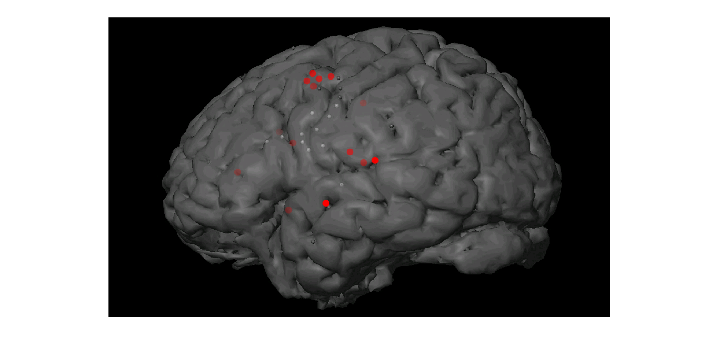

SuppFig Latency peak after word onset

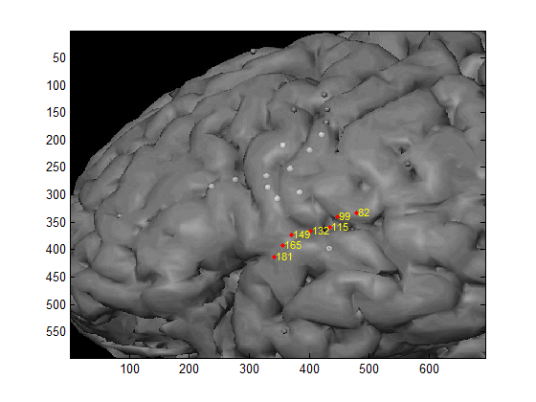

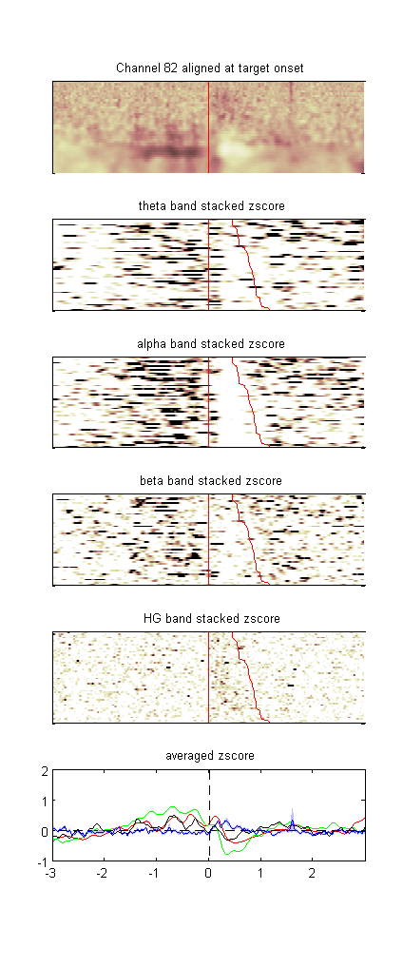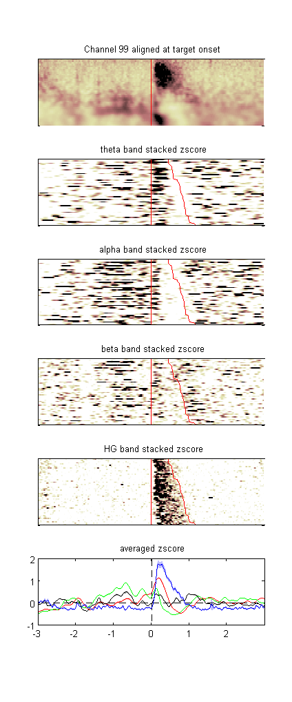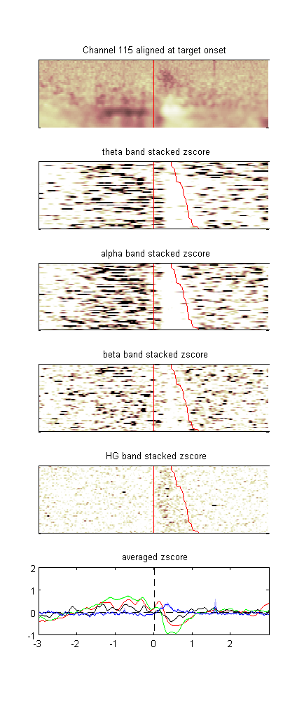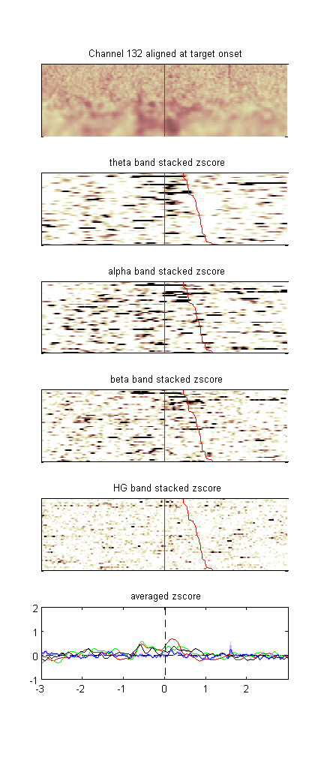

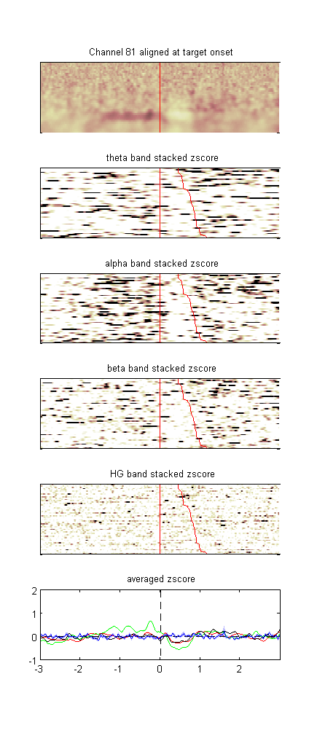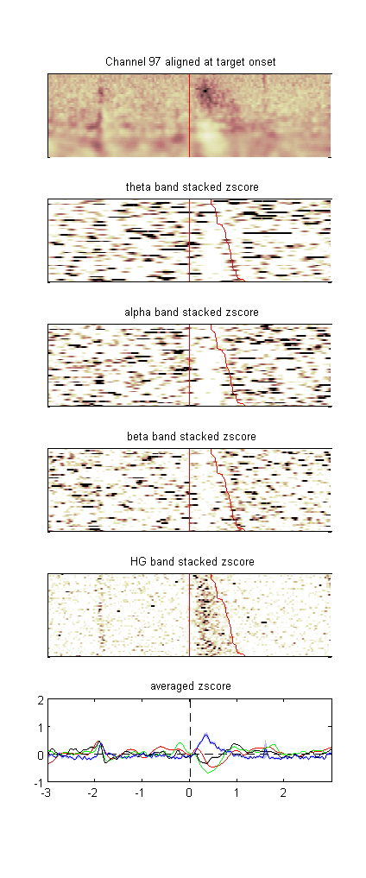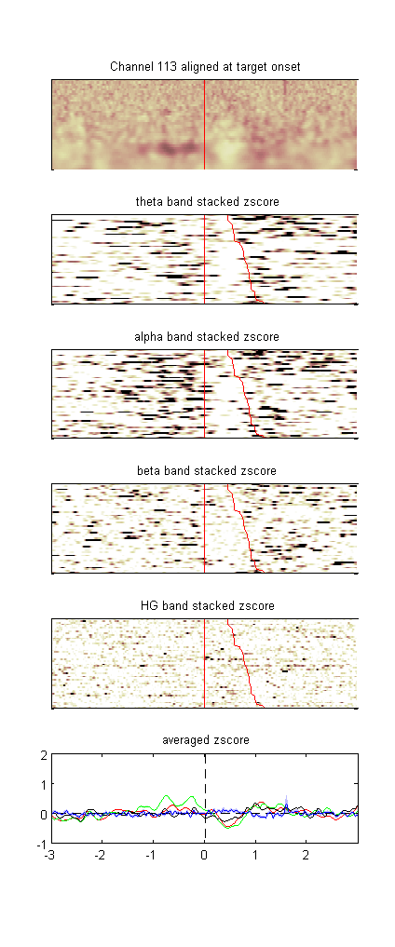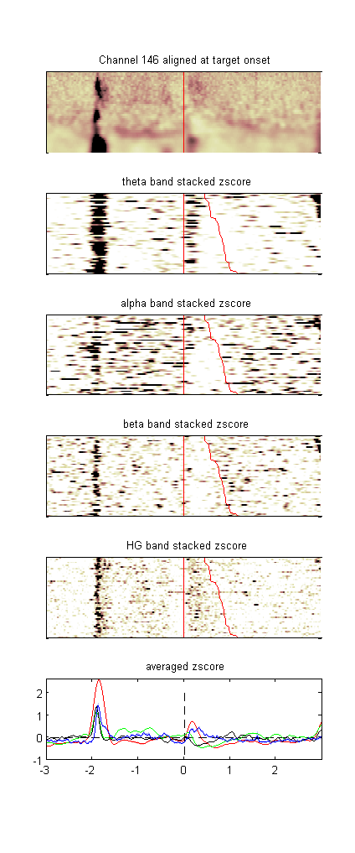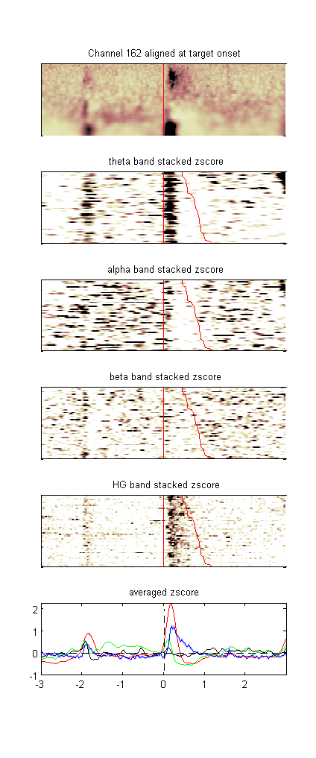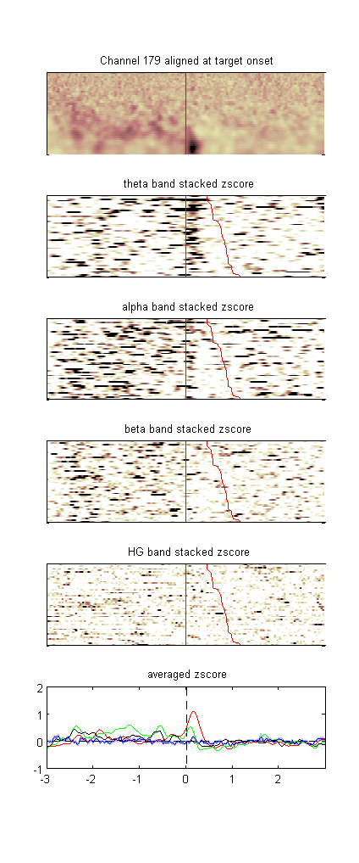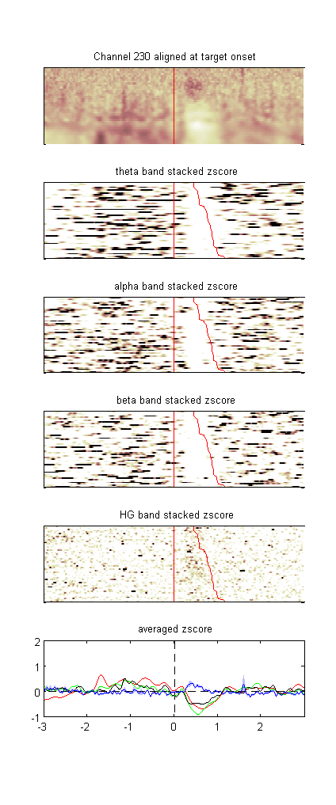

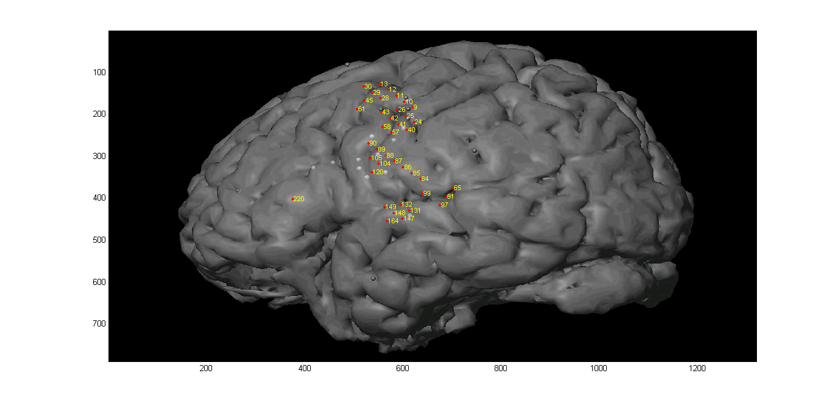

SuppFig Channels responding to response

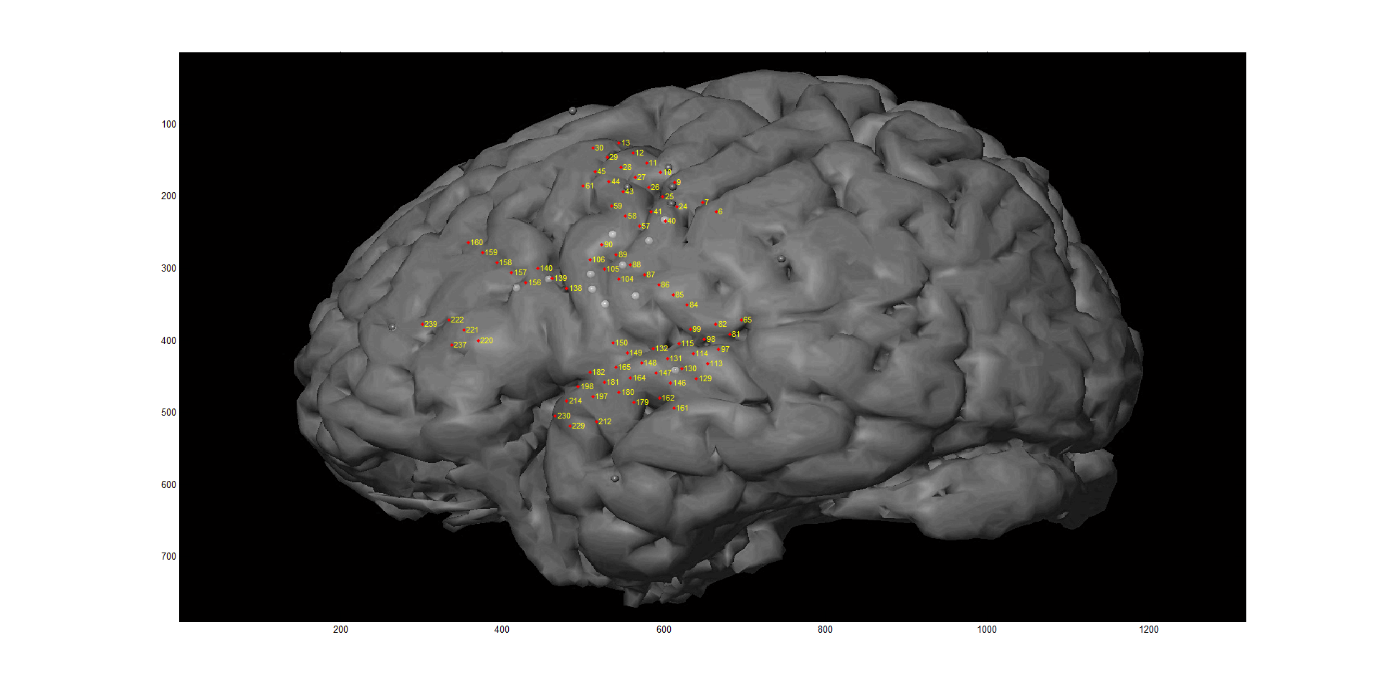  
 Fig 2. Pick a few representative electrodes; show plots for all time points  
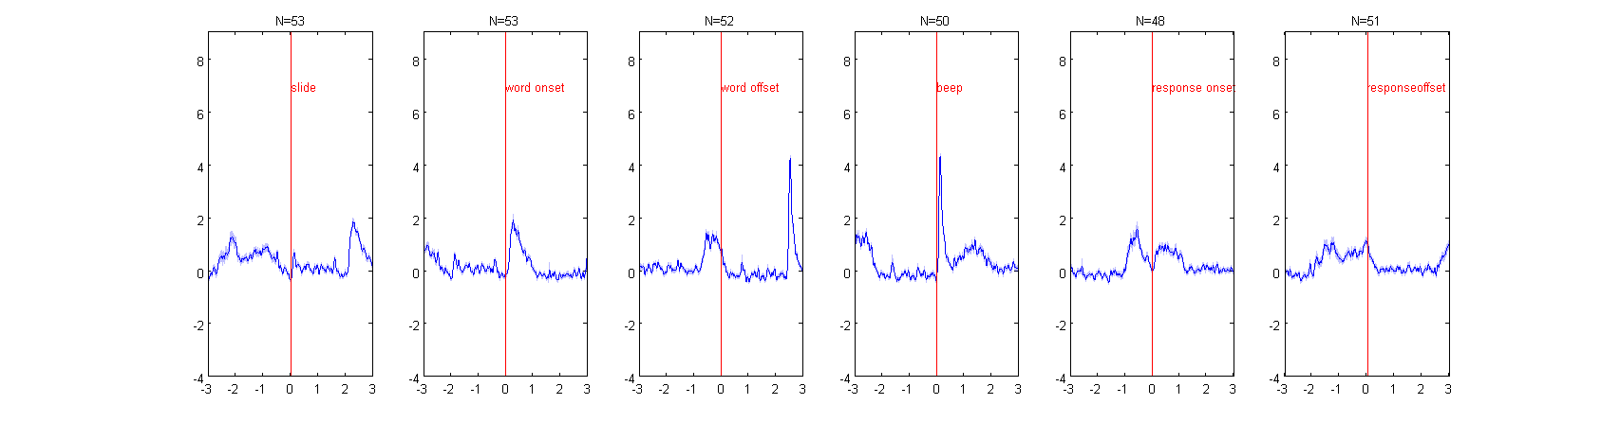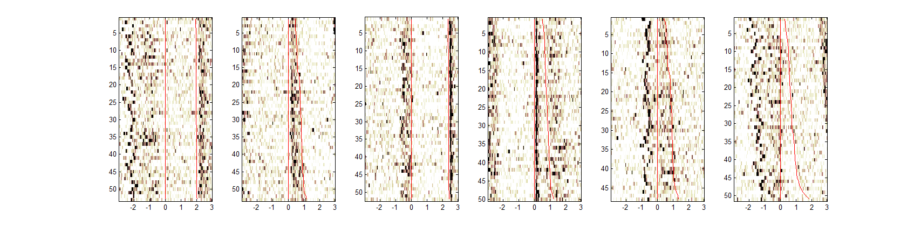

Results  
 1. Spatial functional difference in HG activation   
 -STG (posterior to anterior)  
 -Frontal   
 -Central Sulcus  
 2. Differences due to word type (long difficult, long easy, short easy, pseudo, passive)  
 -At Target, Delay, Response  
 -Contrast by wor[d type](http://web.mac.com/ntandon/iWeb/Site/Publications_files/Khursheed_memoryECOG_11.pdf)  
 [-In STG](http://web.mac.com/ntandon/iWeb/Site/Publications_files/Khursheed_memoryECOG_11.pdf)  
 [4. Correlation of HG to other frequencies](http://web.mac.com/ntandon/iWeb/Site/Publications_files/Khursheed_memoryECOG_11.pdf)  
 [-Theta](http://web.mac.com/ntandon/iWeb/Site/Publications_files/Khursheed_memoryECOG_11.pdf)  
 [-Alpha](http://web.mac.com/ntandon/iWeb/Site/Publications_files/Khursheed_memoryECOG_11.pdf)

4) [Disc](http://web.mac.com/ntandon/iWeb/Site/Publications_files/Khursheed_memoryECOG_11.pdf)ussion  
   
  
  
  
5) Works Cited