INTERNSHIP REPORT

==============================

Arent Dollapaj

Internship

At

Communication Progress

04/10/2021 to 12/12/2021

Searching for an internship

My search for an internship started very early. As soon as the first year of Epitech ended I was already on the search. Firstly, I started scouring some Albanian job sites. I tried using different keywords like internship, student practice, apprenticeship, training etc. They were completely empty, and I couldn’t find anything. Since in my country I couldn’t find any, I tried to see if I could find one outside.

Then I opened the JobTeaser career center. It is an international job searching site. The great thing about it is its partnership with Epitech. This is a great benefit because it can suggest jobs or intern positions exclusive for Epitech students. I started applying daily to internships abroad. There were some pretty good options in very big well-known companies like Boeing, Volkswagen and even Tesla. When I applied for those, I saw that 90.000 other applicants were also waiting for an answer from them. This meant the chances of getting a positive reply from these companies were close to zero.

Months went by and I still couldn’t find an internship. I also tried emailing companies directly even if they didn’t have a notification for an intern position but still no acceptance.

I asked people around me that were working in the field of computer science. In the end a friend of mine suggested that I write to a company called Communication Progress. They accepted me straight away and I was so relieved that I had found an internship and a good one.

Summary

FIRST PART: THE COMPANY...........................................................................................

* + - * General info.............................................................................................
      * Goals........................................................................................................
      * Location and images................................................................................
      * Partners...................................................................................................

SECOND PART: UNDERSTANDING THE INTERNSHIP.....................................................

* Introduction………………………………………………………………………………………..
  + - * Main topic...............................................................................................
      * ................................................................................................................

THIRD PART: THE PROJECT...........................................................................................

* + - * What I had to learn.................................................................................
      * The work…………………………………………………………………………………………….

FOURTH PART: CONCLUSION.......................................................................................

* + - * What I liked.….........................................................................................
      * What I disliked........................................................................................
      * Conclusion..............................................................................................

First part

================================

The company

I. The company

Communication progress is a company that was founded in 1998 by three engineers. It is one of the first Albanian tech companies. It has two decades of experience in Technology of Information and Communication.

Currently the staff is made of 60+ employees which have technology and business knowledge which makes the company a great business partner.

The areas where the Communication Progress is specialized are:

**Software:** Solutions for public administration, forums, web pages, Electronic archival systems, GIS solutions, development and integrations of systems based on the customer requests.

**Communication infrastructure:** A wide range of services and products for communication with voice data and video.

**IT infrastructure:** Rentable solutions for IT infrastructure, server rooms, technological environments.

**Electronic education:** Interactive learning, distance learning, voice and video conferences.

Communication progress has achieved a lot of success in the Albanian IT market due to the summary of these factors:

* Two decades of experience inside and outside the country
* The ability to give technological solutions to a growing market of businesses
* Flexibility in its services
* Expertise in development and integration based on modern standards
* A long history of partnerships
* Technical and financial capabilities that guarantee stability

**Goals of Communication Progress**

The main goal of Communication Progress is the continuous offering of advanced technological solutions while honoring the two main principles, quality and innovation.

Here is a more detailed summary of the objectives and strategies:

Customer loyalty, is the main benefit the customers get from the company

Growth, made possible by the big capacities

Return of investment, which is the main promise of new technology

Diversification, by exploring new markets and also distributing the risk

Employee devotion, by encouraging work and rewarding it based on results

Company image, by working responsibly and with ethic

Social responsibility, by coworking with academic groups, offering professional practices and development programs for students

Environmental aspect

* Conscious and responsible use of electrical energy, paper and other resources
* Management and recycle of electrical waste
* Engagement in environmental campaigns

Economical aspect

* Transparency of economic, social and environmental reports
* Fair competition
* Encourage innovation
* Protects intellectual property
* Safe and convenient services

Global aspect

* Encourages the interest of clients for social and environmental topics
* Respect of human rights
* Takes part in campaigns against poverty

Location and images

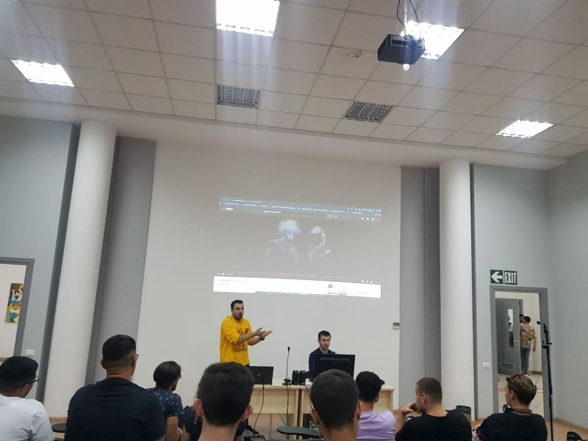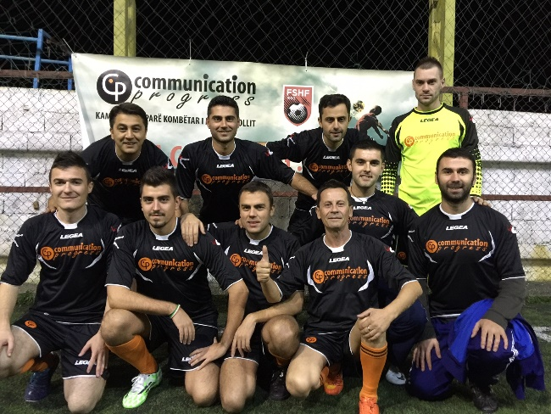

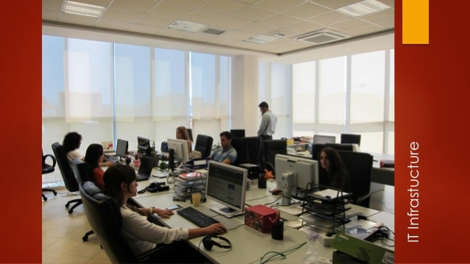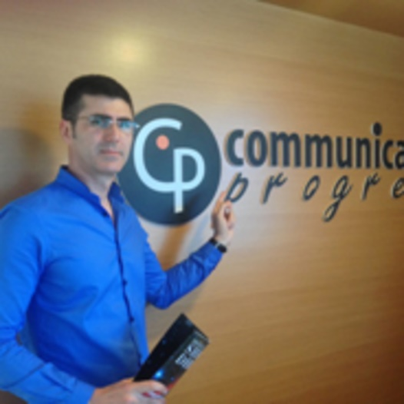

Partners of Communication Progress

Etc.

Second part

================================

Understanding the Internship

What is Odoo?

Odoo is an open-source ERP which stands for a type of software that organizations or businesses use to manage day-to-day business activities such as accounting, project management, risk management and supply chain operations. It provides a range of easy-to-use business applications that form a complete box of tools according to the business needs. Millions of companies all over the world use it daily.

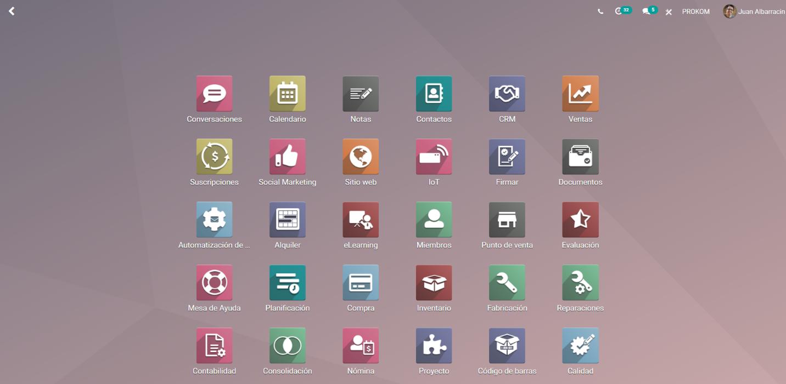

Every business has its own specific needs that Odoo must take care of. This is made possible by the modular logic that Odoo uses where each module behaves like a small application. Different modules have different functions and based on the requirements of the business only the useful modules can be installed or new ones can be created from scratch. This level of customization is the reason why Odoo is so popular among the business market.

There are also more technical advantages of Odoo like its capability to handle plenty of activities like: inventory management, sales, reporting, accounting and automatic invoices etc. It has high capability for details like adding different attributes to the products of your shop. It also supports up and cross selling also recommending products to clients. Another big advantage is its integration with Amazon, eBay and PayPal which lets you open new business options.

General info about Odoo development

In Odoo you focus more on the backend of the module then the UI. The UI is simply arrangement of menus, buttons and views. Everything in Odoo is saved in a database. You create a class in Python which is called a Model. Models are database tabels in Odoo. They can hold any number of fields or columns. They can hold python functions too which can be activated anytime from anywhere. To call a function there are two ways. With a button which you press one that activates an action and that action calls the function or with a cron actions in which you don’t have to press a anything but simply determine the timeframe and let it run automatically when the time comes. An action can also display a view.

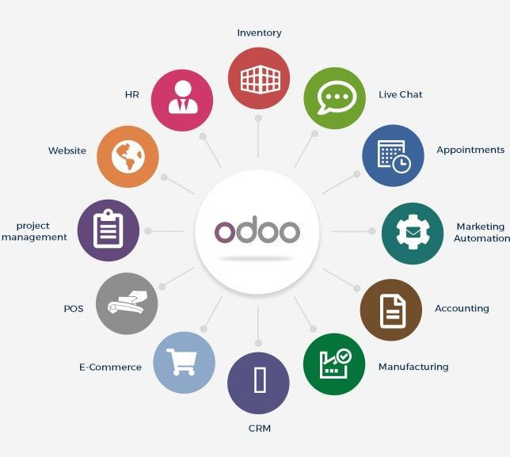 For example the contents of a Table or Model can be displayed in form view, tree view or kanban view. You can choose your view based on you needs. In my modules I have used tree view and form view. The views can be used together too, for exmaple we start with a tree view which displays all the rows one by one and then by clikcing in one of the rows you can display more data from that row in form view which resembles a card. It can display more information than the tree view at the same time since it has more space. In these views you can use xml to customize all the fields of the tables. You can put the fields in certain locations group them, display them similar to a notebook and many more.

Another aspect of Odoo is its saccess rights. To make your module more functional different users need to have different access levels. This is done to avoid creating new modules for each lever of security. Some things that can be secured are clickable menus, buttons, actions etc. For example this is done by verifing if the code of the user is in the rights file of that action that we want to activate. If yes then it will activate but if not nothing will happen. Only the superuser which can be achieved by activating the developer-mode has access to everything. This is changed in the newer versions of Odoo since the developer-user doesn’t have the same accesd rights as the superuser.

II.UNDERSTANDING THE INTERNSHIP

Subject

The purpose of this internship is to prepare future employees for working with Odoo by testing their abilities. It also offers understanding of the business world and its requirements for organization.

Main goal

The main goal is to develop a module that is based on a business type of your choice. The business can be a hotel, a restaurant, a football club etc.

Extra goals

Some additional goals that should be completed during the internship period are:

* Daily communication and reporting with the overseer
* Communicating with other interns and sharing ideas
* Writing clean code
* Doing unique and creative things
* Learn about the business you are making the module on
* Making a simple and clean UI

Environment and tools

The most important tool the intern should know how to use is Python. More specifically he should know how to use: variables, types, lists, basic operations, conditions, loops, classes and objects. Python is used in Odoo to replace query programming language. It is more specifically used to create databases, tables, records and also to write functions that add functionality and automation.

The intern must have knowledge about databases, tables, query language and PostgreSQL.

Third part

================================

The Project

New things I had to learn

The project and the topics associated with it were very new to me. Having completed the first year, I had a good understanding of programming but Odoo was different. One of the things that helped me a lot dealing with new difficulties was the Epitech teaching method where you have the assignment, and the learning has to be done individually. I also had to learn how to ask short and precise questions. My overseer was the busiest employee in the company since he was a specialist. This means that although he did regular checks on me, he still didn’t have enough time to help with everything. So, I needed to do a selection on the questions that I had to ask him by choosing the most important ones. The others I had to figure out by myself.

Some other new things I had to learn were:

**ERD Diagram**, which helped visualize the database and the joins among the tables based on the business model. It was the first step that had to be done and everything else had to be built based on that.

**Databases**, they were fundamental to understanding how Odoo works because everything was stored in a database.

**PostgreSQL**, an object-relational database management which helped me understand keys, foreign keys and the joins between tables which are very important in Odoo.

**Xml**, which is a simple text-based format or a markup language for representing structured information, documents, data, invoices etc. It wasn’t very hard for me because I had worked with html before since they are not very different.

**Python Objects**, are also another important part of Odoo development which weren’t a new thing to me since I had worked a lot with C language structures In the first year.

III.THE WORK

The first days of the internship I spent learning all the new concepts that I was going to use. I had to watch videos, documents and other resources. Then I had to choose the business model I was going to work on. The options were very interesting, but I chose to make an Odoo module for a hotel. The reason for this was that I had worked during summer in a guesthouse in Valbone, Albania. I had helped there with the serving, management and also reservations. I knew how the bookings invoices etc. worked.

That’s why I chose to work on a hotel business type. I also wanted to create something practical that I could use in the guesthouse and truly see how useful an ERP software is.

I also had the option to work remotely or be present every day in the company offices. I thought it would be better to be there every day since I would be able to benefit more from the work environment. It would also mean I could get to know the people working there and ask questions to them about what they do and get work tips from them that they have accumulated over the years. The tutor that was overseeing me was very professional and always came to check what was I doing also encouraging me to ask questions all the time. I was given as seat near the employees. Every day I got to see how they worked but most importantly how they communicated with each other.

In the beginning the progression was a bit slow. I had to familiarize with a new way of programming. I decided to create modules for a chain of 4 hotels. The locations of these hotels were in Albania and for each one I decided to put an Albanian old historical city name. Then I created the ERD diagram of this business which represents how the tables inside the database will be joined and store the information. I used an online tool to visualize it. This process was very interesting because once I did this I started thinking how would I have done It for other businesses like banks hospitals etc. It gave me a new understanding of databases and how useful they are to store information. Its like a sickness because now as soon as I hear about a new business, I think what data does it store and how its database would look like.

My diagram looks like a spider web. There are also the types of joins Odoo uses to connect tables. One2many, Many2one and Many2many. The first join is used when a field of the table is connected to multiple fields of other tables. The second is the exact opposite of the Many2one and they are used Interchangeably with each other. The Many2many connection is a mix of Many2one and One2many because it is used when multiple fields of a table are connected to multiple fields of another table. I have used all three of them in my project to try to understand them because they were a bit confusing I the beginning.

In the middle of the ERD diagram is the hotel name table which holds information for each hotel In the chain like the name, location, manager info, postal code and it also holds an image of it. Most importantly it holds the hotel id which is the primary key or the identifier code that differences the hotels in the database. This Id code is used in the other tables as well to assign data to specific hotels and not cause confusion because without it every hotel would have the same data. That’s why the hotel information table is in the middle if you visualize it. Then connected to the id I made a table which holds information about employees of each hotel, a table that holds information about every client and what hotels they have been to, a table that holds information about bookings that come to the hotels etc. And each one of this tables has fields that hold details about everything.

After doing the diagram I started working on the modules. For doing these modules it required to use Python and XML together. I created two modules designed to be used by the employees, managers and owners of this chain of hotels. Specifically, “Hotel Chain Information” which stores every type of information about the hotels and “Bookings” which holds the reservation and other things. I also selected image logos for the modules which go with each other and have the same graphic style. This made the modules look more professional. Also, along with the modules I made two menus with the name “Hotel” which takes you to the first module and “Bookings” for the second module. They can be seen on the top left of the menu bar along with the starter default modules.

The first module

Hotel chain information is the module that holds every information needed for the hotels. Each one of the four hotels has its own menu. Inside of the menu it has three submenus. The first one is “Hotel info” which when you click it displays a card about the hotel that has information about it like the country where it is located and in what city, the manager of the hotel, how many rooms does it have, the postal code, and an image of it.

Since this was the first module, I made this is the most simple and it took me a lot of time to make. I used this module more like a learning tool to experiment my new knowledge and see what Odoo could doo. Every information in this module is saved in the database and then based on the requirement it is displayed in views like form which is the card in the image above. another view can be tree view where you can see simultaneously multiple rows of data of a table. During this part was the time I asked the most questions to the overseer. I Had just started working with views and in the beginning, they were complicated to implement. But with every passing day I got better at them until I didn’t need to ask the overseer at all. I also got better at troubleshooting the code I was writing since I understood it more.

The second module

Working on the second module I was more confident and more focused. It took me a lot less time to make even though it is more difficult and more complex than the first one. In this module I implemented more things than just simple menus and views like in the first module. This module was more fun to make since I truly knew what I was making and I could customize everything to the details. The conversation with the other interns was also more interesting since I could discuss about ideas and creativity instead of technical errors and things that we didn’t understand. This module is more functional since it deals with the clientel side of the hotel. It includes a calendar which display all the reservations or bookings for every day, week and month. The bookings on the calendar can be clicked and they show a card which holds a more detailed information about the booking like the booked dat, arrival date, departure date, number of nights, price, name and other info of the client, if the booking is cancelled or not and the cancellation date. The bookings are shown on the calendar depending of the arrival date and if it the room is booked for more then one nigth then it will show on the calendar more than once depending on the days of stay.

This module also has a list of every client that has stayed on the hotel chain. When you go to the client list you can select the hotel you want ot view the clients from and the list will appear. Here I also have implemented a Many2many join between the hotel table and the client table. This is very important because if another join would have been made then the client can also be registered on on hotel. But what would happen if a client decides to visit another hotel of this chain or perhaps all of them. This is where the Many2one comes in. It makes possible to register multiple clients to a hotel and multiple hotels ot a clients. So in the client list when you click on a client besides the general information it will include a small list with evey hotel it has been to. This is why different join are important in Odoo. They make sharing information like this possible and open new options to displaying data. Between the two tables the Many2many join creates a small table with two columns. The first column holds a row from the first table and the second column holds a row from the second table. Like this every possible relation bewteen the two tables is saved in the small table.

On this module I also have a menu for some images. There is a menu for the images of rooms and a menu for the images of views. These images are standard, and they depict how the rooms can look like. For the sake of simplicity, I planned that every hotel to have three standard rooms. The first standard room is with a double bed the second with two twin beds and the third is with three twin beds. The menu holds images of these rooms that are similar for every hotel. Also, these images will be displayed on the Booking page and other reservation pages online. If the Odoo server is connected through external API with Booking, then a manager can simply change the images on Odoo, and they will be automatically changed on the online reservation page as well. The same is for the views menu. It holds the images of two standard views. One is the mountain view, and the other is the backyard view. Then in the reservation page when the client selects the room, he can select the view of that room as well.

Although putting images in menus in Odoo doesn’t seem so hard it took me a day to complete since the images took a lot of fixing to display right on Odoo.

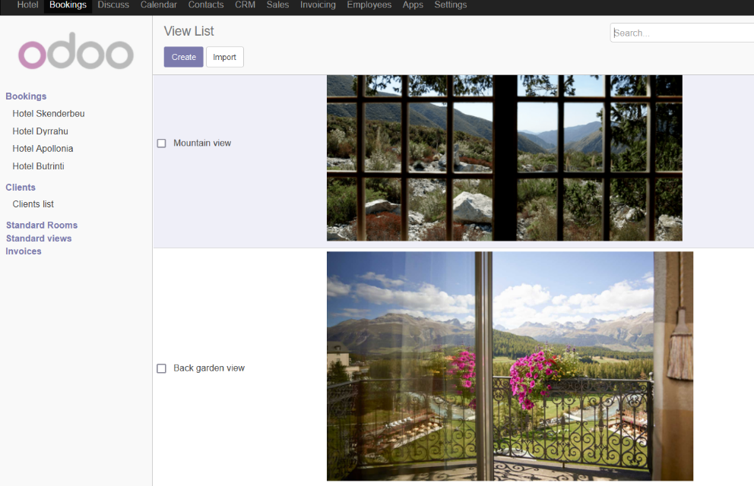

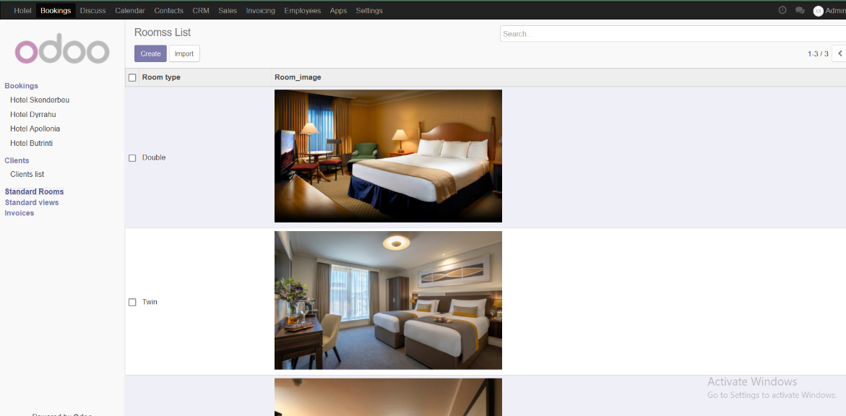

Another great feature of Odoo is the cron actions. They are actions they you can create so they happen chronologically. They can happen in intervals so once a day, once a month, or once a year etc. This means you can automate every repetitive job on Odoo and you don’t need to hire a person or simply waste time yourself or try to remember to do it. Since every online reservation site gets a percentage of every booking that you get from their site I though why don’t I do a cron action that calculates this commission. Since I had worked with the Booking software at the guesthouse in Valbone I knew that the commission it takes for every reservation is 14% of the price of the room and every month an invoice comes with the amount of money you must pay.   
I created a python function that sorts through the rows of the bookings table. For each one of them it checks on the Price field, and it calculates the amount of money for each room. For every iteration after it gets the commission number it adds it to the amount of this month. When every booking of the current month is checked then in a new table it adds a row. There it puts the current month and the current year. In the end it writes the amount you have to pay for this month.

Another cool feature I implemented is that if you click the commission row then it generates a pdf with these data and makes it ready for printing. This Is great for documenting also if the payment needs to be done physically in the bank. This automatic monthly invoice calculation is a feature I got praised for by the overseer which shows the amazing things you can do with Odoo that help your business on lessening the workload.

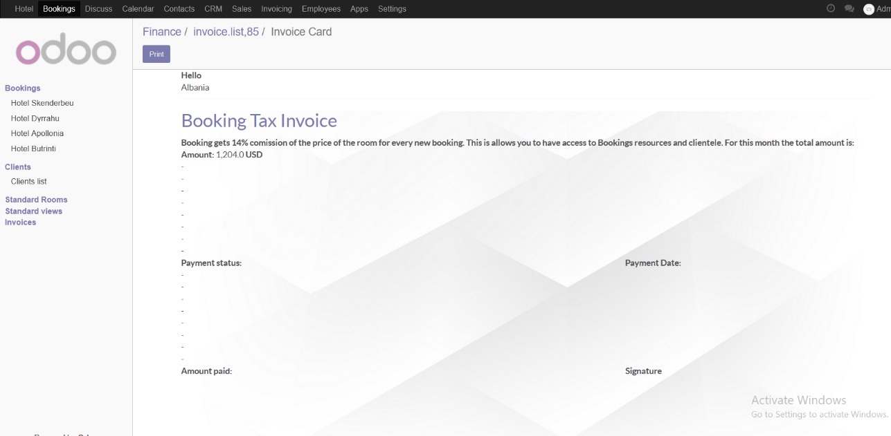

Fourth part

================================

The Conclusion

What I liked about this project

There are many things I liked about this project. Firstly this was a totally new experience for me. It was my first internship. It also was my first introduction to the business world and its mechanics. I also get to see what it takes to have a successfull company. I takes lots of work and devotion to your goals. I liked that as an intern I was treated as equal. This means I was like a new employee. They teached me tips and tricks that they used for their work. This real world experience is very valuable and that is why students with an internship background have a higher chance of getting employed because of this. Besides the project and me I also liked how the companyt treated its employees. They had multiple breaks and a very nice big bathroom. The fact that is was and stayed crystal clean is a factor the shows the devotion of the company and the tidiniess of the employees. The company also had a big dining room with different selections of foods from meats to vegetables. Also Communication Progress offices are very big spacious and very modern. These incourages work because the better the environment your work in the better and the higher quality the work will be.

If I ever open my own business I have noted these things in my mind which will help me be a better employer and also getting the best out of my employees.

Another thing that I liked is the readiness of my tutor. He was always checking on how I was doing and if I had ay questions. He told me that he knew how hard and confusing Odoo can be in the beginning and all I had to do to succeed is concentrate and spend as much time as I can reviewing the Odoo resources online.

About the project itself I liked the fact that it introduces me to new parts of programming like object oriented programming, databases, xml etc. Also I now know how businesses organize all that volum of data that they deal with by using ERPs. The troubleshooting for errors during my Odoo development was enjoyable as it involved using logic but not always since the problems could get pretty complicated fast.

In general the internship at Communication Progress was very dynamic with new things happening, being learned everyday and meeting new people that like programming as much as I do.

THINGS I DIDN’T LIKE ABOUT THE PROJECT

The only thing I didn’t like from the project was the lack of proper learning tools for Odoo. I hasd two main sources of learning Odoo development. The first one was the official doucmentation. It wasnt very detailed and it didn’t have many examples. It only touched on the main things but that’s wasn’t enough. The second source was an Odoo development channel but it had its own problems like the speaker on the videos with a hard dialect of english making it almost impossible to understand and also not very clear explanations of what he was doing. In my opinion Odoo should invest more on its learning program because for new developers it an unkown ground very difficuult to explore.

Another thing I didn’t like about Odoo was its not so good support of development on linux operating system. I wasted the first week of the internship trying to make Odoo server work on my fedora machine. Unfortunately I couldn’t achieve it. So I was forced to download Windows. This made me lose valuable time that I could have used on learning.

Company presentation and final conclusion

I presented the project to the Communication Progress. The board was made of my overseer and some other employees and some other interns. They had a big monitor to present the projects of everybody. Firstly, they asked me to give some impressions about the company and the overseer. Then they asked me some questions about how I managed my time, what resources did I use to learn Odoo development and other minor things. Then I got to the presentation. I showed the UI first. Then I showed the code. They would often interrupt me to ask technical questions. After that I was asked about the conclusion of the project. In the end they were very please and recognized my work which made me very content since I had spent many hours working on it.

The presentation was also a learning experience since every project in the end must be presented and if that isn’t done right then you have wasted your time since nobody will see the values of your work especially nowadays where the focus of people is lessening each day.

According to my vision the project is not completed. But to finalize it takes more time and a lot of knowledge that is more advanced than my level. I had originally planned to connect Odoo with external API to Booking software. This would make possible for automation of bookings totally. It would also give an easier control of the reservations. When I worked at the guesthouse in Valbone we used a notebook to write down bookings and every day we checked them with the booking reservations. But this way was very impractical and slow and during the moment we were checking the rooms new reservations could come in and make a mess in the bookings. This has happened many times. That’s why I wanted to make something that is practical, and I can use it there too. Odoo was perfect for this. I will keep working on my project even though the internship has ended.

I finished my project in time even though of multiple errors in the beginning of the work that delayed me a lot. I created two modules instead of one that was required. I also touched every topic that I could from Odoo development like views, menus, calendar, actions, images so I could learn from as many things as I could. I am very happy with the outcome of this project.

I enjoyed very much working with Odoo and it was a great experience from which I benefited a lot in terms of knowledge and social interactions. I will add it proudly in my CV knowing that it made grow more professionally and for meeting new people.

Since my skills have grown and I hope that on the next internship I will also get a pay. In Albania it is very rare for the interns to get paid because they are still seen as students that only learn. But an intern can and is always willing to do any type of work so he can prove himself useful and learn new skills. That’s why I think every intern should be paid. It also encourages work and improves its quality since a pay means higher responsibilities.

In the future I hope that the internship practice will become more popular in Albania. The best way to learn is to go there and “get your hands dirty”. By throwing yourself in the river of business and learning how to swim. So a student should apply for internships even if it is not required by his school. It is truly an investment on yourself that defintely return profit.