PYTHON ACTIVITY-BASED LEARNING
10 CASE STUDIES WITH OUTPUTS

Case Study 12: Attendance Recovery Computation

1. Problem Statement
Calculate a student's current attendance percentage and find the minimum number of consecutive classes the student must attend to reach 75%.

2. Objectives
- Calculate attendance percentage.
- Check whether attendance is at least 75%.
- Find the minimum extra classes needed.

3. Algorithm
- Read total classes and attended classes.
- Validate the input.
- Calculate attendance percentage.
- Use a while loop until attendance reaches 75%.
- Display extra classes and final percentage.

4. Python Source Code
total = int(input("Enter total classes: "))
attended = int(input("Enter attended classes: "))
if total <= 0 or attended < 0 or attended > total:
print("Invalid input")
else:
percentage = attended / total * 100
extra = 0
while percentage < 75:
total = total + 1
attended = attended + 1
extra = extra + 1
percentage = attended / total * 100
print("Extra classes required:", extra)
print("Final attendance:", round(percentage, 2), "%")

5. Sample Output
Enter total classes: 40
Enter attended classes: 25
Extra classes required: 20
Final attendance: 75.0 %

6. Test Cases
Total=40, attended=30 → 0 extra classes. Total=40, attended=25 → 20 extra classes. Total=0 → Invalid input.
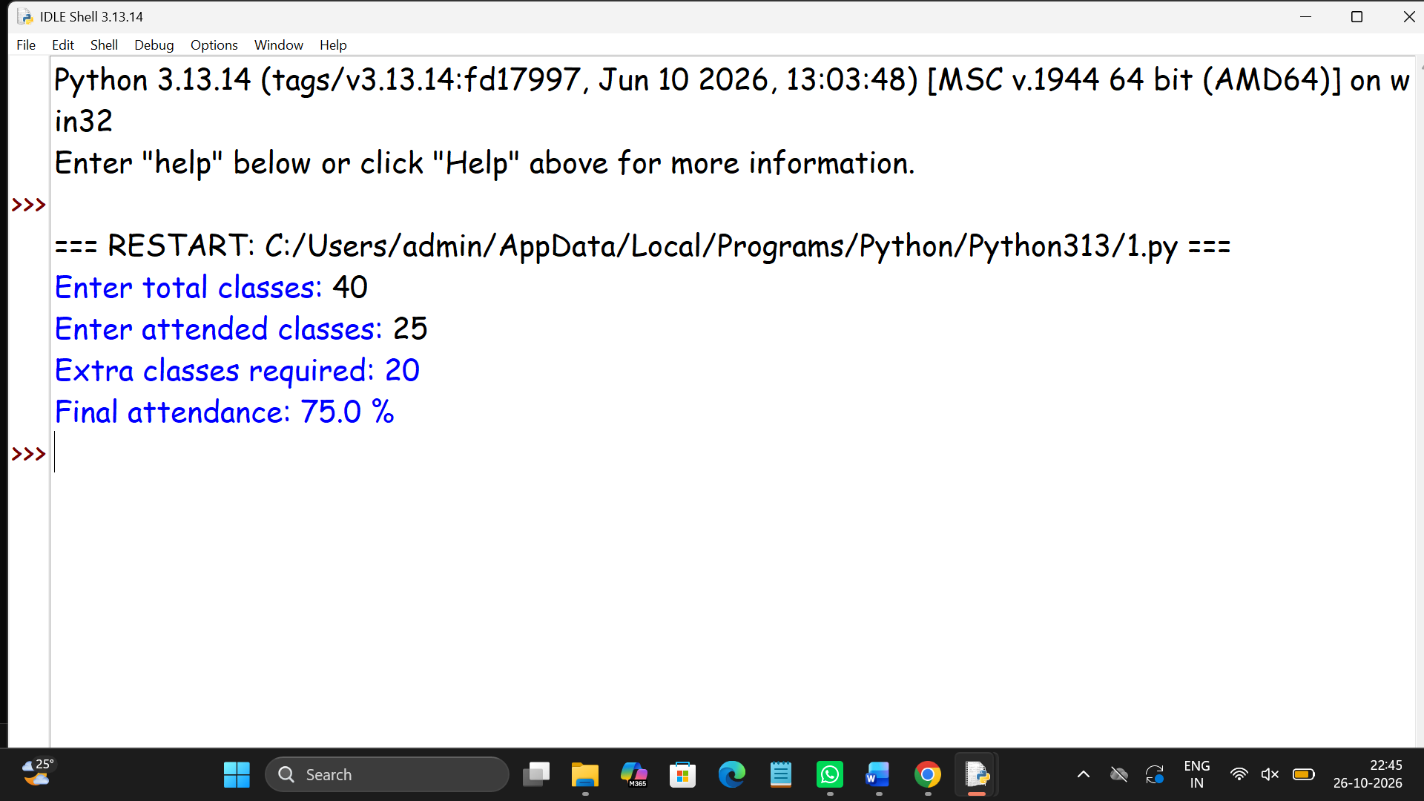

Case Study 17: Student Performance Trend Analysis

1. Problem Statement
Compare a student's marks across examinations and identify improvement or decline for each subject.

2. Objectives
- Store marks in lists.
- Compare marks using a for loop.
- Calculate the change in marks.

3. Algorithm
- Store subject names, previous marks and current marks in lists.
- Visit each subject using a for loop.
- Subtract previous marks from current marks.
- Display improvement, decline or no change.

4. Python Source Code
subjects = ["Python", "Maths", "English"]
previous = [70, 65, 80]
current = [85, 60, 80]
for i in range(len(subjects)):
change = current[i] - previous[i]
print(subjects[i], "change:", change)
if change > 0:
print("Improved")
elif change < 0:
print("Declined")
else:
print("No change")

5. Sample Output
Python change: 15
Improved
Maths change: -5
Declined
English change: 0
No change

6. Test Cases
Python: 70 to 85 → improved by 15. Maths: 65 to 60 → declined by 5. English: 80 to 80 → no change.
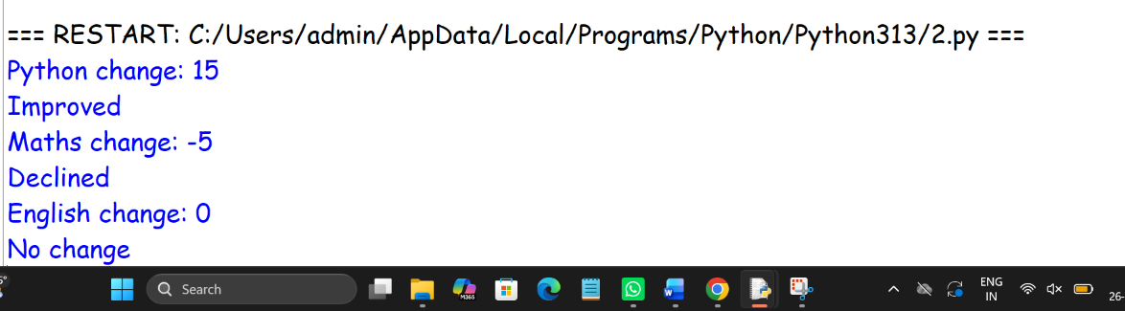

Case Study 19: Multi-Product Shopping Budget Constraint

1. Problem Statement
Calculate the total cost of a shopping basket and check whether it is within a fixed budget.

2. Objectives
- Store product prices and quantities in lists.
- Calculate the total bill.
- Compare the bill with the budget.

3. Algorithm
- Store product names, prices and quantities in lists.
- Calculate each product cost.
- Add costs to find the total.
- Compare total with budget and display the result.

4. Python Source Code
products = ["Pen", "Book", "Bag"]
prices = [10, 50, 400]
quantities = [2, 3, 1]
budget = 600
total = 0
for i in range(len(products)):
cost = prices[i] * quantities[i]
total = total + cost
print(products[i], "cost:", cost)
print("Total bill:", total)
print("Budget:", budget)
if total <= budget:
print("Within budget")
else:
print("Over budget")

5. Sample Output
Pen cost: 20
Book cost: 150
Bag cost: 400
Total bill: 570
Budget: 600
Within budget

6. Test Cases
Budget 600 and total 570 → Within budget. If budget is 500 → Over budget.
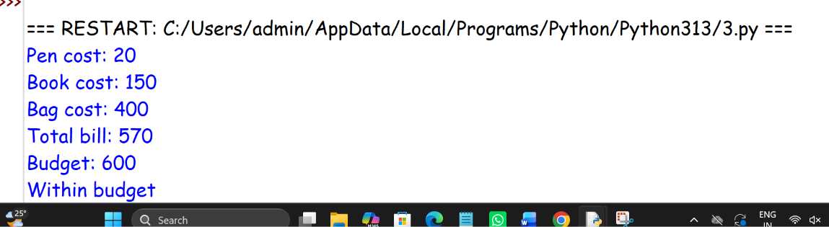

Case Study 31: String-Based Examination Answer Evaluation

1. Problem Statement
Compare student answers with an answer key and calculate correct, incorrect and unanswered questions.

2. Objectives
- Compare strings.
- Count correct, incorrect and unanswered responses.
- Calculate marks.

3. Algorithm
- Store the answer key and student answers as lists.
- Initialize counters to zero.
- Compare each answer using a for loop.
- Add one mark for each correct answer.
- Display the result.

4. Python Source Code
key = ["A", "B", "C", "D", "A"]
answers = ["A", "C", "C", "", "B"]
correct = 0
wrong = 0
unanswered = 0
for i in range(len(key)):
if answers[i] == "":
unanswered = unanswered + 1
elif answers[i] == key[i]:
correct = correct + 1
else:
wrong = wrong + 1
print("Correct:", correct)
print("Incorrect:", wrong)
print("Unanswered:", unanswered)
print("Marks:", correct)

5. Sample Output
Correct: 2
Incorrect: 2
Unanswered: 1
Marks: 2

6. Test Cases
Key A,B,C and answers A,B,C → 3 correct. Empty answer → counted as unanswered.
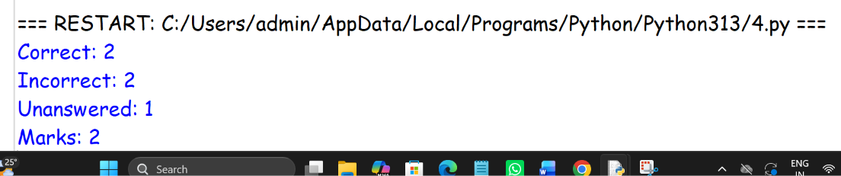

Case Study 39: Multi-Stage Examination Eligibility System

1. Problem Statement
Check examination eligibility based on attendance, internal marks, laboratory completion and fee payment.

2. Objectives
- Read eligibility details.
- Check multiple conditions.
- Display every unmet requirement.

3. Algorithm
- Read attendance, internal marks, lab status and fee status.
- Check each condition.
- Print every unmet requirement.
- If none are unmet, display eligible.

4. Python Source Code
attendance = int(input("Enter attendance percentage: "))
internal = int(input("Enter internal marks out of 30: "))
lab = input("Lab completed? (yes/no): ")
fees = input("Fees paid? (yes/no): ")
eligible = True
if attendance < 75:
print("Attendance requirement not met")
eligible = False
if internal < 15:
print("Internal marks requirement not met")
eligible = False
if lab != "yes":
print("Laboratory not completed")
eligible = False
if fees != "yes":
print("Fees not paid")
eligible = False
if eligible:
print("Eligible for examination")

5. Sample Output
Enter attendance percentage: 80
Enter internal marks out of 30: 20
Lab completed? (yes/no): yes
Fees paid? (yes/no): no
Fees not paid

6. Test Cases
80% attendance, 20 marks, lab yes, fees yes → Eligible. Attendance 60% → attendance requirement not met.
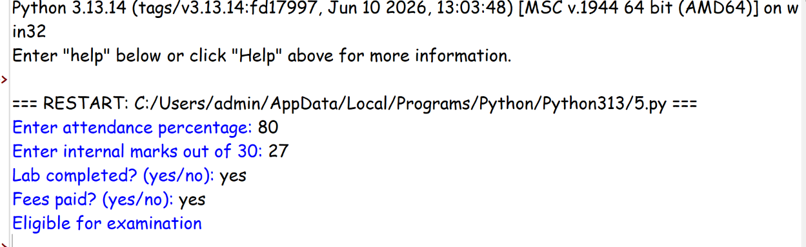
Case Study 53: Food Waste Monitoring System

1. Problem Statement
Calculate leftover meals and food-wastage percentage across several days.

2. Objectives
- Store daily meal data in lists.
- Calculate leftover meals.
- Identify days with high wastage.

3. Algorithm
- Store meals prepared and meals served in lists.
- For each day, calculate leftovers and wastage percentage.
- Compare wastage with the 10% limit.
- Display the daily results.

4. Python Source Code
days = ["Monday", "Tuesday", "Wednesday"]
prepared = [100, 120, 80]
served = [90, 100, 76]
for i in range(len(days)):
leftover = prepared[i] - served[i]
waste = leftover / prepared[i] * 100
print(days[i], "leftover:", leftover)
print("Wastage:", round(waste, 2), "%")
if waste > 10:
print("Above acceptable limit")
else:
print("Within limit")

5. Sample Output
Monday leftover: 10
Wastage: 10.0 %
Within limit
Tuesday leftover: 20
Wastage: 16.67 %
Above acceptable limit
Wednesday leftover: 4
Wastage: 5.0 %
Within limit

6. Test Cases
Prepared 100, served 90 → 10 leftovers and 10% wastage. Prepared 120, served 100 → 20 leftovers and 16.67% wastage.
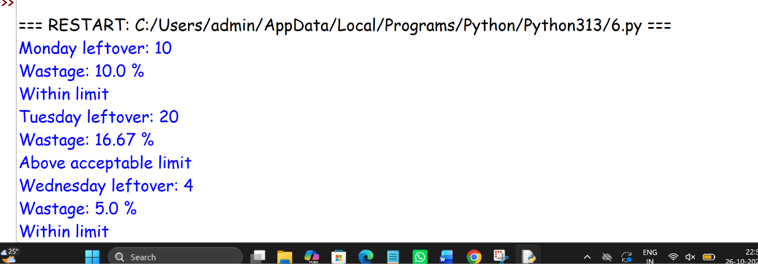

Case Study 13: ATM Transaction Sequence Simulation

1. Problem Statement
Process a sequence of deposits and withdrawals, update the account balance and reject invalid withdrawals.

2. Objectives
- Use a list of transactions.
- Update balance for each transaction.
- Reject withdrawals above the available balance.

3. Algorithm
- Set the starting balance.
- Store transactions in a list of tuples.
- Process each transaction using a for loop.
- Add deposits and validate withdrawals.
- Display final balance and transaction summary.

4. Python Source Code
balance = 1000
transactions = [("deposit", 500), ("withdraw", 200),
("withdraw", 1500), ("withdraw", 100)]
for kind, amount in transactions:
if amount <= 0:
print("Invalid amount")
elif kind == "deposit":
balance = balance + amount
print("Deposit successful:", amount)
elif kind == "withdraw":
if amount <= balance:
balance = balance - amount
print("Withdrawal successful:", amount)
else:
print("Insufficient balance")
print("Final balance:", balance)

5. Sample Output
Deposit successful: 500
Withdrawal successful: 200
Insufficient balance
Withdrawal successful: 100
Final balance: 1200

6. Test Cases
Starting balance 1000; deposit 500; withdraw 200 → balance 1300. Attempt to withdraw 1500 → rejected.
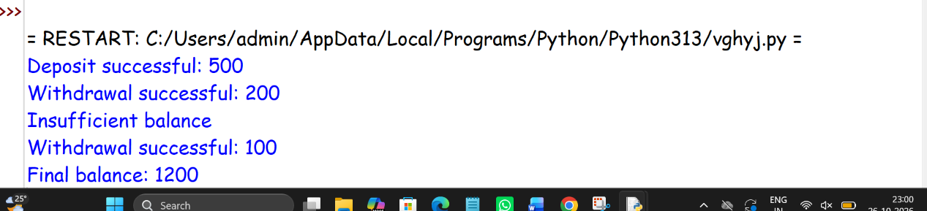

Case Study 38: ATM Menu-Driven Banking Simulation

1. Problem Statement
Create a simple ATM menu for deposit, withdrawal, balance inquiry and exit.

2. Objectives
- Practise while loops.
- Perform repeated menu operations.
- Validate deposits and withdrawals.

3. Algorithm
- Set the initial balance to zero.
- Display the menu inside a while loop.
- Read the user's choice.
- Perform the selected operation.
- Stop when the user selects Exit.

4. Python Source Code
balance = 0
while True:
print("1. Deposit")
print("2. Withdraw")
print("3. Check balance")
print("4. Exit")
choice = input("Enter choice: ")
if choice == "1":
amount = int(input("Enter deposit: "))
if amount > 0:
balance = balance + amount
elif choice == "2":
amount = int(input("Enter withdrawal: "))
if amount > 0 and amount <= balance:
balance = balance - amount
else:
print("Invalid amount or insufficient balance")
elif choice == "3":
print("Balance:", balance)
elif choice == "4":
break
else:
print("Invalid choice")
print("Thank you")

5. Sample Output
1. Deposit
2. Withdraw
3. Check balance
4. Exit
Enter choice: 1
Enter deposit: 500
1. Deposit
2. Withdraw
3. Check balance
4. Exit
Enter choice: 3
Balance: 500
1. Deposit
2. Withdraw
3. Check balance
4. Exit
Enter choice: 4
Thank you

6. Test Cases
Deposit 500 → balance 500. Withdraw 200 → balance 300. Withdraw 400 from balance 300 → rejected.

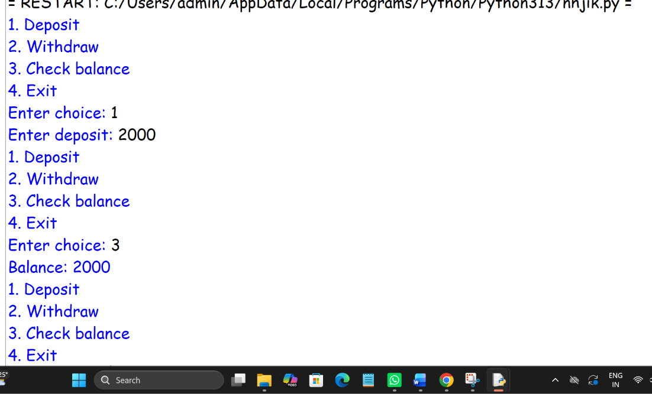

Case Study 42: Student Marks Matrix Analysis

1. Problem Statement
Analyse student marks stored in a nested list and calculate each student's total and average.

2. Objectives
- Represent marks using nested lists.
- Calculate row-wise totals and averages.
- Find the highest total.

3. Algorithm
- Store student names and marks in lists.
- For each student, calculate total and average.
- Compare totals to find the highest scorer.
- Display the results.

4. Python Source Code
names = ["Anu", "Ravi", "Sita"]
marks = [[80, 70, 90], [60, 75, 65], [90, 85, 95]]
highest = 0
top_student = ""
for i in range(len(names)):
total = sum(marks[i])
average = total / len(marks[i])
print(names[i], "total:", total, "average:", average)
if total > highest:
highest = total
top_student = names[i]
print("Top student:", top_student)
print("Highest total:", highest)

5. Sample Output
Anu total: 240 average: 80.0
Ravi total: 200 average: 66.66666666666667
Sita total: 270 average: 90.0
Top student: Sita
Highest total: 270

6. Test Cases
Marks [80,70,90] → total 240, average 80. Marks [90,85,95] → total 270, highest total.
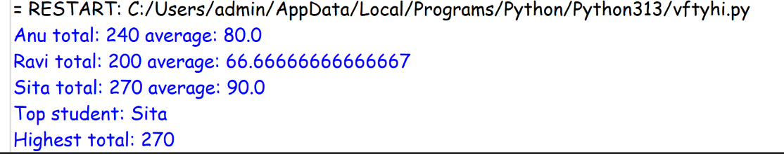

Case Study 45: Weekly Electricity Consumption Matrix

1. Problem Statement
Calculate daily electricity consumption for appliances over a week and identify readings above a limit.

2. Objectives
- Store readings in a nested list.
- Calculate daily totals.
- Identify consumption above a given limit.

3. Algorithm
- Store appliance readings for each day in a nested list.
- Use a for loop to calculate each day's total.
- Compare the total with the daily limit.
- Display totals and warnings.

4. Python Source Code
days = ["Monday", "Tuesday", "Wednesday"]
# Each row contains readings for three appliances
readings = [[2, 3, 4], [4, 5, 3], [1, 2, 2]]
limit = 10
for i in range(len(days)):
total = sum(readings[i])
print(days[i], "consumption:", total, "units")
if total > limit:
print("Consumption above limit")
else:
print("Consumption within limit")

5. Sample Output
Monday consumption: 9 units
Consumption within limit
Tuesday consumption: 12 units
Consumption above limit
Wednesday consumption: 5 units
Consumption within limit

6. Test Cases
Readings [2,3,4] → total 9, within limit. Readings [4,5,3] → total 12, above limit.

