Austen Rhyce Erickson

Database Dev. & Use: Assignment 2.3

6/6/24

**GitHub Repository:**

<https://github.com/arerickson28/csd-310/tree/main/module-2>

**Business Rules:**

A user has at least one role

A user has exactly one birthdate

A user can have none, one, or many dependents

**Entity Relationship Diagram:**

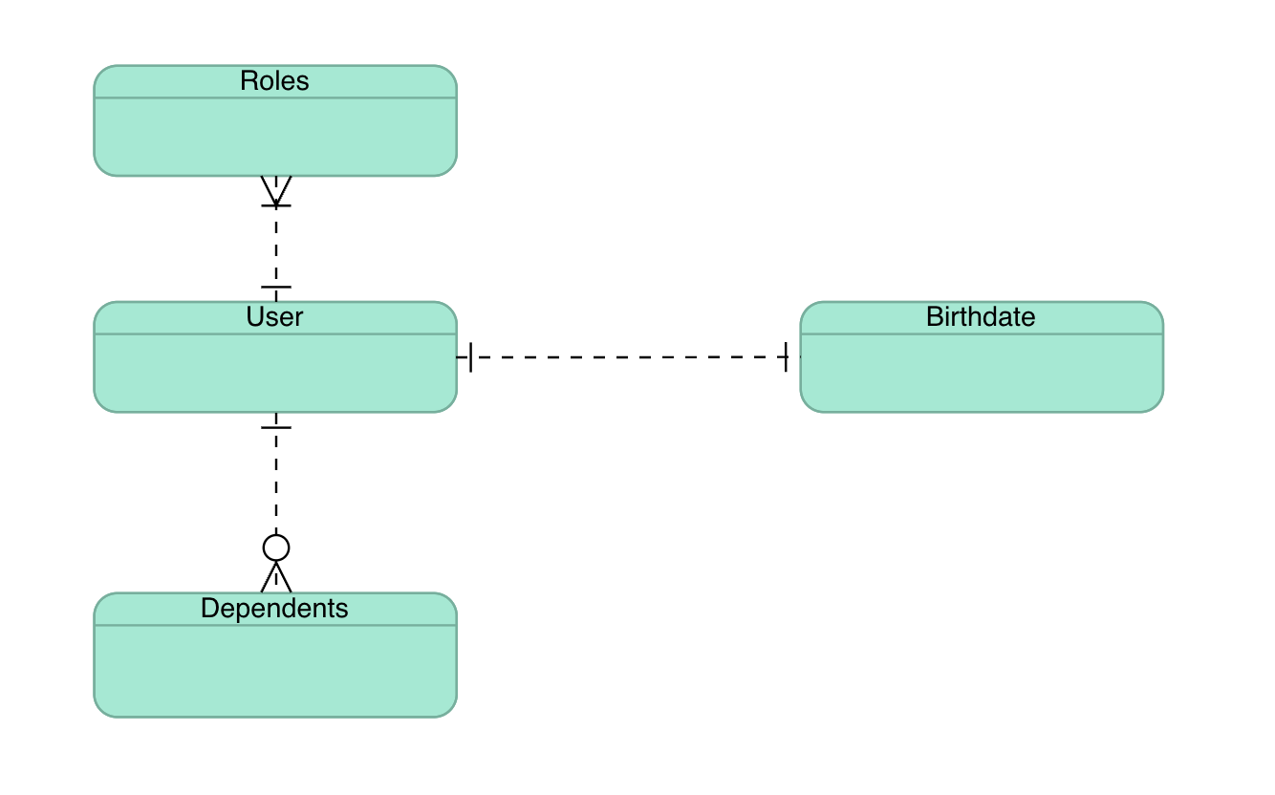

**NoSQL Data Structure:**

