Austen Erickson

Database Dev. & Use: Assignment 3.2

6/15/24

**GitHub Repository:**

<https://github.com/arerickson28/csd-310/tree/main/module-3>

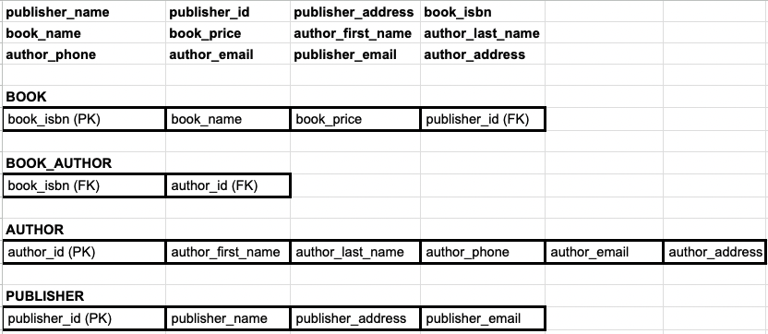

*** Notes ***

* There is a many-to-many relationship between books and authors as an author can write many books and a book can have multiple authors. Therefore, a junction table is needed to relate the book table to the author table.
* A book can have only one publisher so the publisher_id is included as a foreign key in the book table.