Austen Rhyce Erickson

Database Dev. & Use: Assignment 4.2

6/19/24

**Github Repository**

<https://github.com/arerickson28/csd-310/tree/main/module-4>

**Connection Established**

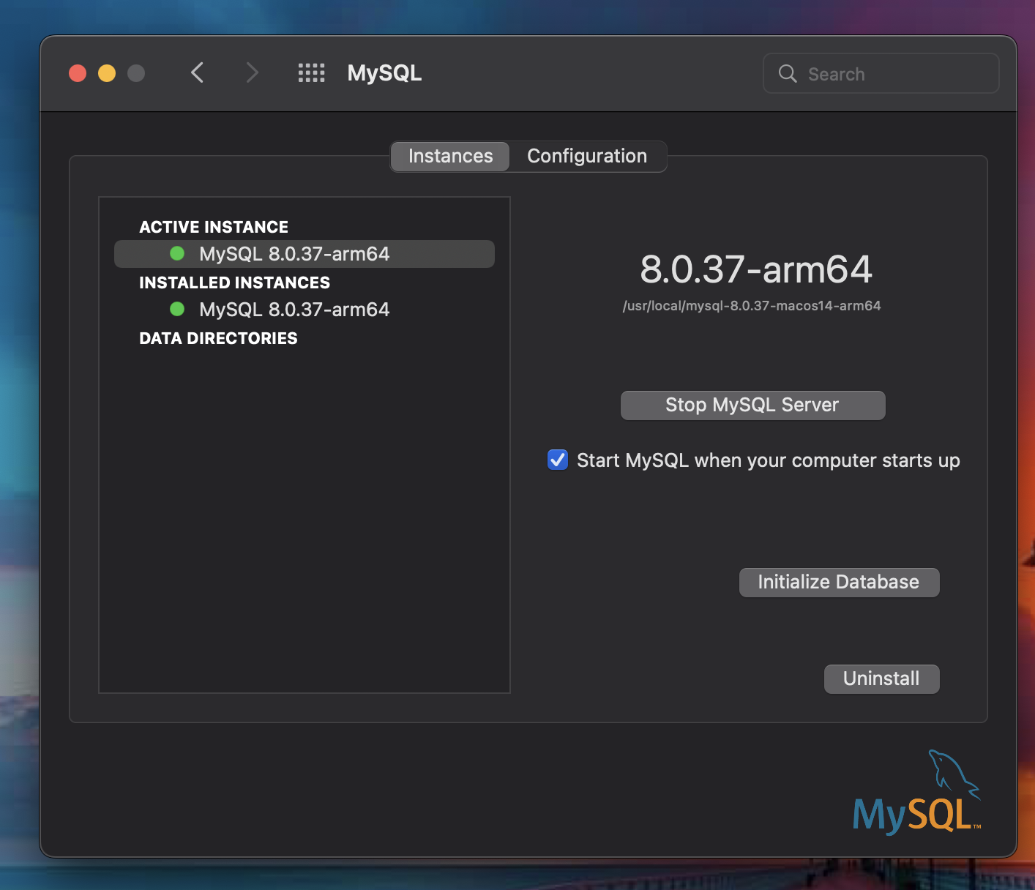

**Creating Database**

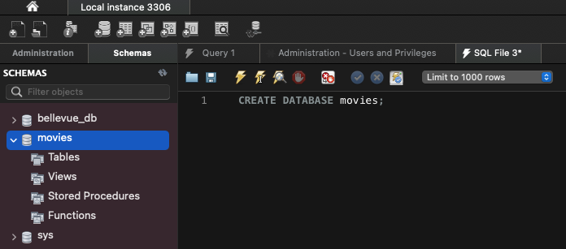

**Show Databases**

