Austen Rhyce Erickson

Database Dev. & Use: Assignment 5.2

**GitHub Repository:**

<https://github.com/arerickson28/csd-310/tree/main/module-5>

Provide three functions to experiment with. For each:

* Provide an explanation of when it might be used
* Provide an appropriate alias for the column header in the results
* Provide the SQL statement, run the statement, then take a screenshot of the results and paste it into your Word document

**FUNCTION ONE**

* DAYNAME(“2024-06-19”) → yields day of the week
* If you only have dates to reference for your query, you can use this function to get results listed as days of the week for those dates.
* A good column header alias for this function would be “Day of Week”
* Can be used in combination with current_date to get the day of the week for the current date. This is the example I’ve included below with column alias “Today’s Weekday”

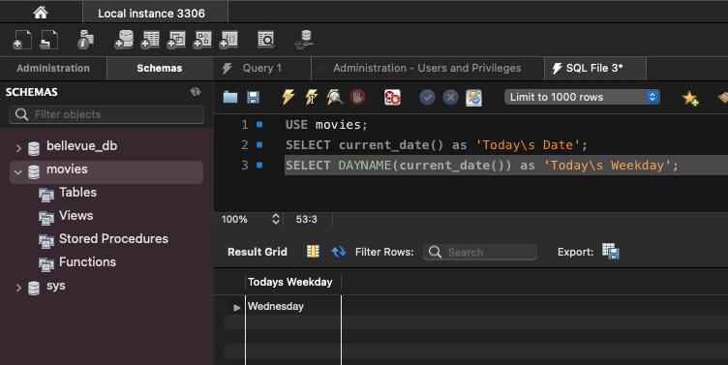

**FUNCTION TWO**

* FLOOR(25.75) → yields 25
* Equivalent to rounding down to the nearest integer
* You might use this if you have a numerical prediction of something that is measured discreetly. For example, if the prediction is 2.50 children in a household. You would round that prediction down to 2 children. Because you can’t have half a child.
* The alias you would use would depend on what the number represents. In this case I would use “Children In Household.”

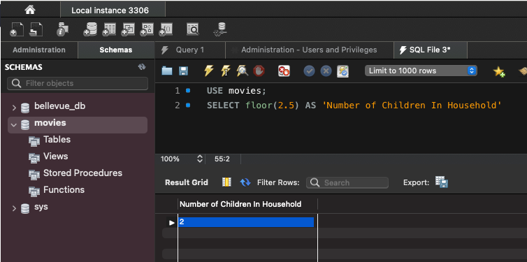

**FUNCTION THREE**

* CEILING(25.75) → yields 26
* Equivalent to rounding up to the nearest integer
* You might use this when you have an estimated number of something that is measured discreetly. For example, if the estimated number of light bulbs needed for proficient lighting is 25.75 light bulbs, you would want to require 26 light bulbs because 25 light bulbs would be insufficient.
* The alias you would use would depend on what the number represents. In this case I would use “Lightbulbs Required”

