Austen Rhyce Erickson

Database Dev. & Use: Assignment 6.2

6.24.24

**GitHub Link:**

<https://github.com/arerickson28/csd-310/tree/main/module-6>

**STEP 5: After Running db_init_2022.sql**

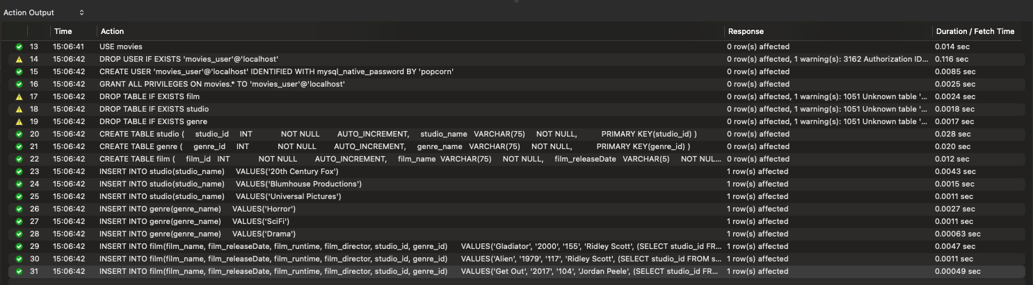

**STEP 6: Show Tables**

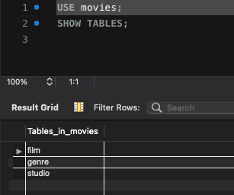

**STEP 8: After Running Python Script**

