Austen Erickson

8/17/24

Assignment: 1.2

Link to GitHub repository:

<https://github.com/arerickson28/csd-340>

Screenshot of initial repository creation:

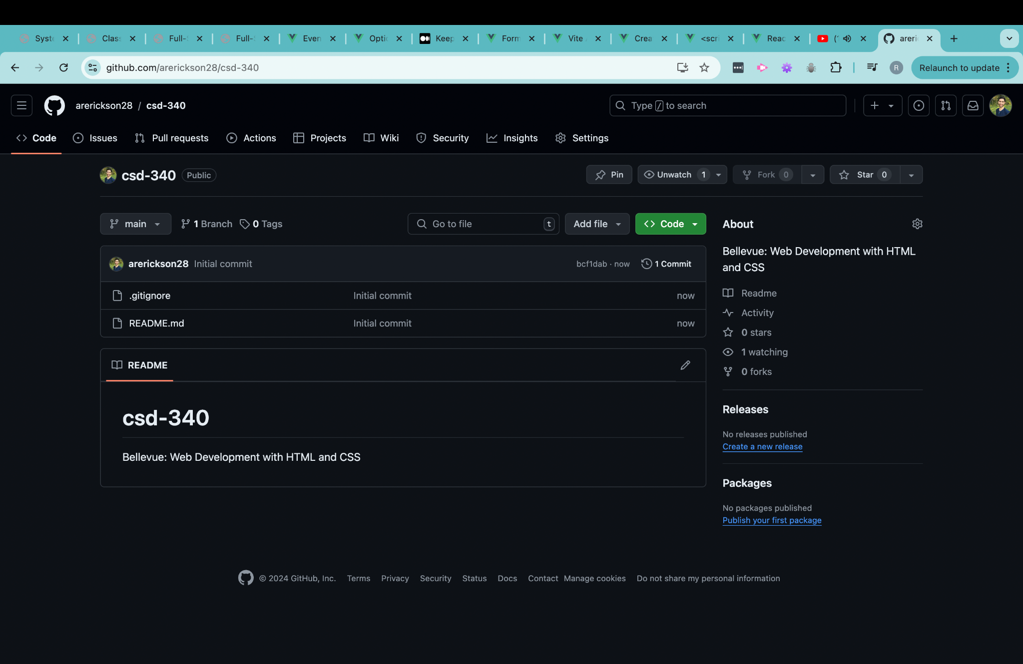

Screenshot of local copy of repository:

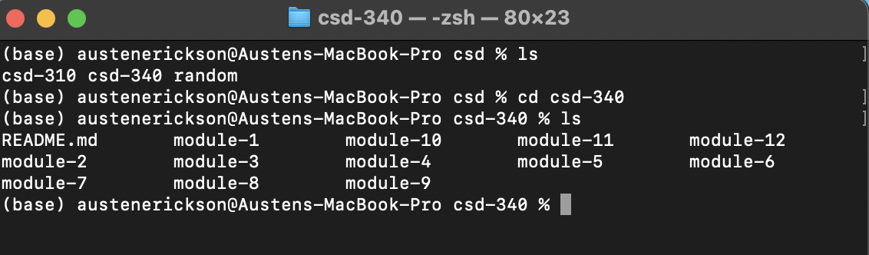

Screenshot of updated repository landing page:

