Austen Erickson

8/17/24

Assignment: 1.3

Link to GitHub repository:

<https://github.com/arerickson28/csd-340/tree/main/module-1>

Screenshot of starter code validation:

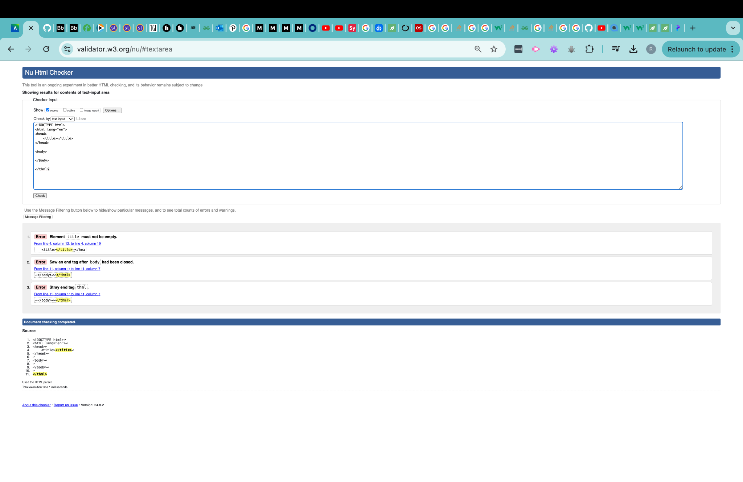

Screenshot of corrected starter code validation: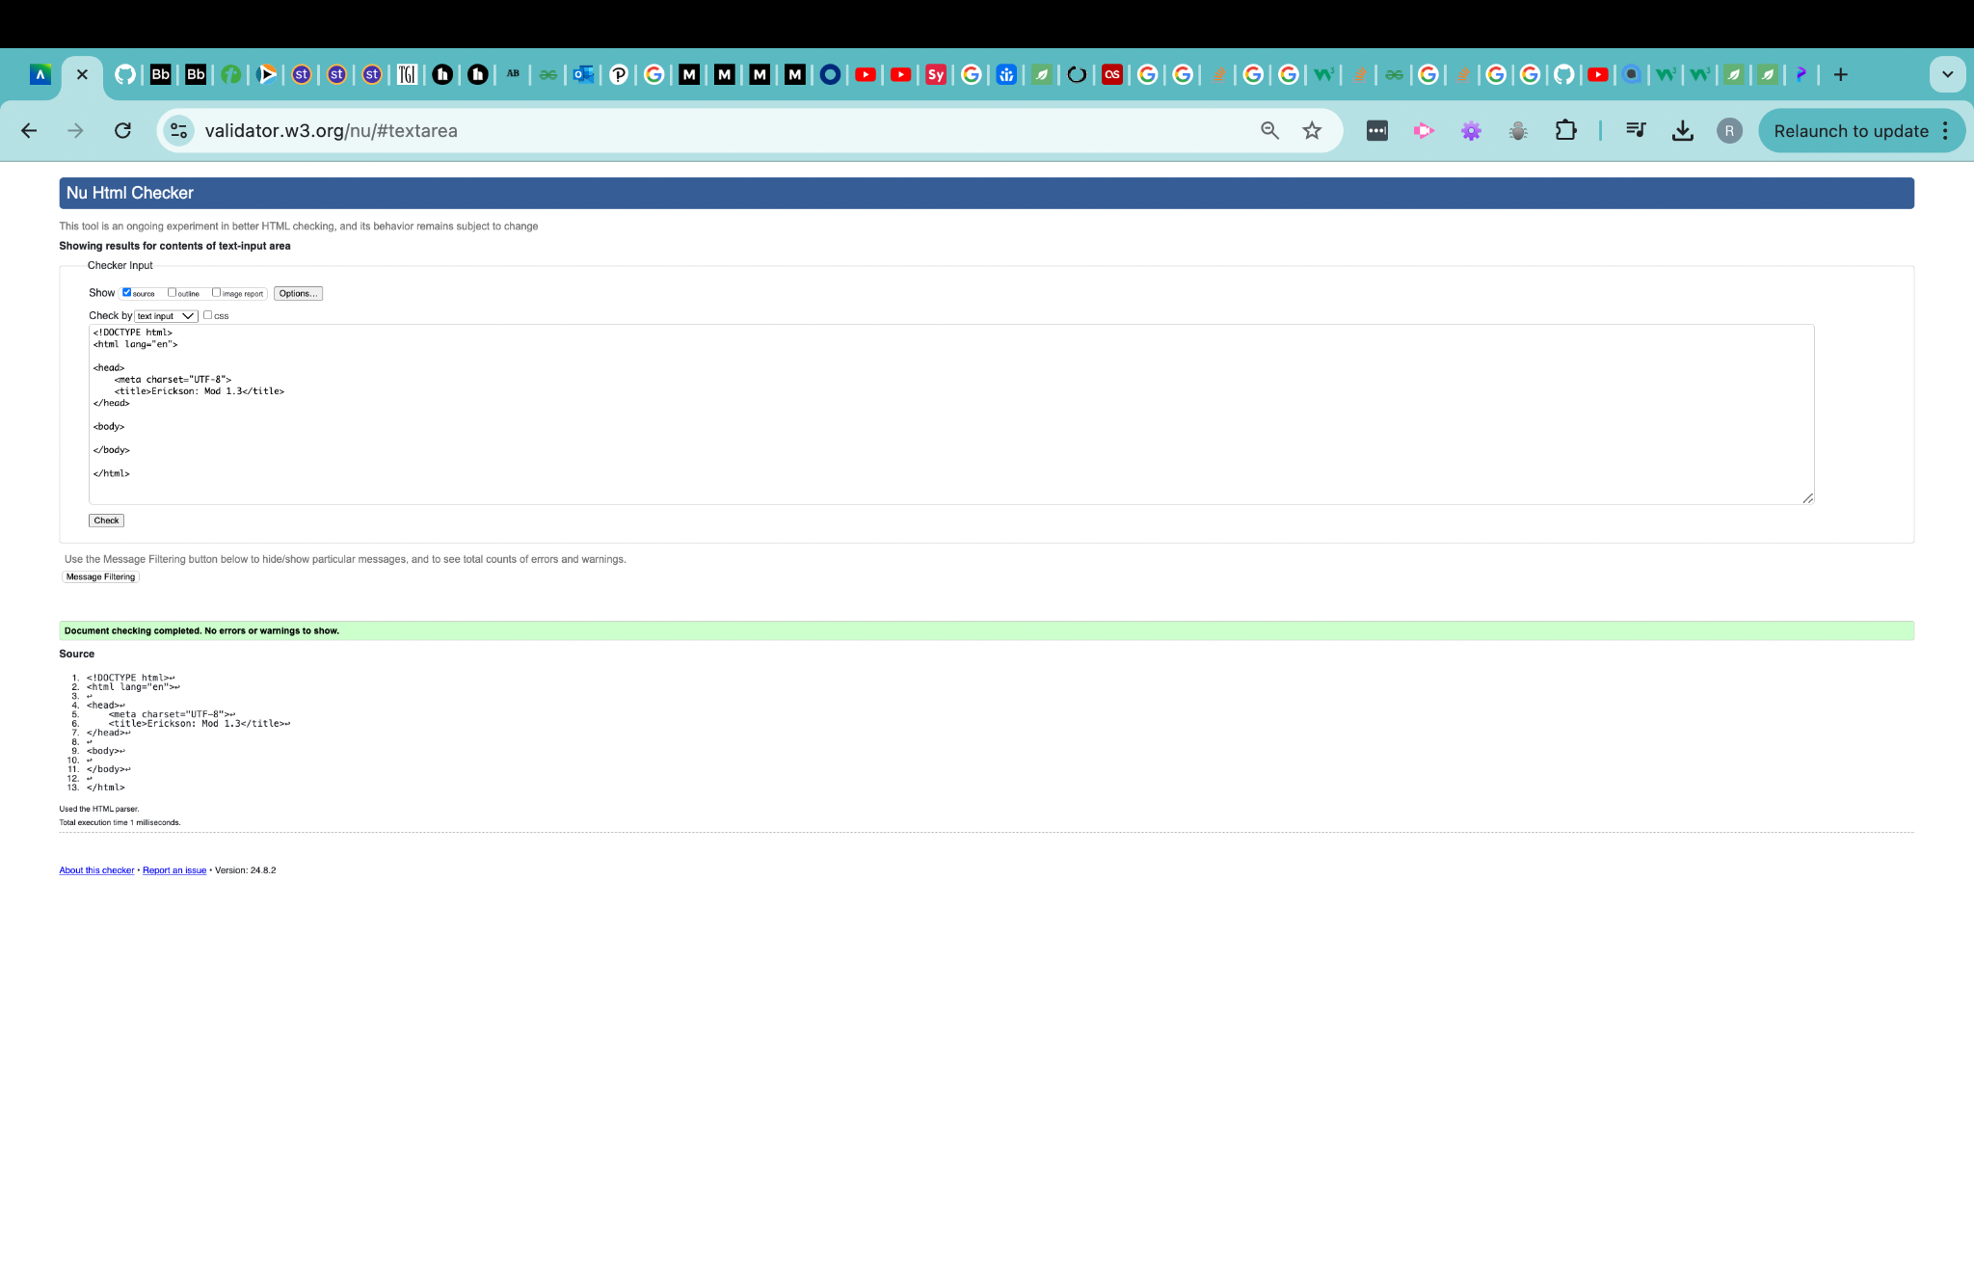

Screenshot of updated html code validation:

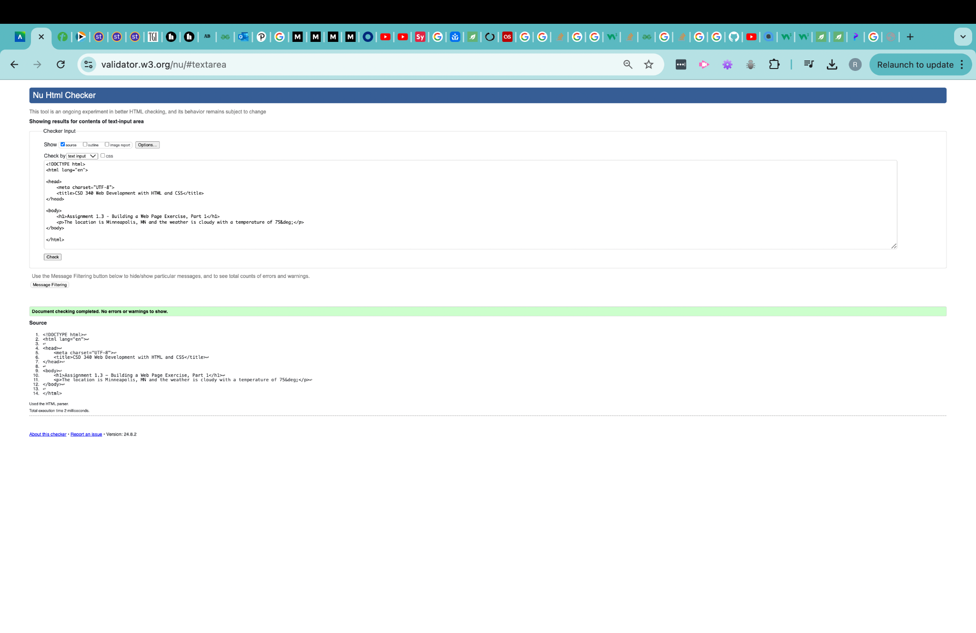

Screenshot of webpage run locally in browser:

