1. Add new RHEL7 repos on the satellite

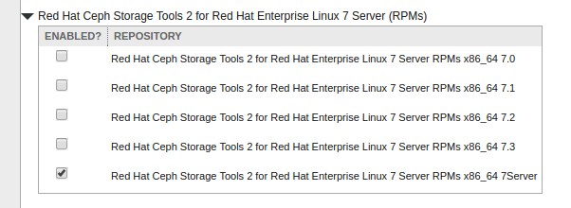
2. check the product content in activation key
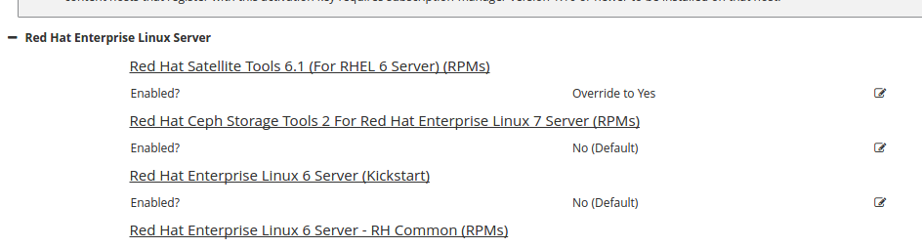
Note. the new product will show up if you have a valid subscription which can support it.

3. select the Release Version to 7Server, but my linux client is RHEL6.

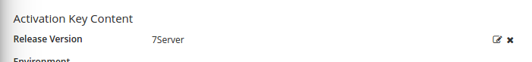

4. try to makecache on the client
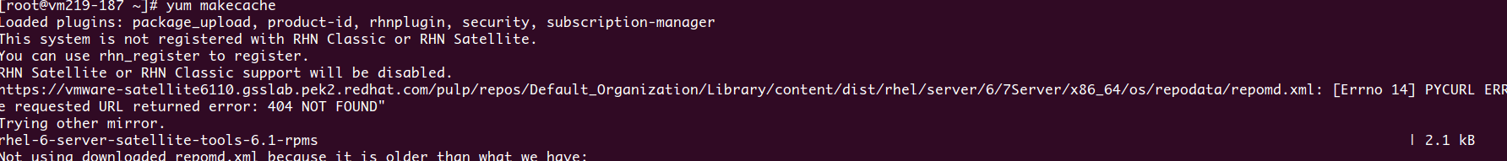
Note. It failed because the directory 7Server will never be created under ../server/6/ by the satellite system, it support to be created under ../server/7/

5. also, you will not find the repos which is not suitable for your current system whether or not you have enabled it in the product content. Please notify.

[root@vm219-187 ~]# subscription-manager repos --list
+----------------------------------------------------------+
Available Repositories in /etc/yum.repos.d/redhat.repo
+----------------------------------------------------------+
Repo ID: rhel-6-server-satellite-tools-6.1-rpms
Repo Name: Red Hat Satellite Tools 6.1 (for RHEL 6 Server) (RPMs)
Repo URL: https://vmware-satellite6110.gsslab.pek2.redhat.com/pulp/repos/Default_Organization/Library/content/dist/rhel/server/6/6Server/$basearch/sat-tools/6.1/os
Enabled: 0

Repo ID: rhel-6-server-rpms
Repo Name: Red Hat Enterprise Linux 6 Server (RPMs)
Repo URL: https://vmware-satellite6110.gsslab.pek2.redhat.com/pulp/repos/Default_Organization/Library/content/dist/rhel/server/6/7Server/$basearch/os
Enabled: 0

Repo ID: rhel-6-server-satellite-tools-6.2-rpms
Repo Name: Red Hat Satellite Tools 6.2 (for RHEL 6 Server) (RPMs)
Repo URL: https://vmware-satellite6110.gsslab.pek2.redhat.com/pulp/repos/Default_Organization/Library/content/dist/rhel/server/6/6Server/$basearch/sat-tools/6.2/os
Enabled: 0

Repo ID: rhel-6-server-rh-common-rpms
Repo Name: Red Hat Enterprise Linux 6 Server - RH Common (RPMs)
Repo URL: https://vmware-satellite6110.gsslab.pek2.redhat.com/pulp/repos/Default_Organization/Library/content/dist/rhel/server/6/7Server/$basearch/rh-common/os
Enabled: 0

Repo ID: rhel-server-dts-6-rpms
Repo Name: Red Hat Developer Toolset RPMs for Red Hat Enterprise Linux 6 Server
Repo URL: https://vmware-satellite6110.gsslab.pek2.redhat.com/pulp/repos/Default_Organization/Library/content/dist/rhel/server/6/7Server/$basearch/devtoolset/os
Enabled: 0

Repo ID: rhel-server-dts2-6-eus-rpms
Repo Name: Red Hat Developer Toolset 2 for RHEL 6 Server EUS (RPMs)
Repo URL: https://vmware-satellite6110.gsslab.pek2.redhat.com/pulp/repos/Default_Organization/Library/content/eus/rhel/server/6/7Server/$basearch/devtoolset/2/os
Enabled: 0

Repo ID: rhel-sap-hana-for-rhel-6-server-rpms
Repo Name: RHEL for SAP HANA (for RHEL 6 Server) (RPMs)
Repo URL: https://vmware-satellite6110.gsslab.pek2.redhat.com/pulp/repos/Default_Organization/Library/content/dist/rhel/server/6/7Server/$basearch/sap-hana/os
Enabled: 0

