1. enable Red hat Ceph Storage To ols 2 for Red Hat Enterprise Linux 7 Server(RPMs)

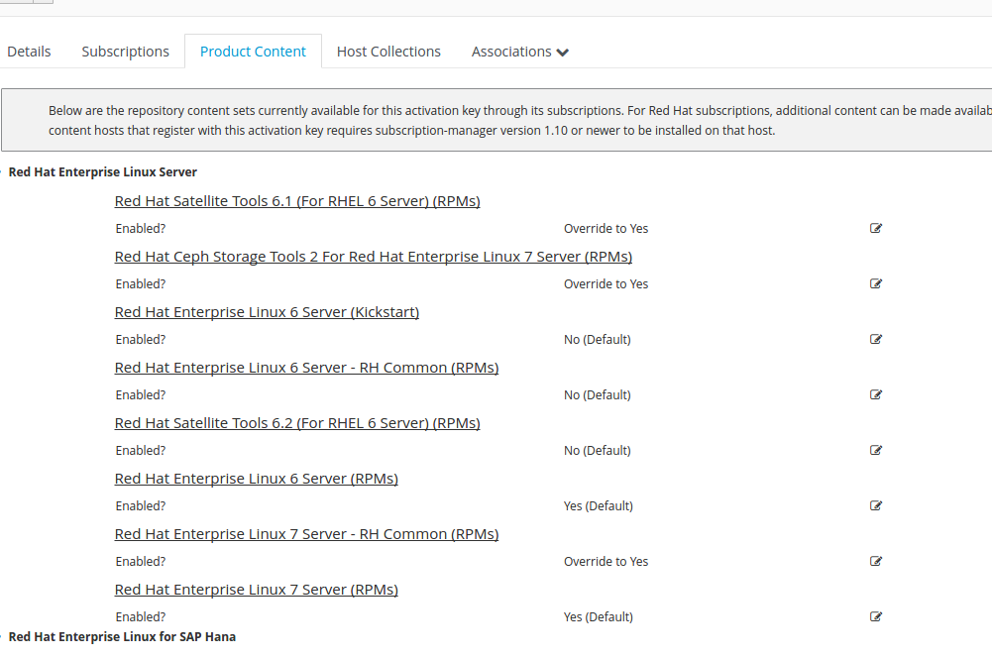
2. use this key to register a new host

3. Content Hosts with the release version 6Server

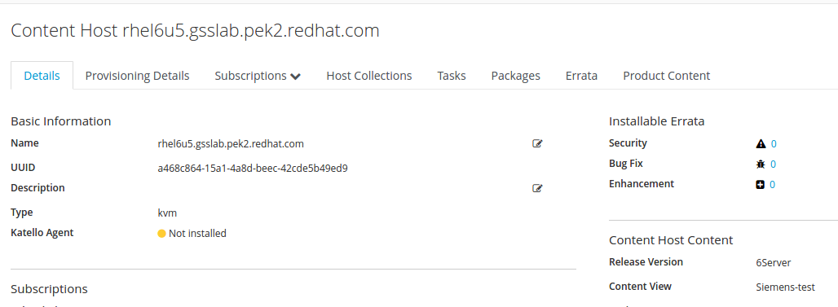
4. product contents on this host
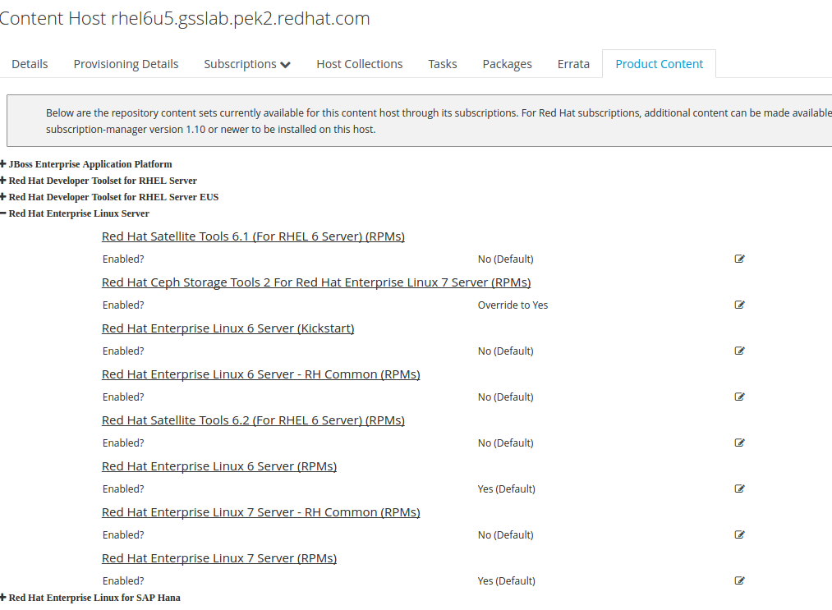
5. yum repolist & subscription-manager repos –list

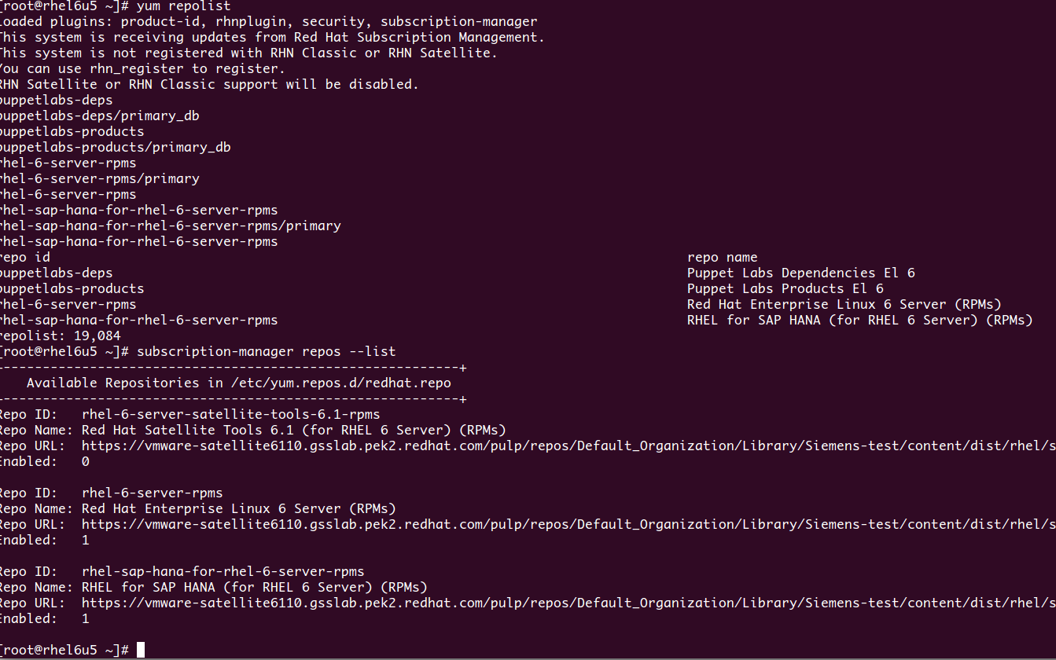
~~~~~~~~~~~~~~~~~~~~~~~~~~~~~~~~~~~~~~~~~~~~~~~~~~~~~~~~~~~~~~~~~~~~~~~~~~

1. another key with release version is 7Server
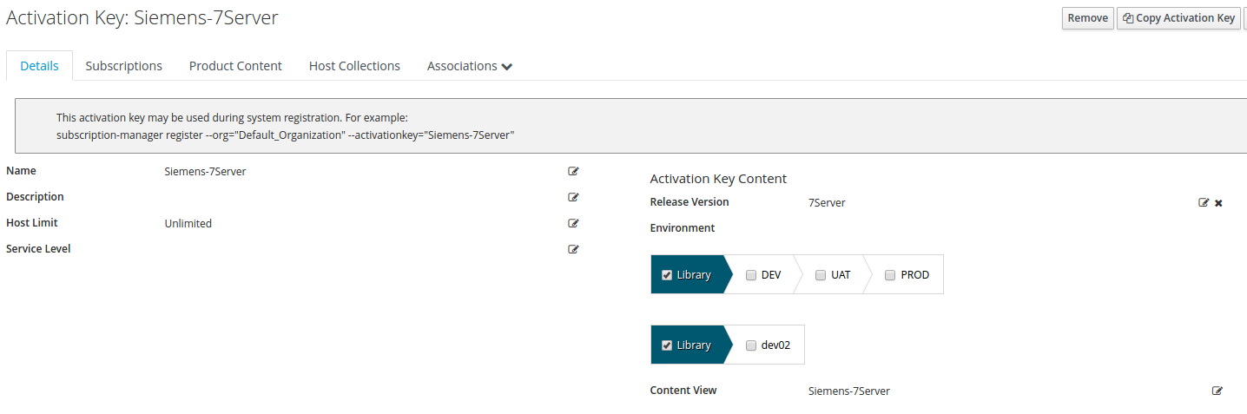
2. force the Ceph Storage and RH Common is on
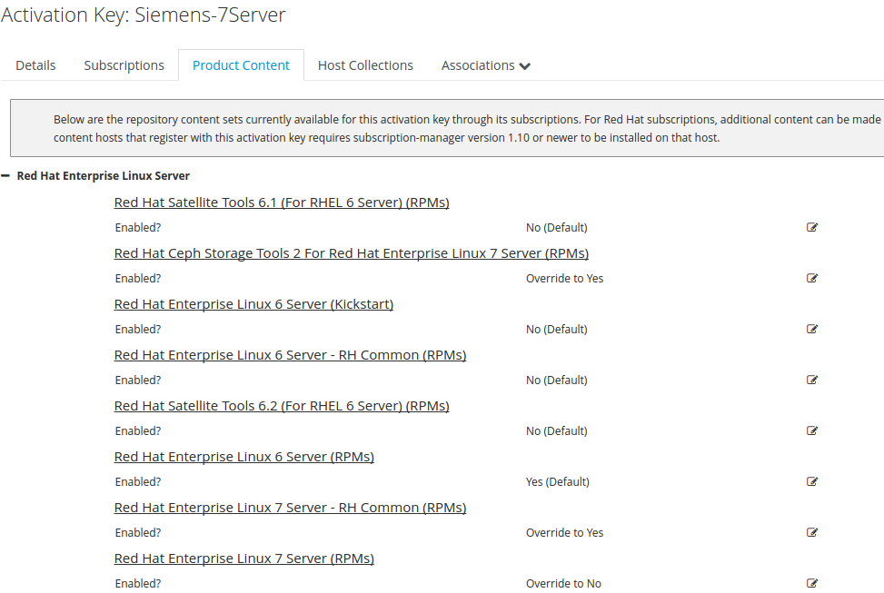

3. repos in content views
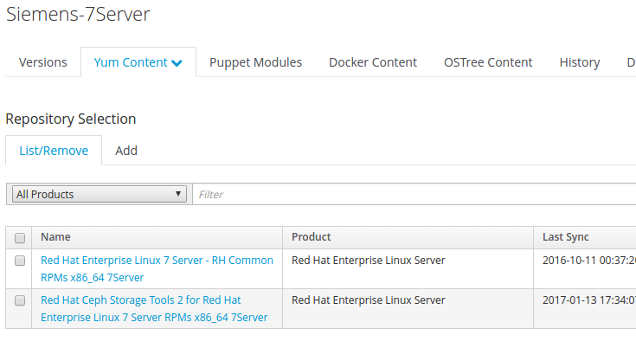
4. register a RHEL6 with this key
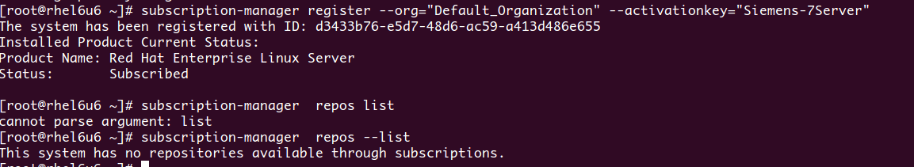
Note: As you can see, no repos here if I do not publish the repos with version 6Server

5. test the key on the RHEL 7 host
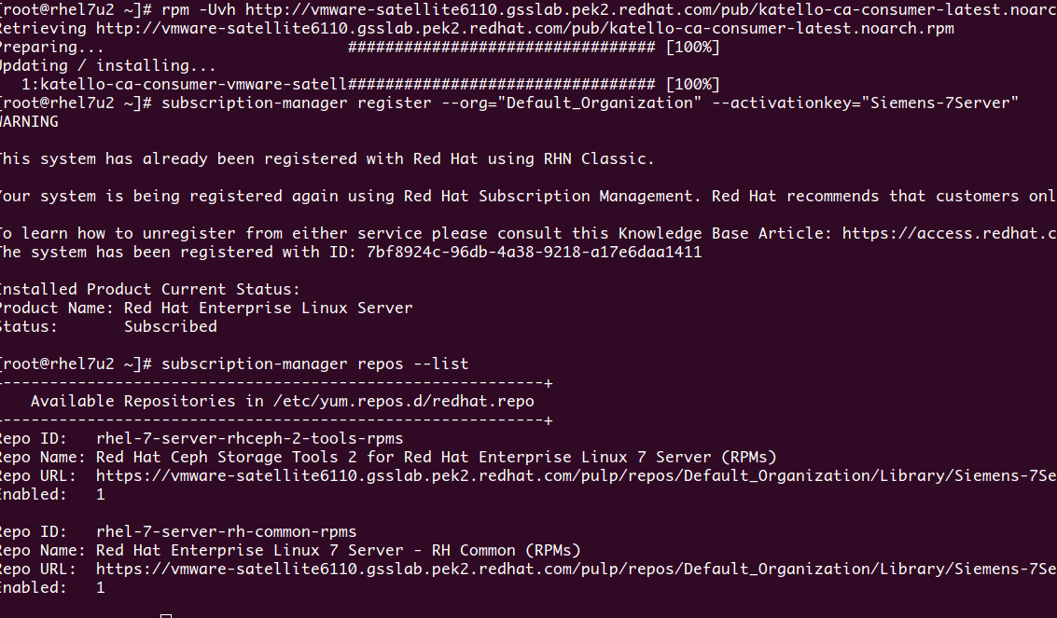
Note: You can find it now in a RHEL7 system.

