1. 初始内存情况：

[root@vmware-satellite6110 ~]# cat /proc/meminfo

MemTotal: 4835768 kB

MemFree: 2202532 kB

Buffers: 14212 kB

Cached: 75096 kB

SwapCached: 0 kB

Active: 548436 kB

Inactive: 1891576 kB

Active(anon): 527072 kB <---- 活动匿名页

Inactive(anon): 1838704 kB <---- 非活动匿名页

Active(file): 21364 kB <----- page cache

Inactive(file): 52872 kB <----- page cache

Unevictable: 0 kB

Mlocked: 0 kB

SwapTotal: 8392700 kB

SwapFree: 8392700 kB

Dirty: 168 kB

Writeback: 0 kB

AnonPages: 2350764 kB <---- 已经使用的匿名页 2.3G左右

Mapped: 23844 kB

Shmem: 15032 kB

Slab: 64284 kB

SReclaimable: 23228 kB

SUnreclaim: 41056 kB

KernelStack: 11168 kB

PageTables: 37052 kB

NFS_Unstable: 0 kB

Bounce: 0 kB

WritebackTmp: 0 kB

CommitLimit: 10810584 kB

Committed_AS: 5673148 kB

VmallocTotal: 34359738367 kB

VmallocUsed: 172604 kB

VmallocChunk: 34359542512 kB

IPC共享内存：



Shmid使用了14M左右共享内存

程序9852地址段7ffcd920e000 中RSS的大小：

grep -A 15 7ffcd920e000 /proc/9852/smaps

7ffcd920e000-7ffcd9c0e000 rw-p 00000000 00:00 0 [stack]

Size: 10244 kB

Rss: 2104 kB <-----

Pss: 2104 kB

Shared_Clean: 0 kB

Shared_Dirty: 0 kB

Private_Clean: 0 kB

Private_Dirty: 2104 kB

Referenced: 4 kB

Anonymous: 2104 kB <-----

AnonHugePages: 0 kB

Swap: 0 kB

KernelPageSize: 4 kB

MMUPageSize: 4 kB

VmFlags: rd wr mr mw me gd ac

7ffcd9d53000-7ffcd9d54000 r-xp 00000000 00:00 0 [vdso]

1. 用程序申请4G的匿名页，申请时加了MAP_LOCKED的标记，所以申请的匿名页不会被交换到swap分区。执行后的结果：

申请共享内存的程序：

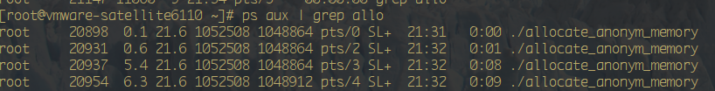

Meminfo的输出：

[root@vmware-satellite6110 ~]# cat /proc/meminfo

MemTotal: 4835768 kB

MemFree: 98116 kB

Buffers: 816 kB

Cached: 26680 kB

SwapCached: 64528 kB

Active: 172256 kB

Inactive: 174112 kB

Active(anon): 158764 kB

Inactive(anon): 163236 kB

Active(file): 13492 kB

Inactive(file): 10876 kB

Unevictable: 4194304 kB

Mlocked: 2608160 kB

SwapTotal: 8392700 kB

SwapFree: 6216128 kB <---- 用了2G左右的swap

Dirty: 528 kB

Writeback: 0 kB

AnonPages: 4479916 kB <----- 4.4G左右的匿名页，其中4G无法被交换至swap

Mapped: 17324 kB

Shmem: 2944 kB

Slab: 58424 kB

SReclaimable: 16808 kB

SUnreclaim: 41616 kB

KernelStack: 11536 kB

PageTables: 45892 kB

NFS_Unstable: 0 kB

Bounce: 0 kB

WritebackTmp: 0 kB

CommitLimit: 10810584 kB

Committed_AS: 10126548 kB

VmallocTotal: 34359738367 kB

VmallocUsed: 172604 kB

VmallocChunk: 34359542512 kB

HardwareCorrupted: 0 kB

AnonHugePages: 1708032 kB

当前进程占用的RSS大小：

[root@vmware-satellite6110 ~]# ps aux | grep 9852

foreman 9852 2.4 0.2 1393564 14372 <---- 14M左右? Sl 20:35 1:47 Passenger RackApp: /usr/share/foreman

程序9852地址段7ffcd920e000 中RSS的大小：

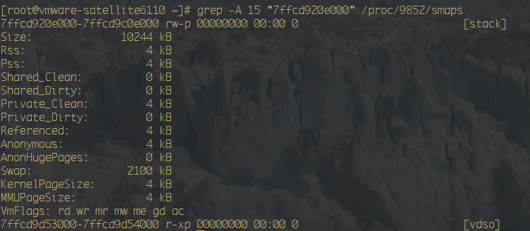

用脚本查看哪些进程使用了swap:

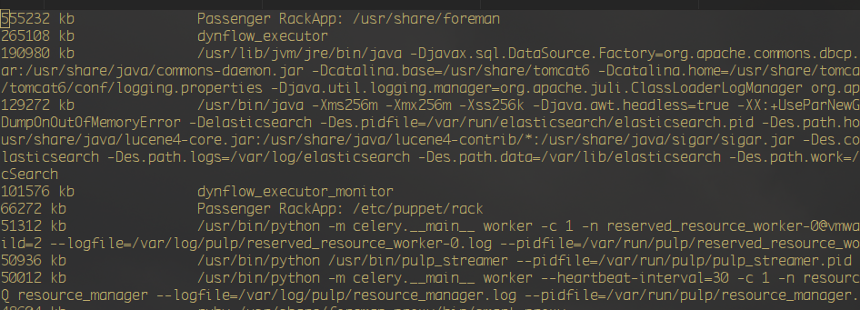

共享内存使用的情况：



已经有12M被放入swap空间了。

1. 杀掉申请匿名页的进程：

[root@vmware-satellite6110 ~]# cat /proc/meminfo

MemTotal: 4835768 kB

MemFree: 3812580 kB

Buffers: 11848 kB

Cached: 61128 kB

SwapCached: 339708 kB

Active: 242400 kB

Inactive: 589824 kB

Active(anon): 221612 kB

Inactive(anon): 541196 kB

Active(file): 20788 kB

Inactive(file): 48628 kB

Unevictable: 0 kB

Mlocked: 0 kB

SwapTotal: 8392700 kB

SwapFree: 6347472 kB

Dirty: 496 kB

Writeback: 0 kB

AnonPages: 514848 kB

Mapped: 26896 kB

可见swap空间还是占用了2.1G左右， 匿名页的大小剩下500M左右。这是由于如果程序没有调用swap中的匿名页或者共享内存。除了杀掉相关进程或者swapoff，内核是不会自动把swap中的数据回写入内存。

执行swapoff -a后/proc/meminfo情况：

