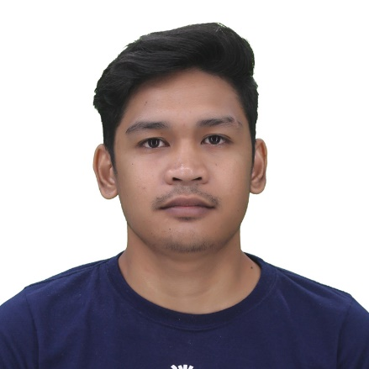

ARDIE

DERRAYAL

145C Lopez Jaena, Subangdaku, Mandaue City 6014 | 0946 507 5177 | [ardiederrayal06@gmail.com](mailto:ardiederrayal06@gmail.com)

**PROFILE**

More than a year of experienced as full stack developer and highly-knowledgeable in the following programs: JavaScript, jQuery, PHP, expertise with html, CSS, Bootstrap and Material Design. I am very familiar and experienced with web application architecture and have worked with a good number of successful development teams.

**PERSONAL INFO**

Date of Birth : June 18, 1994

Place of Birth : Poblacion, Madridejos, Cebu

Sex : Male

Status : Single

Citizenship : Filipino

**PROGRAMING SKILLS**

JavaScript / jQuery / PHP / My SQL / HTML 5 / CSS / React JS / Mongo DB / Express JS / Node JS / Polymer / Firebase

**WORK HISTORY**

SOFTWARE DEVELOPER

Authentic System Solutions | December 2017 – Present

CUSTOMER SERVICRE REPRESENTATIVE

Convergys | October 2015 – January 2016

**EDUCATION**

BACHELOR OF SCIENCE IN INFORMATION TECHNOLOGY

Salazar Colleges of Science and Institute of Technology, Madridejos Cebu

May 26, 2018

**REFERENCE**

Available upon request