**Import our database ‘test’ (Dump20190519)**

1. Open MySQL Workbench and make schemas ‘test’.

2. Menu → Server → Data Import

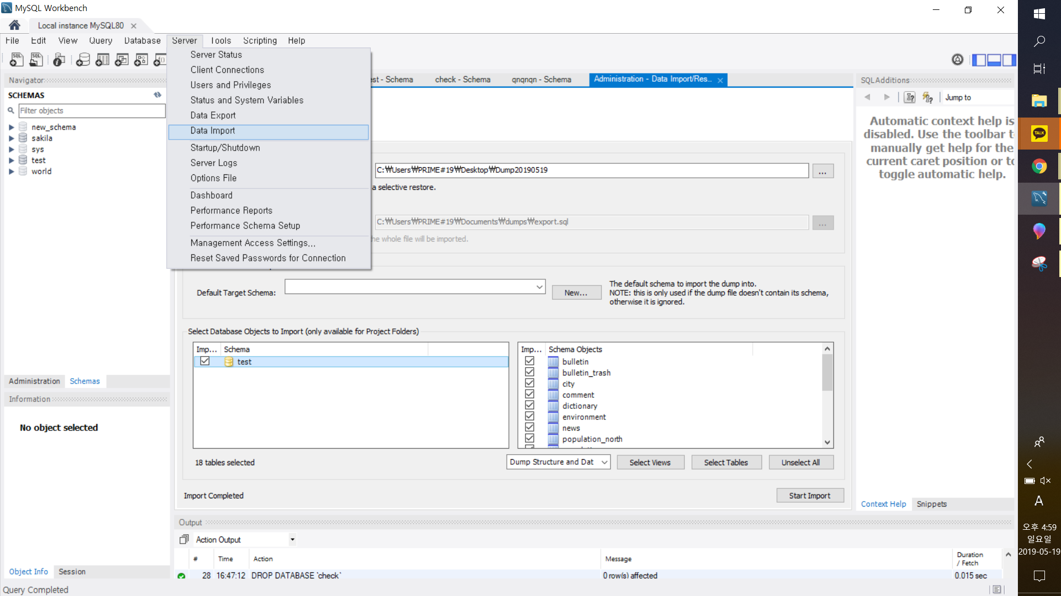

3. Choose the path where the folder is located, click all files and click ‘Start Import’.

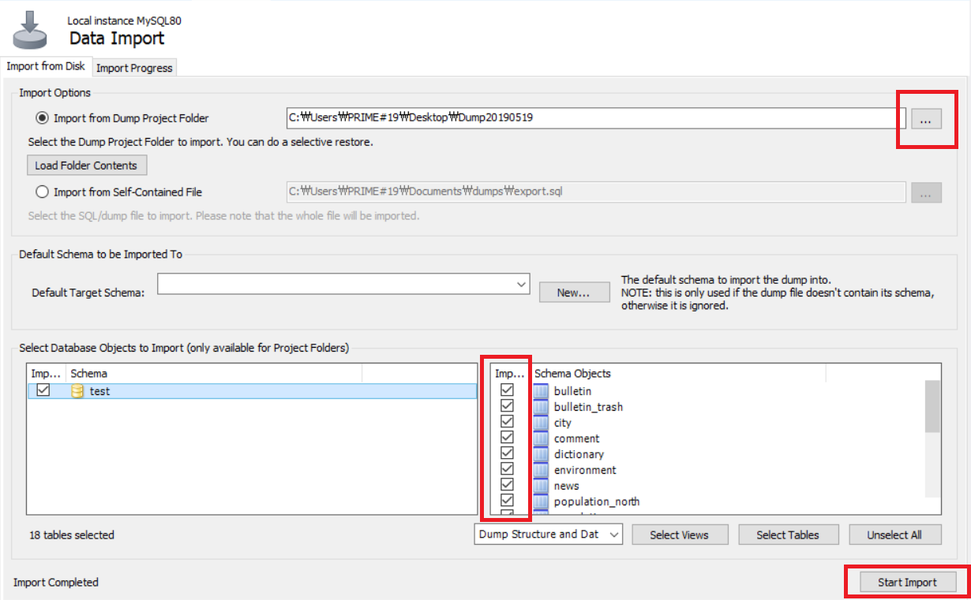

4. Now you have our database ‘test’.

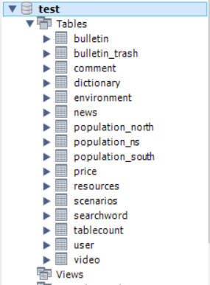

5. But you have to make views using our ‘Scenarios and DML’ to run our program.

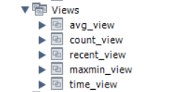

**Set for running our program and run our program (DB4)**

1. Unzip our code file, open ‘Eclipse’ and click ‘Open Projects from File System’.

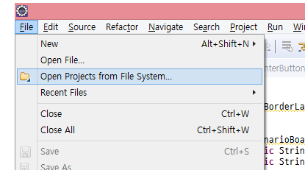

2. Choose the path where the folder is located and import.

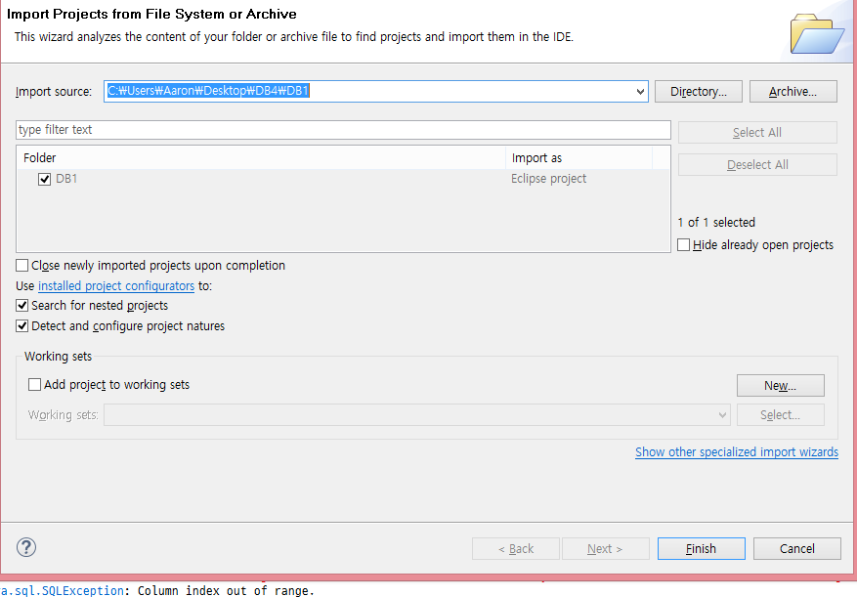

3. Set the path of ‘mysql-connector-java-5.1.46-bin.jar’ file which is attached from ‘Projects - properties - Java build path’ and the path of ‘JRE library’ exactly.

4. In the Test file, change the information associated with mysql to match your computer configuration(root, rootpw) and run ‘Frame’ file which our main program.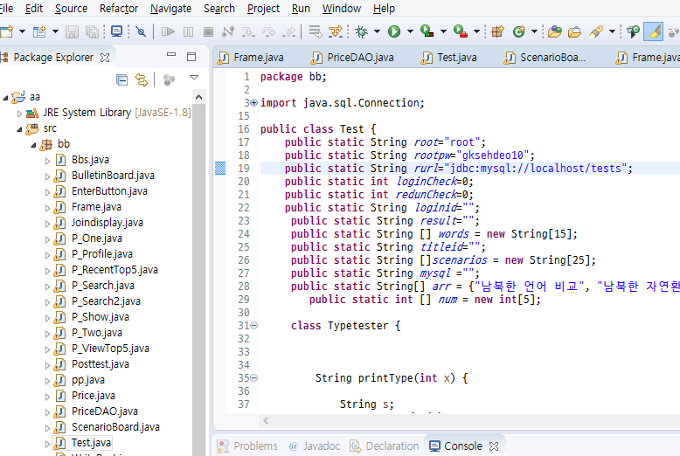

5. If the program does not run and you get an error, you have to make a new project yourself instead of manual number 1 and 2. And copy and paste the code into the project which you made. Run manual number 3 and 4.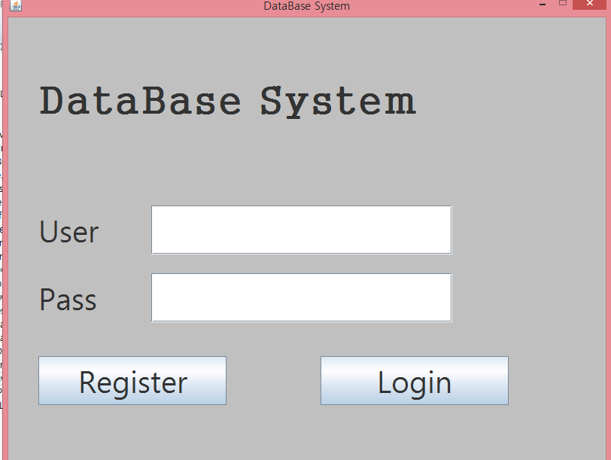

6. If you see this screen, you have succeeded.