U S E R M A N U A L
EasyCater
Customer Mobile App and Admin Panel

EasyCater Catering Services - General Tinio, Nueva Ecija
IT-WS07 Mobile Application Development
Version 1.0 - November 2026

EasyCater User Manual v1.0

1. Introduction
EasyCater is a catering booking platform for EasyCater Catering Services. Customers book catering packages for weddings, birthdays, corporate events and other occasions, while the staff manages everything from the Admin Panel.
Table 1. The three parts of EasyCater
Part | What it does | Where it runs
Customer Mobile App | Browse packages, create bookings, add menu extras, pay downpayment or in full | Android phone (EasyCater app) or browser
Admin Panel | Manage bookings, payments, packages, menu, customers and reports | Laptop/PC browser or Android phone (EasyCater Admin app)
Backend API | Stores all data and enforces the booking rules | Runs on the shop PC (automatic)

2. Getting Started

2.1 Demo accounts
Table 2. Accounts for trying the system
App | Email | Password
Customer app | maria@example.com | Password123
Customer app | juan@example.com | Password123
Admin panel | admin@easycater.com | Admin123!

2.2 Opening the apps
- Browser (customer app): open http://localhost:8100
- Browser (admin panel): open http://localhost:8101
- Phone: open the EasyCater / EasyCater Admin app - the PC must be connected to the phone's hotspot and the backend must be running.

3. Customer Mobile App Guide

3.1 Logging in
1. Open the EasyCater app.
2. Enter your email and password.
3. Tap Sign In. New customers can tap Create account instead and register.
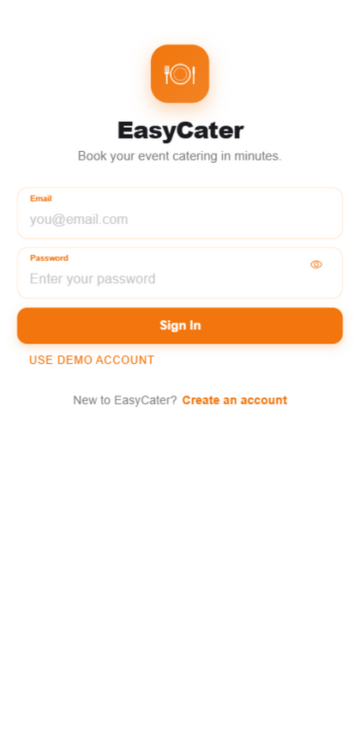
Figure 1. Login screen

3.2 Home
The Home screen shows the featured packages, the next upcoming event and quick links to the main sections of the app.
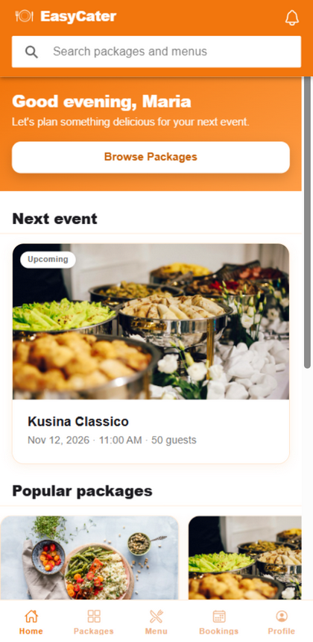
Figure 2. Home screen

3.3 Browsing packages
The Packages tab lists every catering package with its photo, price per head, guest range and star rating. Use the search bar to find a package by name.
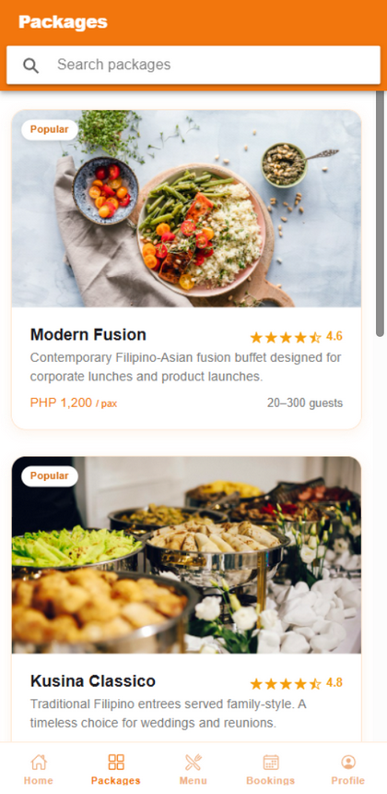
Figure 3. Package list

3.4 Viewing a package
Tap a package to open its details page: description, price, guest range, inclusions and the menu items inside it. Tap Book This Package to start a booking.
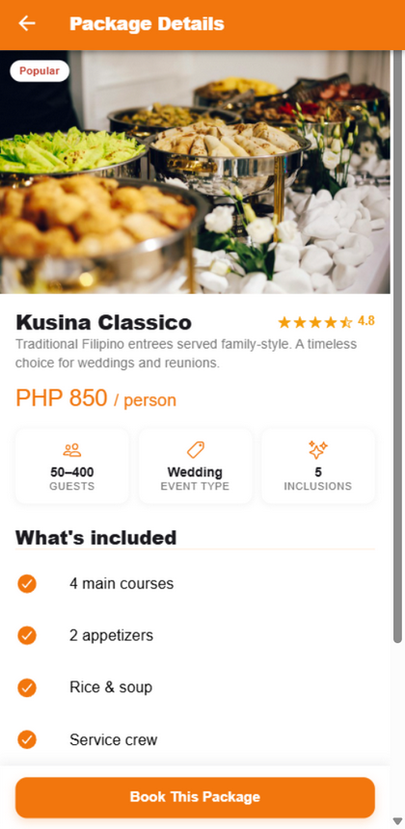
Figure 4. Package details

3.5 Creating a booking
The booking form collects everything the kitchen needs. The checklist at the top turns green as you complete each field - the Continue button unlocks only when everything is filled in.
1. Choose the event type (wedding, birthday, corporate, and so on).
2. Pick the event date from the calendar. Taken dates are disabled - one event per day only.
3. Set the guest count and the event time.
4. Choose the venue and the complete address. Addresses are limited to General Tinio, Nueva Ecija.
5. Tap Continue - add extras to proceed to the menu.
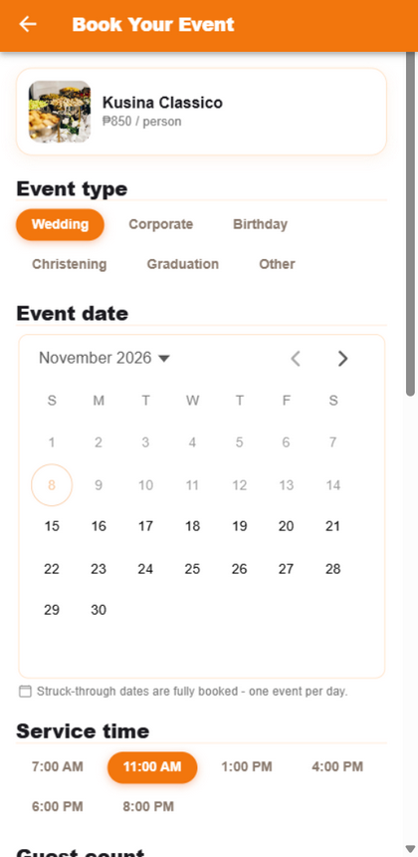
Figure 5. Booking form with completion checklist
Booking rule: bookings must be made at least 7 days before the event date. The calendar disables earlier dates automatically.

3.6 Adding menu extras
After the booking form, the Menu opens so you can add extra dishes to the booking. Tap + Add on any dish - the review bar at the bottom shows the running total, then open the Cart.
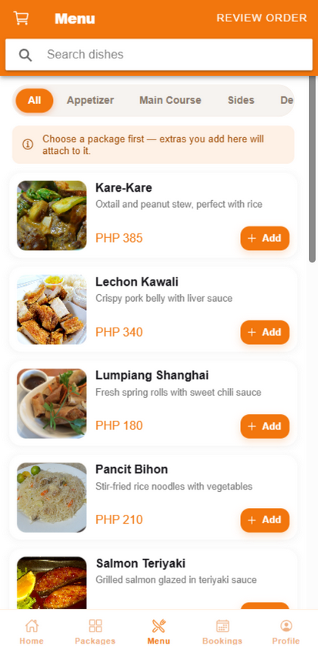
Figure 6. Menu with add-ons

3.7 Paying for your booking
The payment screen offers two fixed options: pay the full amount, or pay the 50% downpayment. Choose the payment method and confirm.
- Downpayment reserves the date immediately.
- Once any payment is made the booking is locked - dates, guest counts and other details can no longer be changed, so review everything before paying.
- A receipt screen appears after a successful payment.

3.8 My Bookings
The Bookings tab lists all your bookings with their status: pending, confirmed, preparing, in-progress, completed or cancelled. Unpaid bookings show Cancel and Pay now buttons.
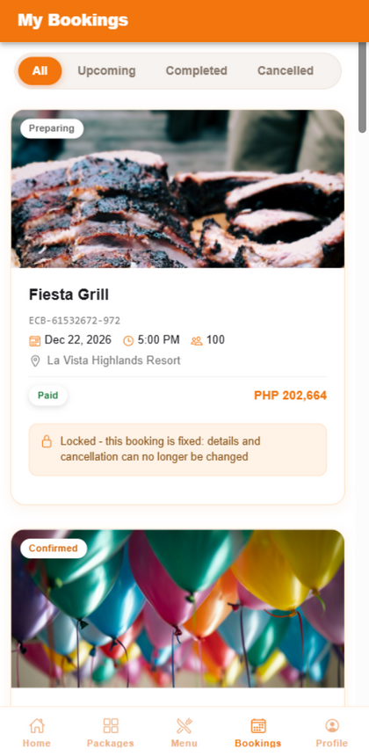
Figure 7. My Bookings
Cancellation rule: a booking can only be cancelled while it is still pending AND at least 2 hours before the event time. Paid bookings are locked.

3.9 Profile
The Profile tab shows your account details and lets you update your name, phone number and address, or log out.
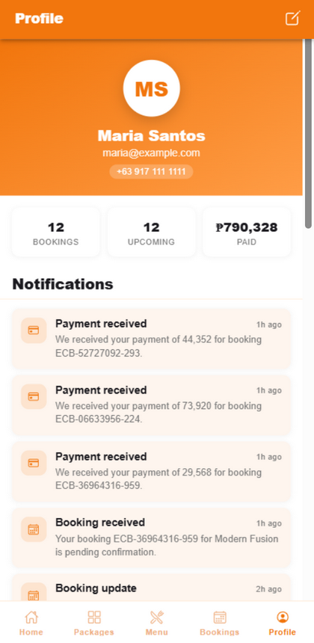
Figure 8. Profile

4. Admin Panel Guide

4.1 Logging in
Open the EasyCater Admin app (or http://localhost:8101) and sign in with an admin account. Customer accounts are rejected here.
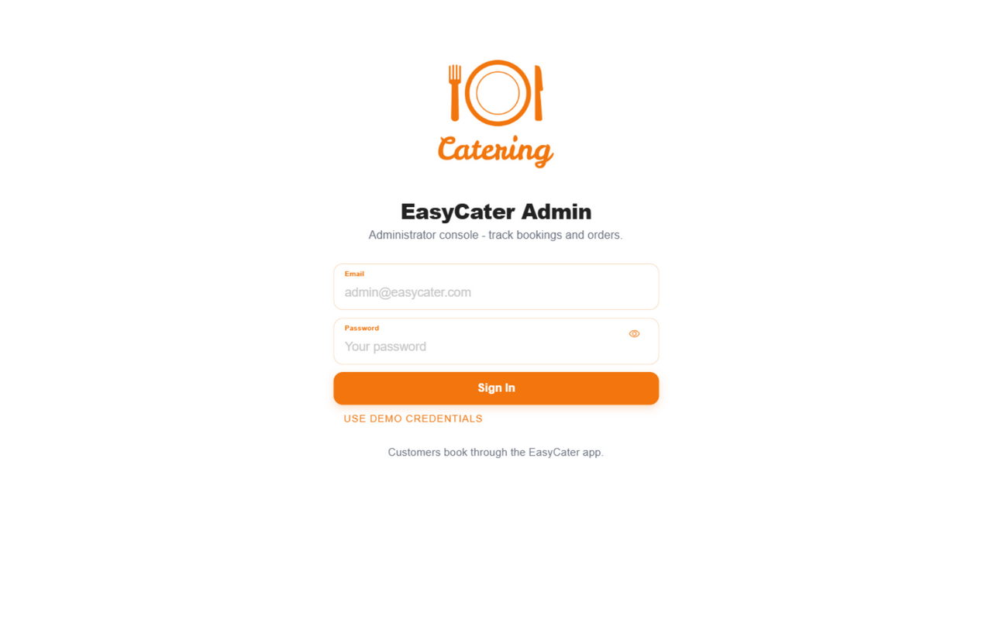
Figure 9. Admin login

4.2 Dashboard
The dashboard summarises the business: total revenue, total bookings, pending requests, customer count, the 6-month revenue trend and the latest bookings.
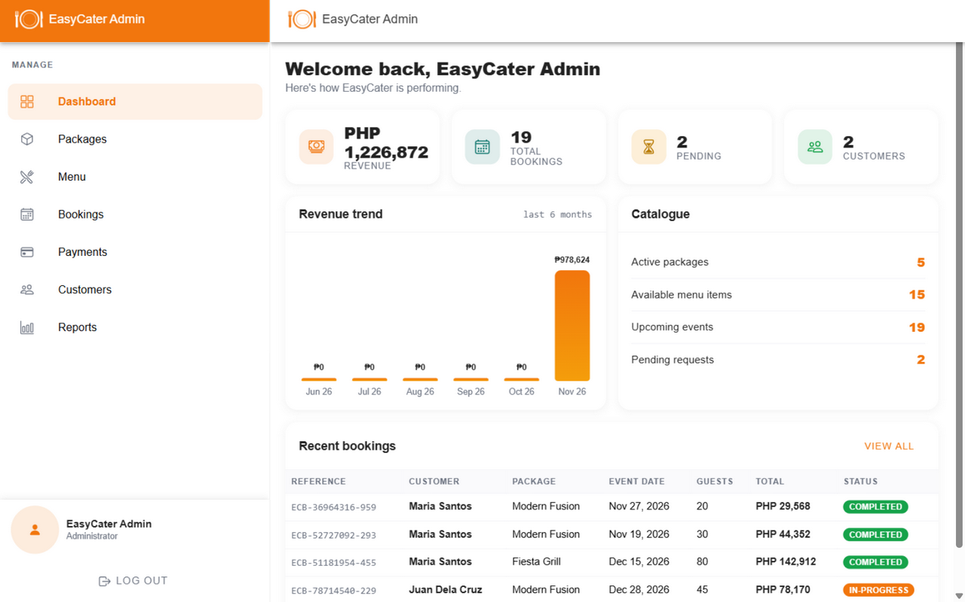
Figure 10. Admin dashboard

4.3 Managing bookings
The Bookings page lists every booking. Filter with the chips at the top, and use the action button on each row to move a booking forward: pending, confirmed, preparing, in-progress, completed.
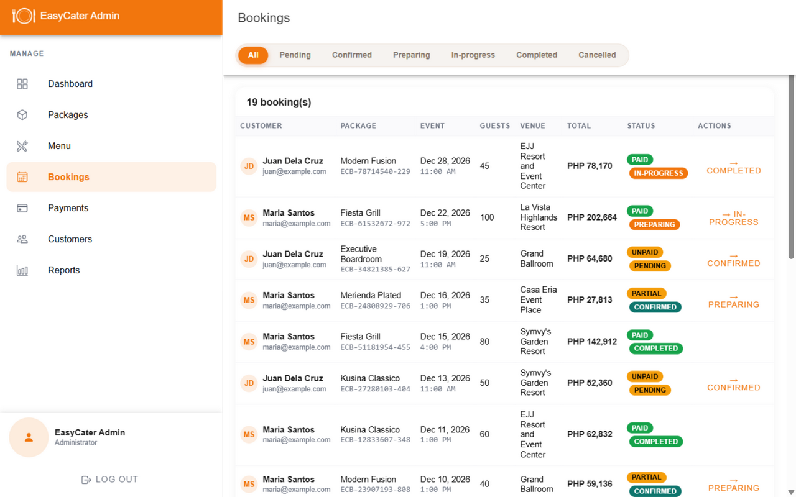
Figure 11. Bookings management

4.4 Managing payments
The Payments page tracks every transaction: collected total, refunds and the payment method used. Pending payments can be verified, and paid payments can be refunded with confirmation.
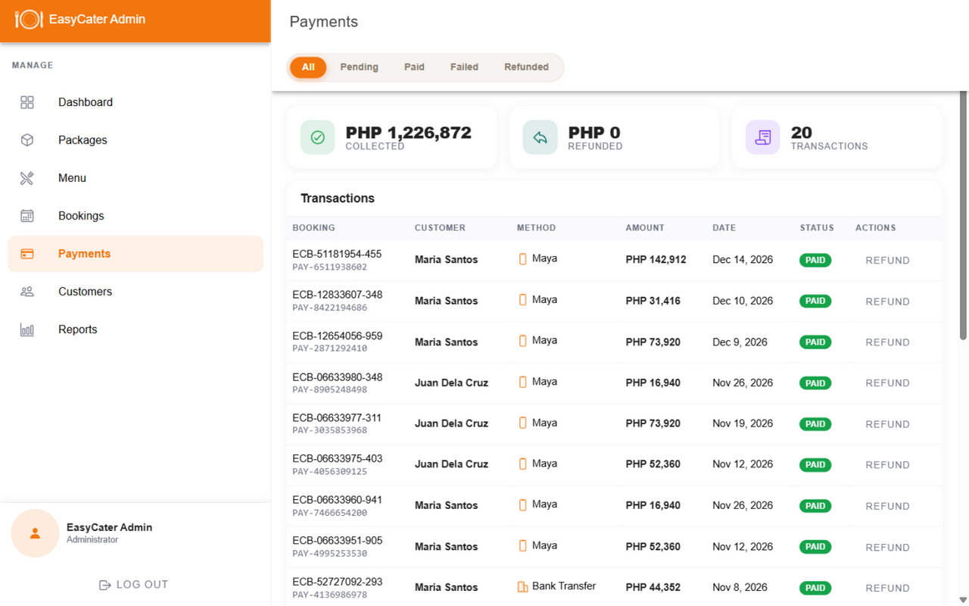
Figure 12. Payments

4.5 Managing customers
The Customers page shows every registered customer with their booking count and total spending. Admins can disable or enable accounts and remove accounts.
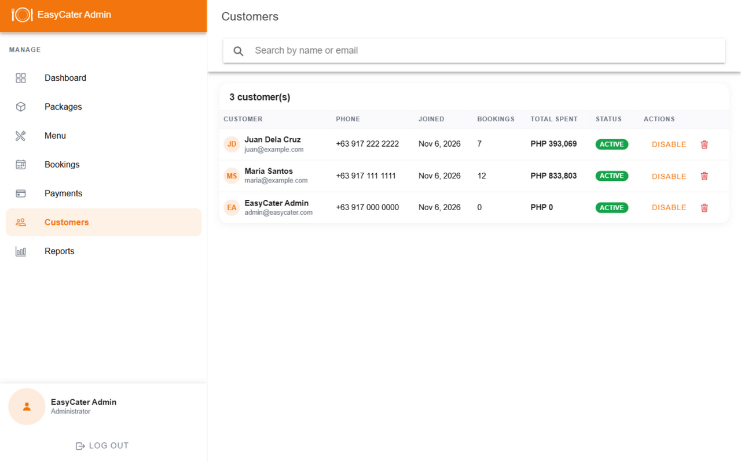
Figure 13. Customers

4.6 Reports
The Reports page shows sales performance: total revenue, monthly revenue chart, sales by package and payment method breakdown.
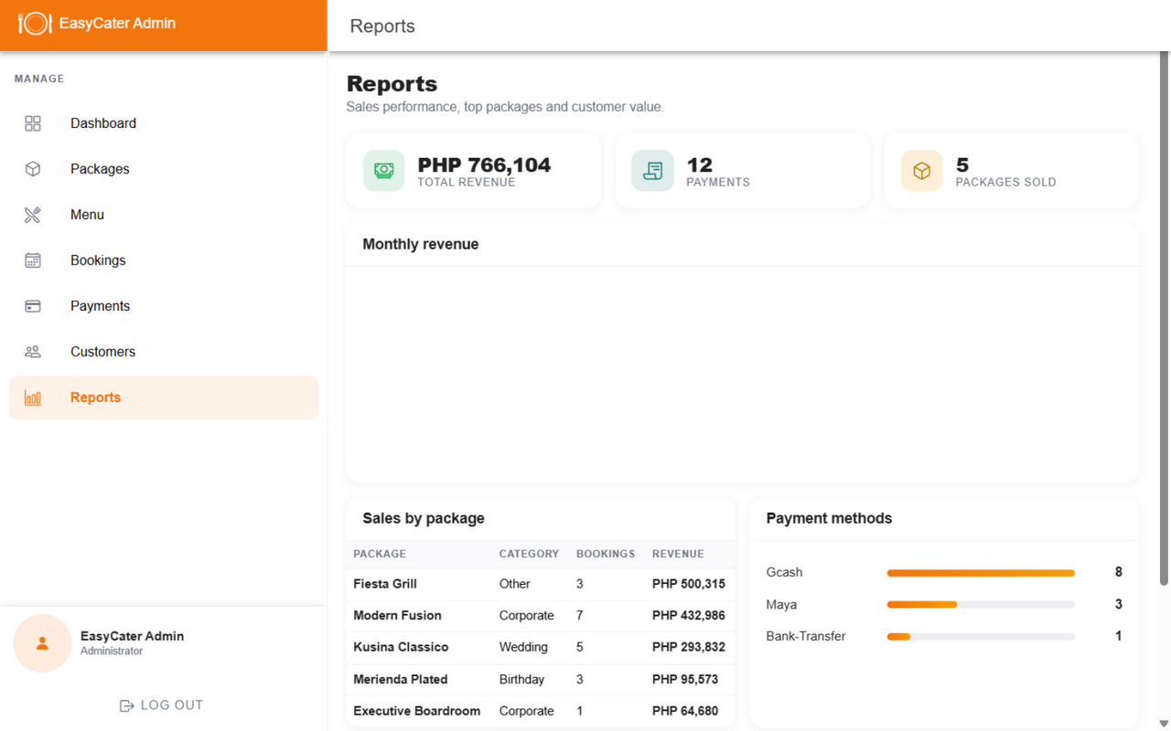
Figure 14. Sales reports

4.7 Packages and menu management
The Packages and Menu pages manage the catalogue: create new packages or dishes with photos and prices, hide items that are unavailable, and delete outdated ones. Changes appear in the customer app immediately.

5. Booking Rules Summary
Table 3. Rules enforced by the system
Rule | Details
7-day lead time | Bookings must be at least 7 days ahead. The calendar blocks earlier dates.
One event per day | A date with an existing booking is shown as taken and cannot be booked.
General Tinio only | Service area covers General Tinio, Nueva Ecija - addresses outside it are rejected.
Complete details | A booking cannot be submitted until every field is filled (the checklist turns green).
2-hour cancellation | Pending bookings can only be cancelled at least 2 hours before the event.
Paid means locked | After a downpayment or full payment, all booking details are final.

6. Need help?
If the app shows empty screens or will not load, the backend server on the shop PC is probably not running. Open the EasyCater folder and double-click START-EASYCATER.bat, wait about a minute, then refresh the app. See PAANO-I-RUN.docx for the full startup and troubleshooting guide.
EasyCater - Catering Services, General Tinio, Nueva Ecija.

