AHA OTT Clone - Comprehensive Technical Implementation Documentation
This document explains not only what features were implemented in the AHA OTT Clone project, but also how they were implemented, why particular design decisions were made, and how the code works internally. The project was developed as a clone-inspired implementation of the Aha OTT platform using HTML, CSS, Vanilla JavaScript, Node.js, and JSON-based storage.

Authentication Module
Purpose:
The authentication module controls user registration, login, logout, session persistence, and page access restrictions.
Implementation Code:
function setUser(username) {
localStorage.setItem("user", username);
}
function getUser() {
return localStorage.getItem("user");
}
Explanation:
When a user successfully logs in, the username is stored inside browser localStorage. Unlike a normal JavaScript variable, localStorage persists even after a page refresh. This makes it suitable for simple session management.
Login Validation:
const match = users.find(function(user) {
return user.username === form.username &&
user.password === form.password;
});
How It Works:
1. User enters username and password.
2. auth.js loads users.json through the backend.
3. The users array is searched using Array.find().
4. If a matching record is found, the username is stored.
5. User is redirected to index.html.
Workflow:
User Login
↓
Read users.json
↓
Validate Credentials
↓
Store Username
↓
Redirect to Homepage
Advantages:
• Very easy to understand.
• No server-side session storage required.
• Suitable for educational projects.
Limitations:
• Passwords are stored in plain text.
• No encryption or hashing.
• Not suitable for production deployment.
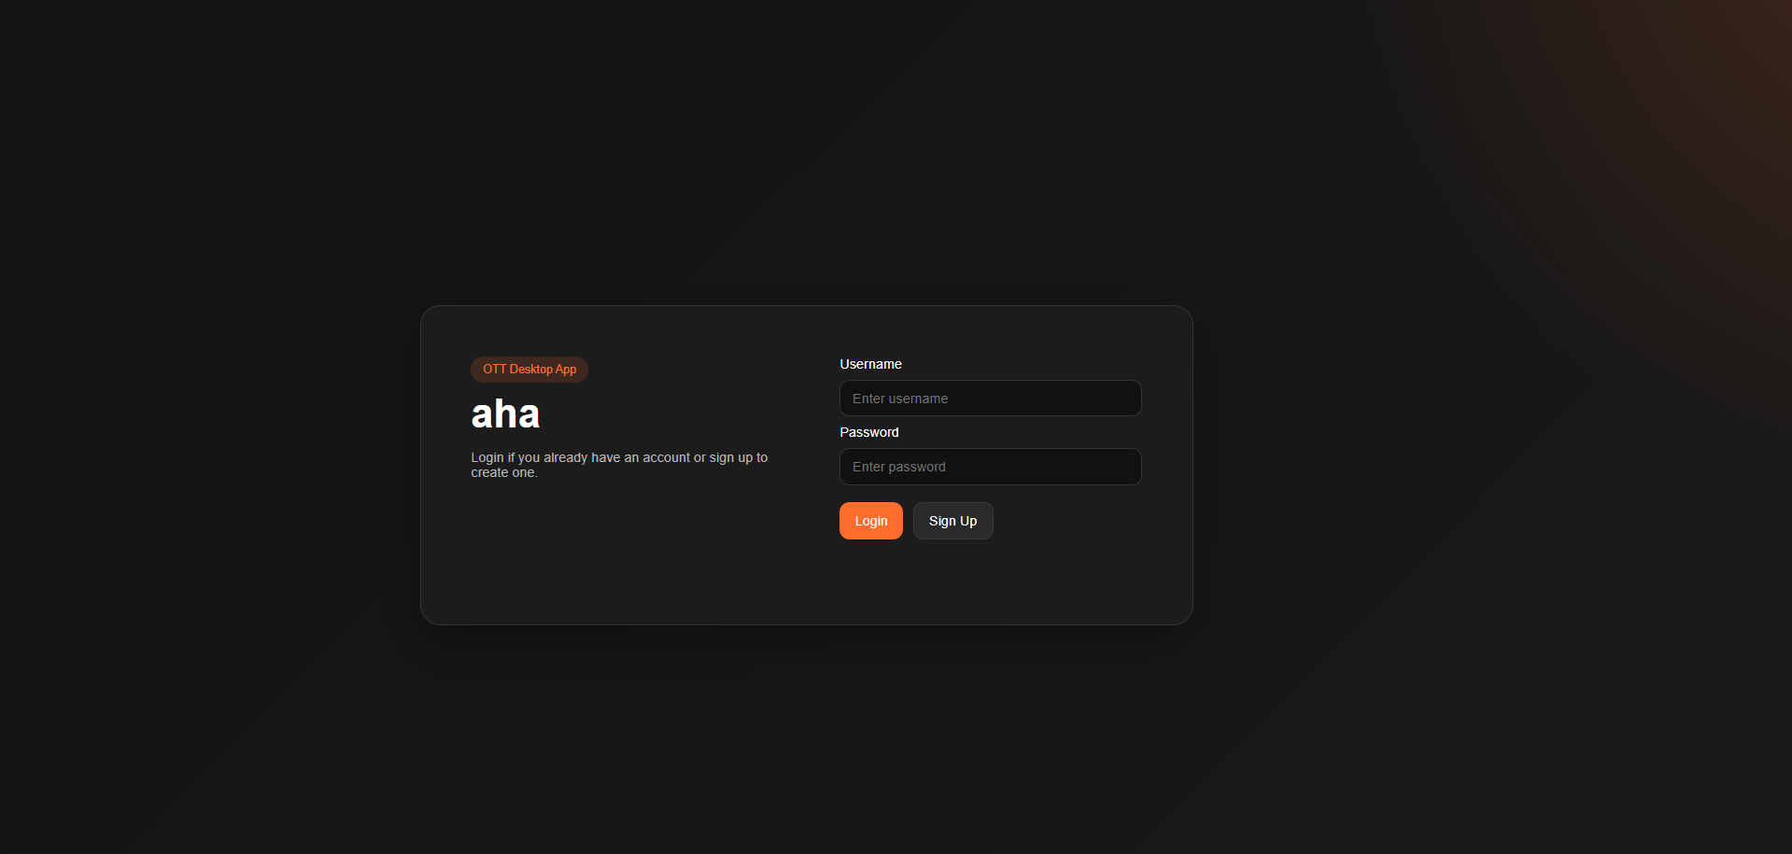

Backend Server Implementation
The backend is implemented using Node.js and serves as the communication layer between the frontend and storage files.
Server Creation:
http.createServer(function(request, response) {
...
});
Responsibilities:
• Serve HTML pages.
• Serve CSS files.
• Serve JavaScript files.
• Serve images and videos.
• Handle JSON API requests.
• Save user progress and watchlists.
JSON API Example:
GET /api/videos.json
GET /api/users.json
POST /api/watchlist.json
POST /api/progress.json
File Reading:
function readJson(name) {
return JSON.parse(
fs.readFileSync(...)
);
}
File Writing:
function writeJson(name, data) {
fs.writeFileSync(...);
}
Request Flow:
Browser
↓
Fetch API
↓
Node.js Server
↓
Read/Write JSON
↓
Return Response
This design separates frontend presentation logic from storage operations.

Hero Banner Module
The hero banner recreates the featured-content experience found on OTT platforms.
Implementation:
heroBanner.style.backgroundImage =
"url('" + heroVideo.thumbnail + "')";
heroTitle.textContent = heroVideo.title;
heroPlayButton.onclick = function() {
openPlayer(heroVideo.id);
};
Explanation:
The application loads videos.json and selects the first video as featured content. Its thumbnail becomes the banner background, while the title and metadata are displayed dynamically.
Workflow:
Load Videos
↓
Select Featured Video
↓
Apply Background Image
↓
Display Metadata
↓
Configure Play Button
This approach allows the homepage to update automatically whenever the JSON data changes.


Search System
The search feature was implemented using client-side filtering.
Code:
video.title.toLowerCase().includes(text)
Explanation:
The search text entered by the user is converted to lowercase. Video titles are also converted to lowercase. This ensures that searching becomes case-insensitive.
Workflow:
User Types
↓
Read Input
↓
Filter Array
↓
Render Results
Advantages:
• Instant results.
• No server requests required.
• Very efficient for small datasets.
The filtering logic is executed whenever the input event occurs, creating a real-time search experience.
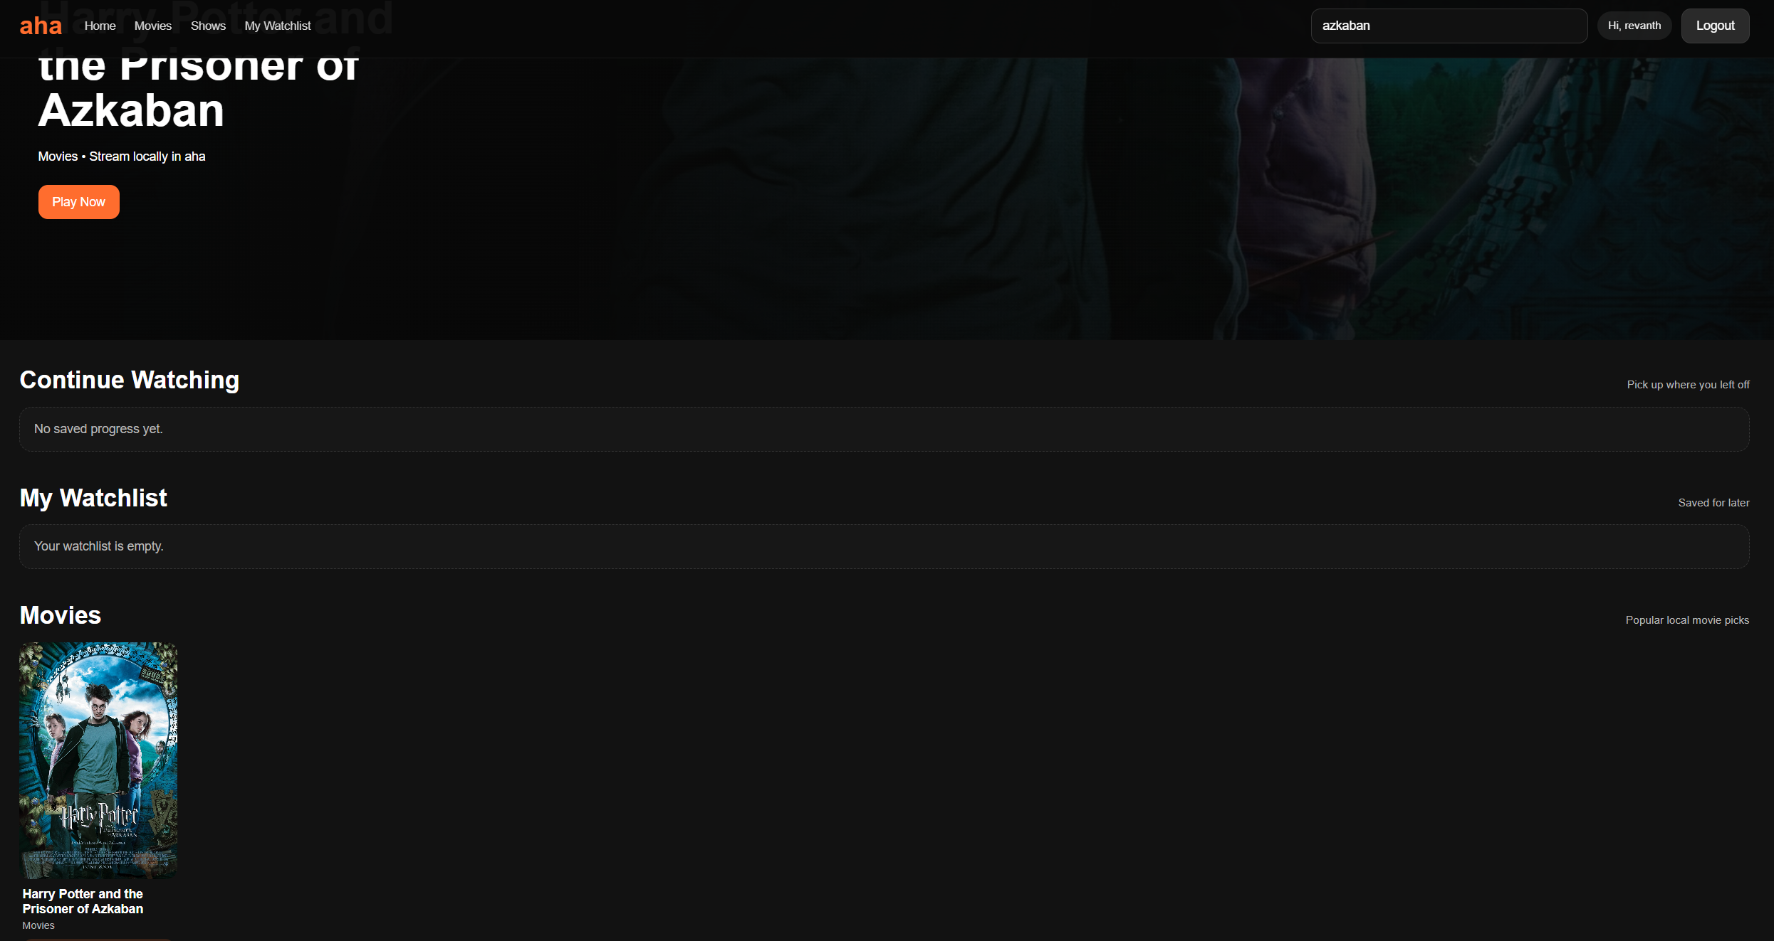

Watchlist Module
Purpose:
Allows users to save videos for future viewing.
Watchlist Structure:
{
"revanth": [1,4,7]
}
Implementation:
const index = ids.indexOf(videoId);
if(index === -1) {
ids.push(videoId);
} else {
ids.splice(index, 1);
}
Explanation:
The selected video's ID is checked against the user's watchlist. If it is not present, it is added. If it already exists, it is removed.
Workflow:
Click Watchlist
↓
Read User Watchlist
↓
Check Video ID
↓
Add or Remove
↓
Update JSON File
↓
Refresh Homepage
This design keeps storage simple while supporting personalized watchlists.
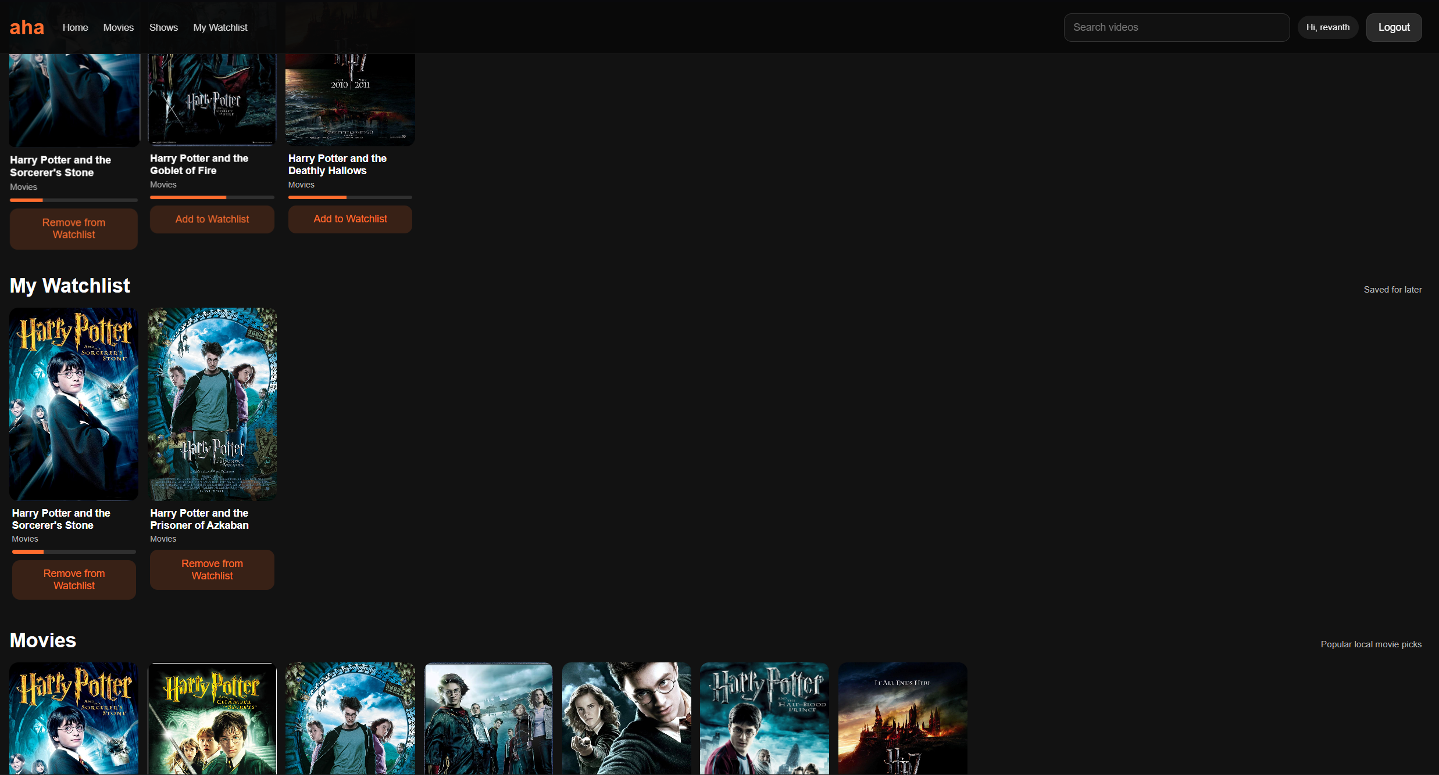

Continue Watching Module
Purpose:
Allows users to resume videos from their last viewing position.
Progress Data:
{
"revanth": {
"1": {
"currentTime": 25.23,
"duration": 136.27
}
}
}
Progress Percentage Formula:
(Current Time / Duration) × 100
The percentage is displayed visually using a progress bar beneath video cards.
Code:
return Math.min(
(currentTime / duration) * 100,
100
);
This ensures the value never exceeds 100%.
Benefits:
• Better user experience.
• Mimics commercial OTT platforms.
• Makes unfinished content easy to find.
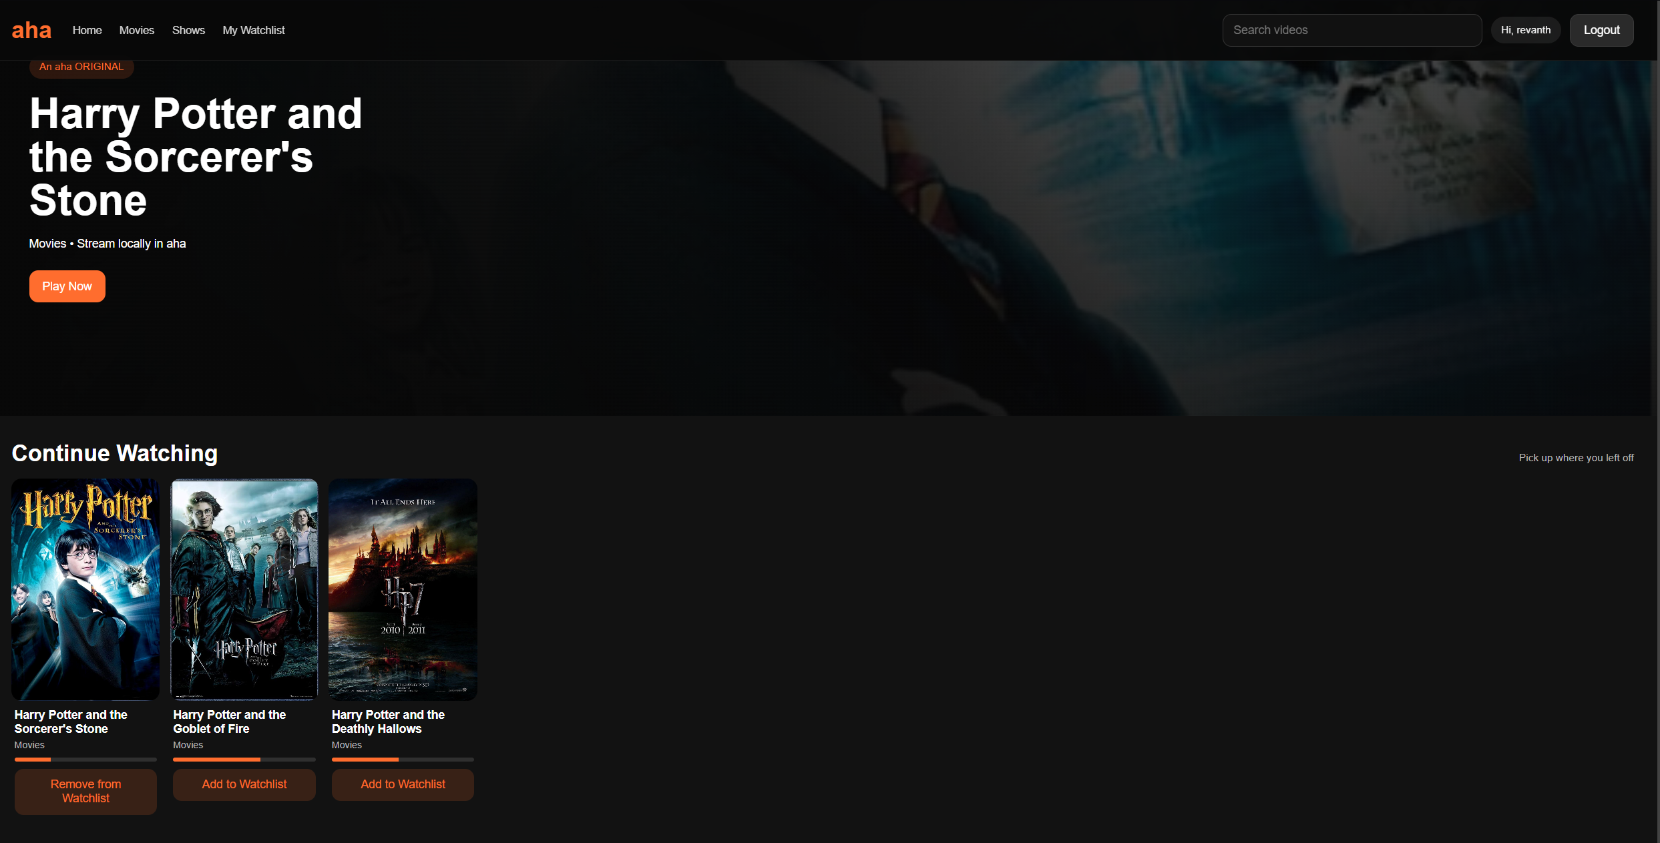

Video Playback Module
The project uses the native HTML5 Video API.
HTML:
<video controls autoplay id="videoPlayer">
<source id="videoSource" src="" type="video/mp4">
</video>
Dynamic Loading:
source.src = video.video;
player.load();
How It Works:
1. User selects a video card.
2. Video ID is passed through URL parameters.
3. player.js reads the ID.
4. videos.json is searched.
5. Matching file path is assigned.
6. Browser loads the video.
Using HTML5 video controls removes the need for third-party libraries while providing play, pause, volume, fullscreen, and seeking functionality.

Playback Resume and Progress Saving
Resume Playback:
player.currentTime = savedTime;
Metadata Event:
player.addEventListener(
"loadedmetadata",
function() {
player.currentTime = savedTime;
}
);
Automatic Saving:
player.addEventListener(
"timeupdate",
function() {
...
}
);
Progress is saved every five seconds.
Workflow:
Video Playing
↓
Time Update Event
↓
Save Current Position
↓
Update progress.json
When the video is opened again, the stored timestamp is restored automatically.
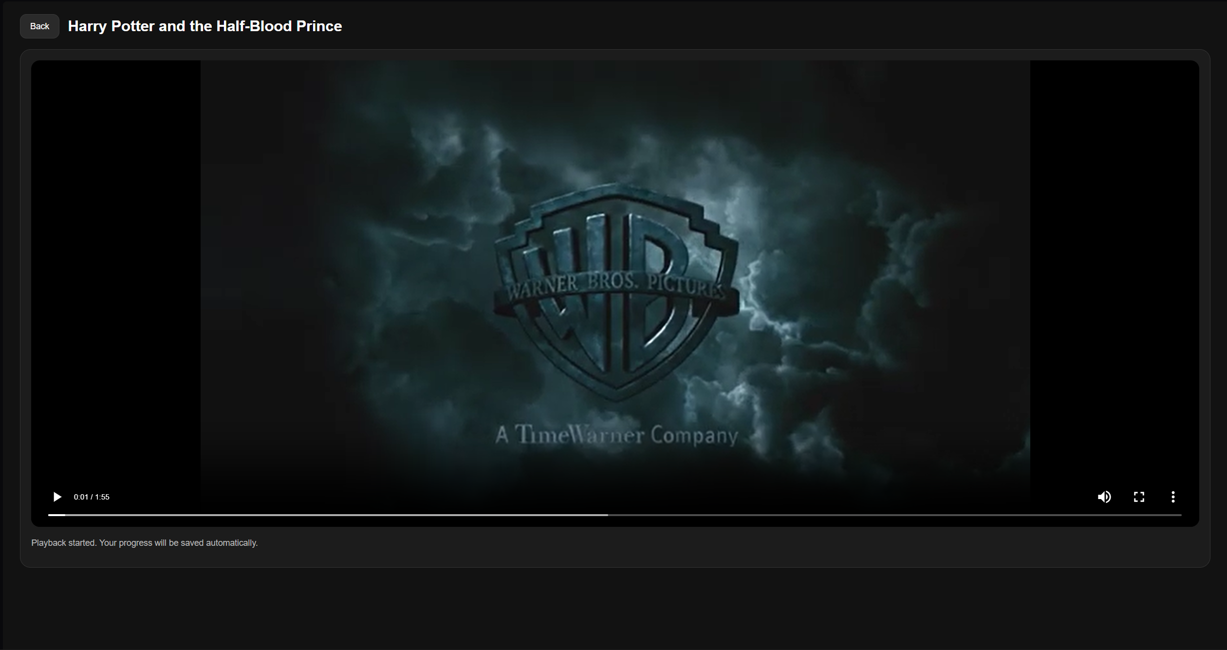

HTTP Range Request Support
This is one of the most advanced features in the project.
Code:
const range = request.headers.range;
response.writeHead(206, {
"Content-Range": ...
});
Why It Exists:
When users drag the playback timeline, the browser should not reload the entire MP4 file.
Without Range Requests:
Seek Video
↓
Reload Entire File
With Range Requests:
Seek Video
↓
Request Required Bytes Only
↓
Stream Requested Segment
Implementation:
fs.createReadStream(filePath, {
start: start,
end: end
});
Benefits:
• Faster seeking.
• Reduced bandwidth usage.
• Better streaming experience.
• Mimics real OTT behavior.

UI and UX Design
The interface follows common OTT design principles.
Design Decisions:
• Dark theme for cinematic appearance.
• Orange accent colors inspired by Aha branding.
• Large hero banner.
• Horizontal content rows.
• Card-based content presentation.
CSS Techniques Used:
• CSS Variables
• Flexbox
• Grid Layouts
• Media Queries
• Hover Effects
• Responsive Design
Responsive Example:
@media (max-width: 820px) {
...
}
The responsive design ensures usability across different screen sizes.

Comparison with Original Aha Website
Implemented Features:
✓ Hero Banner
✓ Movies Section
✓ Shows Section
✓ Login System
✓ Watchlist
✓ Continue Watching
✓ Video Playback
Not Implemented:
✗ Subscription Management
✗ Payment Gateway
✗ Cloud Streaming Infrastructure
✗ Recommendation Engine
✗ Mobile Application
The objective was not to recreate every commercial feature but to understand and implement the major OTT concepts.

Conclusion
The AHA OTT Clone successfully demonstrates how a modern streaming platform works internally. Through the implementation of authentication, dynamic rendering, watchlists, progress tracking, video playback, and HTTP range requests, the project provides practical exposure to frontend and backend development.
The project achieves its objective of recreating the core experience of the Aha website while remaining beginner-friendly and easy to understand. It also serves as a strong foundation for future expansion using databases, cloud hosting, secure authentication, and scalable streaming technologies.

