

DATA STRUCUTRES AND ALGORITHMS
23CSE203
LAB MANUAL

Submitted by

Name | Avirneni Revanth Sri Sai
Roll No | AV.SC.U4CSE25011
Year/Sem/Section | 2nd year/Sem-3/CSE-A
Credits | 05

Submitted to

Name | Dr. RAJ KUMAR BATCHU
Department | School of Computing
Designation | Asst. Professor (SI Grade)

S.NO | TITLE | PAGE NO | REMARKS
1. | WEEK 1: 1a. Recursive countdown from n to Launch.  1b. Recursive calculation of compound growth factor.  1c. Recursive search for employee ID in list.  1d. Recursive factorial calculation for parcel arrangements.  1e. Recursive Fibonacci series generation. | 3 - 12
2. | WEEK 2: 2a. Write a python program to perform linear search on the give input.  2b. Write a python program to perform binary search on the given. Verify by taking sorted array as an input.  2c. Write a python program to perform binary search on the given. Verify by taking unsorted array as an input. | 13 - 19
3. | WEEK 3:
4. | WEEK 4:

WEEK – 1
1A. AIM: A rocket launch system displays a countdown before launch. Instead of using a loop, implement the countdown using recursive. Write a recursive python program to display a countdown from n to 1, followed by “Launch”.
PROGRAM:
def launch(n):
if n <= 0:
print("Launch!")
return
print(n)
return launch(n-1)

n = int(input("enter number: "))
launch(n)

OUTPUT:
Positive Case:
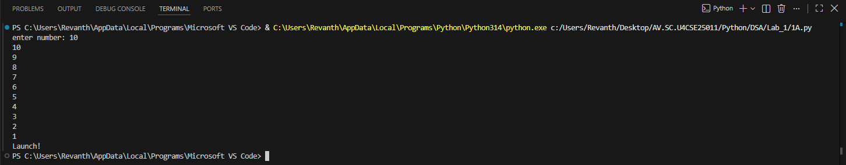
Negative Case:
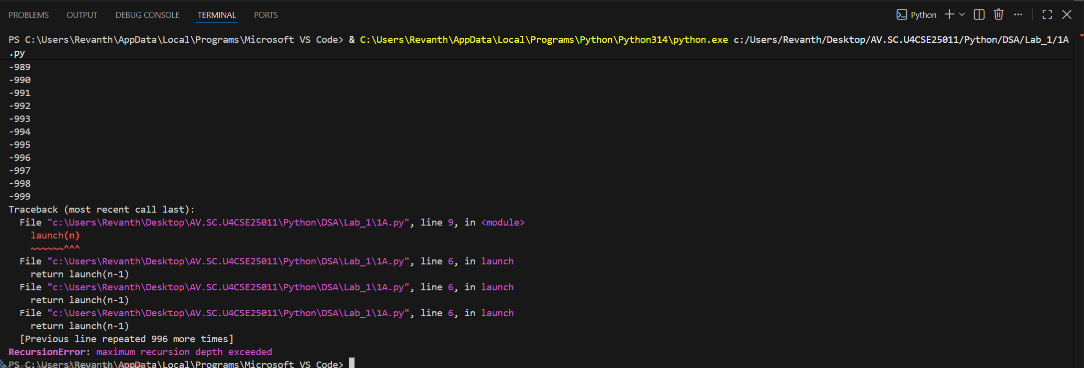

EXPLANATION:
Condition 1: Positive Input (n > 0)
- The function checks if n <= 0. Since n is positive, this condition is False.
- It executes the else block:
  - Prints the current value of n.
  - Calls itself recursively with n - 1.
- This recurses until n becomes 0.
- Finally, when n = 0, the condition n <= 0 becomes True.
- After the recursive calls finish, the function returns None (since no return is defined).
- The calling print (countdown (10)) will display the countdown, the launch message, and then None.
Condition 2: Negative Input (n <= 0)
- The condition if n <= 0 is immediately True.
- It directly prints:
Launch!
- No recursion happens because the else block is skipped.
- The function ends and returns None.
- The calling print (countdown (-1)) will display:
Launch!
None

ERROR TABLE:

S.NO | Error Obtained | Rectification
1. | Negative case was not added instead of “<=” “==” was used | Used “<=” instead of “==”

1B. AIM: Banks calculate the growth of an investment using compound interest. The formula requires calculating powers, which can be implemented recursively. Write a recursive program to calculate P^{n}(power), Where p = principal growth factor, n = number of years.
PROGRAM:
def calc(p,n):
if n == 0:
return 1
return p*calc(p,n-1)

print(calc(2,4))

OUTPUT:
Positive Case:
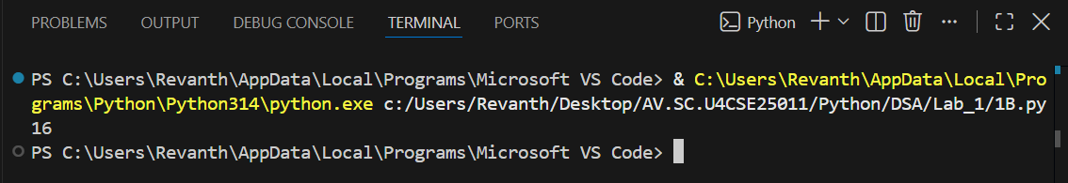

Negative Case:
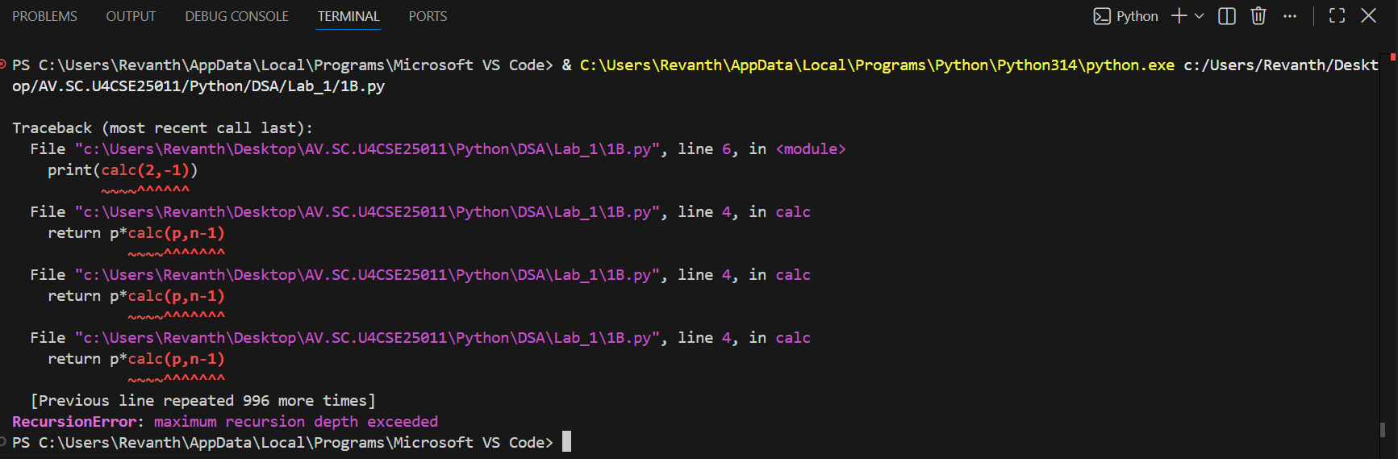

EXPLANATION:
Condition 1: Positive Input (n ≥ 0)
- User enters a positive number of years (e.g., n = 3).
- The function checks if n == 0. Since n is positive, this is False.
- It executes the else block:
  - Multiplies p by the result of power (p, n-1).
- Recursion continues until n becomes 0.
- At n = 0, the base case returns 1.
- The recursive calls unwind, multiplying p repeatedly.
- The output is $p^{n}$, i.e., the growth factor raised to the number of years.
Condition 2: Negative Input (n < 0)
- User enters a negative number of years (e.g., n = -2).
- The function checks if n == 0. Since n is negative, this is False.
- It executes the else block:
  - Calls power (p, n-1) with an even smaller negative number.
- Recursion continues indefinitely (-2 → -3 → -4 → …).
- The base case (n == 0) is never reached.
- Python raises a “Recursion Error: maximum recursion depth exceeded.”
ERROR TABLE:

S.NO | Error Obtained | Rectification
1. | Floating-Point  I have entered a floating-point value in the years. | Later it was rectified by giving the integer value.
2. | Large Input Error  I have given a huge input value. | It was rectified by passing default limit of Python.

1C. AIM: An HR department stores employee IDs in a list. Develop a recursive program to search for a given employee ID. Write a recursive function to search for an employee ID in a list.

PROGRAM:
def search(a, i, n):
if n > len(a):
return "not found"
elif len(a) == 0:
return "empty list"
elif n < len(a) and a[n] == i:
return f"found at index {n}"

return search(a,i,n+1)
a = [2,4,5,1,9,7,3]
print(search(a,1,0))

#a is list, i is id, n is search from index.
OUTPUT:
Positive Case;
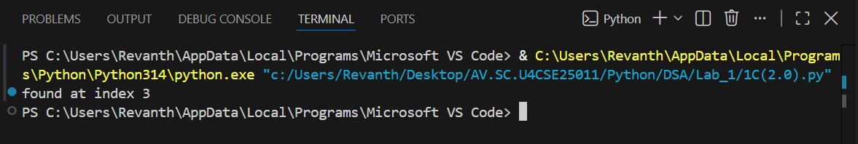
Negative Case;

EXPLANATION:
Condition 1: ID Found
- The function starts at index 0.
- It compares emp_list[index] with the target.
- If a match is found, the function immediately returns True.
- The recursion stops early — no need to check further elements.
- The main program prints:
found at “index”
Condition 2: ID Not Found
- The function checks each element recursively.
- If the end of the list is reached (index == len(emp_list)), the base case returns False.
- The recursion unwinds, propagating False back to the main program.
- The main program prints:
not found

ERROR TABLE:

S.NO | Error Obtained | Rectification
1. | Empty List  I haven’t entered the values in the list. | The empty list was filled with the IDs.
2. | Logical Error  I have entered the duplicate values. | It was rectified by removing the duplicates.

1D. AIM: In a logistics company, the number of possible ways to arrange n different parcels are calculated using the factorial formula (n!). Develop a recursive program to calculate the factorial of a given number.
PROGRAM:
def fact(n):
if n == 0:
return 1
return n*fact(n-1)
n = int(input("enter the number for factorial: "))
print(fact(n))

OUTPUT:
Positive Case;
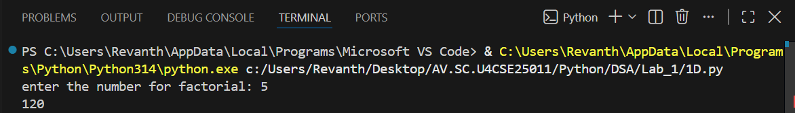
Negative Case; 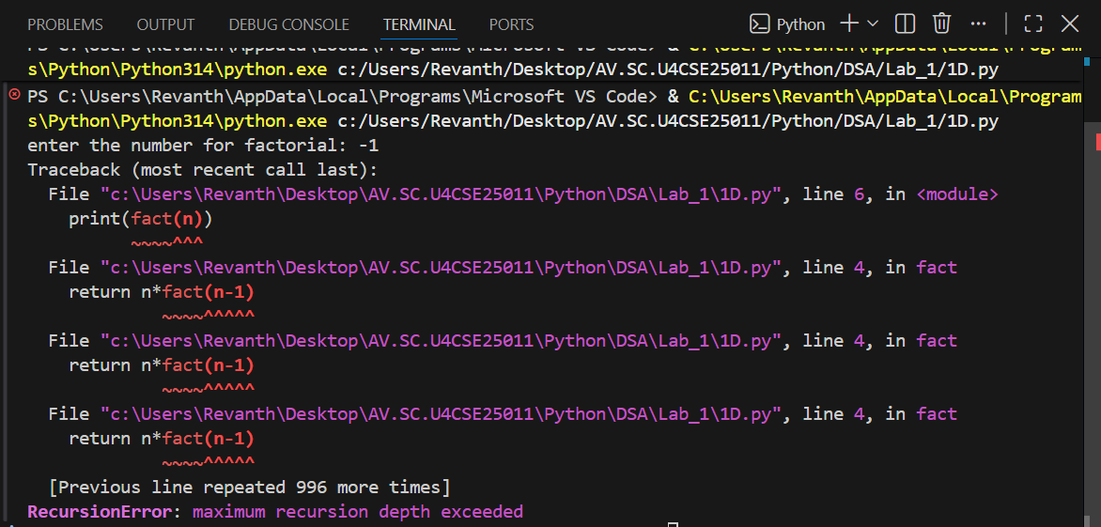

EXPLANATION:
Condition 1: When n == 0
- The function checks:
if n == 0:
return 1
- By definition, $0!=1$.
- So if the user enters 0, the program outputs:
Possible ways to arrange 0 different parcels is 1
Condition 2: When n > 0
- The function executes:
else:
return n * factorial(n - 1)
- This means the function calls itself with a smaller number until it eventually reaches n == 0.
- Uses recursion to multiply numbers down to 1.

ERROR TABLE:

S.NO | Error Obtained | Rectification
1. | Large Input Error  I have entered a very large number. | It was rectified by entering limited values.

1E. AIM: Write a recursive python program to print the first n yerms of the Fibonacci Series.
PROGRAM:
def fib(n):
if n <=2:
return n-1
return fib(n-1) + fib(n-2)
def fibo(n):
if n > 0:
fibo(n-1)
print(fib(n))

n = int(input("enter n: "))
fibo(n)

OUTPUT:
Positive Case: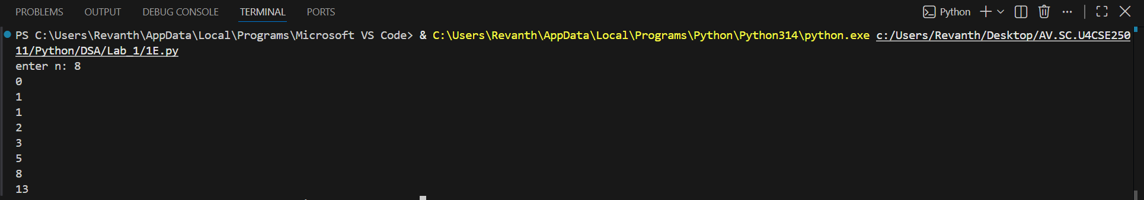

Negative Case:
EXPLANATION:
Condition 1: When n <= 1
- Inside the function:
if n <= 1:
return n
- This is the base case of recursion.
- If n = 0, it returns 0.
- If n = 1, it returns 1.
- These are the starting points of the Fibonacci sequence..
Condition 2: When n > 1
- The function executes:
else:
return fib(n - 1) + fib(n - 2)
- This means the Fibonacci number at position n is the sum of the two previous numbers.
- The recursion keeps breaking down until it reaches the base case (n <= 1).
ERROR TABLE:
S.NO | Error Obtained | Rectification
1. | Negative Input  I haven’t entered the negative value. | Later, it was rectified by entering positive values.
2. | Very large input  Recursion depth exceeded. | It was rectified by entering limited values.

WEEK – 2
2A. AIM: Write a python program to perform linear search on the give input.
PROGRAM:
def search(arr,e):
for i in range(len(arr)):
if arr[i] == e:
return i
return -1

a = [2,6,4,3,7,13,22,11,24,42]
print(search(a,13))

OUTPUT:
Positive Case;
Negative Case;

EXPLANATION:
Condition 1: Element Found
- The program takes an array of numbers from the user.
- It then asks for a key (the element to search).
- The linear_search function goes through the array one element at a time.
- If the current element matches the key, the function returns its index.
- In this case, the program prints:
Element found at index <position>
Example:
- Input array: [10, 20, 30, 40]
- Key: 30
- Output: Element found at index 2
Condition 2: Element Not Found
- If the loop finishes and no element matches the key, the function returns -1.
- The program then prints:
Element not found
ERROR TABLE:

S.NO | Error Obtained | Rectification
1. | Indentation error  Return -1 was typed inside the if loop condition. | Later, it was rectified by typing it outside the if loop and inside the for loop.
2. | Syntax error  Invalid syntax,  ! == -1 | It was rectified by re-typing,  ! = -1.

2B. AIM: Write a python program to perform binary search on the given. Verify by taking sorted array as an input.

PROGRAM:
def bin_search(arr,e):
arr.sort()
l = 0
h = len(arr)-1
while l <= h:
m = (l+h)//2
if arr[m] == e:
return m , arr
elif arr[m] > e:
h = m-1
else:
l = m+1
return -1 , arr
a = [2,6,4,3,7,13,22,11,24,42]
print(bin_search(a,13))

OUTPUT:
Positive Case:

Negative Case:
EXPLANATION:
Condition 1: Element Found
- The program asks the user to enter elements in sorted order (binary search only works on sorted arrays).
- The binary_search function starts with two pointers:
- low → beginning of the array
- high → end of the array
- It calculates the middle index mid = (low + high) // 2.
- If the middle element equals the key, the function returns that index.
- The program then prints:
(<index>, arr)
Example:
- Input array: [5, 10, 15, 20, 25]
- Key: 20
- Output: Element found at index 3
Condition 2: Element Not Found
- If the key is not equal to the middle element, the algorithm adjusts the search range:
  - If arr[mid] < key, search continues in the right half (low = mid + 1).
  - If arr[mid] > key, search continues in the left half (high = mid - 1).
- This process repeats until low > high.
- If the key is not found, the function returns -1.
- The program then prints:
(-1, arr)

Example:
- Input array: [2,6,4,3,7,13,22,11,24,42]
- Key: 13
- Output: 6

ERROR TABLE:
S.NO | Error Obtained | Rectification
1. | Wrong middle calculation  mid = (low + high) / 2 | It was rectified by re-typing,  mid = (low + high) // 2.
2. | Incorrect loop condition  low < high | Later, it was rectified by writing as  low <= high.

2C. AIM: Write a python program to perform binary search on the given. Verify by taking unsorted array as an input.
PROGRAM:
def bin_search(arr,e):
l = 0
h = len(arr)-1
while l <= h:
m = (l+h)//2
if arr[m] == e:
return m
elif arr[m] > e:
h = m-1
else:
l = m+1
return -1
a = [2,6,4,3,7,13,22,11,24,42]
print(bin_search(a,13))
OUTPUT:
Positive Case;
Negative Case;
A semantic error occurs in this case,

EXPLANATION:
Condition 1: Input List Already Sorted
- The program first checks if the entered list is already sorted or not.
- If true, it prints:
The input list is already sorted.
- Then it directly applies binary search on the given list.
- If the key is found, it prints the index:
Element found at index <position>
- Otherwise, it prints:
Element not found
Example:
- Input array: [5, 10, 15, 20]
- Key: 15
- Output:
The input list is already sorted.
Sorted list: [5, 10, 15, 20]
Element found at index 2
Condition 2: Input List Not Sorted
- If the entered list is not sorted, the program prints
The input list is not sorted.
The list is sorting...
- It then sorts the list using:
arr.sort()
- After sorting, it prints the sorted list and applies binary search.
- If the key is found, it prints the index in the sorted list.
- Otherwise, it prints:
Element not found
Example:
- Input array: [20, 5, 15, 10]
- Key: 10
- Output:
The input list is not sorted.
The list is sorting...
Sorted list: [5, 10, 15, 20]
Element found at index 1

ERROR TABLE:

S.NO | Error Obtained | Rectification
1. | Semantic error  Given an empty list | It was rectified by entering the values in the list.
2. | Duplicate elements  It does not guarantee the 1st or last occurrence | Later, it was rectified by not entering the duplicate values.

