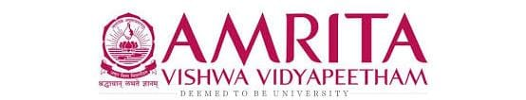

DATA STRUCUTRES AND ALGORITHMS
23CSE203
LAB MANUAL

Submitted by

Name | Avirneni Revanth Sri Sai
Roll No | AV.SC.U4CSE25011
Year/Sem/Section | 2nd year/Sem-3/CSE-A
Credits | 05

Submitted to

Name | Dr. RAJ KUMAR BATCHU
Department | School of Computing
Designation | Asst. Professor (SI Grade)

S.NO | TITLE | PAGE NO | REMARKS
1. | WEEK 1: 1a. Recursive countdown from n to Launch.  1b. Recursive calculation of compound growth factor.  1c. Recursive search for employee ID in list.  1d. Recursive factorial calculation for parcel arrangements.  1e. Recursive Fibonacci series generation.
2. | WEEK 2: 2a. Write a python program to perform linear search on the give input.  2b. Write a python program to perform binary search on the given. Verify by taking sorted array as an input.  2c. Write a python program to perform binary search on the given. Verify by taking unsorted array as an input.
3. | WEEK 3: 3a. Write a program to perform Bubble Sort technique on the user given input. 3b. Write a program to perform Insertion Sort technique on the user given input. 3c. Write a program to perform Selection Sort technique on the user given input. 3d. Write a program to perform Merge Sort technique on the user given input. 3e. Write a program to perform Quick Sort technique on the user given input.
4. | WEEK 4: Write a python program to implement a single linked list which would perform the below operations, by taking an input from the user. a. Create a linked list. b. Insert at beginning. c. Insert at end. d. Insert at a specific index. e. Delete by value. f. Delete 1st node. g. Delete last node. h. Count no. of nodes i. Display. j. Exit.

WEEK – 1
1A. AIM: A rocket launch system displays a countdown before launch. Instead of using a loop, implement the countdown using recursive. Write a recursive python program to display a countdown from n to 1, followed by “Launch”.
PROGRAM:
def launch(n):
if n <= 0:
print("Launch!")
return
print(n)
return launch(n-1)

n = int(input("enter number: "))
launch(n)

OUTPUT:
Positive Case:
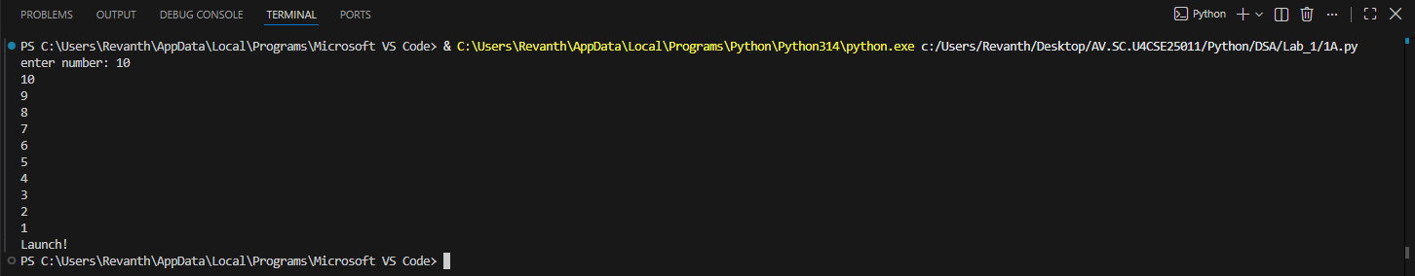
Negative Case:
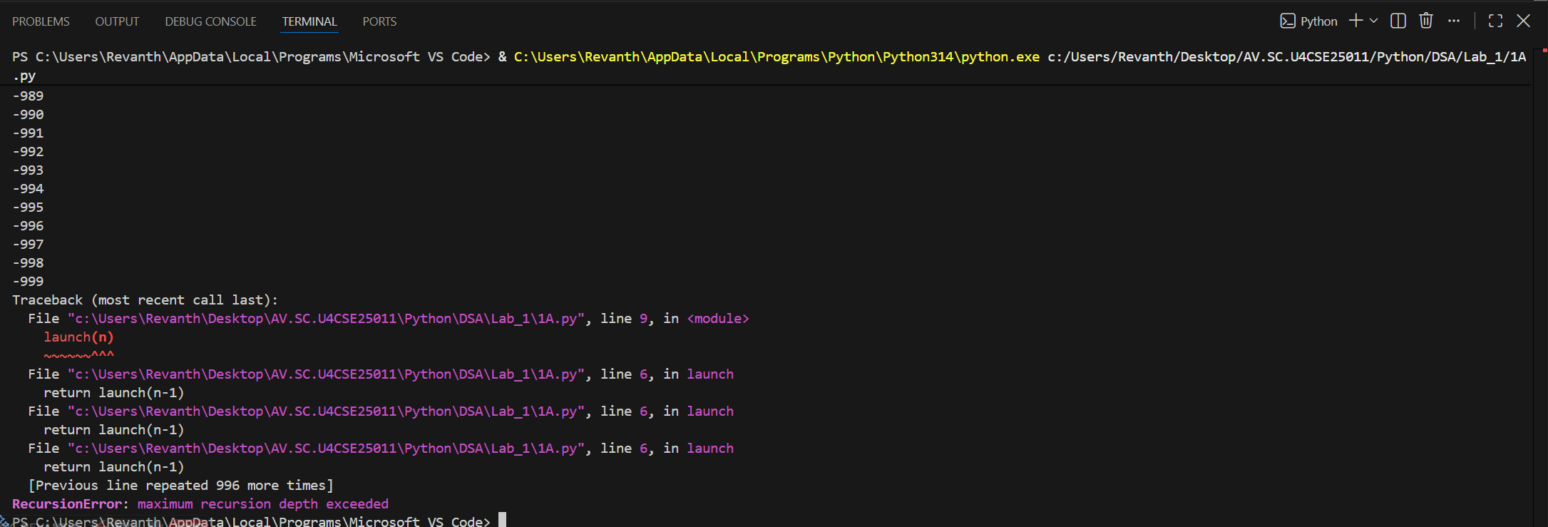

EXPLANATION:
Condition 1: Positive Input (n > 0)
- The function checks if n <= 0. Since n is positive, this condition is False.
- It executes the else block:
  - Prints the current value of n.
  - Calls itself recursively with n - 1.
- This recurses until n becomes 0.
- Finally, when n = 0, the condition n <= 0 becomes True.
- After the recursive calls finish, the function returns None (since no return is defined).
- The calling print (countdown (10)) will display the countdown, the launch message, and then None.
Condition 2: Negative Input (n <= 0)
- The condition if n <= 0 is immediately True.
- It directly prints:
Launch!
- No recursion happens because the else block is skipped.
- The function ends and returns None.
- The calling print (countdown (-1)) will display:
Launch!
None

ERROR TABLE:

S.NO | Error Obtained | Rectification
1. | Negative case was not added instead of “<=” “==” was used | Used “<=” instead of “==”

1B. AIM: Banks calculate the growth of an investment using compound interest. The formula requires calculating powers, which can be implemented recursively. Write a recursive program to calculate P^{n}(power), Where p = principal growth factor, n = number of years.
PROGRAM:
def calc(p,n):
if n == 0:
return 1
return p*calc(p,n-1)

print(calc(2,4))

OUTPUT:
Positive Case:
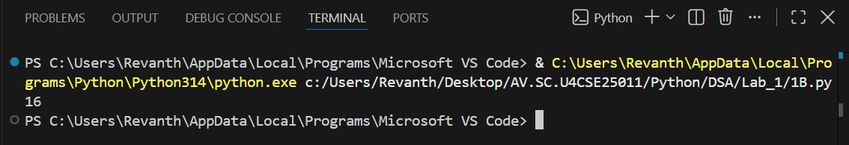

Negative Case:
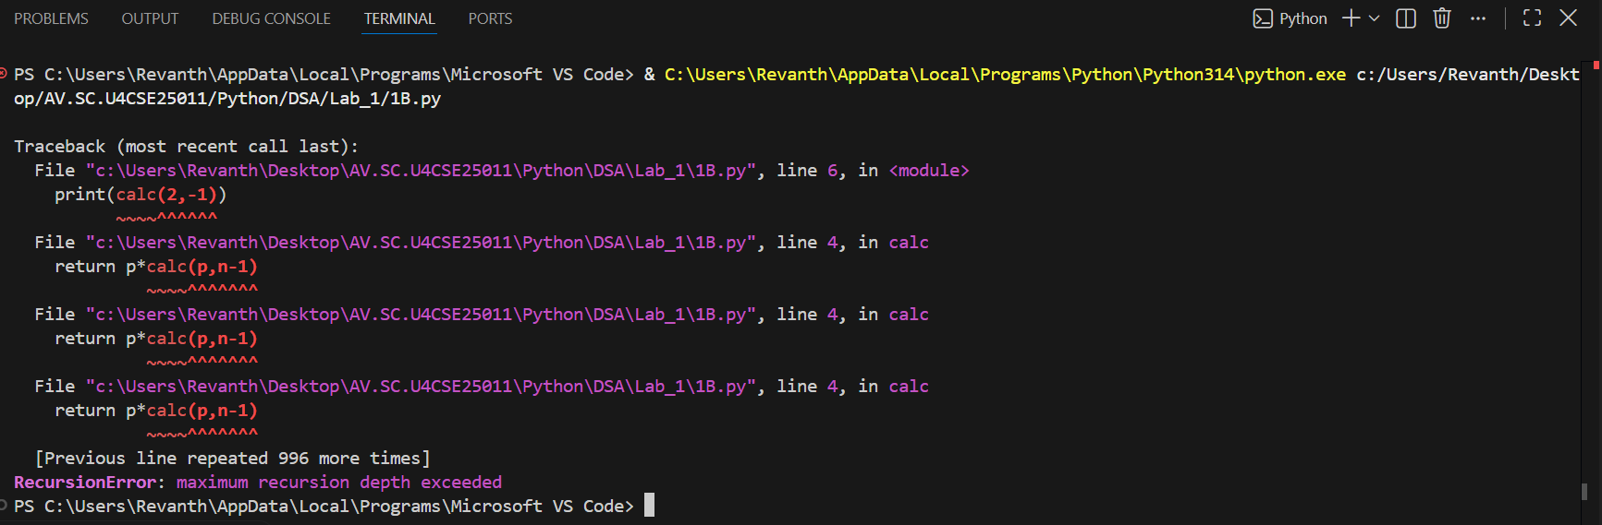

EXPLANATION:
Condition 1: Positive Input (n ≥ 0)
- User enters a positive number of years (e.g., n = 3).
- The function checks if n == 0. Since n is positive, this is False.
- It executes the else block:
  - Multiplies p by the result of power (p, n-1).
- Recursion continues until n becomes 0.
- At n = 0, the base case returns 1.
- The recursive calls unwind, multiplying p repeatedly.
- The output is ${\text{p}}^{\text{n}}$, i.e., the growth factor raised to the number of years.
Condition 2: Negative Input (n < 0)
- User enters a negative number of years (e.g., n = -2).
- The function checks if n == 0. Since n is negative, this is False.
- It executes the else block:
  - Calls power (p, n-1) with an even smaller negative number.
- Recursion continues indefinitely (-2 → -3 → -4 → …).
- The base case (n == 0) is never reached.
- Python raises a “Recursion Error: maximum recursion depth exceeded.”
ERROR TABLE:

S.NO | Error Obtained | Rectification
1. | Floating-Point  I have entered a floating-point value in the years. | Later it was rectified by giving the integer value.
2. | Large Input Error  I have given a huge input value. | It was rectified by passing default limit of Python.

1C. AIM: An HR department stores employee IDs in a list. Develop a recursive program to search for a given employee ID. Write a recursive function to search for an employee ID in a list.

PROGRAM:
def search(a, i, n):
if n > len(a):
return "not found"
elif len(a) == 0:
return "empty list"
elif n < len(a) and a[n] == i:
return f"found at index {n}"

return search(a,i,n+1)
a = [2,4,5,1,9,7,3]
print(search(a,1,0))

#a is list, i is id, n is search from index.
OUTPUT:
Positive Case;
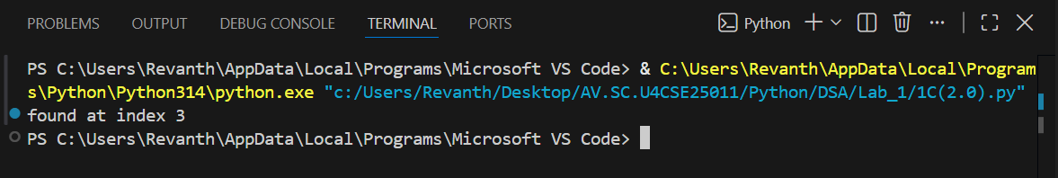
Negative Case;

EXPLANATION:
Condition 1: ID Found
- The function starts at index 0.
- It compares emp_list[index] with the target.
- If a match is found, the function immediately returns True.
- The recursion stops early — no need to check further elements.
- The main program prints:
found at “index”
Condition 2: ID Not Found
- The function checks each element recursively.
- If the end of the list is reached (index == len(emp_list)), the base case returns False.
- The recursion unwinds, propagating False back to the main program.
- The main program prints:
not found

ERROR TABLE:

S.NO | Error Obtained | Rectification
1. | Empty List  I haven’t entered the values in the list. | The empty list was filled with the IDs.
2. | Logical Error  I have entered the duplicate values. | It was rectified by removing the duplicates.

1D. AIM: In a logistics company, the number of possible ways to arrange n different parcels are calculated using the factorial formula (n!). Develop a recursive program to calculate the factorial of a given number.
PROGRAM:
def fact(n):
if n == 0:
return 1
return n*fact(n-1)
n = int(input("enter the number for factorial: "))
print(fact(n))

OUTPUT:
Positive Case;
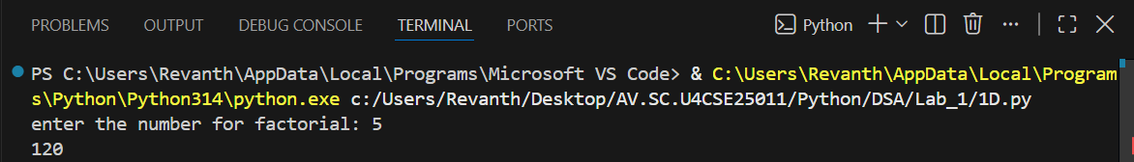
Negative Case; 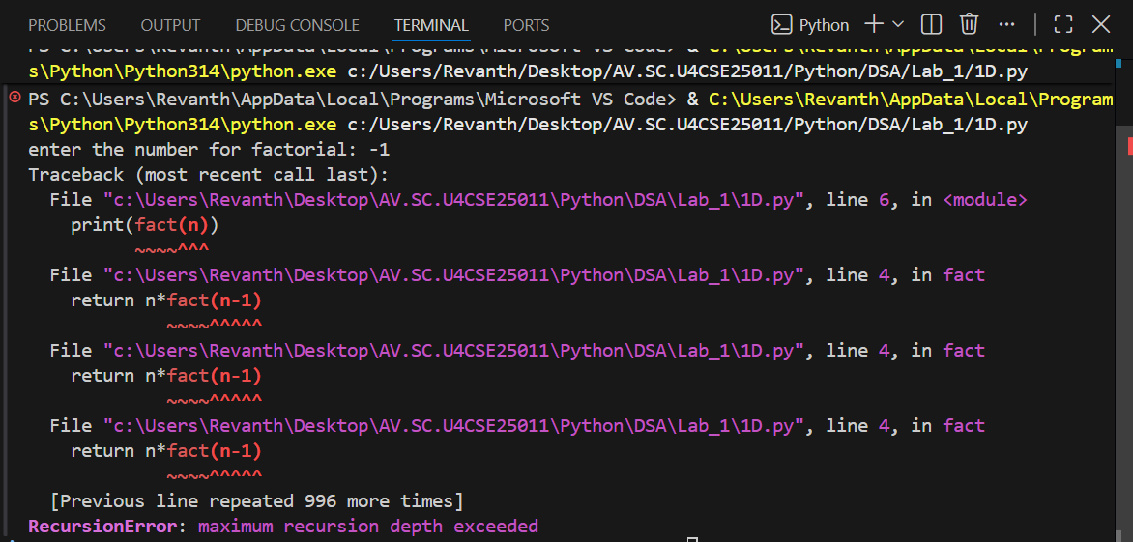

EXPLANATION:
Condition 1: When n == 0
- The function checks:
if n == 0:
return 1
- By definition, $\text{0!=1}$.
- So if the user enters 0, the program outputs:
Possible ways to arrange 0 different parcels is 1
Condition 2: When n > 0
- The function executes:
else:
return n * factorial(n - 1)
- This means the function calls itself with a smaller number until it eventually reaches n == 0.
- Uses recursion to multiply numbers down to 1.

ERROR TABLE:

S.NO | Error Obtained | Rectification
1. | Large Input Error  I have entered a very large number. | It was rectified by entering limited values.

1E. AIM: Write a recursive python program to print the first n yerms of the Fibonacci Series.
PROGRAM:
def fib(n):
if n <=2:
return n-1
return fib(n-1) + fib(n-2)
def fibo(n):
if n > 0:
fibo(n-1)
print(fib(n))

n = int(input("enter n: "))
fibo(n)

OUTPUT:
Positive Case: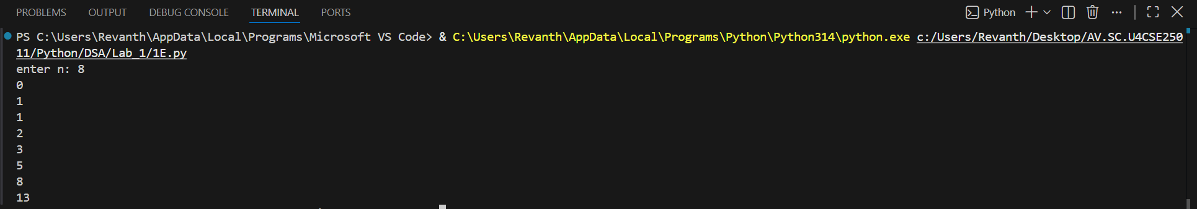

Negative Case:
EXPLANATION:
Condition 1: When n <= 1
- Inside the function:
if n <= 1:
return n
- This is the base case of recursion.
- If n = 0, it returns 0.
- If n = 1, it returns 1.
- These are the starting points of the Fibonacci sequence..
Condition 2: When n > 1
- The function executes:
else:
return fib(n - 1) + fib(n - 2)
- This means the Fibonacci number at position n is the sum of the two previous numbers.
- The recursion keeps breaking down until it reaches the base case (n <= 1).
ERROR TABLE:
S.NO | Error Obtained | Rectification
1. | Negative Input  I haven’t entered the negative value. | Later, it was rectified by entering positive values.
2. | Very large input  Recursion depth exceeded. | It was rectified by entering limited values.

WEEK – 2
2A. AIM: Write a python program to perform linear search on the give input.
PROGRAM:
def search(arr,e):
for i in range(len(arr)):
if arr[i] == e:
return i
return -1

a = [2,6,4,3,7,13,22,11,24,42]
print(search(a,13))

OUTPUT:
Positive Case;
Negative Case;

EXPLANATION:
Condition 1: Element Found
- The program takes an array of numbers from the user.
- It then asks for a key (the element to search).
- The linear_search function goes through the array one element at a time.
- If the current element matches the key, the function returns its index.
- In this case, the program prints:
Element found at index <position>
Example:
- Input array: [10, 20, 30, 40]
- Key: 30
- Output: Element found at index 2
Condition 2: Element Not Found
- If the loop finishes and no element matches the key, the function returns -1.
- The program then prints:
Element not found
ERROR TABLE:

S.NO | Error Obtained | Rectification
1. | Indentation error  Return -1 was typed inside the if loop condition. | Later, it was rectified by typing it outside the if loop and inside the for loop.
2. | Syntax error  Invalid syntax,  ! == -1 | It was rectified by re-typing,  ! = -1.

2B. AIM: Write a python program to perform binary search on the given. Verify by taking sorted array as an input.

PROGRAM:
def bin_search(arr,e):
arr.sort()
l = 0
h = len(arr)-1
while l <= h:
m = (l+h)//2
if arr[m] == e:
return m , arr
elif arr[m] > e:
h = m-1
else:
l = m+1
return -1 , arr
a = [2,6,4,3,7,13,22,11,24,42]
print(bin_search(a,13))

OUTPUT:
Positive Case:

Negative Case:
EXPLANATION:
Condition 1: Element Found
- The program asks the user to enter elements in sorted order (binary search only works on sorted arrays).
- The binary_search function starts with two pointers:
- low → beginning of the array
- high → end of the array
- It calculates the middle index mid = (low + high) // 2.
- If the middle element equals the key, the function returns that index.
- The program then prints:
(<index>, arr)
Example:
- Input array: [5, 10, 15, 20, 25]
- Key: 20
- Output: Element found at index 3
Condition 2: Element Not Found
- If the key is not equal to the middle element, the algorithm adjusts the search range:
  - If arr[mid] < key, search continues in the right half (low = mid + 1).
  - If arr[mid] > key, search continues in the left half (high = mid - 1).
- This process repeats until low > high.
- If the key is not found, the function returns -1.
- The program then prints:
(-1, arr)

Example:
- Input array: [2,6,4,3,7,13,22,11,24,42]
- Key: 13
- Output: 6

ERROR TABLE:
S.NO | Error Obtained | Rectification
1. | Wrong middle calculation  mid = (low + high) / 2 | It was rectified by re-typing,  mid = (low + high) // 2.
2. | Incorrect loop condition  low < high | Later, it was rectified by writing as  low <= high.

2C. AIM: Write a python program to perform binary search on the given. Verify by taking unsorted array as an input.
PROGRAM:
def bin_search(arr,e):
l = 0
h = len(arr)-1
while l <= h:
m = (l+h)//2
if arr[m] == e:
return m
elif arr[m] > e:
h = m-1
else:
l = m+1
return -1
a = [2,6,4,3,7,13,22,11,24,42]
print(bin_search(a,13))
OUTPUT:
Positive Case;
Negative Case;
A semantic error occurs in this case,

EXPLANATION:
Condition 1: Input List Already Sorted
- The program first checks if the entered list is already sorted or not.
- If true, it prints:
The input list is already sorted.
- Then it directly applies binary search on the given list.
- If the key is found, it prints the index:
Element found at index <position>
- Otherwise, it prints:
Element not found
Example:
- Input array: [5, 10, 15, 20]
- Key: 15
- Output:
The input list is already sorted.
Sorted list: [5, 10, 15, 20]
Element found at index 2
Condition 2: Input List Not Sorted
- If the entered list is not sorted, the program prints
The input list is not sorted.
The list is sorting...
- It then sorts the list using:
arr.sort()
- After sorting, it prints the sorted list and applies binary search.
- If the key is found, it prints the index in the sorted list.
- Otherwise, it prints:
Element not found
Example:
- Input array: [20, 5, 15, 10]
- Key: 10
- Output:
The input list is not sorted.
The list is sorting...
Sorted list: [5, 10, 15, 20]
Element found at index 1

ERROR TABLE:

S.NO | Error Obtained | Rectification
1. | Semantic error  Given an empty list | It was rectified by entering the values in the list.
2. | Duplicate elements  It does not guarantee the 1st or last occurrence | Later, it was rectified by not entering the duplicate values.

WEEK-3

3a)Aim:- Write a Python program to perform Bubble Sort on a given list of elements.
Program:-
def bubble_sort(arr):
n = len(arr)
for i in range(n):
swapped = False
for j in range(0, n - i - 1):
if arr[j] > arr[j + 1]:
arr[j], arr[j + 1] = arr[j + 1], arr[j]
swapped = True
if not swapped:
break
return arr

a = []
while True:
elem = input("Enter an element (or enter stop to finish):- ")
if elem.lower() == "stop":
break
a.append(int(elem))

print("Original List:", a)
sorted_list = bubble_sort(a)
print("Sorted List: ", sorted_list)
OUTPUT:-
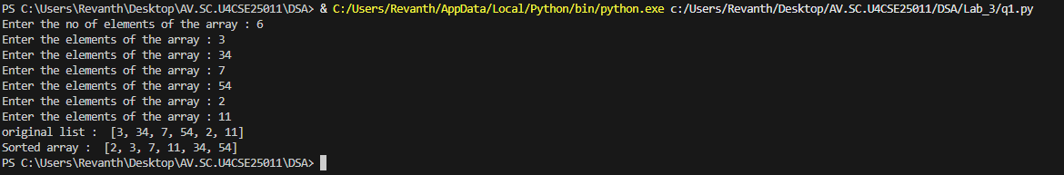
Explanation:
This program uses the Bubble Sort technique to sort elements in a list.
- The function bubble_sort(arr) is defined to sort the given list arr.
- The variable n = len(arr) stores the number of elements in the list.
- A loop runs from i = 0 to n-1, representing each pass of the sorting process.
- A variable swapped is initialized as False at the beginning of each pass.
  - It is used to check whether any swapping occurred during the pass.
- Another loop runs from j = 0 to n-i-2, comparing adjacent elements.
- The condition if arr[j] > arr[j + 1]: checks if the current element is greater than the next element.
  - If true, the elements are swapped using arr[j], arr[j + 1] = arr[j + 1], arr[j].
  - The variable swapped is set to True.
- After each pass, if no swapping occurs (swapped == False), the loop breaks early.
  - This indicates that the list is already sorted.
- The function returns the sorted list.
- The user inputs elements into the list a until "stop" is entered.
- The original list is printed, followed by the sorted list after calling bubble_sort(a).
Error Table:
S.No | Error Obtained | Rectification
01. | ValueError when non-integer input is entered | Ensure input is integer or handle using try-except
02. | Program fails for empty list (no elements entered) | Check if list is empty before sorting
03. | Sorting modifies original list | Use a copy of list if original order must be preserved
04. | Inefficient for large inputs (high time complexity) | Use faster algorithms like merge sort or quick sort

3b) Aim: Write a Python program to perform Insertion Sort on a given list of elements.
Program:-
def insertion_sort(arr):
for i in range(1, len(arr)):
key = arr[i]
j = i - 1
while j >= 0 and key < arr[j]:
arr[j + 1] = arr[j]
j -= 1
arr[j + 1] = key
return arr

a = []
while True:
elem = input("Enter an element (or enter stop to finish):- ")
if elem.lower() == "stop":
break
a.append(int(elem))

print("Original List:", a)
sorted_list = insertion_sort(a)
print("Sorted List: ", sorted_list)

Output:-
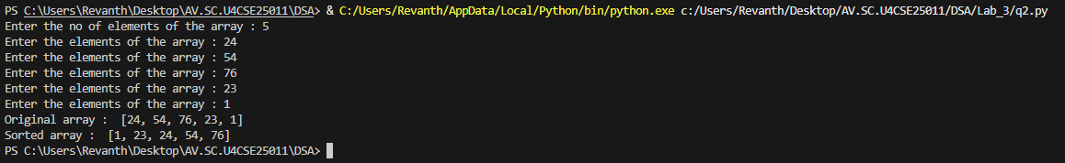
Explanation:
This program uses the Insertion Sort technique to sort elements in a list.
- The function insertion_sort(arr) is defined to sort the given list arr.
- A loop runs from i = 1 to len(arr) - 1, considering one element at a time as the key element.
- The variable key = arr[i] stores the current element to be inserted into the sorted portion of the list.
- The variable j = i - 1 points to the last element of the already sorted portion.
- A while loop runs as long as j >= 0 and key < arr[j].
  - This shifts elements one position ahead using arr[j + 1] = arr[j].
  - The value of j is decreased by 1 after each shift.
- After shifting all larger elements, the key is placed at the correct position using arr[j + 1] = key.
- This process continues until the entire list is sorted.
- The function returns the sorted list.
- The user inputs elements into the list a until "stop" is entered.
- The original list is printed, followed by the sorted list after calling insertion_sort(a).
Error Table:
S.No | Error Obtained | Rectification
01. | ValueError when non-integer input is entered | Ensure input is integer or handle using try-except
02. | Program fails for empty list | Check if list is empty before sorting
03. | Sorting modifies original list | Use a copy of list if original order must be preserved
04. | Incorrect output if comparison condition is wrong (key > arr[j]) | Ensure correct condition key < arr[j] is used

3c) Aim: Write a Python program to perform Selection Sort on a given list of elements.
Program:-
def selection_sort(arr):
n = len(arr)
for i in range(n):
min_idx = i
for j in range(i + 1, n):
if arr[j] < arr[min_idx]:
min_idx = j
arr[i], arr[min_idx] = arr[min_idx], arr[i]
return arr

a = []
while True:
elem = input("Enter an element (or enter stop to finish):- ")
if elem.lower() == "stop":
break
a.append(int(elem))

print("Original List:", a)
sorted_list = selection_sort(a)
print("Sorted List: ", sorted_list)

Output:-
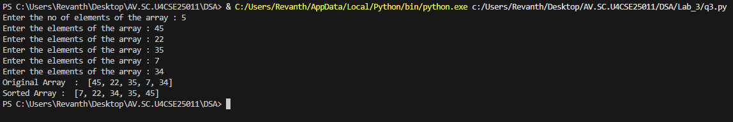

Explanation:
This program uses the Selection Sort technique to sort elements in a list.
- The function selection_sort(arr) is defined to sort the given list arr.
- The variable n = len(arr) stores the number of elements in the list.
- A loop runs from i = 0 to n-1, representing the position where the smallest element should be placed.
- The variable min_idx = i is initialized to store the index of the minimum element in the unsorted portion.
- Another loop runs from j = i + 1 to n-1, comparing elements in the unsorted part of the list.
- The condition if arr[j] < arr[min_idx]: checks if a smaller element is found.
  - If true, min_idx is updated with the index of that smaller element.
- After finding the smallest element, it is swapped with the element at position i using
arr[i], arr[min_idx] = arr[min_idx], arr[i].
- This process continues until the entire list is sorted.
- The function returns the sorted list.
- The user inputs elements into the list a until "stop" is entered.
- The original list is printed, followed by the sorted list after calling selection_sort(a).

Error Table:
S.No | Error Obtained | Rectification
01. | ValueError when non-integer input is entered | Ensure input is integer or handle using try-except
02. | Program fails for empty list | Check if list is empty before sorting
03. | Sorting modifies original list | Use a copy of list if original order must be preserved
04. | Incorrect sorting if comparison condition is wrong (arr[j] > arr[min_idx]) | Ensure correct condition arr[j] < arr[min_idx] is used

3d) Aim: Write a Python program to perform Merge Sort on a given list of elements.
Program:-
def merge_sort(arr):
if len(arr) > 1:
mid = len(arr) // 2
L = arr[:mid]
R = arr[mid:]

merge_sort(L)
merge_sort(R)

i = j = k = 0

while i < len(L) and j < len(R):
if L[i] <= R[j]:
arr[k] = L[i]
i += 1
else:
arr[k] = R[j]
j += 1
k += 1

while i < len(L):
arr[k] = L[i]
i += 1
k += 1

while j < len(R):
arr[k] = R[j]
j += 1
k += 1
return arr

a = []
while True:
elem = input("Enter an element (or enter stop to finish):- ")
if elem.lower() == "stop":
break
a.append(int(elem))

print("Original List:", a)
sorted_list = merge_sort(a)
print("Sorted List: ", sorted_list)
Output:-
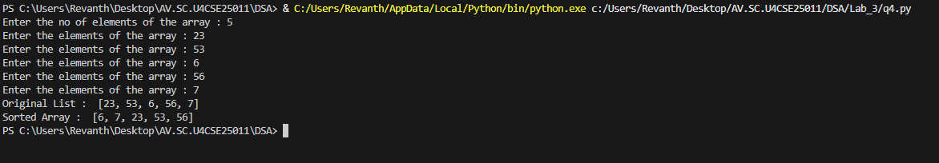

Explanation:
This program uses the Merge Sort technique to sort elements in a list using recursion.
- The function merge_sort(arr) is defined to sort the given list arr.
- The condition if len(arr) > 1: checks whether the list has more than one element.
  - If not, the list is already sorted (base case).
- The list is divided into two halves:
  - mid = len(arr) // 2 finds the middle index.
  - L = arr[:mid] stores the left half.
  - R = arr[mid:] stores the right half.
- The function recursively calls itself on both halves using merge_sort(L) and merge_sort(R).
- Three variables i, j, and k are initialized to 0:
  - i → index for left sublist
  - j → index for right sublist
  - k → index for merged list
- A while loop compares elements of L and R:
  - The smaller element is placed into arr[k].
  - Corresponding indices are incremented.
- After one sublist is exhausted, remaining elements of the other sublist are copied using two separate while loops.
- The sorted elements are merged back into the original list arr.
- The function returns the sorted list.
- The user inputs elements into the list a until "stop" is entered.
- The original list is printed, followed by the sorted list after calling merge_sort(a).
Error Table:
S.No | Error Obtained | Rectification
01. | ValueError when non-integer input is entered | Ensure input is integer or handle using try-except
02. | Program fails for empty list | Check if list is empty before sorting
03. | Incorrect merging if indices (i, j, k) are not updated properly | Ensure all indices are incremented correctly
04. | High memory usage due to creating sublists (L and R) | Use optimized in-place merge sort if required

3e) Aim:- Write a Python program to perform Quick Sort on a given list of elements.
Program:-
def quick_sort(arr, low=0, high=None):
if high is None:
high = len(arr) - 1

if low < high:
pivot = arr[high]
i = low - 1

for j in range(low, high):
if arr[j] <= pivot:
i += 1
arr[i], arr[j] = arr[j], arr[i]
arr[i + 1], arr[high] = arr[high], arr[i + 1]
pi = i + 1
quick_sort(arr, low, pi - 1)
quick_sort(arr, pi + 1, high)

return arr

a = []
while True:
elem = input("Enter an element (or enter stop to finish):- ")
if elem.lower() == "stop":
break
a.append(int(elem))

print("Original List:", a)
sorted_list = quick_sort(a)
print("Sorted List: ", sorted_list)
Output:-
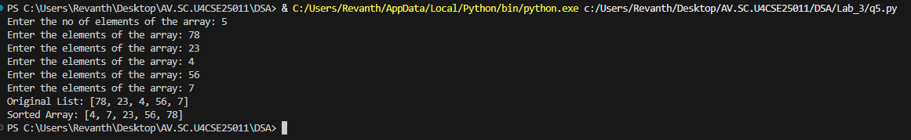

Explanation:
This program uses the Quick Sort technique to sort elements in a list using recursion.
- The function quick_sort(arr, low=0, high=None) is defined with parameters:
  - arr: The list to be sorted
  - low: Starting index (default 0)
  - high: Ending index (default last index of list)
- If high is None, it is initialized as len(arr) - 1.
- The condition if low < high: ensures that sorting is performed only when there are at least two elements.
- The last element arr[high] is chosen as the pivot.
- The variable i = low - 1 is used to track the position of smaller elements.
- A loop runs from j = low to high - 1:
  - If arr[j] <= pivot, i is incremented and elements are swapped using
arr[i], arr[j] = arr[j], arr[i].
- After the loop, the pivot is placed at its correct position using
arr[i + 1], arr[high] = arr[high], arr[i + 1].
- The pivot index pi = i + 1 divides the array into two parts.
- The function recursively sorts:
  - Left subarray → quick_sort(arr, low, pi - 1)
  - Right subarray → quick_sort(arr, pi + 1, high)
- The function returns the sorted list.
- The user inputs elements into list a until "stop" is entered.
- The original list and sorted list are printed.
Error Table:
S.No | Error Obtained | Rectification
01. | ValueError when non-integer input is entered | Ensure input is integer or handle using try-except
02. | Program fails for empty list | Check if list is empty before sorting
03. | Worst-case performance (O(n²)) for already sorted list | Use better pivot selection (e.g., middle or random pivot)
04. | Recursion depth error for very large lists | Increase recursion limit or use iterative approach

WEEK-4

4(a)Aim:-
Write a Python program to implement a Singly Linked List with the following operations:
- Create a singly linked list with n nodes.
- Insert a node at the beginning of the linked list.
- Insert a node at the end of the linked list.
- Insert a node at a specific position.
- Delete a node by its value.
- Delete the first node.
- Delete the last node.
- Count the number of nodes in the linked list.
- Display/Traverse the linked list.
- Exit the program.
Implement the above operations using a menu-driven program and a Node class.
PROGRAM:-
class Node: def init(self, data): self.data = data self.next = None
class SinglyLinkedList:
def __init__(self):
self.head = None
def create(self):
n = int(input("Enter number of nodes: "))
if n <= 0:
print("Number of nodes must be greater than 0.")
return
for i in range(n):
data = int(input(f"Enter data for node {i + 1}: "))
new_node = Node(data)
if self.head is None:
self.head = new_node
else:
temp = self.head
while temp.next is not None:
temp = temp.next
temp.next = new_node
print("Linked List created successfully.")
def insert_beginning(self, data):
new_node = Node(data)
new_node.next = self.head
self.head = new_node
print("Node inserted successfully.")
def insert_end(self, data):
new_node = Node(data)
if self.head is None:
self.head = new_node
print("Node inserted successfully.")
return
temp = self.head
while temp.next is not None:
temp = temp.next
temp.next = new_node
print("Node inserted successfully.")
def insert_at_position(self, data, position):
if position < 1:
print("Invalid position.")
return
new_node = Node(data)
if position == 1:
new_node.next = self.head
self.head = new_node
print("Node inserted successfully.")
return
temp = self.head
for i in range(position - 2):
if temp is None:
print("Invalid position.")
return
temp = temp.next
if temp is None:
print("Invalid position.")
return
new_node.next = temp.next
temp.next = new_node
print("Node inserted successfully.")
def delete_by_value(self, value):
if self.head is None:
print("Linked List is empty.")
return
if self.head.data == value:
self.head = self.head.next
print("Node deleted successfully.")
return
temp = self.head
while temp.next is not None:
if temp.next.data == value:
temp.next = temp.next.next
print("Node deleted successfully.")
return
temp = temp.next
print("Value not found.")
def delete_first(self):
if self.head is None:
print("Linked List is empty.")
return
deleted_value = self.head.data
self.head = self.head.next
print("First node deleted:", deleted_value)
def delete_last(self):
if self.head is None:
print("Linked List is empty.")
return
if self.head.next is None:
deleted_value = self.head.data
self.head = None
print("Last node deleted:", deleted_value)
return
temp = self.head
while temp.next.next is not None:
temp = temp.next
deleted_value = temp.next.data
temp.next = None
print("Last node deleted:", deleted_value)
def count_nodes(self):
count = 0
temp = self.head
while temp is not None:
count += 1
temp = temp.next
print("Number of nodes:", count)
def display(self):
if self.head is None:
print("Linked List is empty.")
return
temp = self.head
print("Linked List:")
while temp is not None:
print(temp.data, end=" -> ")
temp = temp.next
print("None")
sll = SinglyLinkedList()
while True:
print("\n======================================")
print(" SINGLY LINKED LIST")
print("======================================")
print("1. Create Linked List")
print("2. Insert at beginning")
print("3. Insert at end")
print("4. Insert at specific position")
print("5. Delete by value")
print("6. Delete First Node")
print("7. Delete Last Node")
print("8. Count no of nodes")
print("9. Display / Traverse")
print("10. Exit")
print("======================================")
ch = int(input("Enter your choice: "))
if ch == 1:
sll.create()
elif ch == 2:
data = int(input("Enter data: "))
sll.insert_beginning(data)
elif ch == 3:
data = int(input("Enter data: "))
sll.insert_end(data)
elif ch == 4:
data = int(input("Enter data: "))
position = int(input("Enter position (starting from 1): "))
sll.insert_at_position(data, position)
elif ch == 5:
value = int(input("Enter value to delete: "))
sll.delete_by_value(value)
elif ch == 6:
sll.delete_first()
elif ch == 7:
sll.delete_last()
elif ch == 8:
sll.count_nodes()
elif ch == 9:
sll.display()
elif ch == 10:
print("Exiting program...")
break
else:
print("Invalid choice. Please enter a number between 1 and 10.")

OUTPUT:
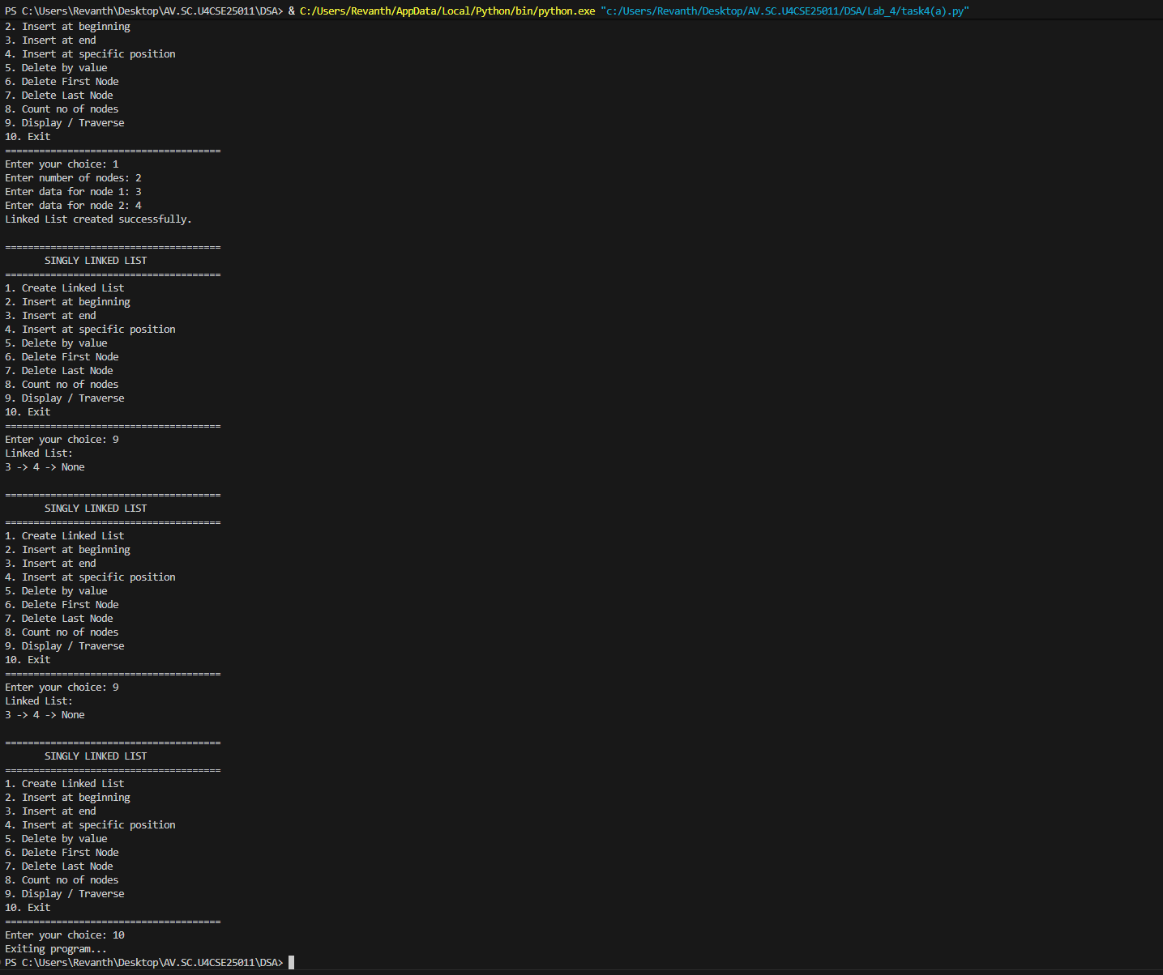

Explanation:
- The program implements a Singly Linked List using Node and SinglyLinkedList classes.
- Each node contains data and a next pointer that stores the reference to the next node.
- The head points to the first node of the linked list.
- The program supports insertion at the beginning, end, and a specific position.
- It supports deletion by value, from the beginning, and from the end.
- The count_nodes() function counts the total number of nodes.
- The display() function traverses and prints all nodes in the list.
- A menu-driven program is used to allow the user to select different operations.

4(b)aim:-
To write a Python program to implement a Doubly Linked List and perform insertion, deletion, counting, and traversal operations in both forward and backward directions.

Program:-
class Node: def init(self, data): self.data = data self.prev = None self.next = None
class DoublyLinkedList: def init(self): self.head = None
def create(self):
n = int(input("Enter number of nodes: "))
if n <= 0:
print("Number of nodes must be greater than 0.")
return
for i in range(n):
data = int(input(f"Enter data for node {i + 1}: "))
new_node = Node(data)
if self.head is None:
self.head = new_node
else:
temp = self.head
while temp.next is not None:
temp = temp.next
temp.next = new_node
new_node.prev = temp
print("Linked List created successfully.")
def insert_beginning(self):
data = int(input("Enter data: "))
new_node = Node(data)
if self.head is None:
self.head = new_node
else:
new_node.next = self.head
self.head.prev = new_node
self.head = new_node
print("Node inserted at beginning.")
def insert_end(self):
data = int(input("Enter data: "))
new_node = Node(data)
if self.head is None:
self.head = new_node
else:
temp = self.head
while temp.next is not None:
temp = temp.next
temp.next = new_node
new_node.prev = temp
print("Node inserted at end.")
def insert_position(self):
position = int(input("Enter position: "))
data = int(input("Enter data: "))
if position <= 0:
print("Invalid position.")
return
new_node = Node(data)
if position == 1:
if self.head is not None:
new_node.next = self.head
self.head.prev = new_node
self.head = new_node
print("Node inserted.")
return
temp = self.head
for i in range(position - 2):
if temp is None:
print("Position does not exist.")
return
temp = temp.next
if temp is None:
print("Position does not exist.")
return
new_node.next = temp.next
new_node.prev = temp
if temp.next is not None:
temp.next.prev = new_node
temp.next = new_node
print("Node inserted.")
def delete_by_value(self):
value = int(input("Enter value to delete: "))
temp = self.head
while temp is not None:
if temp.data == value:
if temp.prev is None:
self.head = temp.next
if self.head is not None:
self.head.prev = None
else:
temp.prev.next = temp.next
if temp.next is not None:
temp.next.prev = temp.prev
print("Node deleted.")
return
temp = temp.next
print("Value not found.")
def delete_first(self):
if self.head is None:
print("Linked List is empty.")
return
self.head = self.head.next
if self.head is not None:
self.head.prev = None
print("First node deleted.")
def delete_last(self):
if self.head is None:
print("Linked List is empty.")
return
temp = self.head
while temp.next is not None:
temp = temp.next
if temp.prev is None:
self.head = None
else:
temp.prev.next = None
print("Last node deleted.")
def count(self):
count = 0
temp = self.head
while temp is not None:
count += 1
temp = temp.next
print("Number of nodes:", count)
def display_forward(self):
if self.head is None:
print("Linked List is empty.")
return
temp = self.head
print("Forward:", end=" ")
while temp is not None:
print(temp.data, end=" <-> ")
temp = temp.next
print("None")
def display_backward(self):
if self.head is None:
print("Linked List is empty.")
return
temp = self.head
while temp.next is not None:
temp = temp.next
print("Backward:", end=" ")
while temp is not None:
print(temp.data, end=" <-> ")
temp = temp.prev
print("None")
dll = DoublyLinkedList()
while True:
print("\n======================================")
print(" DOUBLY LINKED LIST")
print("======================================")
print("1. Create Linked List")
print("2. Insert at beginning")
print("3. Insert at end")
print("4. Insert at specific position")
print("5. Delete by value")
print("6. Delete First Node")
print("7. Delete Last Node")
print("8. Count no of nodes")
print("9. Display Forward")
print("10. Display Backward")
print("11. Exit")
choice = int(input("Enter your choice: "))
if choice == 1:
dll.create()
elif choice == 2:
dll.insert_beginning()
elif choice == 3:
dll.insert_end()
elif choice == 4:
dll.insert_position()
elif choice == 5:
dll.delete_by_value()
elif choice == 6:
dll.delete_first()
elif choice == 7:
dll.delete_last()
elif choice == 8:
dll.count()
elif choice == 9:
dll.display_forward()
elif choice == 10:
dll.display_backward()
elif choice == 11:
print("Program ended.")
break
else:
print("Invalid choice.")
Output:-
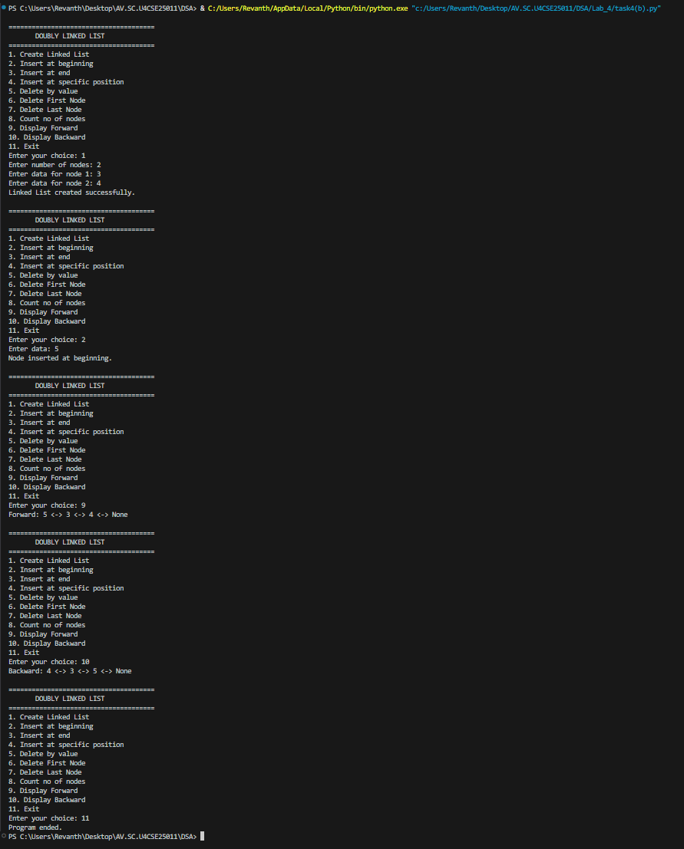
Explanation
- The program implements a Doubly Linked List using a Node class.
- Each node contains data, prev, and next references.
- The head points to the first node of the list.
- Nodes can be inserted at the beginning, end, or a specific position.
- Nodes can be deleted by value, from the beginning, or from the end.
- The program counts the nodes and displays the list in forward and backward directions.

4(c)Aim: To write a Python program to implement a Circular Linked List and perform insertion, deletion, counting, and traversal operations.

Program:-
class Node: def init(self, data): self.data = data self.next = None
class CircularLinkedList: def init(self): self.head = None
def create(self):
n = int(input("Enter number of nodes: "))
if n <= 0:
print("Number of nodes must be greater than 0.")
return
for i in range(n):
data = int(input(f"Enter data for node {i + 1}: "))
new_node = Node(data)
if self.head is None:
self.head = new_node
new_node.next = self.head
else:
temp = self.head
while temp.next != self.head:
temp = temp.next
temp.next = new_node
new_node.next = self.head
print("Circular Linked List created successfully.")
def insert_beginning(self):
data = int(input("Enter data: "))
new_node = Node(data)
if self.head is None:
self.head = new_node
new_node.next = self.head
else:
temp = self.head
while temp.next != self.head:
temp = temp.next
new_node.next = self.head
temp.next = new_node
self.head = new_node
print("Node inserted at beginning.")
def insert_end(self):
data = int(input("Enter data: "))
new_node = Node(data)
if self.head is None:
self.head = new_node
new_node.next = self.head
else:
temp = self.head
while temp.next != self.head:
temp = temp.next
temp.next = new_node
new_node.next = self.head
print("Node inserted at end.")
def insert_position(self):
position = int(input("Enter position: "))
data = int(input("Enter data: "))
if position <= 0:
print("Invalid position.")
return
new_node = Node(data)
if position == 1:
if self.head is None:
self.head = new_node
new_node.next = self.head
else:
temp = self.head
while temp.next != self.head:
temp = temp.next
new_node.next = self.head
temp.next = new_node
self.head = new_node
print("Node inserted.")
return
if self.head is None:
print("Position does not exist.")
return
temp = self.head
for i in range(position - 2):
temp = temp.next
if temp == self.head:
print("Position does not exist.")
return
new_node.next = temp.next
temp.next = new_node
print("Node inserted.")
def delete_by_value(self):
if self.head is None:
print("Circular Linked List is empty.")
return
value = int(input("Enter value to delete: "))
current = self.head
previous = None
while True:
if current.data == value:
if current == self.head and current.next == self.head:
self.head = None
elif current == self.head:
temp = self.head
while temp.next != self.head:
temp = temp.next
self.head = self.head.next
temp.next = self.head
else:
previous.next = current.next
print("Node deleted.")
return
previous = current
current = current.next
if current == self.head:
break
print("Value not found.")
def delete_first(self):
if self.head is None:
print("Circular Linked List is empty.")
return
if self.head.next == self.head:
self.head = None
else:
temp = self.head
while temp.next != self.head:
temp = temp.next
self.head = self.head.next
temp.next = self.head
print("First node deleted.")
def delete_last(self):
if self.head is None:
print("Circular Linked List is empty.")
return
if self.head.next == self.head:
self.head = None
print("Last node deleted.")
return
temp = self.head
while temp.next.next != self.head:
temp = temp.next
temp.next = self.head
print("Last node deleted.")
def count(self):
if self.head is None:
print("Number of nodes: 0")
return
count = 0
temp = self.head
while True:
count += 1
temp = temp.next
if temp == self.head:
break
print("Number of nodes:", count)
def display(self):
if self.head is None:
print("Circular Linked List is empty.")
return
temp = self.head
print("Head to Tail:", end=" ")
while True:
print(temp.data, end=" -> ")
temp = temp.next
if temp == self.head:
break
print("(back to head)")
def display_tail_to_head(self):
if self.head is None:
print("Circular Linked List is empty.")
return
tail = self.head
while tail.next != self.head:
tail = tail.next
print("Tail to Head:", end=" ")
current = tail
while True:
print(current.data, end="")
if current == self.head:
break
print(" <- ", end="")
temp = self.head
while temp.next != current:
temp = temp.next
current = temp
print(" (reached head)")
def exit_program(self):
print("Program ended.")
cll = CircularLinkedList()
while True:
print("\n======================================")
print(" CIRCULAR LINKED LIST")
print("======================================")
print("1. Create Linked List")
print("2. Insert at beginning")
print("3. Insert at end")
print("4. Insert at specific position")
print("5. Delete by value")
print("6. Delete First Node")
print("7. Delete Last Node")
print("8. Count no of nodes")
print("9. Display Head to Tail")
print("10. Display Tail to Head")
print("11. Exit")
choice = int(input("Enter your choice: "))
if choice == 1:
cll.create()
elif choice == 2:
cll.insert_beginning()
elif choice == 3:
cll.insert_end()
elif choice == 4:
cll.insert_position()
elif choice == 5:
cll.delete_by_value()
elif choice == 6:
cll.delete_first()
elif choice == 7:
cll.delete_last()
elif choice == 8:
cll.count()
elif choice == 9:
cll.display()
elif choice == 10:
cll.display_tail_to_head()
elif choice == 11:
cll.exit_program()
break
else:
print("Invalid choice.")
Output:-
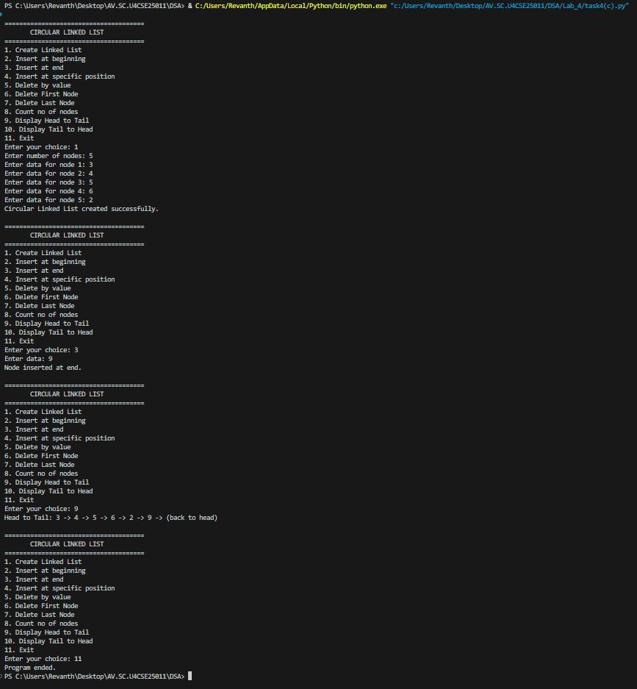

Explanation
- The program implements a Circular Linked List using a Node class.
- Each node contains data and a next reference.
- The last node points back to the head, forming a circular structure.
- Nodes can be inserted at the beginning, end, or a specific position.
- Nodes can be deleted by value, from the beginning, or from the end.
- The program counts the nodes and displays the list in head-to-tail and tail-to-head directions.
- A menu-driven approach is used to perform all the operations.

WEEK – 5
5. AIM: Write a python program to implement a stack using an Array, Linked list. Implement the stack operations such as push, pop, peak and also display the stack elements.
PROGRAM:
ARRAY:
stack = []
size = int(input("Enter stack size: "))
while True:
print("\n1. Push")
print("2. Pop")
print("3. Peek")
print("4. Display")
print("5. Exit")
ch = int(input("Enter choice: "))
if ch == 1:
if len(stack) == size:
print("Stack Overflow")
else:
data = int(input("Enter data: "))
stack.append(data)
elif ch == 2:
if len(stack) == 0:
print("Stack Underflow")
else:
print("Deleted:", stack.pop())
elif ch == 3:
if len(stack) == 0:
print("Stack is empty")
else:
print("Top element:", stack[-1])
elif ch == 4:
if len(stack) == 0:
print("Stack is empty")
else:
print("Stack:", stack)
elif ch == 5:
break
else:
print("Invalid choice")
OUTPUT:
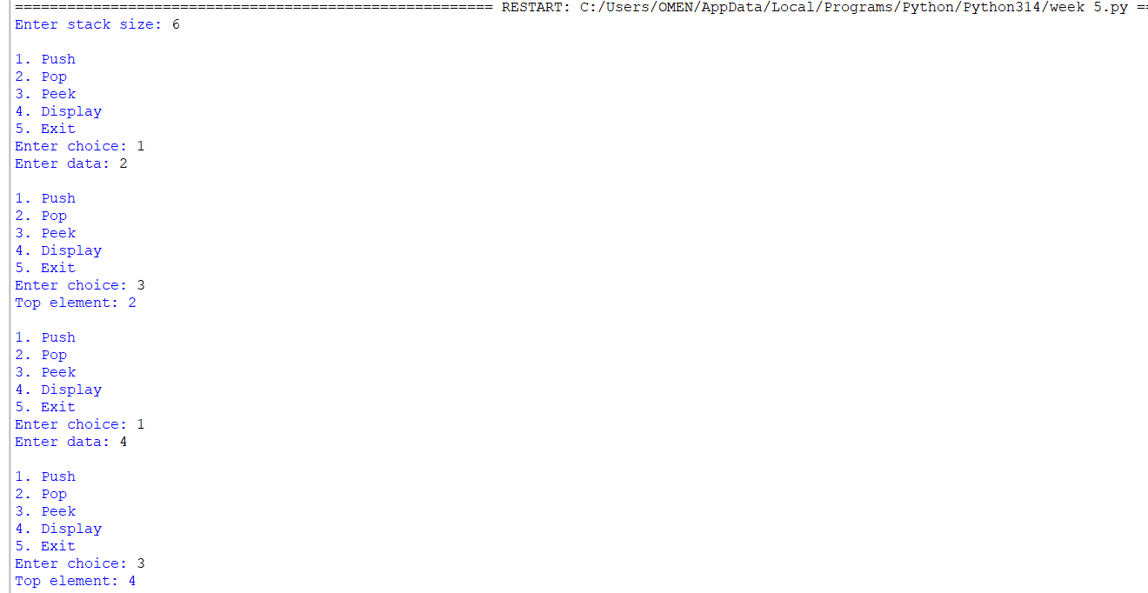
Negative output: 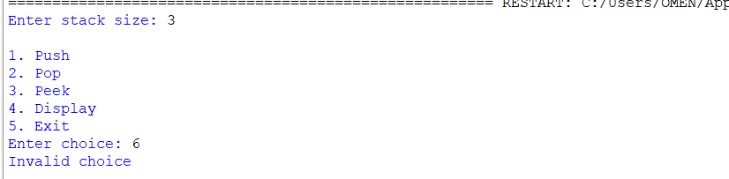
- stack = [] creates an empty stack.
- append() is used for push.
- pop() is used for pop.
- stack[-1] gives the top/peek element.
- len(stack) == size checks for overflow.
- len(stack) == 0 checks for underflow.
Error Table
Error | Cause | Solution
Stack Overflow | Stack is full | Do not push more elements
Stack Underflow | Stack is empty | Push an element before pop
Empty stack | No elements present | Perform Push
ValueError | Non-integer input | Enter integer values

STACK USING LINKED LIST:
PROGRAM:
class Node:
def __init__(self, data):
self.data = data
self.next = None

top = None

while True:
print("\n1. Push")
print("2. Pop")
print("3. Peek")
print("4. Display")
print("5. Exit")

ch = int(input("Enter choice: "))

if ch == 1:
data = int(input("Enter data: "))
new = Node(data)

new.next = top
top = new

elif ch == 2:
if top is None:
print("Stack Underflow")
else:
print("Deleted:", top.data)
top = top.next

elif ch == 3:
if top is None:
print("Stack is empty")
else:
print("Top element:", top.data)

elif ch == 4:
if top is None:
print("Stack is empty")
else:
temp = top
while temp:
print(temp.data, end=" ")
temp = temp.next
print()

elif ch == 5:
break

else:
print("Invalid choice")

OUTPUT:
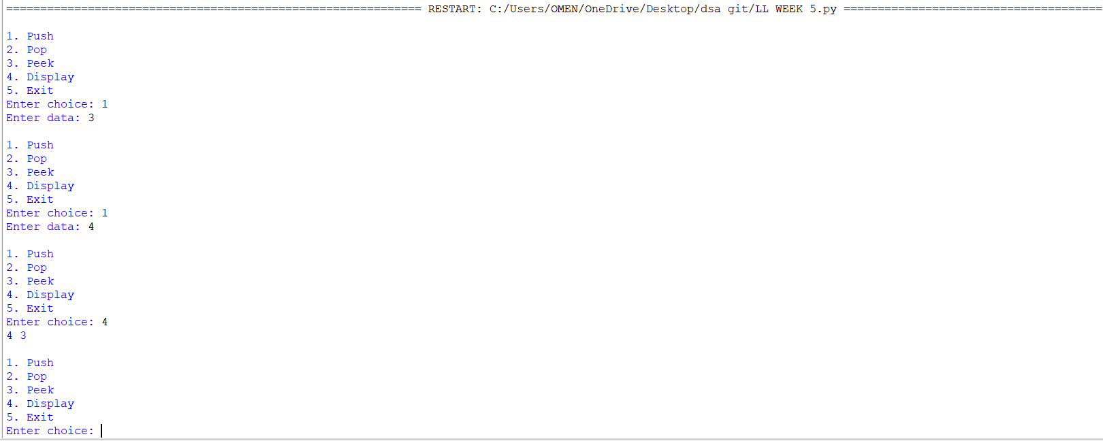
Negative output:
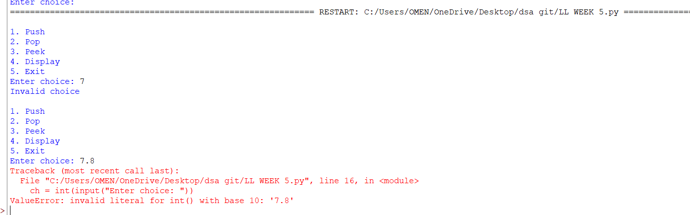
Push
new.next = top
top = new
The new node is inserted at the top.
Pop
top = top.next
The current top node is removed and the next node becomes the top.
Peek
top.data
Displays the element at the top without deleting it.
Display
temp = top
while temp:
print(temp.data, end=" ")
temp = temp.next
Traverses the linked list from top to bottom.
Error Table
Error | Cause | Solution
Stack Underflow | top is None | Push an element first
Empty stack | No nodes exist | Perform Push
AttributeError | Accessing top.data when top is None | Check top is None
ValueError | Invalid integer input | Enter an integer

WEEK – 6
6. AIM: To implement Queue and its operations such as Enqueue, Dequeue, Peek, Display with a menu driven approach.
6a. Using Array, Linked list, Data structures.
6b. Circular Queue.
PROGRAM:
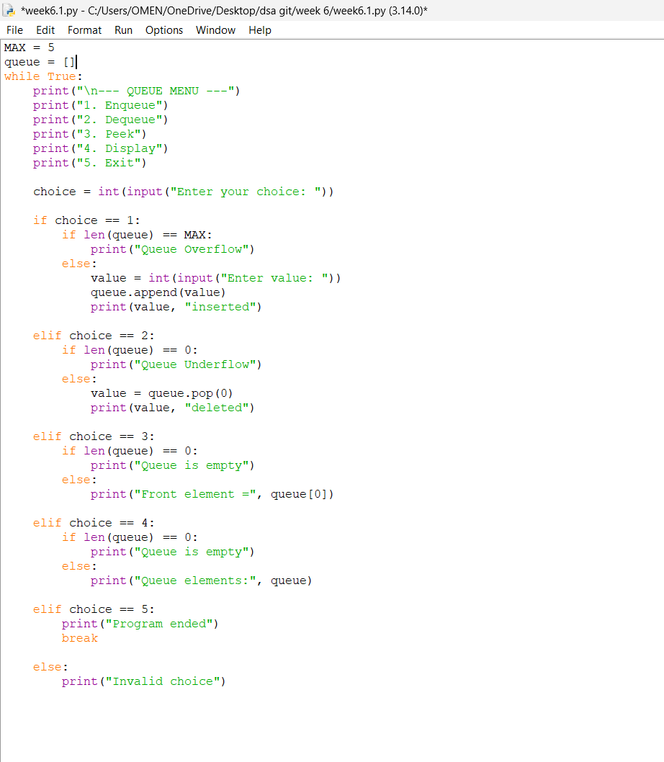

OUTPUT:
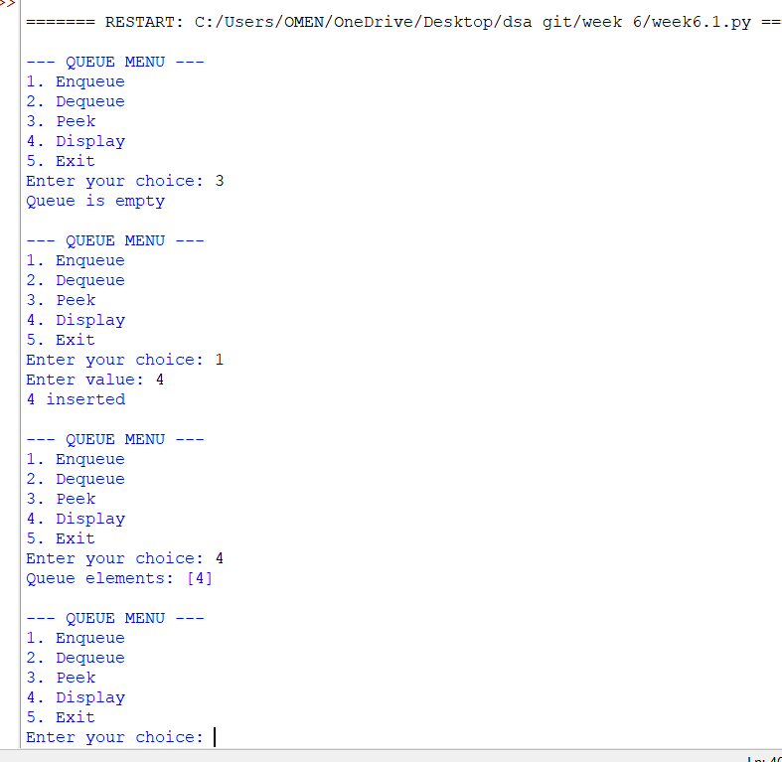

EXPLANATION:
🔹 What is a Queue?
- A Queue is a linear data structure that follows the FIFO (First In First Out) principle.
- Elements are inserted at the rear and removed from the front.
Arrays:
🔹 Components in the Code
- Initialization (__init__)
  - Creates a queue of fixed size.
  - Uses an array (self.queue) to store elements.
  - front and rear pointers track the first and last elements.
  - Both start at -1 (empty queue).
- Enqueue (Insertion)
  - Adds an element at the rear.
  - If rear == size - 1, → Overflow (queue full).
  - If queue is empty (front == -1), set front = 0.
  - Increment rear and insert the element.
- Dequeue (Deletion)
- Removes an element from the front.
- If queue is empty (front == -1 or front > rear), → Underflow.
- Deletes the element at front, increments front.
- If all elements are deleted (front > rear), reset both pointers to -1.
4. Peek
- Shows the element at the front without removing it.
- If empty, prints "Queue is empty".
5. Display
- Prints all elements between front and rear.
- If empty, prints "Queue is empty".
🔹 Menu-Driven Program
- User chooses operations from a menu:
  - Enqueue → Insert element.
  - Dequeue → Remove element.
  - Peek → Show front element.
  - Display → Show all elements.
  - Exit → End program.
- The loop continues until the user selects Exit.
🔹 Characteristics of This Queue
- It is a Linear Queue (not circular).
- Overflow occurs when rear == size - 1.
- Underflow occurs when queue is empty.
- Once rear reaches the end, no more insertions are possible even if earlier slots are freed (limitation of linear queue).
Linked List:
🔹 Structure in the Code
- Initialization (__init__)
  - Creates a queue of fixed size (default = 5).
  - Uses an array (self.queue) to store elements.
  - front and rear pointers track the first and last elements.
  - Both start at -1 (empty queue).
- Enqueue (Insertion)
  - Adds an element at the rear.
  - If rear == size - 1, → Overflow (queue full).
  - If queue is empty (front == -1), set front = 0.
  - Increment rear and insert the element.
- Dequeue (Deletion)
  - Removes an element from the front.
  - If queue is empty (front == -1), → Underflow.
  - Deletes the element at front, increments front.
  - If all elements are deleted (front > rear), reset both pointers to -1.
- Peek
  - Shows the element at the front without removing it.
  - If empty, prints "Queue is empty".
- Display
  - Prints all elements between front and rear.
  - If empty, prints "Queue is empty".
🔹 Characteristics of This Queue
- It is a Linear Queue (not circular).
- Overflow occurs when rear == size - 1.
- Underflow occurs when queue is empty (front == -1).
- Once rear reaches the end, no more insertions are possible even if earlier slots are freed (limitation of linear queue).

6b. To implement Circular Queue and its operation.
PROGRAM:
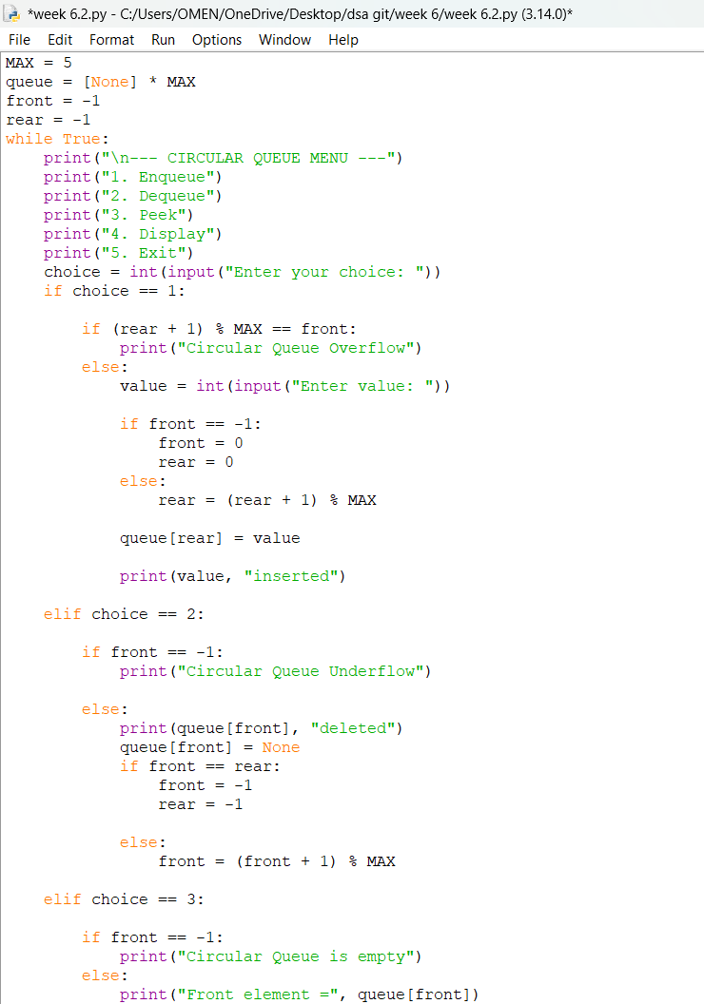
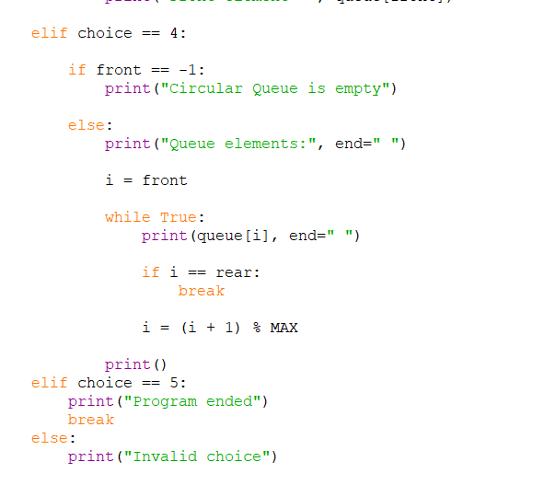

OUTPUT: 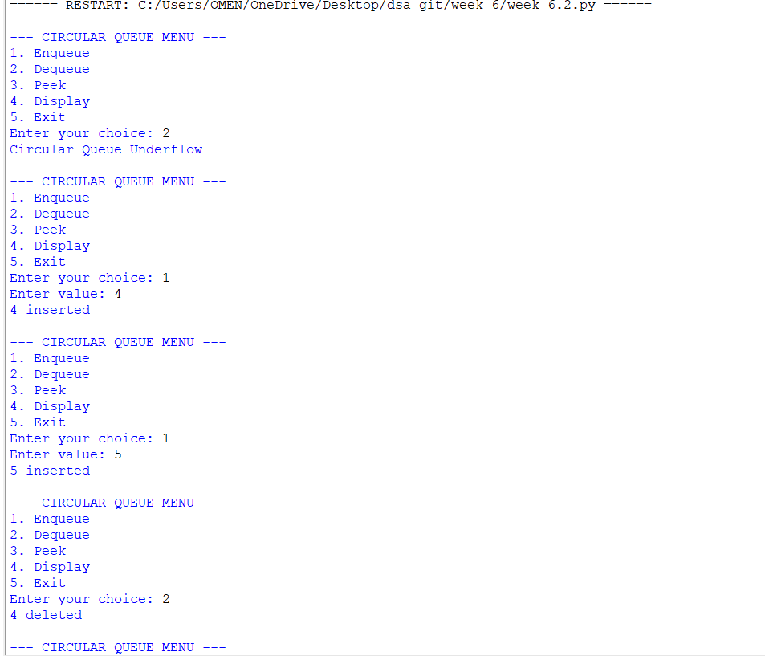

EXPLANATION:
🔹 Concept of Circular Queue
- A Circular Queue is a linear data structure that follows the FIFO (First In First Out) principle.
- Unlike a simple linear queue, the last position connects back to the first position, forming a circle.
- This design solves the problem of wasted space in a linear queue when elements are deleted from the front.
🔹 Structure in the Code
- Initialization (__init__)
  - Creates a queue of fixed size.
  - Uses an array (self.queue) to store elements.
  - front and rear pointers track the first and last elements.
  - Both start at -1 (empty queue).
- Enqueue (Insertion)
  - Adds an element at the rear.
  - Overflow occurs if (rear + 1) % size == front (queue full).
  - If queue is empty (front == -1), both front and rear are set to 0.
  - Otherwise, rear moves forward using modulo arithmetic: (rear + 1) % size.
3. Dequeue (Deletion)
- Removes an element from the front.
- Underflow occurs if front == -1 (queue empty).
- If only one element is left (front == rear), both pointers reset to -1.
- Otherwise, front moves forward using (front + 1) % size.
4.Display
- Prints all elements from front to rear using modulo arithmetic.
- Traverses circularly until it reaches the rear.
🔹 Menu-Driven Program
- User chooses operations from a menu:
  - Enqueue → Insert element.
  - Dequeue → Remove element.
  - Display → Show all elements.
  - Exit → End program.
- The loop continues until the user selects Exit.
🔹 Characteristics of Circular Queue
- Efficient use of memory: Freed spaces are reused.
- FIFO principle maintained.
- Overflow condition: (rear + 1) % size == front.
- Underflow condition: front == -1.

ERROR TABLE:
S.NO | Error Obtained | Rectification
1. | Redundant underflow check → Condition if self.front == -1 or self.front > self.rear: is slightly redundant because resetting pointers already handles empty state. | Simplify to if self.front == -1.
2. | Missing underflow condition → In dequeue, only checks if self.front == -1. If multiple deletions occur, front > rear is not handled, leading to incorrect behavior. | Add condition: if self.front == -1 or self.front > self.rear.
3. | Circular Queue: Display traversal limitation → Display prints values but not indices, making debugging harder. | Optional improvement: print both index and value.

