

User Interface Design (23CSE113)

Submitted by: | Avirneni Revanth Sri Sai
Roll No: | AV.SC.U4CSE25011
Year/Sem/section: | 1st year/sem-2/CSE-A

Submitted to: | Dr. Rajkumar Batchu Sir
Department: | Computer Science Engineering
Designation: | ASST.PROFFESSOR (SI.GRADE)

INDEX
S.NO | TITLE |  |  | PAGE NO
1 | Week-1:  1. Installation of VS Code tool.  2. Understanding basic of html  structure.  3. Understanding basic html tags. |  |  | 3-15
2 | Week-2:  1.Style Attribute  2.Tables  3.Tags |  |  | 15-21
3 | Week-3:-  understanding some more tags in htmt, colspan, rowsan, Syllabus, Timetable, ordered, unordered and nested lists. |  |  | 21-40

Installation of VS CODE

WEEK-1
1A) AIM: Steps to install VS CODE.
Program:
Step-1: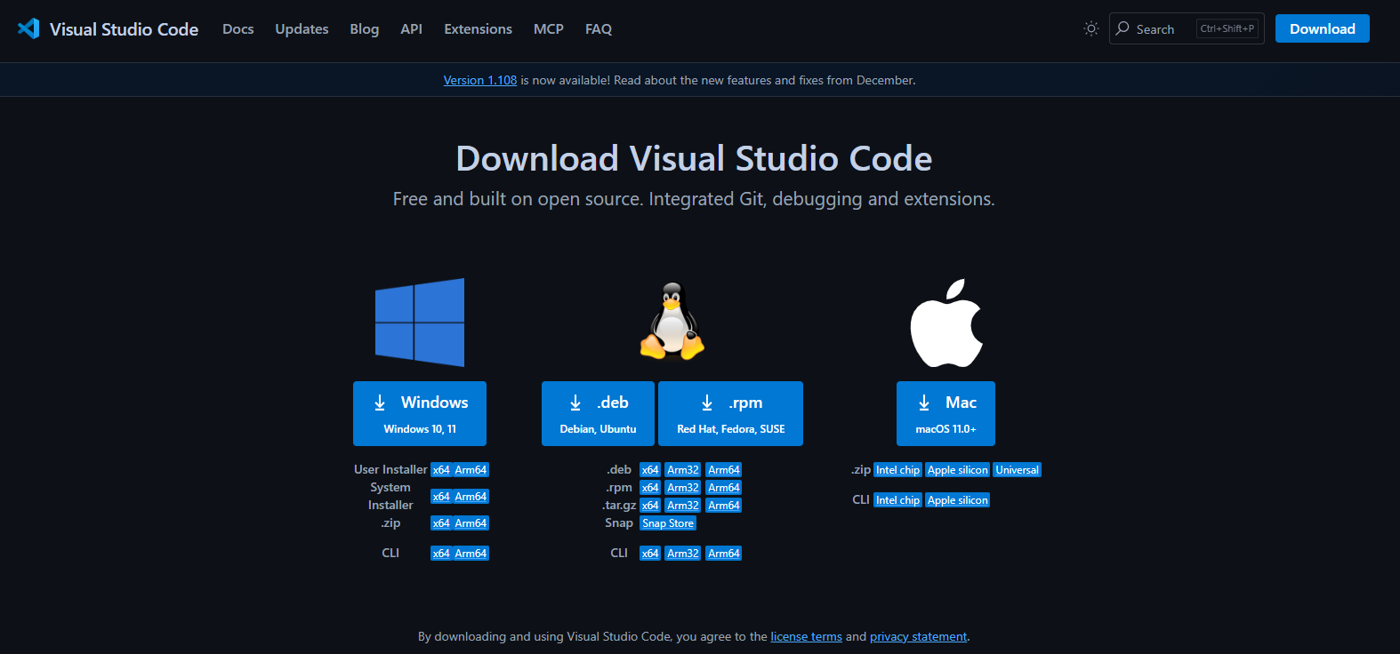
Step-2:
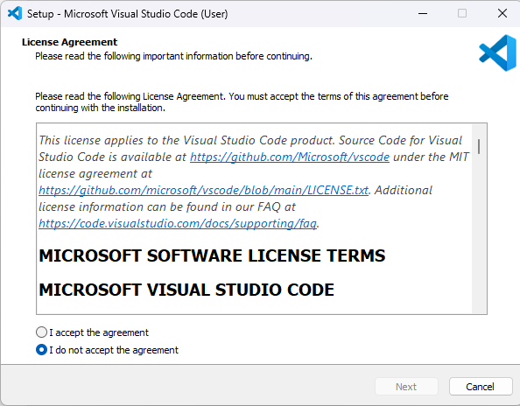
Step-3:
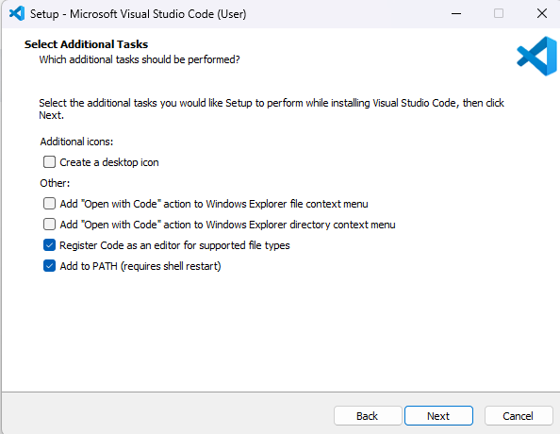

Step-4:
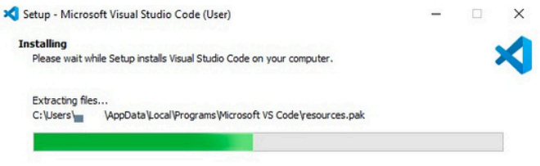

Step-5:
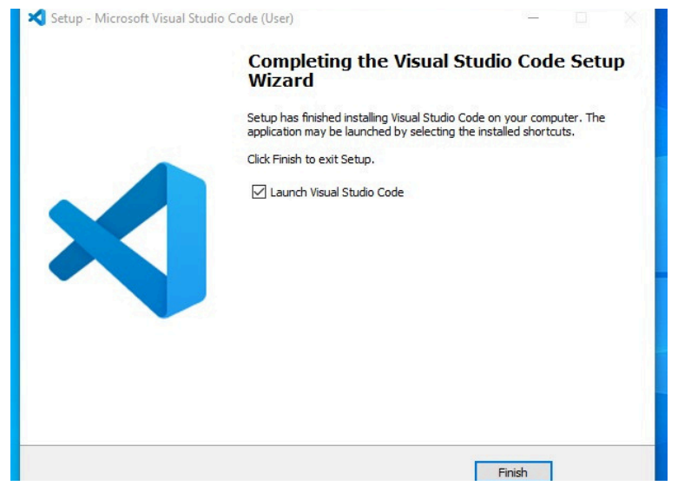

Step-6: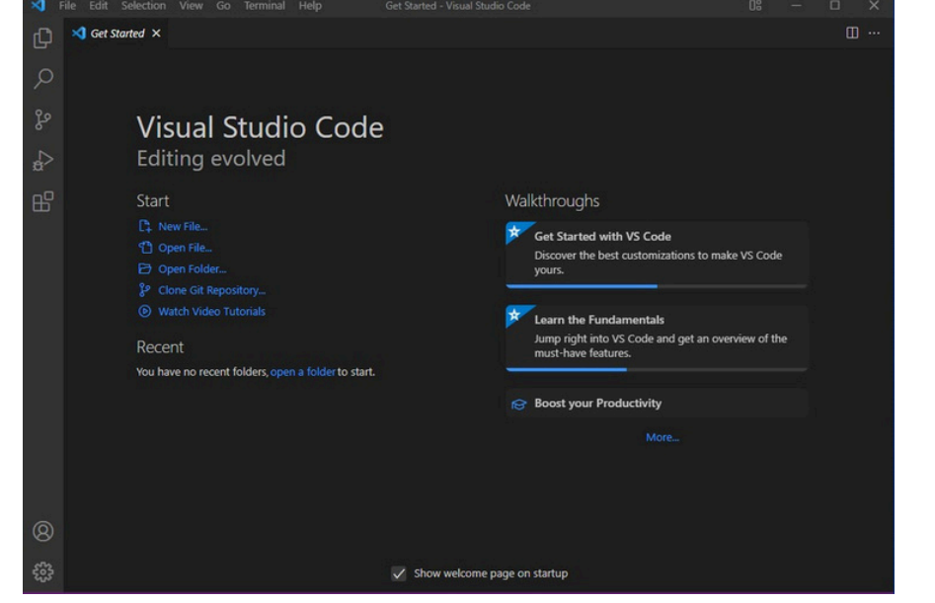

1B) AIM: To learn the basics of html.

Program:
<!DOCTYPE html>
<html>
<head>
<title>Student Details</title>
</head>
<body>
<h1>My personal details</h1>
<p>Name: Revanth</p>
<p>Age: 17</p>
<p>Gender: Male</p>
<p>Department: CSE</p>
</body>
</html>

Output:
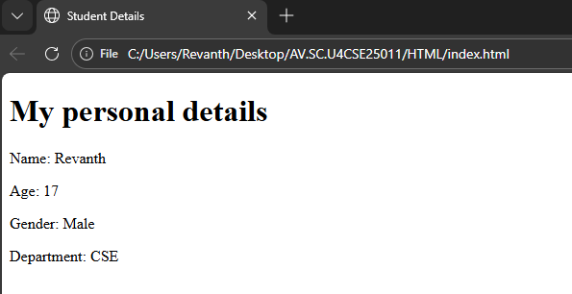

Program:
<!DOCTYPE html>
<html>
<head>
<title>Student Details</title>
</head>
<body>
<h1>Heading 1</h1>
<h2>Heading 2</h2>
<h3>Heading 3</h3>
<h4>Heading 4</h4>
<h5>Heading 5</h5>
<h6>Heading 6</h6>
<p>Paragraph</p>
</body>
</html>
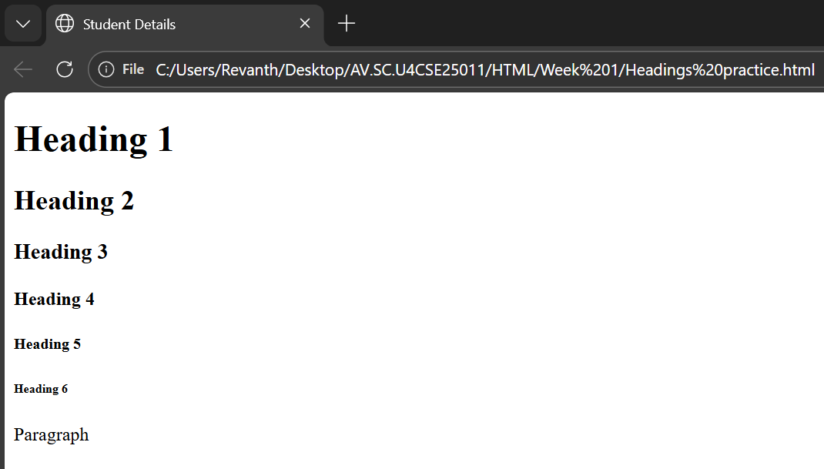

1C) AIM : understanding basic html tags.
Tags - <p>; <h1>; <img>;<a>

Program:

<!DOCTYPE html>
<html>
<head>
<title>Links</title>
</head>
<body>
<h1>Links of colleges</h1>
<h3>Amrita:</h3>
<img src="https://webfiles.amrita.edu/2025/12/amrita-logo-new.svg" alt="Amrita University" width="100" height="50"><br>
<a href="https://www.amrita.edu">Amrita University</a>
<p>Amrita Vishwa Vidyapeetham is a multi-disciplinary, research-intensive, private university, educating a vibrant student population of over 30,000 by 2000+ strong faculty. Accredited with the highest possible A++ grade by NAAC, Amrita offers more than 300 UG, PG, and Ph.D. programs across various disciplines, including Engineering, Management, Medical Sciences, Ayurveda, Life Sciences, Physical Sciences, Agricultural Sciences, Law, Arts & Humanities, and Social & Behavioral Sciences.</p>
<h3>SRM AP</h3>
<img src="https://www.srmap.edu.in/wp-content/uploads/2025/01/srm-university-logo-1.png" alt="SRM University AP" width="100" height="50"><br>
<a href=https://www.srmap.edu.in> SRM University AP</a>
<p>SRM University-AP, Andhra Pradesh is a private university in India. It was established in 2017 by the SRM Trust. The university is located in the city of Amaravati, the capital of Andhra Pradesh. It offers undergraduate, postgraduate, and doctoral programs in various fields such as engineering, management, science, and humanities.</p>
<h3>VIT AP</h3>
<img src="C:\Users\Revanth\Desktop\AV.SC.U4CSE25011\HTML\VIT-AP.webp" alt="VIT AP University" width="100" height="50"><br>
<a href=https://vitap.ac.in>VIT AP University</a>
<p>VIT-AP University is a private university located in Amaravati, Andhra Pradesh, India. It is part of the Vellore Institute of Technology (VIT) group of institutions. Established in 2017, VIT-AP offers undergraduate, postgraduate, and doctoral programs in various fields such as engineering, science, management, and humanities. The university aims to provide quality education and foster research and innovation among its students and faculty.</p>
</body>
</html>

Output:
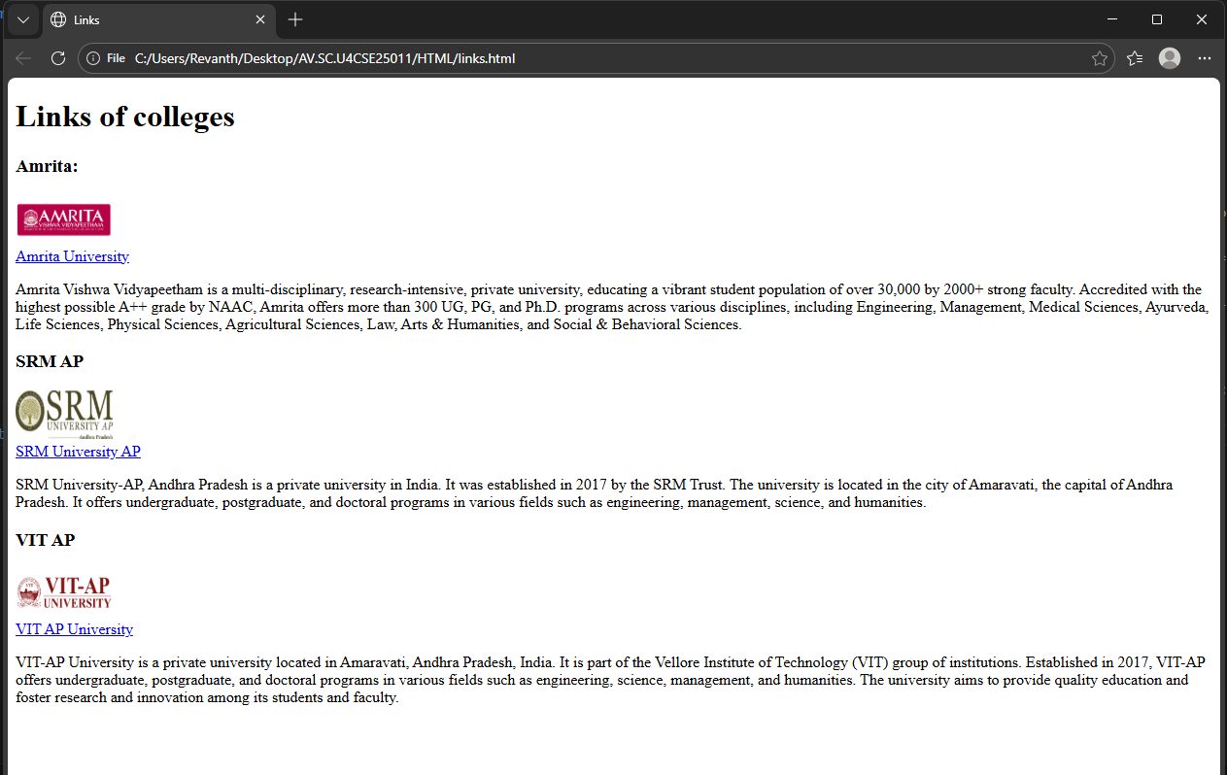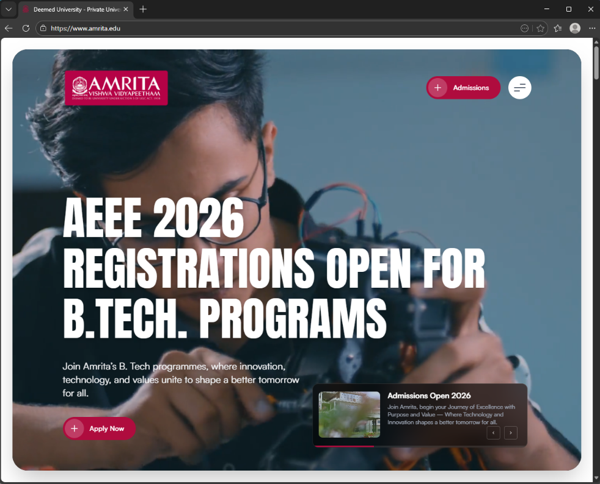

HTML
- HTML stands for Hyper Text Markup Language.
- It is a standard markup language for creating webpages.
- It consists of a series of elements.
- The elements of HTML tells the browser how to display the content.
- It contains a lot of tags, which are useful to write a code.
- An HTML element is defined by a start tag, some content, and an end tag.
- Opening tag: - <tagname>, closing tag: - </tagname>.
- Some of those tags are:
- <!DOCTYPE html>: this tells the browser that this page is written in HTML.
- <html>: this holds the entire page.
- <title>: this sets the name of the page.
- <head>: this contains information about the page.
- <body>: this contains everything that is visible on the web page.
- <h1>: this shows the biggest heading on the web page. There are still 5 more headings up to <h6>, which represent different sizes of headings or texts.
- <p> : this is used to write a paragragh.
- <pre>: this shows text exactly as written including spaces and line breaks.
- <br>: this moves the text to a new line.
- <img>: this displays an image on the web page.
- <a>: this creates a clickable link in the webpage to another page.
And their closing tags.

WEEK-2
AIM: To create a restaurant menu using tables
Program:
<!DOCTYPE html>
<html>
<head>
<title>Restaurant Menu</title>
</head>
<body style="background-image: url(menu\ bg.avif);background-repeat: no-repeat; background-size: cover;font-size: large;text-align: center;">
<h1 style="color: darkred;">Copper Spoon Restaurant</h1>
<h4 style="color: purple;">Delicious food at affordable prices</h4>
<img src="menu.png" alt="Restaurant Image" width="300">
<h2 style="color: darkred;">About Us</h2>
<pre>
Copper Spoon is a family restaurant.
We serve fresh food every day.
Quality and hygiene are our top priority.
</pre>
<h2 style="color: darkred;">Menu</h2>
<img src="soup.png" alt="Soup" align="left" style="margin-left: 600px;">
<table style="margin-left: 1160px; margin-right: auto;border: 1px solid black;padding: 10px;">
<caption style="color: darkblue;font-size: x-large;font-weight: bold;">Starters</caption>
<tr>
<th style="border: 1px solid black;">Item</th>
<th style="border: 1px solid black;">Price (₹)</th>
</tr>
<tr>
<td>Veg Soup</td>
<td>80</td>
</tr>
<tr>
<td>French Fries</td>
<td>100</td>
</tr>
<tr>
<td>Paneer Tikka</td>
<td>150</td>
</tr>
</table><br>
<table style="margin-left: 1130px; margin-right: auto;border: 1px solid black;padding: 10px;">
<caption style="color: darkblue;font-size: x-large;font-weight: bold;">Main Course</caption>
<tr>
<th style="border: 1px solid black;">Item</th>
<th style="border: 1px solid black;">Price (₹)</th>
</tr>
<tr>
<td>Veg Fried Rice</td>
<td>180</td>
</tr>
<tr>
<td>Chicken Biryani</td>
<td>250</td>
</tr>
<tr>
<td>Paneer Butter Masala</td>
<td>220</td>
</tr>
<tr>
<td>Chicken Noodles</td>
<td>160</td>
</tr>
<tr>
<td>Butter Naan</td>
<td>40</td>
</tr>
</table>
<img src="ice.jpg" alt="Dessert" align="right" style="margin-right: 600px; width: 300px; height: 200px;"><br>
<table style="margin-left: 1160px; margin-right: auto;border: 1px solid black;padding: 10px;">
<caption style="color: darkblue;font-size: x-large;font-weight: bold;">Desserts</caption>
<tr>
<th style="border: 1px solid black;">Item</th>
<th style="border: 1px solid black;">Price (₹)</th>
</tr>
<tr>
<td>Ice Cream</td>
<td>70</td>
</tr>
<tr>
<td>Gulab Jamun</td>
<td>60</td>
</tr>
<tr>
<td>Mojito</td>
<td>70</td>
</tr> </table>
<h2 style="color: darkred;margin-left: 900px;">Contact Information</h2>
<pre style="text-align: left; margin-left: 1100px;">
Phone : 7075909353
Email : copperspoon@gmail.com
Address : Lakshmipuram, main road, Guntur.
</pre>
<p>Thank you for visiting our restaurant!</p>
</body>
</html>
Output:
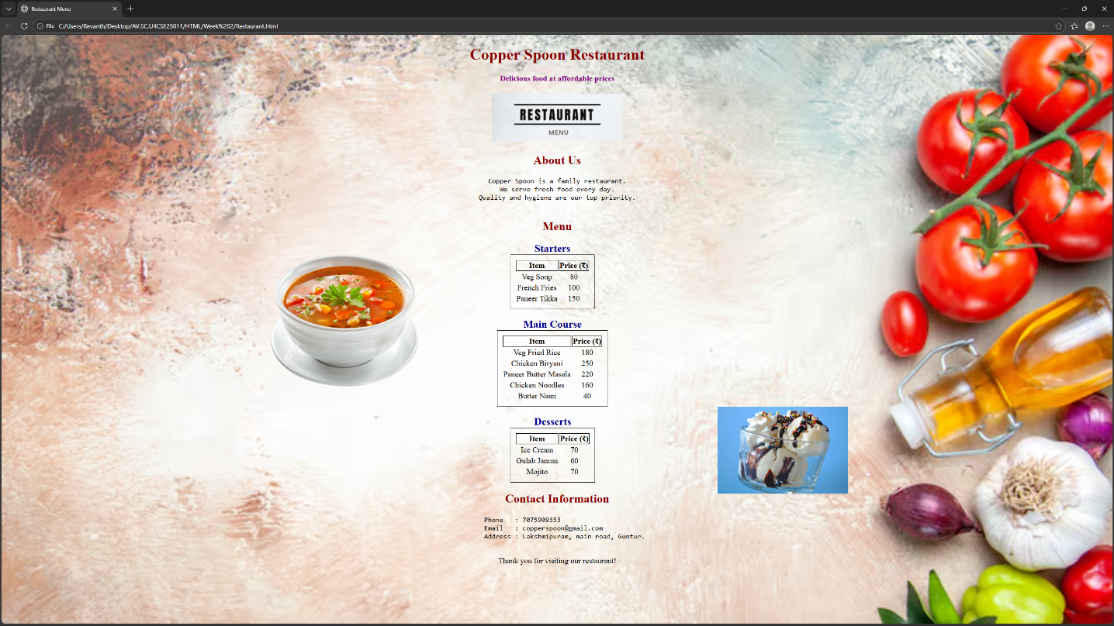

Tags
<u> – Underlines the text between the open tag and closed tag.
<b> – Displays text in bold.
<strong> – Marks text as strongly important and usually displays it in bold.
<sub> – Shows text as subscript, which is, below the normal text line.
<i> – Displays text in italic style.
<sup> – Shows text as superscript, which is, above the normal text line.
<del> – Represents deleted or removed text with a strike-through.
<mark> – Highlights text to indicate special importance.

WEEK-3

3A) AIM: Class Timetable using html elements
Program:
<!DOCTYPE html>
<html>
<head>
<title>Timetable</title>
</head>
<body>
<table border="1px" cellspacing="0" cellpadding="5" style="text-align: center; margin-left: auto; margin-right: auto;width: 100%;">
<tr>
<th colspan="12">Master Time Table CSE II Semester A Section</th>
</tr>
<tr>
<td colspan="4" style="text-align: left;">Dept. CSE</td>
<td rowspan="3" colspan="8" style="text-align: left;">Class Room Venue: 510</td>
</tr>
<tr>
<td colspan="4" style="text-align: left;">Class: B.Tech CSE-A</td>
</tr>
<tr>
<td colspan="4" style="text-align: left;">Semester-II</td>
</tr>
<tr style="text-align: left; height: 100px;">
<td colspan="4"><pre>
Class Advisors:
1. Name: Dr. K. Sindhu
Email : k_sindhu@av.amrita.edu
Mobile Number : +91-9959387057</pre></td>
<td colspan="8">
<pre>2. Name: Dr. Sumanta Kumar Nanda
Email : n_sumantakumar@av.amrita.edu
Mobile Number :+91- 7978115993</pre></td>
</tr>
<tr>
<th rowspan="2" width="70px">Time/ Day</th>
<td width="70px">Slot 1</td>
<td width="70px">Slot 2</td>
<td rowspan="2" width = "50px">10:35am - 10:45am</td>
<td width="70px">Slot 3</td>
<td width="70px">Slot 4</td>
<td width="70px">Slot 5</td>
<td rowspan="2" width = "50px">1:15pm - 2:05pm</td>
<td width="70px" style="padding: 0px;">Slot 6</td>
<td rowspan="2" width = "50px">3:00pm - 3:10pm</td>
<td width="70px">Slot 7</td>
<td width="70px">Slot 8</td>
</tr>
<tr>
<td>8:55am - 9:45am</td>
<td>9:45am - 10:35am</td>
<td>10:45am - 11:35am</td>
<td>11:35am - 12:25pm</td>
<td>12:25pm - 1:15pm</td>
<td>2:05pm - 3:00pm</td>
<td>3:10pm - 4:00pm</td>
<td>4:00pm - 5:00pm</td>
</tr>
<tr height="67px">
<th>Monday</th>
<td>23CSE111Object Oriented Programming</td>
<td>23CSE113User Interface Design</td>
<td rowspan="5" style="writing-mode: sideways-lr; background-color: yellow;">Short Break</td>
<td colspan="2" style="background-color: skyblue;">23MAT116Discrete Mathematics LAB</td>
<td>Library</td>
<td rowspan="5" style="writing-mode: sideways-lr; background-color: yellow;">Lunch Break</td>
<td>Library</td>
<td rowspan="5" style="writing-mode: sideways-lr; background-color: yellow;">Short Break</td>
<td colspan="2">Library/Sports</td>
</tr>
<tr height="67px">
<th>Tuesday</th>
<td colspan="2" style="background-color: skyblue;">23CSE111Object Oriented Programming LAB</td>
<td>23MAT116Discrete Mathematics</td>
<td colspan="2" style="background-color: skyblue;">23MAT117 Linear Algebra LAB</td>
<td>Library</td>
<td colspan="2">22ADM111 Glimpses of Glorious India</td>
</tr>
<tr height="67px">
<th>Wednesday</th>
<td>23PHY115Modern Physics</td>
<td>23MAT117 Linear Algebra </td>
<td>Library</td>
<td>23PHY115Modern Physics</td>
<td>23CSE111Object Oriented Programming</td>
<td style="background-color:skyblue;">23MEE115Manufacturing Practice LAB</td>
<td colspan="2" style="background-color: skyblue;">23MEE115Manufacturing Practice LAB</td>
</tr>
<tr height="67px">
<th>Thursday</th>
<td>23CSE113User Interface Design</td>
<td>23MAT117 Linear Algebra </td>
<td colspan="2" style="background-color: skyblue;">23CSE113User Interface Design LAB</td>
<td>23MAT116Discrete Mathematics</td>
<td style="color: red;">Counselling</td>
<td colspan="2">Library/Sports</td>
</tr>
<tr height="67px">
<th>Friday</th>
<td>23MAT117 Linear Algebra </td>
<td>23PHY115Modern Physics</td>
<td>23CSE111Object Oriented Programming</td>
<td>23MAT116Discrete Mathematics</td>
<td style="color: red;">Counselling</td>
<td>22ADM111 Glimpses of Glorious India</td>
<td colspan="2">Library/Sports</td>
</tr>
<tr>
<th>Course Code</th>
<th colspan="3" style="text-align: left;">Course Name</th>
<th>L-T-P</th>
<th>Credits</th>
<th colspan="3">Faculty Name</th>
<td></td>
<th colspan="2">Assisting Faculty</th>
</tr>
<tr>
<th>23MAT111</th>
<td colspan="2" style="text-align: left;">Discrete Mathematics</td>
<td></td>
<td>3-0-2</td>
<td>4</td>
<td colspan="3" style="text-align: left;">Dr.Ram Pratap Chauhan</td>
<td></td>
<td colspan="2"></td>
</tr>
<tr>
<th>23MAT117</th>
<td colspan="2" style="text-align: left;">Linear Algebra</td>
<td></td>
<td>3-0-2</td>
<td>4</td>
<td colspan="3" style="text-align: left;">Dr. Rashmi Prasad</td>
<td></td>
<td colspan="2"></td>
</tr>
<tr>
<th>23CSE111</th>
<td colspan="2" style="text-align: left;">Object Oriented Programming</td>
<td></td>
<td>3-0-2</td>
<td>4</td>
<td colspan="3" style="text-align: left;">Dr. Balaji TK</td>
<td></td>
<td colspan="2" style="text-align: left;">Dr. Satya Rajendra Singh</td>
</tr>
<tr>
<th>23PHY115</th>
<td colspan="2" style="text-align: left;">Modern Physics</td>
<td></td>
<td>2-1-0</td>
<td>3</td>
<td colspan="3" style="text-align: left;">Dr. C R Kesavulu</td>
<td></td>
<td colspan="2" style="text-align: left;"></td>
</tr>
<tr>
<th>23CSE113</th>
<td colspan="2" style="text-align: left;">User Interface Design</td>
<td></td>
<td>2-0-2</td>
<td>3</td>
<td colspan="3" style="text-align: left;">Dr. Rajkumar Batchu</td>
<td></td>
<td colspan="2" style="text-align: left;">Dr. Barge Bharadwaj</td>
</tr>
<tr>
<th>23MEE115</th>
<td colspan="2" style="text-align: left;">Manufacturing Practice</td>
<td></td>
<td>0-0-3</td>
<td>1</td>
<td colspan="3" style="text-align: left;">Dr. Sathies S</td>
<td></td>
<td colspan="2" style="text-align: left;"></td>
</tr>
<tr>
<th>22ADM111</th>
<td colspan="2" style="text-align: left;">Glimpses of Glorious India</td>
<td></td>
<td>2-0-1</td>
<td>2</td>
<td colspan="3" style="text-align: left;">Dr. Siva Panuganti</td>
<td></td>
<td colspan="2" style="text-align: left;"></td>
</tr>
<tr>
<td></td>
<td colspan="2">Total(15L + 1Tut + 12P=28hrs)</td>
<td></td>
<td>15-1-12</td>
<td>21</td>
<td colspan="3"></td>
<td></td>
<td colspan="2"></td>
</tr>
</table>
</body>
</html>

Output:
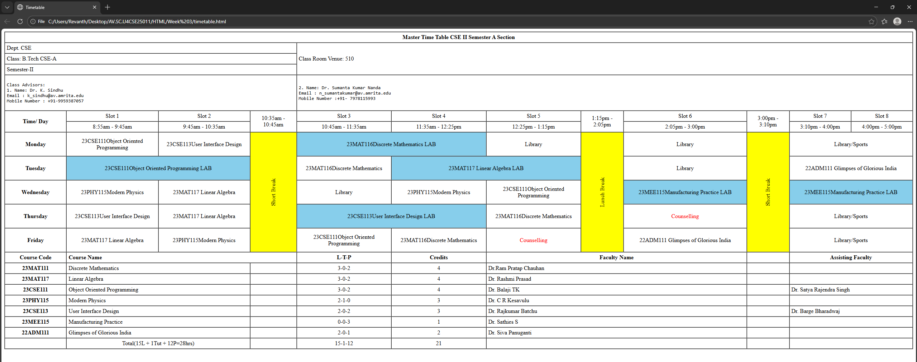

3B) AIM: Syllabus and Timetable using HTML

PROGRAM:
<!DOCTYPE html>
<html>
<head>
<title>Syllabus</title>
</head>
<body>
<h1 style="text-align: center;">Syllabus of B.Tech CSE</h1>
<table width ="100%" style="text-align: center;">

<tr>
<td><h3>Discrete Mathematics 23MAT116</h3></td>
<td><h3>Linear Algebra 23MAT117</h3></td>
</tr>
<tr></tr>
<td><img src="dm.png"></td>
<td ><img src="la.png"></td>
</tr>
<tr>
<td><br><br></td>
</tr>
<tr>
<td><h3>Object Oriented Programming 23CSE111</h3></td>
<td><h3>Modern Physics 23PHY115</h3></td>
</tr>
<tr>
<td><img src="oops.png"></td>
<td><img src="mp.png"></td>
</tr>
<tr>
<td><br><br></td>
</tr>
<tr>
<td><h3>User Interface Design 23CSE113</h3></td>
<td><h3>Manufacturing Practice 23MEE115</h3></td>
</tr>
<tr>
<td><img src="uid.png"></td>
<td><img src="mpl.png"></td>
</tr>
<tr>
<td><br><br></td>
</tr>
<tr>
<td colspan="2"><h3>Glimpses of Glorious India 22ADM111</h3></td>
</tr>
<tr>
<td colspan="2"><img src="gg.png"></td>
</tr>
<tr>
<td colspan="2"><br><br></td>
</tr>

</table>

</body>

<body>
<table border="1px" cellspacing="0" cellpadding="5" style="text-align: center; margin-left: auto; margin-right: auto;width: 100%;">
<tr>
<th colspan="12">Master Time Table CSE II Semester A Section</th>
</tr>
<tr>
<td colspan="4" style="text-align: left;">Dept. CSE</td>
<td rowspan="3" colspan="8" style="text-align: left;">Class Room Venue: 510</td>
</tr>
<tr>
<td colspan="4" style="text-align: left;">Class: B.Tech CSE-A</td>
</tr>
<tr>
<td colspan="4" style="text-align: left;">Semester-II</td>
</tr>
<tr style="text-align: left; height: 100px;">
<td colspan="4"><pre>
Class Advisors:
1. Name: Dr. K. Sindhu
Email : k_sindhu@av.amrita.edu
Mobile Number : +91-9959387057</pre></td>
<td colspan="8">
<pre>2. Name: Dr. Sumanta Kumar Nanda
Email : n_sumantakumar@av.amrita.edu
Mobile Number :+91- 7978115993</pre></td>
</tr>
<tr>
<th rowspan="2" width="70px">Time/ Day</th>
<td width="70px">Slot 1</td>
<td width="70px">Slot 2</td>
<td rowspan="2" width = "50px">10:35am - 10:45am</td>
<td width="70px">Slot 3</td>
<td width="70px">Slot 4</td>
<td width="70px">Slot 5</td>
<td rowspan="2" width = "50px">1:15pm - 2:05pm</td>
<td width="70px" style="padding: 0px;">Slot 6</td>
<td rowspan="2" width = "50px">3:00pm - 3:10pm</td>
<td width="70px">Slot 7</td>
<td width="70px">Slot 8</td>
</tr>
<tr>
<td>8:55am - 9:45am</td>
<td>9:45am - 10:35am</td>
<td>10:45am - 11:35am</td>
<td>11:35am - 12:25pm</td>
<td>12:25pm - 1:15pm</td>
<td>2:05pm - 3:00pm</td>
<td>3:10pm - 4:00pm</td>
<td>4:00pm - 5:00pm</td>
</tr>
<tr height="67px">
<th>Monday</th>
<td>23CSE111Object Oriented Programming</td>
<td>23CSE113User Interface Design</td>
<td rowspan="5" style="writing-mode: sideways-lr; background-color: yellow;">Short Break</td>
<td colspan="2" style="background-color: skyblue;">23MAT116Discrete Mathematics LAB</td>
<td>Library</td>
<td rowspan="5" style="writing-mode: sideways-lr; background-color: yellow;">Lunch Break</td>
<td>Library</td>
<td rowspan="5" style="writing-mode: sideways-lr; background-color: yellow;">Short Break</td>
<td colspan="2">Library/Sports</td>
</tr>
<tr height="67px">
<th>Tuesday</th>
<td colspan="2" style="background-color: skyblue;">23CSE111Object Oriented Programming LAB</td>
<td>23MAT116Discrete Mathematics</td>
<td colspan="2" style="background-color: skyblue;">23MAT117 Linear Algebra LAB</td>
<td>Library</td>
<td colspan="2">22ADM111 Glimpses of Glorious India</td>
</tr>
<tr height="67px">
<th>Wednesday</th>
<td>23PHY115Modern Physics</td>
<td>23MAT117 Linear Algebra </td>
<td>Library</td>
<td>23PHY115Modern Physics</td>
<td>23CSE111Object Oriented Programming</td>
<td style="background-color:skyblue;">23MEE115Manufacturing Practice LAB</td>
<td colspan="2" style="background-color: skyblue;">23MEE115Manufacturing Practice LAB</td>
</tr>
<tr height="67px">
<th>Thursday</th>
<td>23CSE113User Interface Design</td>
<td>23MAT117 Linear Algebra </td>
<td colspan="2" style="background-color: skyblue;">23CSE113User Interface Design LAB</td>
<td>23MAT116Discrete Mathematics</td>
<td style="color: red;">Counselling</td>
<td colspan="2">Library/Sports</td>
</tr>
<tr height="67px">
<th>Friday</th>
<td>23MAT117 Linear Algebra </td>
<td>23PHY115Modern Physics</td>
<td>23CSE111Object Oriented Programming</td>
<td>23MAT116Discrete Mathematics</td>
<td style="color: red;">Counselling</td>
<td>22ADM111 Glimpses of Glorious India</td>
<td colspan="2">Library/Sports</td>
</tr>
<tr>
<th>Course Code</th>
<th colspan="3" style="text-align: left;">Course Name</th>
<th>L-T-P</th>
<th>Credits</th>
<th colspan="3">Faculty Name</th>
<td></td>
<th colspan="2">Assisting Faculty</th>
</tr>
<tr>
<th>23MAT111</th>
<td colspan="2" style="text-align: left;">Discrete Mathematics</td>
<td></td>
<td>3-0-2</td>
<td>4</td>
<td colspan="3" style="text-align: left;">Dr.Ram Pratap Chauhan</td>
<td></td>
<td colspan="2"></td>
</tr>
<tr>
<th>23MAT117</th>
<td colspan="2" style="text-align: left;">Linear Algebra</td>
<td></td>
<td>3-0-2</td>
<td>4</td>
<td colspan="3" style="text-align: left;">Dr. Rashmi Prasad</td>
<td></td>
<td colspan="2"></td>
</tr>
<tr>
<th>23CSE111</th>
<td colspan="2" style="text-align: left;">Object Oriented Programming</td>
<td></td>
<td>3-0-2</td>
<td>4</td>
<td colspan="3" style="text-align: left;">Dr. Balaji TK</td>
<td></td>
<td colspan="2" style="text-align: left;">Dr. Satya Rajendra Singh</td>
</tr>
<tr>
<th>23PHY115</th>
<td colspan="2" style="text-align: left;">Modern Physics</td>
<td></td>
<td>2-1-0</td>
<td>3</td>
<td colspan="3" style="text-align: left;">Dr. C R Kesavulu</td>
<td></td>
<td colspan="2" style="text-align: left;"></td>
</tr>
<tr>
<th>23CSE113</th>
<td colspan="2" style="text-align: left;">User Interface Design</td>
<td></td>
<td>2-0-2</td>
<td>3</td>
<td colspan="3" style="text-align: left;">Dr. Rajkumar Batchu</td>
<td></td>
<td colspan="2" style="text-align: left;">Dr. Barge Bharadwaj</td>
</tr>
<tr>
<th>23MEE115</th>
<td colspan="2" style="text-align: left;">Manufacturing Practice</td>
<td></td>
<td>0-0-3</td>
<td>1</td>
<td colspan="3" style="text-align: left;">Dr. Sathies S</td>
<td></td>
<td colspan="2" style="text-align: left;"></td>
</tr>
<tr>
<th>22ADM111</th>
<td colspan="2" style="text-align: left;">Glimpses of Glorious India</td>
<td></td>
<td>2-0-1</td>
<td>2</td>
<td colspan="3" style="text-align: left;">Dr. Siva Panuganti</td>
<td></td>
<td colspan="2" style="text-align: left;"></td>
</tr>
<tr>
<td></td>
<td colspan="2">Total(15L + 1Tut + 12P=28hrs)</td>
<td></td>
<td>15-1-12</td>
<td>21</td>
<td colspan="3"></td>
<td></td>
<td colspan="2"></td>
</tr>
</table>
</body>
</html>

OUTPUT:
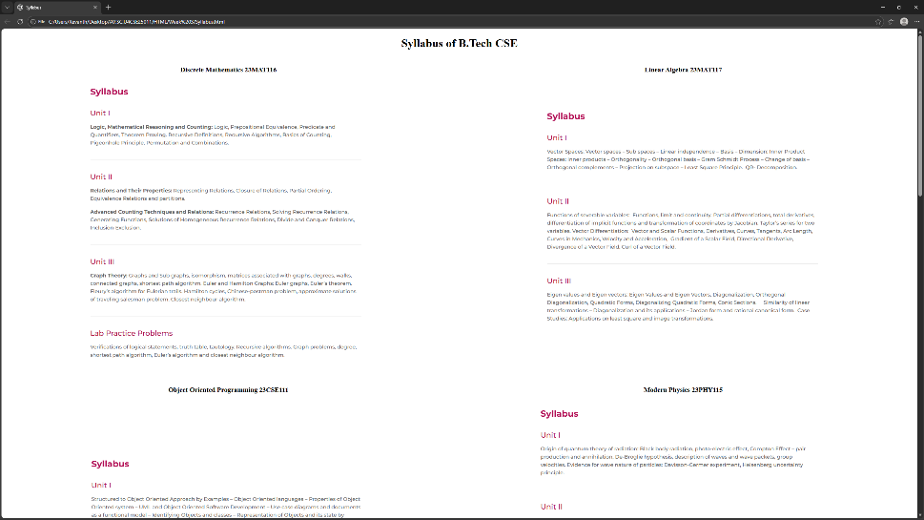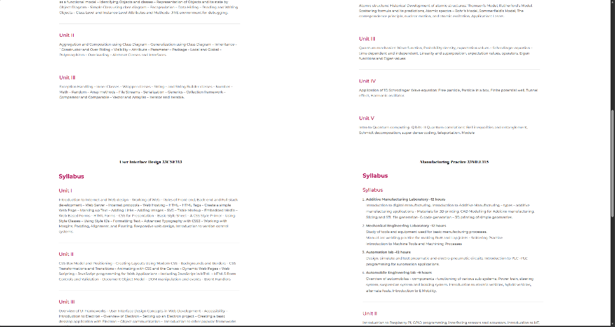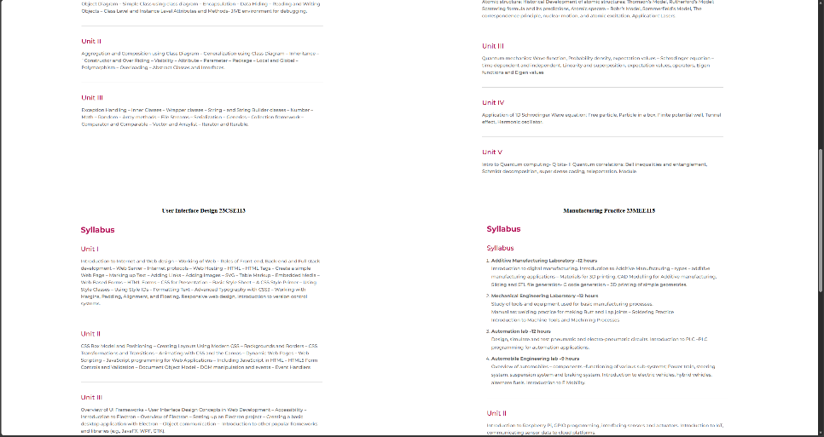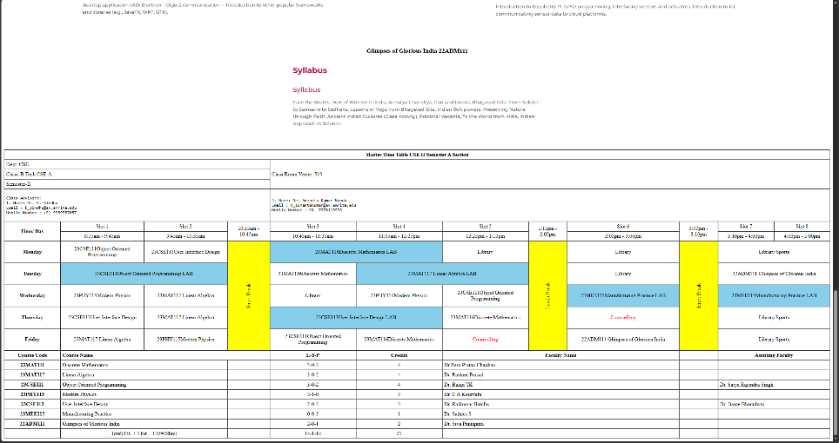

WEEK-4

4A) AIM: Regestration form using HTML tags.
PROGRAM:
<!DOCTYPE html>
<html>
<head>
<title>Admission Form</title>
</head>
<body style="background-color: lightskyblue; text-align: center;">
<h1>Admission Form</h1>
<form>
<table border="1px" align="center" cellpadding="10px" cellspacing="0px" style="background-color: white; text-align: left;">
<tr>
<td><label for="name">Name:</label></td>
<td><input type="text" id="name" name="name" placeholder="Enter your name" required></td>
</tr>
<tr>
<td><label for="email">Email:</label></td>
<td><input type="email" id="email" name="email" placeholder="Enter your email"></td>
</tr>
<tr>
<td><label for="phone">Phone Number:</label></td>
<td><input type="tel" id="phone" name="phone" placeholder="Enter your phone number"></td>
</tr>
<tr>
<td><label for="gender">Gender:</label></td>p;
<td>
<input type="radio" id="male" name="gender" value="male">
<label for="male">Male</label>
<input type="radio" id="female" name="gender" value="female">
<label for="female">Female</label>
</td>
</tr>
<tr>
<td><label for="course">Course:</label></td>
<td>
<select id="course" name="course">
<option value="">Select Course</option>
<option value="btech">B.Tech</option>
<option value="mtech">M.Tech</option>
<option value="phd">Ph.D.</option>
</select>
</td>
</tr>
<tr>
<td><label for="hobbies">Hobbies:</label></td>
<td>
<input type="text" id="hobbies" name="hobbies" placeholder="Enter your hobbies">
</td>
</tr>
<tr>
<td><label for="dob">Date of Birth:</label></td>
<td><input type="date" id="dob" name="dob" max="2026-02-12"></td>
</tr>
<tr>
<td><label for="certificate">Upload certificate:</label></td>
<td><input type="file" id="certificate" name="certificate"></td>
</tr>
<tr>
<td><label for="address">Address:</label></td>
<td><textarea id="address" name="address" rows="4" cols="30" placeholder="Enter your address"></textarea></td>
</tr>
<tr>
<td colspan="2" align="center">
<input type="submit" value="Submit">
<input type="reset" value="Reset"></td>
</tr>
</table>
</form>
</html>

OUTPUT:
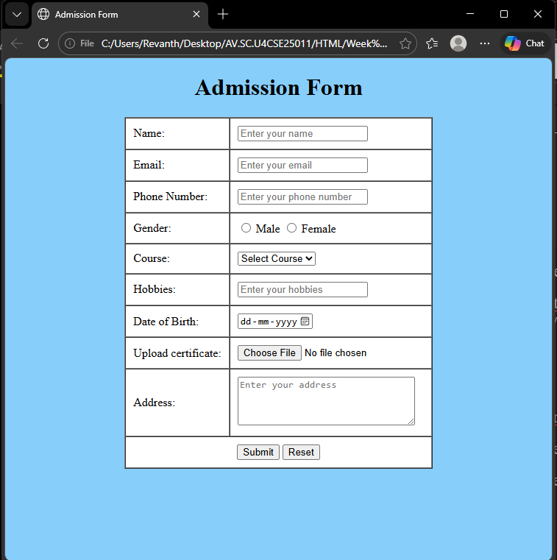
4B) AIM: Two different forms in one webpage using iframes.
PROGRAM:
Main page:
<!DOCTYPE html>
<html>
<head>
<title>Login Form</title>
</head>
<body style="background-color: beige;">
<h1 style="text-align: center;">Two forms displayed using iframes</h1>
<div style="display:flex; gap:20px; flex-wrap:wrap; margin-left: auto; margin-right: auto; width: 80%;">
<iframe src="u_login_page.html" height="350" style="flex:1; border: 2px solid black;"></iframe>
<iframe src="user_registration.html" height="350" style="flex:1; border: 2px solid black;"></iframe>
</div>
</body>
</html>

Login form:
<!DOCTYPE html>
<html>
<head>
<title>Login Form</title>
</head>
<body style="text-align: center;">
<h1>User Login</h1>
<form>
<table border="1px" align="center" cellpadding="10px" cellspacing="0px" style="text-align: left;">
<tr>
<td><label for="username">Username:</label></td>
<td><input type="text" id="username" name="username" placeholder="Enter your username" required></td>
</tr>
<tr>
<td><label for="password">Password:</label></td>
<td><input type="password" id="password" name="password" placeholder="Enter your password"></td>
</tr>
<tr>
<td colspan="2" style="text-align: center;"><input type="submit" value="Login"></td>
</tr>
</table>
</form>
</html>

Registaration form:

<!DOCTYPE html>
<html>
<head>
<title>User Registration</title>
</head>
<body style="text-align: center;">
<h1>User Registration</h1>
<form>
<table border="1px" align="center" cellpadding="10px" cellspacing="0px" style="text-align: left;">
<tr>
<td><label for="name">Name:</label></td>
<td><input type="text" id="name" name="name" placeholder="Enter your name" required></td>
</tr>
<tr>
<td><label for="email">Email:</label></td>
<td><input type="email" id="email" name="email" placeholder="Enter your email" required></td>
</tr>
<tr>
<td><label for="password">Password:</label></td>
<td><input type="password" id="password" name="password" placeholder="Enter your password"></td>
</tr>
<tr>
<td><label for="phone">Phone:</label></td>
<td><input type="tel" id="phone" name="phone" placeholder="Enter your phone number"></td>
</tr>
<tr>
<td colspan="2" style="text-align: center;">
<input type="submit" value="Register">
<input type="reset" value="Reset">
</td>
</tr>
</table>
</form>
</html>

OUTPUT:
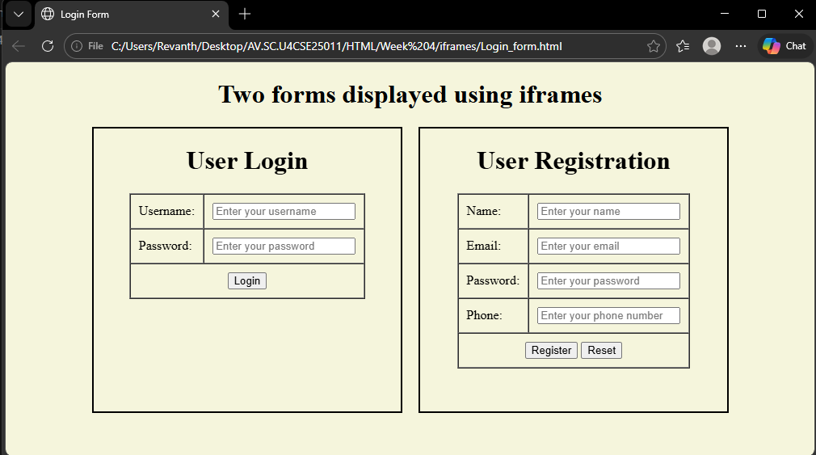
If screen size is minimised:
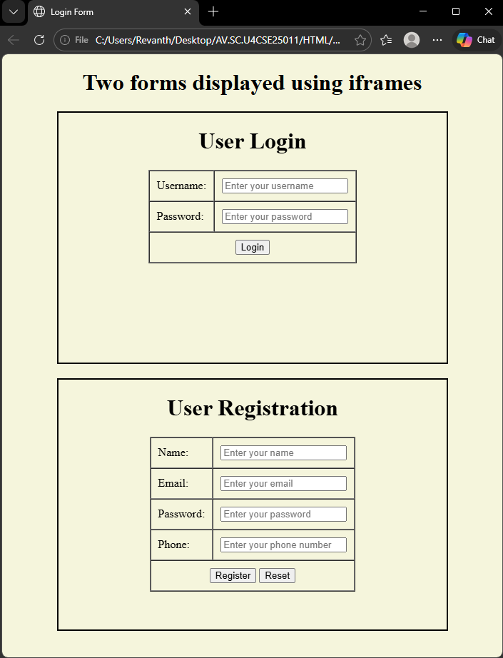

WEEK-5

5A) AIM: To create a responsive card layout using HTML and CSS with three cards, each containing an image, title, and button.
PROGRAM:
<!DOCTYPE html>
<html>
<head>
<title>Card Layout with Images</title>
<style>
body{
font-family: Arial, sans-serif;
background-color: #f2f2f2;
}
.card-container{
display: flex;
justify-content: center;
gap: 30px;
margin-top: 50px;
}
.card{
background-color: white;
width: 260px;
border-radius: 10px;
box-shadow: 0px 4px 8px rgba(0,0,0,0.2);
text-align: center;
overflow: hidden;
}
.card img{
width: 100%;
height: 180px;
object-fit: cover;
}
.card-content{
padding: 15px;
}
.card h2{
margin: 10px 0;
}
.card p{
font-size: 14px;
color: gray;
}
.card button{
margin-top: 10px;
padding: 8px 15px;
border: none;
background-color:blue;
color: white;
border-radius: 5px;
cursor: pointer;
}
</style>
</head>
<body>
<div class="card-container">
<div class="card">
<img src="valorant.jpg">
<div class="card-content">
<h2>Valorant</h2>
<p>Valorant is a popular 5v5 character-based tactical first-person shooter developed by Riot Games. It combines precise, high-stakes gunplay with unique agent abilities, requiring strategic teamwork and fast thinking across 13-round halves. Players can choose from a diverse roster of agents to outplay opponents in various competitive and casual modes.</p>
<button>Read More</button>
</div>
</div>
<div class="card">
<img src="cs2.jpg">
<div class="card-content">
<h2>Counter-Strike 2</h2>
<p>Counter-Strike 2 (CS2) is a premier tactical first-person shooter developed by Valve, released on September 27, 2023, as a free-to-play, direct successor to Counter-Strike: Global Offensive. Built on the Source 2 engine, the game features major technical upgrades including revamped, high-fidelity maps, overhauled lighting, and a new "sub-tick" server architecture designed for better gameplay responsiveness. While it maintains the core 5v5 bomb-defusal gameplay, it introduces dynamic, volumetric smoke grenades that interact with the environment.</p>
<button>Read More</button>
</div>
</div>
<div class="card">
<img src="fn.jpg">
<div class="card-content">
<h2>Fortnite</h2>
<p>Fortnite, developed by Epic Games and released in 2017, is a massively popular free-to-play battle royale game that has become a major cultural phenomenon. In the primary game mode, 100 players skydive onto an island, scavenging for weapons and resources to be the last person or team standing while avoiding a shrinking "storm". A key differentiator from other shooters is the ability to instantly build structures for defense or tactical advantage, along with a bright, cartoonish art style that appeals to a wide audience. With constant updates, seasonal changes, and collaborations, Fortnite</p>
<button>Read More</button>
</div>
</div>
</div>
</body>
</html>

OUTPUT:
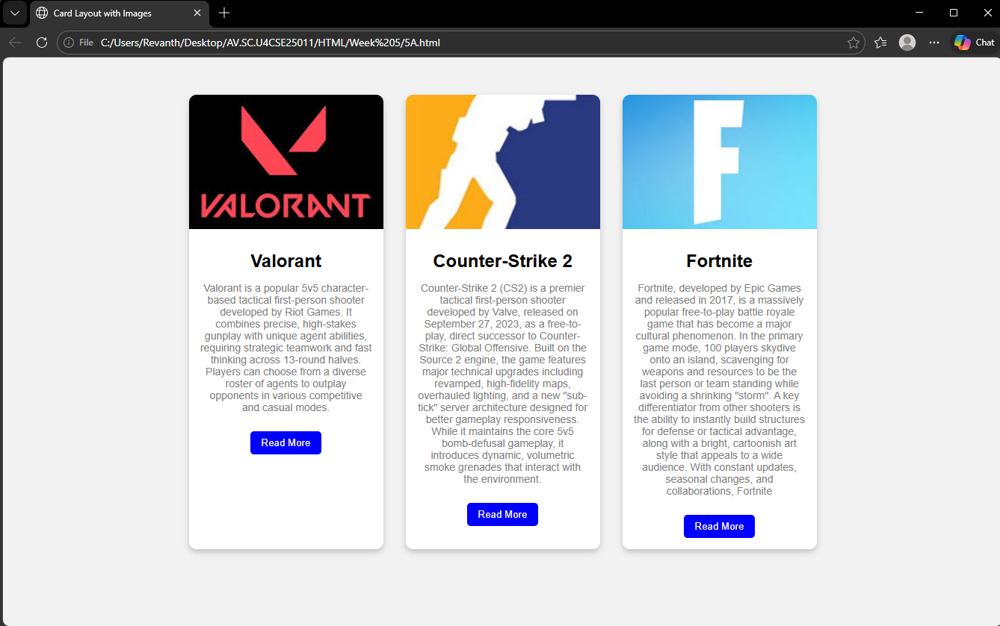

5B) AIM: To design a mini website using iframe with navigation links (Home, About, Contact), where clicking on each link displays the respective content within the same page using internal or external CSS.
PROGRAM:
<!DOCTYPE html>
<html>
<head>
<title>Mini Website - Amrita</title>
<style>
body{
margin:0;
font-family: Arial, sans-serif;
}
.header{
background: purple;
color:white;
text-align:center;
padding:15px;
}
.nav{
background:black;
text-align:center;
padding:12px;
}
.nav label{
color:white;
margin:0 20px;
font-size:18px;
cursor:pointer;
}
.nav label:hover{
color:yellow;
}
iframe{
width:100%;
height:500px;
border:none;
}
input{
display:none;
}
.content{
display:none;
}
#home:checked ~ #homeFrame,
#about:checked ~ #aboutFrame,
#contact:checked ~ #contactFrame{
display:block;
}
</style>
</head>
<body>
<div class="header">
<h2>Theesakapo</h2>
</div>
<input type="radio" name="menu" id="home" >
<input type="radio" name="menu" id="about">
<input type="radio" name="menu" id="contact">
<div class="nav">
<label for="home">Home</label>
<label for="about">About</label>
<label for="contact">Contact</label>
</div>
<iframe id="homeFrame" class="content" srcdoc="
<h1>Welcome to Theesakapo</h1>
<p>Theesakapo is a leading technology company based in Guntur, India, founded by Revanth in 2026. It started as a vast e-commerce platform offering a wide range of products and services, including electronics, clothing, groceries, and digital content. Theesakapo is also known for its fast delivery services, which has become a major revenue stream for the company. With its customer-centric approach, innovative technologies like 5 min delivery and VIP delivery, and global reach, Theesakapo has become one of the largest and most influential companies in the world.</p>">
</iframe>
<iframe id="aboutFrame" class="content" srcdoc="
<h1>About Us</h1>
<p>We are a team of passionate individuals dedicated to providing the best shopping experience possible. Our mission is to make online shopping simple, secure, and enjoyable for everyone.
<br>Our vision is to be the most customer-centric company in the world, where customers can find and discover anything they might want to buy online. We are committed to innovation, quality, and customer satisfaction, and we strive to exceed our customers' expectations every day.</p>
<p>At Theesakapo, we believe in giving back to the community and supporting sustainable practices. We are committed to reducing our environmental impact and promoting social responsibility in all aspects of our business.</p>
<p>Thank you for choosing Theesakapo. We look forward to serving you and providing you with an exceptional shopping experience.</p>">
</iframe>
<iframe id="contactFrame" class="content" srcdoc="
<h1>Contact Us</h1>
<p>If you have any questions or need assistance, please feel free to reach out to us at
<br>Email: info@theesakapo.com</p>
">
</iframe>
</body>
</html>
OUTPUT:
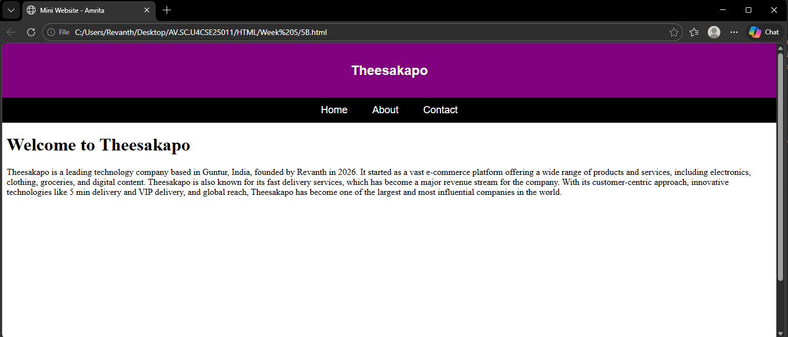
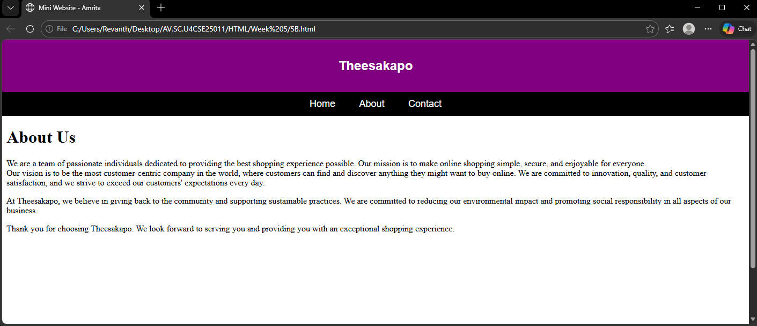
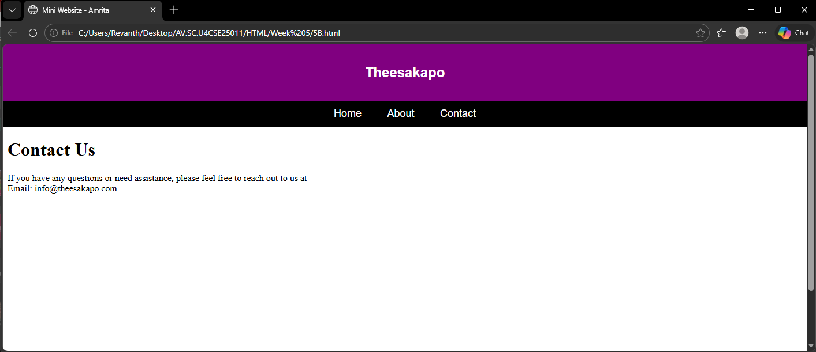

5C) AIM: To design an Amrita login page using HTML and CSS that displays different campuses, where clicking on each campus shows its details on the same page.
PROGRAM:
<!DOCTYPE html>
<html>
<head>
<title>Amrita Vishwa Vidyapeetham</title>
<style>
body{
margin:0;
font-family: Arial, sans-serif;
background: linear-gradient(to right, rgb(85, 0, 0), rgb(255, 0, 0));
}
.container{
width: 90%;
margin: 30px auto;
background: white;
padding: 20px;
border-radius: 10px;
box-shadow: 0px 0px 10px gray;
}
h1{
text-align: center;
color: crimson;
}
.campus-links{
text-align: center;
margin-bottom: 20px;
}
.campus-links a{
text-decoration: none;
margin: 0 15px;
color: black;
font-weight: bold;
}
.campus-links a:hover{
color: crimson;
}
.main{
display: flex;
gap: 20px;
}
.login{
width: 35%;
background: #f4f4f4;
padding: 20px;
border-radius: 10px;
}
.login input, .login select{
width: 100%;
padding: 10px;
margin: 10px 0;
border-radius: 5px;
border: 1px solid gray;
}
.login button{
width: 100%;
padding: 10px;
background: rgb(131, 0, 0);
color: white;
border: none;
border-radius: 5px;
cursor: pointer;
}
.about{
width: 65%;
background: #fafafa;
padding: 20px;
border-radius: 10px;
}
.campus-content{
display: none;
}
.campus-content:target{
display: block;
}
.campus-content img{
width: 90%;
height: 550px;
object-fit: cover;
border-radius: 10px;
margin-bottom: 15px;
}
</style>
</head>
<body>
<div class="container">
<h1>AMRITA VISHWA VIDYAPEETHAM</h1>
<div class="campus-links">
<a href="#amaravati">Amaravati</a>
<a href="#chennai">Chennai</a>
<a href="#amritapuri">Amritapuri</a>
<a href="#coimbatore">Coimbatore</a>
<a href="#bangalore">Bangalore</a>
<a href="#mysore">Mysore</a>
</div>
<div class="main">
<div class="about">
<h3>About the Campus</h3>
<div id="amaravati" class="campus-content">
<img src="amaravati.jpg" alt="Amaravati Campus">
<h4>Amaravati Campus</h4>
<p>Modern infrastructure and advanced engineering programs.A newer campus, expanding the university's presence in South India.</p>
</div>
<div id="amritapuri" class="campus-content">
<img src="amritapuri.jpg" alt="Amritapuri Campus">
<h4>Amritapuri Campus</h4>
<p>Main campus located in Kerala known for research excellence.Known for engineering and biotechnology.Situated near the beach, it focuses on, for example, biotechnology, engineering, and spiritual-based education.</p>
</div>
<div id="chennai" class="campus-content">
<img src="chennai.jpg" alt="Chennai Campus">
<h4>Chennai Campus</h4>
<p>Strong industry collaboration and technical programs.Offers various engineering programs.</p>
</div>
<div id="coimbatore" class="campus-content">
<img src="coimbatore.jpg" alt="Coimbatore Campus">
<h4>Coimbatore Campus</h4>
<p>Known for innovation and academic excellence.Administrative headquarters, engineering, and business schools.Located in Ettimadai, it is the administrative headquarters and houses the main Schools of Engineering and Business. It features a large, green campus with extensive infrastructure (libraries, labs).</p>
</div>
<div id="mysore" class="campus-content">
<img src="mysore.jpg" alt="Mysore Campus">
<h4>Mysore Campus</h4>
<p>Focused on computing and engineering education.</p>
</div>
<div id="bangalore" class="campus-content">
<img src="bengaluru.jpg" alt="Bangalore Campus">
<h4>Bangalore Campus</h4>
<p>Offers management and technology programs.Focuses on engineering and technology. Focuses on technology, with strong placement opportunities and proximity to the tech hub.</p>
</div>
</div>
<div class="login">
<h3>Student Login</h3>
<input type="text" placeholder="Username">
<input type="password" placeholder="Password">
<input type="email" placeholder="Enter Email" required>
<input type="tel" placeholder="Enter Phone Number" required>
<select required>
<option value="">Select Course</option>
<option>B.Tech</option>
<option>M.Tech</option>
<option>BCA</option>
<option>MCA</option>
<option>BBA</option>
<option>MBA</option>
<option>PhD</option>
<option>Other</option>
</select>
<button>Login</button>
</div>
</div>
<div class="footer">
<p style="text-align:center;font-size: large; margin:auto;">Life and living are not the same. For living, we may need a job, money, a home, a car and other creature comforts. However, these alone fail to make life complete. For that, we need love, compassion, tenderness — a heart that knows and responds to the pain of others. We need broadmindedness and maturity in thought and action.<br>– Amma –</p>
</div>
</div>
</body>
</html>

OUTPUT:
