**LAB # 8**

**Mutability and Immutability**

**OBJECTIVE:**

Understanding and implementing the concept of mutability and immutability.

**MUTABILITY AND IMMUTABILITY:**

Mutable means the objects can be changes and immutable means cannot be changed. In the Java programming language there are many mechanism through which mutability and immutability are achieved.

**Mutable object:**

The objects in which you can change the fields and states after the object is created are known as Mutable objects. Example: java.util.Date, StringBuilder, and etc.

**Immutable object:**

The objects in which you cannot change anything once the object is created are known as Immutable objects. Example: Boxed primitive objects like Integer, Long and etc.

**Difference:**

|  |  |
| --- | --- |
| Mutable | Immutable |
| Fields can be changed after the object creation. | Fields cannot be changed after object creation. |
| Generally provides a method to modify the field value. | Does not have any method to modify the field value. |
| Has Getter and Setter methods. | Has only Getter method |
| Example: StringBuilder, java.util.Date. | Example: String, Boxed primitive objects like Integer, Long and etc. |

***How to create a Mutable class?***

To create a mutable class in Java you have to make sure the following requirements are satisfied:

* Provide a method to modify the field values
* Getter and Setter method

Consider the following code:

|  |
| --- |
| **public** **class** Use {  **private** String coursename;  Use(String coursename)  {  **this**.coursename = coursename;  }  **public** String getName()  {  **return** coursename;  }  **public** **void** setName(String coursename)  {  **this**.coursename = coursename;  }  **public** **static** **void** main(String[] args)  {  System.***out***.println("Adding Previous course!");  Use obj = **new** Use("Software Design Architecture");  System.***out***.println("" +obj.getName()+"\n");    // update the name, this object is mutable  System.***out***.println("Updating current course!");  obj.setName("Software Construction and Development");  System.***out***.println("" +obj.getName());    }  } |

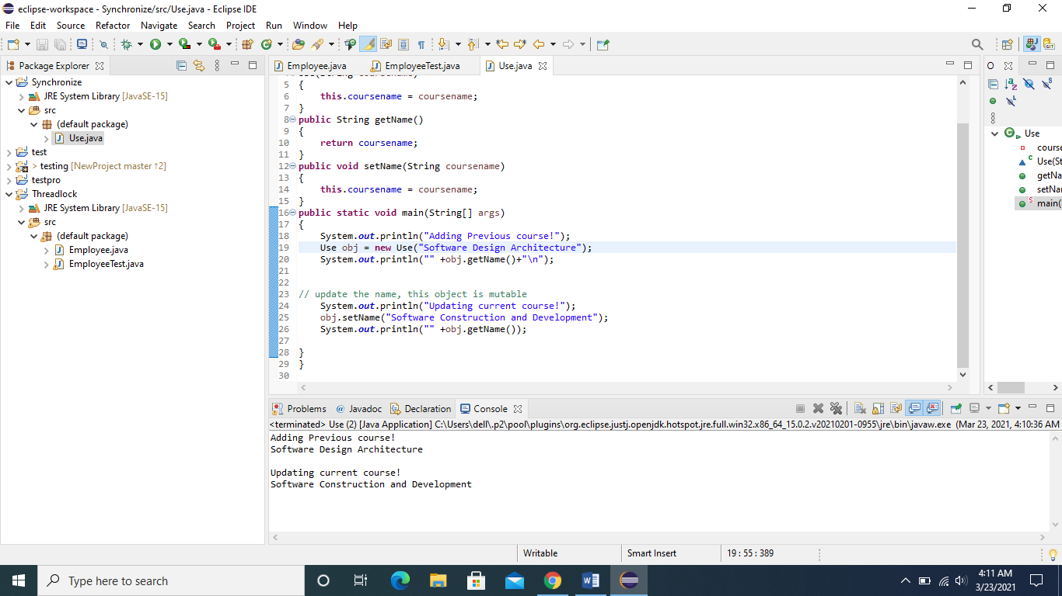

***How to create an Immutable class?***

To create an immutable class in Java you have to make sure the following requirements are satisfied:

* A class should be declared as final so that it can’t be extended.
* All the fields should be made private so that direct access is not allowed
* No setter methods
* Make all mutable fields final, so that they can be assigned only once.

|  |
| --- |
| **public** **final** **class** Use {  **final** String courseName;  **final** **int** rollNumber;  **public** Use (String courseName, **int** rollNumber) {  **this**.courseName = courseName;  **this**.rollNumber = rollNumber;  }  **public** String getCourseName() {  **return** courseName;  }  **public** **int** getRollNumber() {  **return** rollNumber;  }  **public** **static** **void** main(String[] args) {  Use obj = **new** Use ("Software Construction and Development" , 100);  // Since no setters are available contents cannot be modified.  // Also as variables are declared final they cannot be modified  System.***out***.println("Course is " + obj.getCourseName());  System.***out***.println("Roll Number is " + obj.getRollNumber());  }  } |

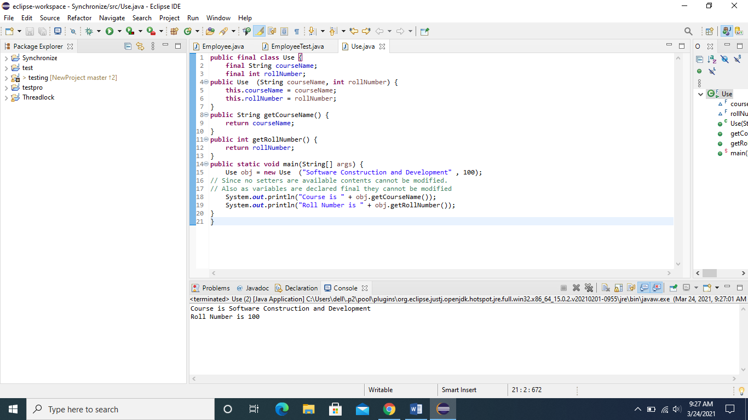

**Lab Task:**

1. Apply concept of mutability and immutability for the task promoted and failed students. The roll number, subject code, and subject name would have to be entered at time of object creation and with getter method these variables should be printed. (Hint: Those students who are failed in previous semester will be registered in immutable class, and promoted students are registered in mutable class)
2. Write a program that will calculate the below 4 formulas. Decide what to make mutable and what to make immutable and perform task operations. Formulas are:

Circumference of circle: **C = 2 π r**

Area of circle: **A = π r²**

Volume of sphere: **V = 4/3 π r3**

Surface area of sphere: **A =** **4 π r²**

(Hint: Value of pie would be constant and value of radius should be variant)