### **LAB # 09**

#### **OSPF (OPEN SHORTEST PATH FIRST)**

**OBJECTIVE**

Configuring Routing Protocol: OSPF using single area and multi area.

**Lab Task:**

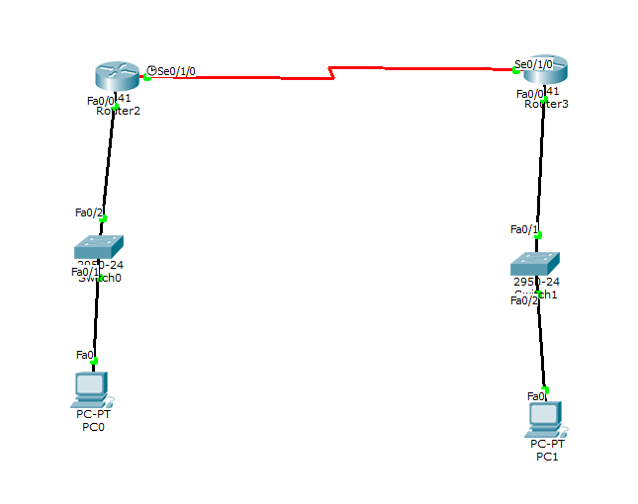

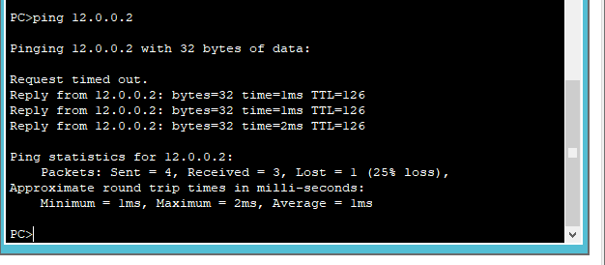

**CLI**

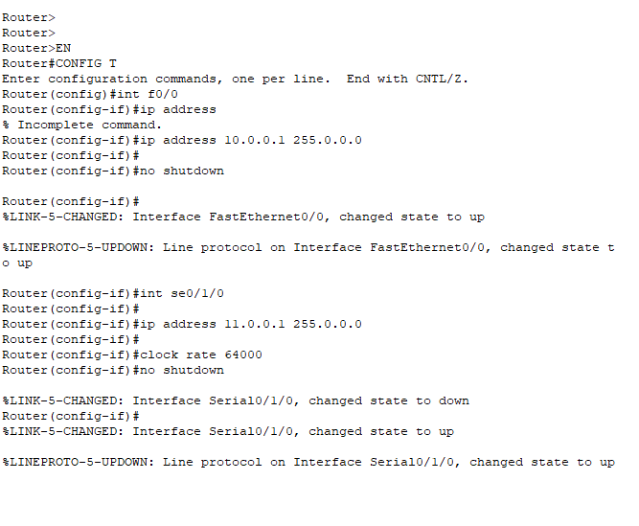

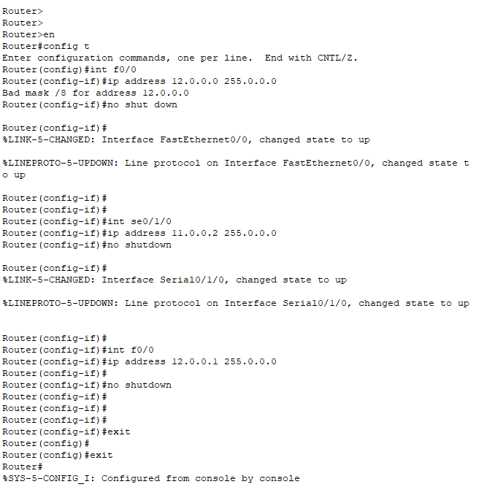

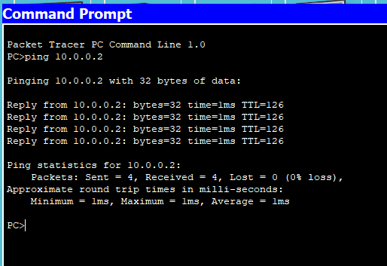

**CLI** 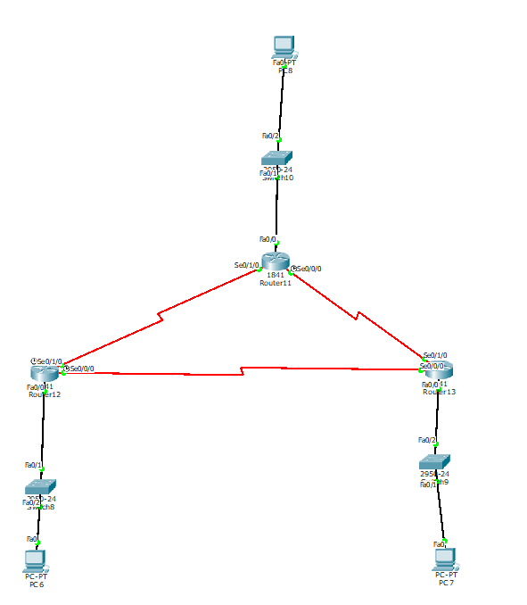

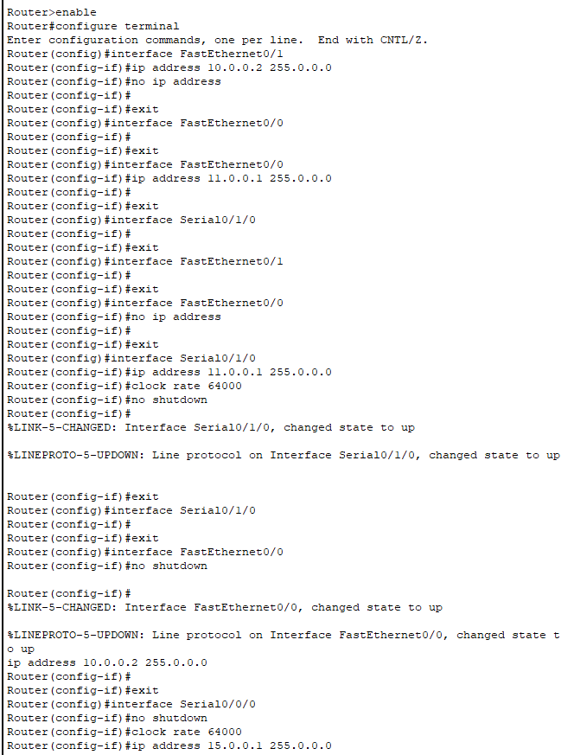

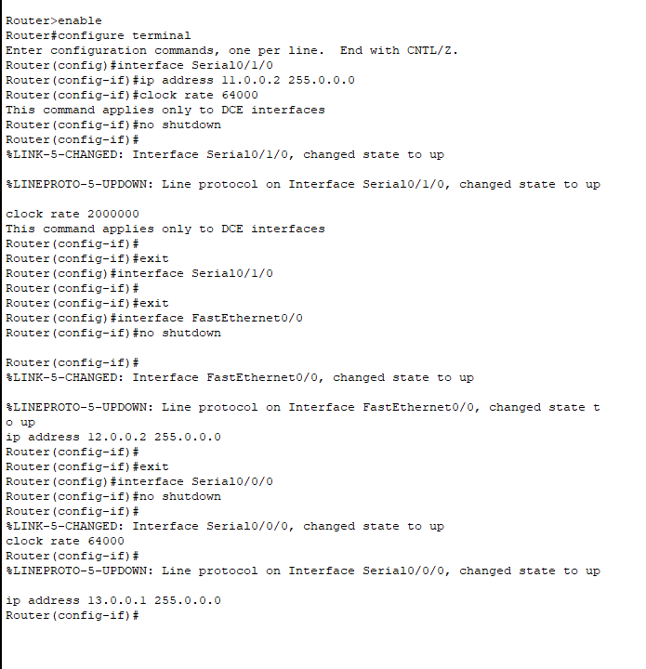

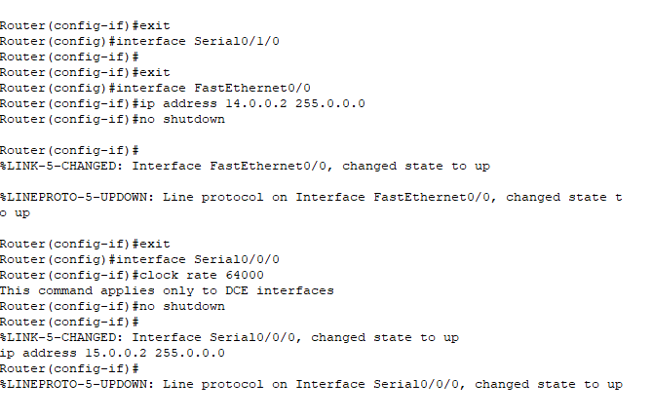

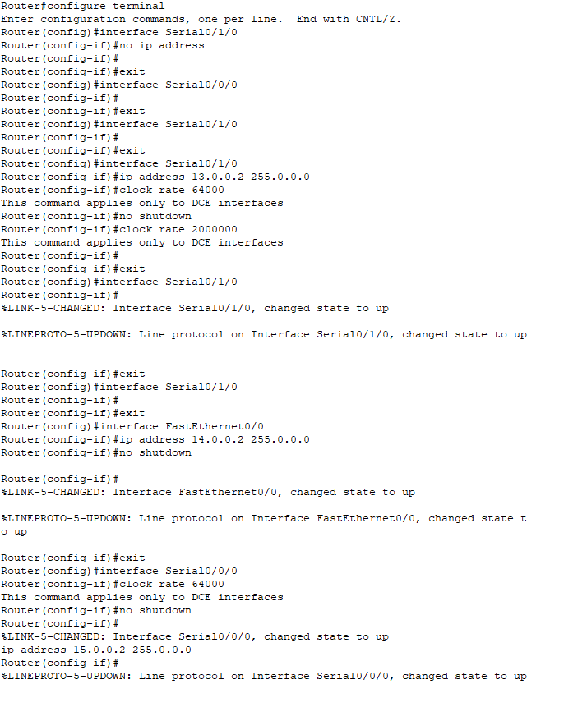

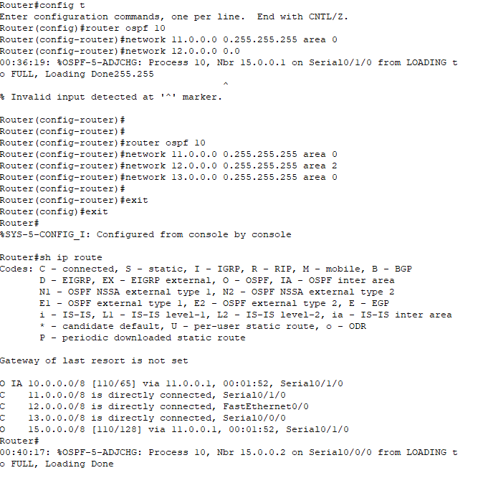

**HOME ASSIGNMENTS**

1. What does the OSPF routing table keep track of?

**ANS:**

A basic routing table includes the following information: Destination: The IP address of the packet's final destination. Next hop: The IP address to which the packet is forwarded. Interface: The outgoing network interface the device should use when forwarding the packet to the next hop or final destination.

2. What does the OSPF neighbour table keep track of?

**ANS:**

The OSPF process builds and maintains three separate tables: • A neighbor table – contains a list of all neighboring routers. A topology table – contains a list of all possible routes to all known networks within an area. A routing table – contains the best route for each known network.