**LAB # 07**

**STATIC ROUTES (IPv4 and IPv6)**

**OBJECTIVE**

(a) Configure and Verify Serial Connectivity and Static Routing using IPv4

(b) Configure and Verify Serial Connectivity and Static Routing using IPv6

**Lab Task:**

### Step-01: (Create Design Topology)

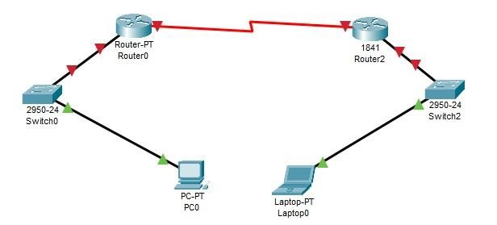

### Step-02: (Assign IP’s Address for Pc0 and Laptop0)

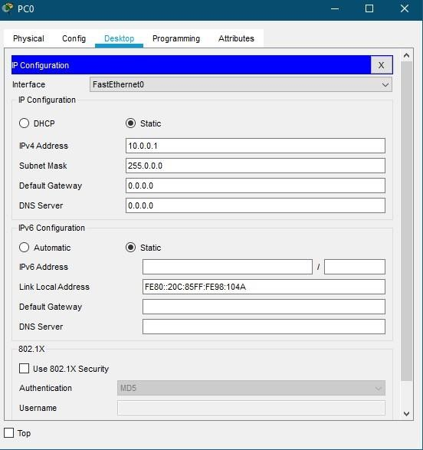

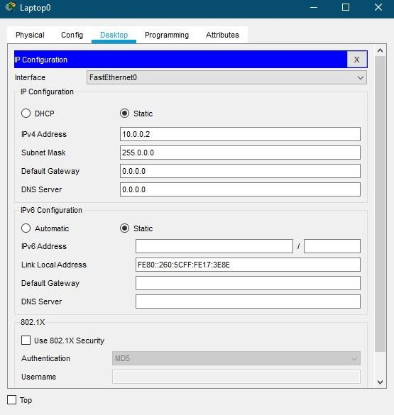

### Step-03: (Router0 configuration)

Router>en

Router#

Router#configure terminal

Enter configuration commands, one per line. End with CNTL/Z.

Router(config)#hostname AseefRouter0

AseefRouter0(config)#interface serial 2/0

AseefRouter0(config-if)#no shutdown

%LINK-5-CHANGED: Interface Serial2/0, changed state to down

AseefRouter0(config-if)#ip address 10.0.0.1 255.0.0.0

AseefRouter0(config-if)#exit

AseefRouter0(config)#interface fastEthernet 0/0

AseefRouter0(config-if)#ip address 11.0.0.1 255.0.0.0

AseefRouter0(config-if)#no shutdown

AseefRouter0(config-if)#

%LINK-5-CHANGED: Interface FastEthernet0/0, changed state to up %LINEPROTO-5-UPDOWN: Line protocol on Interface FastEthernet0/0, changed state to up AseefRouter0(config-if)#exit

AseefRouter0(config)#ip route 12.0.0.0 255.0.0.0 10.0.0.2 150

AseefRouter0(config)#

### Step-03: (Router1841 (1) configuration)

Router>enable

Router#configure terminal

Enter configuration commands, one per line. End with CNTL/Z.

Router(config)#hostname AseefRouter1

AseefRouter1(config)#interface serial 2/0

AseefRouter1(config-if)#no shutdown

AseefRouter1(config-if)#

%LINK-5-CHANGED: Interface Serial2/0, changed state to up

AseefRouter1(config-if)#ip address 10.0.0.2 255.0.0.0

AseefRouter1(config-if)#clock rate 64000

This command applies only to DCE interfaces

AseefRouter1(config-if)#exit

AseefRouter1(config)#interface fastEthernet 0/0

AseefRouter1(config-if)#ip address 12.0.0.1 255.0.0.0

AseefRouter1(config-if)#no shutdown

AseefRouter1(config-if)#

%LINK-5-CHANGED: Interface FastEthernet0/0, changed state to up

%LINEPROTO-5-UPDOWN: Line protocol on Interface FastEthernet0/0, changed state to up

AseefRouter1(config-if)#ip route 11.0.0.0 255.0.0.0 10.0.0.1 150

AseefRouter1(config)#

### Step-04: (For Router0, Verifying Static Routes)

AseefRouter0# show ip route static

S 12.0.0.0/8 [150/0] via 10.0.0.2

### Step-05: (For Router0, Checking Routing Table) AseefRouter0# show ip route

Codes: C - connected, S - static, I - IGRP, R - RIP, M - mobile, B - BGP

D - EIGRP, EX - EIGRP external, O - OSPF, IA - OSPF inter area

N1 - OSPF NSSA external type 1, N2 - OSPF NSSA external type 2

E1 - OSPF external type 1, E2 - OSPF external type 2, E - EGP i -

IS-IS, L1 - IS-IS level-1, L2 - IS-IS level-2, ia - IS-IS inter area

* - candidate default, U - per-user static route, o - ODR

P - periodic downloaded static route

Gateway of last resort is not set

C 10.0.0.0/8 is directly connected, Serial2/0

C 11.0.0.0/8 is directly connected, FastEthernet0/0

S 12.0.0.0/8 [150/0] via 10.0.0.2

### Step-06: (For Router1, Verifying Static Routes)

AseefRouter1#show ip route static

S 11.0.0.0/8 [150/0] via 10.0.0.1

### Step-07: (For Router0, Checking Routing Table)

AseefRouter1# show ip route

Codes: C - connected, S - static, I - IGRP, R - RIP, M - mobile, B - BGP

D - EIGRP, EX - EIGRP external, O - OSPF, IA - OSPF inter area

N1 - OSPF NSSA external type 1, N2 - OSPF NSSA external type 2

E1 - OSPF external type 1, E2 - OSPF external type 2, E - EGP i -

IS-IS, L1 - IS-IS level-1, L2 - IS-IS level-2, ia - IS-IS inter area

* - candidate default, U - per-user static route, o - ODR

P - periodic downloaded static route

Gateway of last resort is not set

C 10.0.0.0/8 is directly connected, Serial2/0

S 11.0.0.0/8 [150/0] via 10.0.0.1

C 12.0.0.0/8 is directly connected, FastEthernet0/0

**HOME ASSIGNMENTS**

1. Write difference in DCE and DTE.What do you mean by clock synchronization? **Answer:**

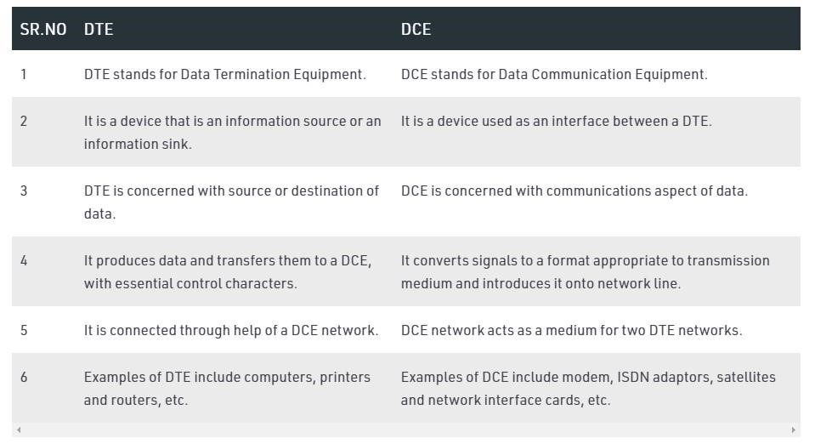

Clock synchronization is a topic in computer science and engineering that aims to coordinate otherwise independent clocks. Even when initially set accurately, real clocks will differ after some amount of time due to clock drift, caused by clocks counting time at slightly different rates

1. Describe a network route. Difference between static and default routes

**Answer:**

In general, a route refers to the path a data packet travels on a network. The route includes every device that handles the packet between its source to its destination, including routers, switches, and firewalls. ... The five major routing methods are unicast, broadcast, multicast, anycast, and geocast.

Default routing can be considered a special type of static routing. The difference between a normal static route and a default route is that a default route is used to send packets destined to any unknown destination to a single next hop address.

1. Write difference between IPv4 and IPv6.Describe the advantages of IPv6

**Answer:** **KEY DIFFERENCE**

IPv4 is 32-Bit IP address whereas IPv6 is a 128-Bit IP address. IPv4 is a numeric addressing method whereas IPv6 is an alphanumeric addressing method. IPv4 binary bits are separated by a dot(.) ... IPv4 supports broadcast whereas IPv6 doesn't support broadcast

More Efficient Routing – IPv6 reduces the size of routing tables and makes routing more efficient and hierarchical. ... More efficient packet processing – Compared with the IPv4, IPv6 contains no

IP-level checksum, so the checksum does not need to be recalculated at every router hop.