**LAB # 08**

**RIP (Routing Information Protocol)**

**OBJECTIVE:**

Configuring Routing Protocol: RIPv2 and RIP-NG

**Lab Task:**

RIP Version – 01

### Step-01: (Create/Design Topology)

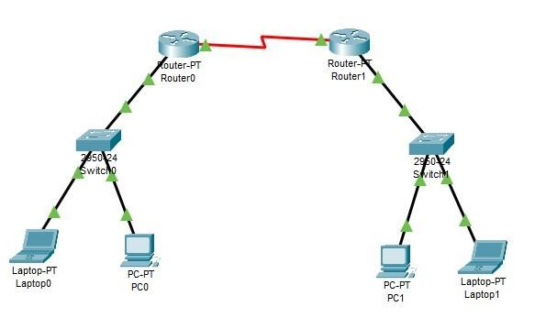

### Step 02: (Assign Ip Address for Pc and Laptop for Switch0)

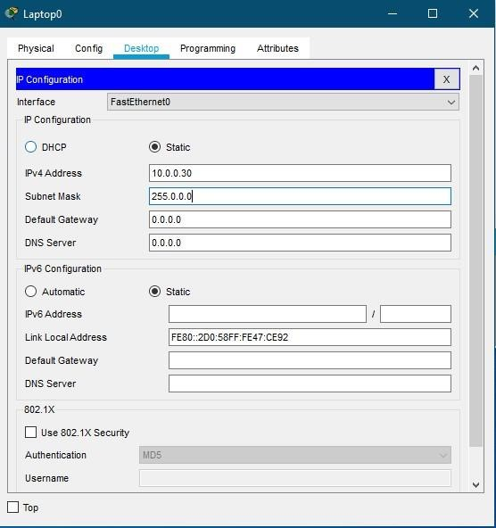

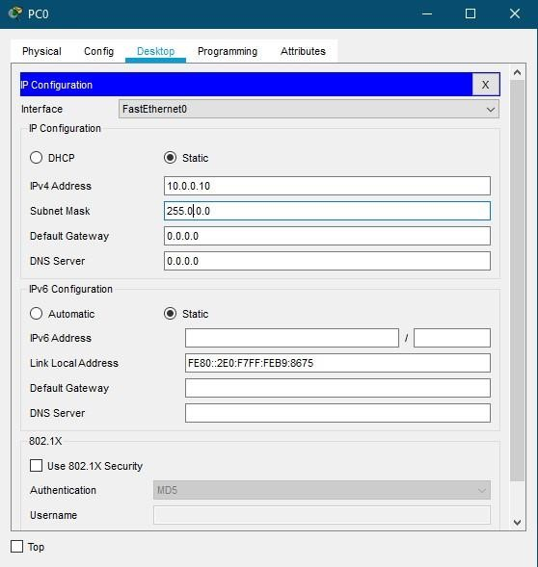

### Step 03: (Assign Ip Address for Pc and Laptop for Switch1)

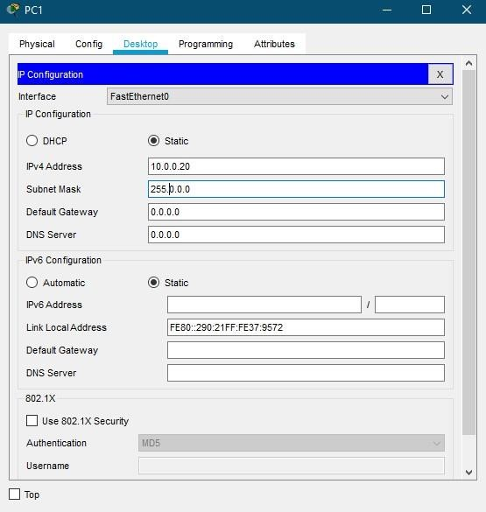

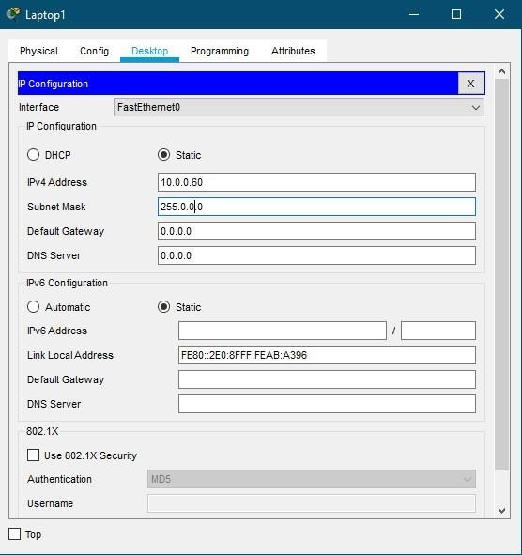

### Step 04: (Configuration for Router0)

Router>enable

Router#configure terminal

Enter configuration commands, one per line. End with CNTL/Z.

Router(config)#hostname AseefRouter0

AseefRouter0(config)#interface serial 2/0

AseefRouter0(config-if)#ip address 10.0.0.10 255.0.0.0

AseefRouter0(config-if)#no shutdown

%LINK-5-CHANGED: Interface Serial2/0, changed state to down

AseefRouter0(config-if)#exit

AseefRouter0(config)#interface fastEthernet 0/0

AseefRouter0(config-if)#ip address 11.0.0.1 255.0.0.0

AseefRouter0(config-if)#no shutdown

AseefRouter0(config-if)#

%LINK-5-CHANGED: Interface FastEthernet0/0, changed state to up

%LINEPROTO-5-UPDOWN: Line protocol on Interface FastEthernet0/0, changed state to up

AseefRouter0(config-if)#exit

AseefRouter0(config)#router rip

AseefRouter0(config-router)# network 10.0.0.0 AseefRouter0(config-router)# network 11.0.0.0

AseefRouter0(config-router)#

### Step-05: (Configuration for Router1)

Router>enable

Router#configure terminal

Enter configuration commands, one per line. End with CNTL/Z.

Router(config)#hostname AseefRouter1

AseefRouter1(config)# interface serial 2/0

AseefRouter1(config-if)#ip address 10.0.0.20 255.0.0.0

AseefRouter1(config-if)#clock rate 64000

This command applies only to DCE interfaces

AseefRouter1(config-if)#no shutdown

AseefRouter1(config-if)#

%LINK-5-CHANGED: Interface Serial2/0, changed state to up

AseefRouter1(config-if)#exit

%LINEPROTO-5-UPDOWN: Line protocol on Interface Serial2/0, changed state to up

AseefRouter1(config)#interface fastEthernet 0/0

AseefRouter1(config-if)#ip address 12.0.0.1 255.0.0.0

AseefRouter1(config-if)#no shutdown

AseefRouter1(config-if)#

%LINK-5-CHANGED: Interface FastEthernet0/0, changed state to up

%LINEPROTO-5-UPDOWN: Line protocol on Interface FastEthernet0/0, changed state to up

AseefRouter1(config-if)#exit

AseefRouter1(config)#router rip

AseefRouter1(config-router)#network 10.0.0.0

AseefRouter1(config-router)#network 12.0.0.0

AseefRouter1(config-router)#exit

AseefRouter1(config)#

### Step-06: (Verification for RIP 01)

AseefRouter0#show ip route

Codes: C - connected, S - static, I - IGRP, R - RIP, M - mobile, B - BGP

D - EIGRP, EX - EIGRP external, O - OSPF, IA - OSPF inter area

N1 - OSPF NSSA external type 1, N2 - OSPF NSSA external type 2

E1 - OSPF external type 1, E2 - OSPF external type 2, E - EGP i -

IS-IS, L1 - IS-IS level-1, L2 - IS-IS level-2, ia - IS-IS inter area

* - candidate default, U - per-user static route, o - ODR

P - periodic downloaded static route

Gateway of last resort is not set

C 10.0.0.0/8 is directly connected, Serial2/0

C 11.0.0.0/8 is directly connected, FastEthernet0/0

R 12.0.0.0/8 [120/1] via 10.0.0.20, 00:00:02, Serial2/0

AseefRouter0#

RIP Version – 02

## Step-01: (Configuration for Router0)

AseefRouter0#config t

Enter configuration commands, one per line. End with CNTL/Z.

AseefRouter0(config)#interface serial 2/0

AseefRouter0(config-if)#ip address 10.0.0.30 255.0.0.0

AseefRouter0(config-if)#interface fastEthernet 0/0

AseefRouter0(config-if)#ip address 11.1.0.1 255.255.0.0

AseefRouter0(config-if)#exit

AseefRouter0(config)#router rip

AseefRouter0(config-router)#network 10.0.0.0

AseefRouter0(config-router)#network 11.1.0.0

AseefRouter0(config-router)#exit

AseefRouter0(config)#

## Step-02: (Configuration for Router1)

AseefRouter1#config t

Enter configuration commands, one per line. End with CNTL/Z.

AseefRouter1(config)#interface serial 2/0

AseefRouter1(config-if)#ip address 10.0.0.60 255.0.0.0

AseefRouter1(config-if)#interface fastEthernet 0/0

AseefRouter1(config-if)#ip address 12.1.0.1 255.255.0.0 AseefRouter1(config-if)#exit

AseefRouter1(config)#router rip

AseefRouter1(config-router)#network 10.0.0.0

AseefRouter1(config-router)#network 12.1.0.0

AseefRouter1(config-router)#exit

AseefRouter1(config)#exit

AseefRouter1#

%SYS-5-CONFIG_I: Configured from console by console

AseefRouter1#

## Step-03: (Verification for RIP 01)

AseefRouter1#show ip route

Codes: C - connected, S - static, I - IGRP, R - RIP, M - mobile, B - BGP

D - EIGRP, EX - EIGRP external, O - OSPF, IA - OSPF inter area

N1 - OSPF NSSA external type 1, N2 - OSPF NSSA external type 2

E1 - OSPF external type 1, E2 - OSPF external type 2, E - EGP i -

IS-IS, L1 - IS-IS level-1, L2 - IS-IS level-2, ia - IS-IS inter area

* - candidate default, U - per-user static route, o - ODR

P - periodic downloaded static route

Gateway of last resort is not set

C 10.0.0.0/8 is directly connected, Serial2/0

R 11.0.0.0/8 [120/1] via 10.0.0.30, 00:00:18, Serial2/0

12.0.0.0/16 is subnetted, 1 subnets

C 12.1.0.0 is directly connected, FastEthernet0/0

AseefRouter1#

**Home Assignment:**

1. Which type of protocol is RIP?

Answer:Routing Information Protocol (RIP)

The Routing Information Protocol (RIP) is one of the oldest distance-vector routing protocols which employs the hop count as a routing metric. RIP prevents routing loops by implementing a limit on the number of hops allowed in a path from source to destination

1. Difference between RIP version 1 and RIP version 2

**Answer:** RIP v1 is an older, no longer much used routing protocol. RIP v2 is a classless protocol and it supports classful, variable-length subnet masking (VLSM), CIDR, and route summarization. ... RIPng works basically in the same manner as RIP v2 with one notable exception. RIPng can only run on IPv6 networks

1. Which command is used to display whether RIP is running on the router

**Answer:** The show ip protocols command indicates that the proper networks are configured for RIP advertisements. You can confirm that these RIP advertisements are being received by looking at the routing table of R1 and R2 using the show ip route command

1. Difference between classful and classless routing

**Answer:** In classful routing, hello messages are not used. While in classless routing, hello messages are used. ... In classful routing, address is divided into three parts which are: Network, Subnet and Host. While in classless routing, address is divided into two parts which are: Subnet and Host.