Internal Voltage Model for a Generator in PST V3

pstV3p1
Dan Trudnowski
June 2020
Draft 2

Introduction
This report describes a new method to model a voltage-behind-impedance generator model in PST. I term this an “Internal Voltage Model” (IVM) for a generator. Such a model is used to model a grid-forming inverter-based generator.
The IVM is a voltage behind impedance model. The interface model is in Figure 1 below where V_{T} is the terminal voltage. Internal voltage magnitude E and angle δ are calculated via a user-defined model thru time constants T_{v} and T_{d}, respectively. The user-defined model is written in function ivmmod_dyn.m which is called every integration time step and allows for dynamic states to be defined. Any number of model structures can be modeled. Time constants T_{v} and T_{d} are defined in the mac_con settings.
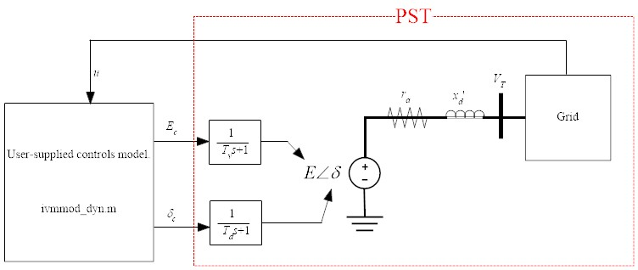
Figure 1: IVM Interface model.

Declaring IVM Buses
The IVM bus is handled as a generator in PST and must be declared as a voltage-controlled bus type 2 in the “bus” matrix. The parameters are set in the mac_con matrix. It is recognized by PST by setting the inertia constant (H) to zero. The format with an example:
% col 1 generator number
% col 2 bus number
% col 3 generator MVA base
% col 4 Not used
% col 5 r_a
% col 6 Not used
% col 7 x’_d
% col 8 Not used
% col 9 Td
% col 10 Tv
% col 11 Not used
% col 12 Not used
% col 13 Not used
% col 14 Not used
% col 15 Not used
% col 16 0 (this is H for a syn generator)
% col 17 Not used
% col 18 Not used
% col 19 bus number

% An example:
mac_con = […
% 1 2 3 4 5 6 7 8 9 10 11 12 13 14 15 16 17 18 19
% num bus base NA r_a NA x'_d NA Td Tv NA NA NA NA NA 0 NA NA bus
3 2 100 0 0 0 0.1 0 0.05 0.05 0 0 0 0 0 0 0 0 2];

Defining a model in ivmmod_dyn.m
The function ivmmod_dyn.m is used to define the IVM model to set the variables δ_{c} and E_{c} in Figure 1. The function is called every integration step and allows for arbitrary dynamic models. Key variables are defined in the comments in the function along with the below examples.

Example 1
Consider the system in Figure 2 with an IVM generator placed into bus 2. The data file is d2m_ivmmod1.m. The IVM input voltage (E_{c} in Figure 1) is set to the initial-condition voltage of E plus a step of 0.1 pu at t = 1 sec. The IVM input voltage angle (δ_{c} in Figure 1) is set to the initial-condition angle of δ plus a step of 0.2 radians at t = 4 sec. The control model is in ivmmod_dyn_Example1.m. The script to run the non-linear simulation and plot the results is the file Example1.m. The results are shown in Figure 3.

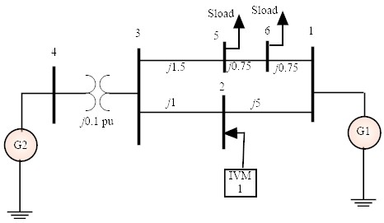
Figure 2: Example one-line.
Figure 3: Example 1 simulation result.

