W25

Grading Criteria for Emotional Expression (Sub-factors)
1. Lexical Emotional Intensity (Word Choice & Valence)
Measures how strong the emotional words are in the response.
Includes emotionally charged words, adjectives, exclamations, and extreme expressions.
Example: "I was devastated" (high intensity) vs. "I felt a little sad" (low intensity).

2. Personalization & Subjectivity
Measures the level of self-referencing and personal connection to the emotion.
Uses first-person pronouns ("I," "me," "my") and subjective expressions.
Example: "I struggled a lot with this" (high personalization) vs. "People sometimes struggle with this" (low personalization).

3. Descriptive Depth & Detail
Measures the specificity and richness of emotional descriptions.
Includes metaphor, sensory descriptions, and elaboration on experiences.
Example: "My heart was racing, and I couldn’t catch my breath" (high detail) vs. "I was nervous" (low detail).

4. Reflectiveness & Insight
Measures whether the response analyzes or reflects on the emotion or its cause.
Includes introspection, cognitive processing words ("realized," "understood"), and lessons learned.
Example: "This taught me resilience and made me a stronger person" (high insight) vs. "It was just a bad time" (low insight).

5. Expressive Structure & Emphasis
Measures how emotion is conveyed through structure, repetition, punctuation, and formatting.
Includes sentence variation, punctuation (ellipses, exclamation marks), emphasis (capitalization, repetition).
Example: "I just... I just couldn’t believe it!" (high expressive structure) vs. "I was surprised" (low expressive structure).

Graphs with Arnav’s script
For reference, the models in chronological order are GPT-4, GPT-4o, o1.

Average response intimacy for each model

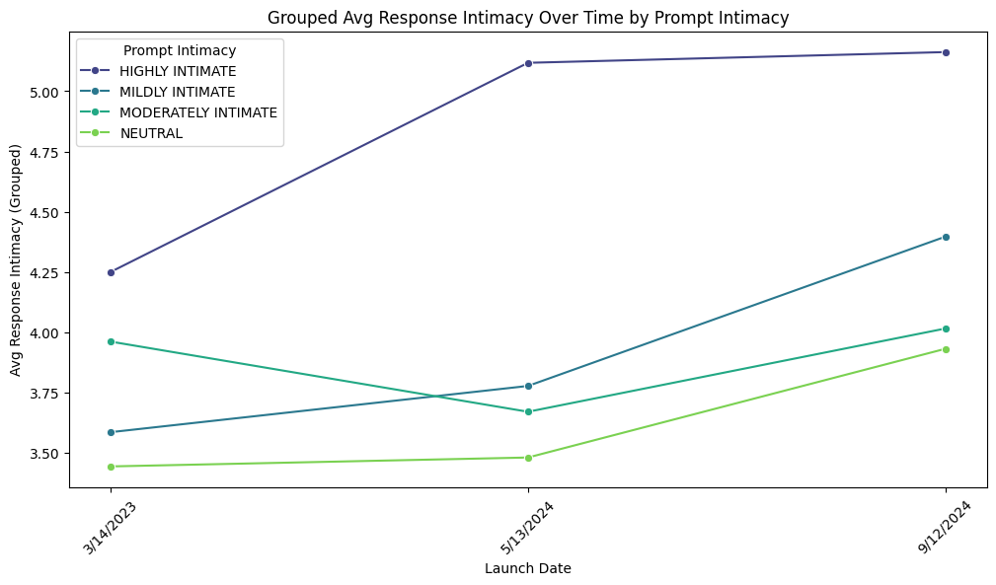
Response intimacy grouped by prompt type
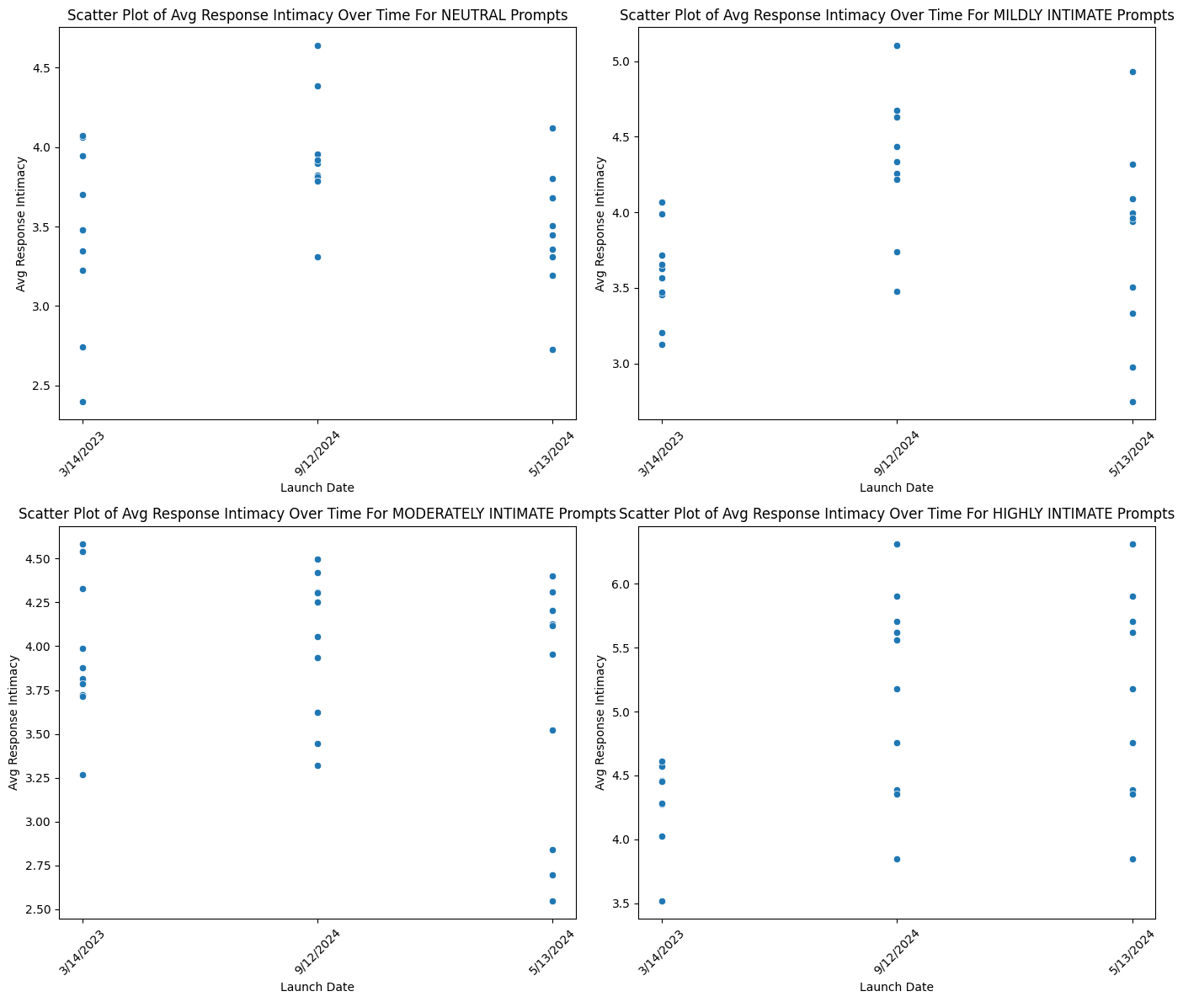

Average value for each metric grouped by prompt intimacy
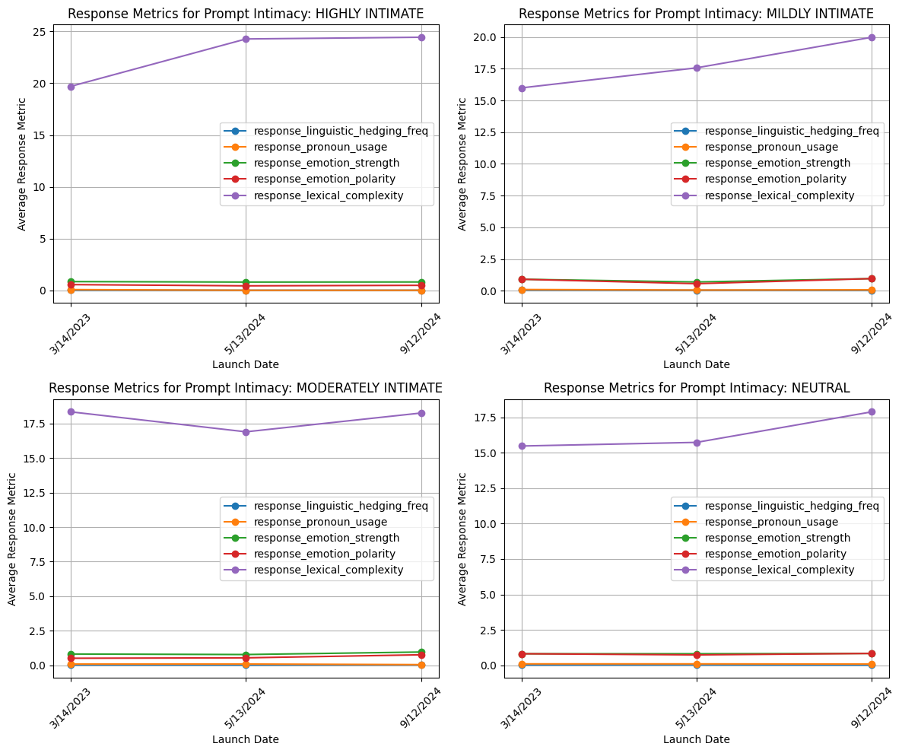

Citations
Pei, J., Jurgens D. (2020). Quantifying Intimacy in Language.

Alm, C.O., Roth, D., Sproat, R. (2005). Emotions from Text: Machine Learning for Text-based Emotion Prediction

Kahn, J.H., Tobin R.M., Massey, A.E., & Anderson, J.A. (2007). Measuring emotional expression with
the Linguistic Inquiry and Word Count

Bantum, E. O., Elhadad, N., Owen, J. E., Zhang, S., Golant, M., Buzaglo, J., Stephen, J., & Giese-Davis, J. (2017). Machine Learning for Identifying Emotional Expression in Text: Improving the Accuracy of Established Methods.

McDonell, M., Owen, J.E., Bantam, E.O. (2020). Identification of Emotional Expression With Cancer Survivors: Validation of Linguistic Inquiry and Word Count

