Importing the libraries used in the code:
import numpy as np
import pandas as pd
import matplotlib.pyplot as plt
from sklearn.preprocessing import LabelEncoder
# for shape histogram
import seaborn as sns
sns.set()
np.set_printoptions(suppress=True)

pd.read_csv: Read a comma-separated values (csv) file into DataFrame
#Read a comma-separated values (csv) file into DataFrame.
data=pd.read_csv('weatherHistory.csv')

DataFrame.head(n=5) :
Returns the first n rows.
#.head():n Returns the first row
data.head(5)

Displaying the dataset columns.
data.columns

Using .drop() to remove columns that are not needed from the dataset.
#Read a comma-separated values (csv) file into DataFrame.
dataset=data.drop(['Formatted Date', 'Summary','Precip Type','Daily Summary','Loud Cover'], axis=1)
#.head():n Returns the first row
dataset.head()

np.array: Converts the dataset output from a table format into a NumPy array (or another nested sequence structure), allowing us to access and work with individual lists and elements more easily while coding. Therefore, we convert the dataset into an array.
#Convert dataset table to array
arr=np.array(dataset)
arr

We consider all rows and column 0, which corresponds to Temperature (C), as the target variable.
y=arr[:,0]
y

We select all rows and all columns starting from column 1 as X, meaning we exclude the target variable from the input features.
X=arr[:,1:]
X

Indicates the number of rows and columns.
dataset.shape

We allocate 80% of our data to X_train.
#train 0.8 data from X
X_train = X[:round(.8* len(X)) ]

The remaining 20% of the data is used for testing, so we specify that all data from 80% of the dataset length onward should be assigned to the test set.
#test : From 0.8 onwards X for test=0.2
X_test = X[round(.8 * len(X)):]

We do the same for our labels, assigning the first 80% of them to the training set.
#train 0.8 data from y
y_train = y[:round(.8* len(y)) ]

And the remaining 20% is assigned to the test set.
#test : From 0.8 onwards y for test=0.2
y_test = y[round(.8 * len(y)):]

After splitting the X data for training, the number of rows in X_train decreases from 96,453 to 77,162.
X_train.shape
Output:
(77162, 5)
After splitting y for training, the number of rows in y_train decreases from 96,453 to 77,162.
y_train.shape

Standardization of Data:
Data standardization refers to normalizing the distribution of data. Standardization transforms the mean of the data to 0 and the variance to 1. As the data values extend toward infinity, the variance becomes closer to 1.

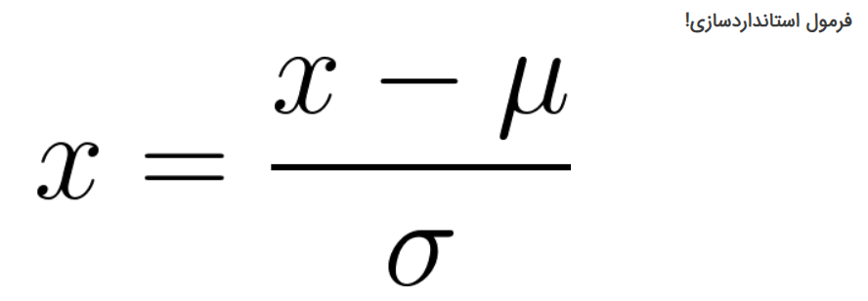
In the image above, x represents the data value, μ represents the mean of the data, and σ represents the variance of the data.
Standardization of X_train:
# Step 1: Calculate the mean and standard deviation for each feature
mean = np.mean(X_train, axis=0)
std_dev = np.std(X_train, axis=0)

# Step 2: Apply z-score standardization
normalized_data_X_train = (X_train - mean) / std_dev

# Now, 'normalized_data_X_train' contains the normalized values.

print("Original Data:")
print(X_train)
print("\nNormalized Data:")
print(normalized_data_X_train)

Standardization of X_test:
# Step 1: Calculate the mean and standard deviation for each feature
mean = np.mean(X_test, axis=0)
std_dev = np.std(X_test, axis=0)

# Step 2: Apply z-score standardization
normalized_data_X_test = (X_test - mean) / std_dev

# Now, 'normalized_data_X_test' contains the normalized values.

print("Original Data:")
print(X_test)
print("\nNormalized Data:")
print(normalized_data_X_test)

2.Normal Equations
Linear Regression Model:
The linear regression model is expressed as follows:
$$h_{θ}(x)=θ_{0}+θ_{1}x_{1}+θ_{2}x_{2}+⋯+θ_{n}x_{n}$$
- $h_{θ}(x)$: predicted output
- $θ_{0},θ_{1},θ_{2},…,θ_{n}$: parameters that need to be learned
- $x_{0},x_{1},x_{2},…,x_{n}$: input features
Cost Function:
The cost function measures the difference between the predicted values and the actual values. For linear regression, the cost function is often defined as the Mean Squared Error (MSE):
$$J(θ)=\frac{1}{2m}\sum_{i=1}^{m}{{\left(h_{θ}(x^{i})-y^{i}\right)}^{2}}$$
- m: number of training samples
- $x^{i},y^{i}$: training examples
Normal Equation:
To find the optimal parameters $θ$that minimize the cost function, we can use the Normal Equation:
$$θ=(X^{T}X)^{-1}X^{T}y$$
- X: the matrix of input features (including a column of ones for the bias term)
- y: the vector of target values
from numpy.linalg import inv
import time

Feature Matrix X:
Add a column of ones to the feature matrix X for the bias term.
X_new_train=np.hstack((np.ones((normalized_data_X_train.shape[0],1)),normalized_data_X_train))
X_new_test=np.hstack((np.ones((normalized_data_X_test.shape[0],1)),normalized_data_X_test))

Compute Parameters $θ$ :
Use the normal equation to calculate the optimal parameters $θ$:
$$θ={(XX^{T})}^{-1}X^{T}y$$
X_new_T=np.transpose(X_new_train)
# Record the start time
start_time = time.time()
theta = []
# Calculate the linear regression solution using the normal equations
# theta=np.linalg.inv(X_new_T.dot(X_new)).dot(X_new_T).dot(y_new)

# Calculate parameters using the normal equation
theta_X=np.linalg.inv(X_new_T@(X_new_train))
theta_y=X_new_T@y_train
theta=theta_X@theta_y
theta

Now, $θ$ contains the values that minimize the cost function.
Calculate Predictions :
Use the learned parameters $θ$ to make predictions on the training data

def predict(X,theta):
y_pred = np.dot(X,theta)
return y_pred

#Make predictions on the test
y_pred = predict(X_new_test,theta)
calculate $R^{2}$-score:
Compare the predicted values to the actual values and compute the $R^{2}$-score
$$R^{2}=1-\frac{\sum_{i=1}^{m}{{(y^{i}-h_{θ}(X^{i}))}^{2}}}{\sum_{i=1}^{m}{{(y^{i}-y^{^})}^{2}}}$$

m: is the number of training examples.
$y^{i}: is the actual output for the ith example.$
$h_{θ}\left(X^{i}\right): is the predicted output for the ith example.$
$y^{^}: is the mean of the actual outputs.$
T_ss=$\sum_{i=1}^{m}{{(y^{i}-y^{^})}^{2}}$
R_ss=$\sum_{i=1}^{m}{{(y^{i}-h_{θ}(X^{i}))}^{2}}$

def r2_score(y,y_pred):
mean_y = sum(y)/len(y)
T_ss = sum((y-mean_y)**2)
R_ss = sum((y-y_pred)**2)
R2 = 1-R_ss/T_ss
return R2

#Calculate R^2 score
r2_score(y_test,y_pred)
print(r2_score(y_test,y_pred))

save required running time:
# Record the end time
end_time = time.time()

# Calculate the running time
running_time = end_time - start_time
print("\nRunning Time:", running_time, "seconds")
print(theta)

3 : mini-batch stochastic gradient descent
There are many methods for optimizing a network. In the following section, Batch Gradient Descent, Mini-Batch Gradient Descent, and Stochastic Gradient Descent are compared.

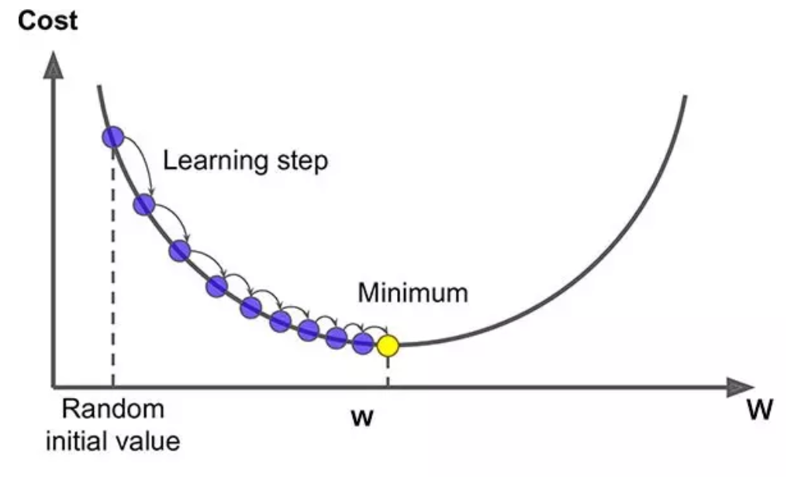
Batch Gradient descent:
In this algorithm, the approach is based on evaluating the errors over the entire training dataset. The model is updated and optimized only after the computations have been performed on all training samples. In other words, if the dataset is large, all training data must first be fed into the network before updating the model parameters. This results in significant computational complexity. Moreover, the model is optimized only once after a costly computation, making the process inefficient for large datasets.
Stochastic Gradient Descent (SGD)
In this method, instead of evaluating all samples and then computing the loss and gradients, the model parameters are updated after processing each individual training sample. If we have N training samples, this update cycle must be repeated N times, with the weights being updated after every sample.
While this approach greatly reduces computational complexity, it introduces noise into the optimization process. Since the model is updated based on a single sample at a time, each update is subject to uncertainty, and the optimization path becomes highly variable. In addition, some samples may be outliers, yet they still influence the parameter updates, causing the optimization process to proceed in a noisy manner.
Mini-Batch Gradient Descent
In this approach, instead of using either the entire dataset or a single sample, a small batch of training samples is processed at each iteration. For example, if the dataset contains N samples, the model may be trained on batches of 200 samples at a time.
This method reduces the noise associated with Stochastic Gradient Descent because updates are based on multiple samples rather than a single one. As a result, the optimization process becomes more stable and reliable while maintaining computational efficiency.
The goal of this algorithm is to optimize a model’s parameters by repeatedly updating them using gradients computed from small batches of training data.
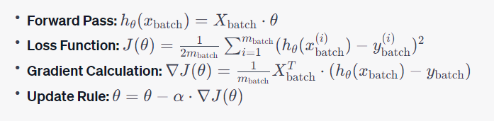
X=normalized_data_X_train
y=y_train
num_epochs=100
def mini_batch_sgd(X, y,learning_rate,batch_size, num_epochs):
# Add a column of ones for the bias term
X_new_train=np.hstack((np.ones((X.shape[0],1)),X))

n=X_new_train.shape[0]
d=X_new_train.shape[1]
weights = np.zeros(d) # Initialize weights with zeros=theta

The initial weights are initialized with a size equal to shape[1] of the normalized X data, meaning that one weight is assigned to each input feature.
weights = np.zeros(normalized_data_X_train.shape[1])
weights
output:
array([0., 0., 0., 0., 0., 0.])
n=normalized_data_X_train.shape[0]
d=normalized_data_X_train.shape[1]
print(n)
print(d)
output:
77162
6
for epoch in range(num_epochs):
# Shuffle the data at the beginning of each epoch to ensure randomness
permutation = np.random.permutation(n)
X_shuffled = X_new_train[permutation]
y_shuffled = y[permutation]

In this for loop, the process runs for the specified number of epochs, which is set to 100 in this case. During each iteration, a list of random indices, equal to the number of rows in the normalized X dataset, is generated and stored in permutation.
permutation = np.random.permutation(77162)
permutation
output:
array([75073, 71713, 42189, ..., 47402, 19625, 4254])
Next, we retrieve the data corresponding to each of these indices. For each sample, X contains 7 features (columns).
X_shuffled = X_new_train[permutation]
Output:
array([[ 1. , 0.59752851, -0.51124797, ..., 1.31338449,
0.27247123, 0.09895446],
[ 1. , -1.52481855, 0.96393425, ..., -1.585484 ,
-1.75773297, 0.13039159],
[ 1. , 0.49558619, -0.56211632, ..., -0.74927194,
-0.04914528, 0.09089366],
...,
[ 1. , -0.75743359, 1.16740766, ..., 1.03464713,
-0.7607218 , 0.27403508],
[ 1. , -0.18881055, 0.20090896, ..., 1.41558818,
1.41018962, 0.19697381],
[ 1. , 2.12410207, -2.34250866, ..., 0.03119266,
0.04733967, 0.08355833]])
X_shuffled.shape

(77162, 7)
y_shuffled = y[permutation]

Up to this point, we are randomly selecting samples from our dataset.
We randomly choose a mini-batch from the training data, and its corresponding target values are assigned to $y^{i}$.

for i in range(0, n, batch_size):
# Create a mini-batch from the shuffled data
X_mini_batch = X_shuffled[i:i + batch_size]
y_mini_batch = y_shuffled[i:i + batch_size]

Now, samples are selected according to the batch size. For example, if we have 1,000 training samples and the batch size is 10, then the dataset will be divided into 100 batches, each containing 10 samples.
X_mini_batch = X_shuffled[0:0 + 10]
Output:
array([[ 1. , -1.80913007, 0.09917226, -0.77072437, 1.26692826,
-0.04914528, 0.24928842],
[ 1. , 0.30297153, 0.9130659 , 0.40223477, -0.37762213,
-0.23005456, 0.10080845],
[ 1. , 0.59343033, 0.09917226, -0.924819 , -1.49257155,
-0.04914528, 0.15022116],
[ 1. , -1.14573653, 0.76046084, -1.07431379, 0.73732729,
-0.7607218 , 0.2079365 ],
[ 1. , 0.00277955, 0.81132919, -1.11111251, -1.18596046,
0.37699659, 0.19197611],
[ 1. , -0.01719909, 0.50611908, -0.63272917, -0.26612719,
1.23732074, 0.15134967],
[ 1. , 0.00021819, 0.86219754, -0.62122957, 1.1925983 ,
-1.50043976, 0.09887385],
[ 1. , -1.45412488, 0.60785578, -0.88112052, -0.70281571,
-1.777834 , 0.27669514],
[ 1. , -0.30663334, -1.83382513, -0.26474199, -1.74343517,
0.04331947, 0.19108943],
[ 1. , 1.78702643, -2.0881669 , -0.89492004, -0.10817602,
1.47853312, 0.10693466]])

Thus, our first mini-batch is formed as shown above.
Next, we compute the forward pass, and then subtract the predicted values from the corresponding target values to calculate the errors.

predictions = X_mini_batch.dot(weights)
errors = predictions - y_mini_batch

Next, in order to obtain the optimal θ (theta) parameters, we first need to compute the gradient.
X_mini_batch_T=np.transpose(X_mini_batch)
gradient = (1/batch_size)* np.dot(X_mini_batch_T,errors)

weights -= learning_rate * gradient

return weights

The output of θ (theta) for batch_size = 10.
array([11.75180284, 9.51820927, -0.22610551, 0.70488953, 0.05329859, 0.04603773, -0.00458471])

Next, we calculate the R² score (R-squared) for each batch size.
X_new_test=np.hstack((np.ones((normalized_data_X_test.shape[0],1)),normalized_data_X_test))
def predict(X,weights):
y_pred = np.dot(X,weights)
return y_pred

#Make predictions on the test
y_pred = predict(X_new_test,weights)

def r2_score(y,y_pred):
mean_y = sum(y)/len(y)
T_ss = sum((y-mean_y)**2)
R_ss = sum((y-y_pred)**2)
R2 = 1-R_ss/T_ss
return R2

#Calculate R^2 score
r2_score(y_test,y_pred)
print(r2_score(y_test,y_pred))

Output for batch size = 10:
0.979284497788595
Output for batch size = 20:
0.9831221421739512
Output for batch size = 30:
0.9817343400626438
Output for batch size = 40:
0.9811839211346159
Output for batch size = 50:
0.9817093164938259
Output for batch size = 100:
0.9815312114428538

Based on the accuracy obtained from this code, as the batch size increases, the R² score decreases.

4 :
def mini_batch_sgd(X, y,learning_rate,batch_size, num_epochs):
# Add a column of ones for the bias term
X_new_train=np.hstack((np.ones((X.shape[0],1)),X))
d=2

X_poly = np.column_stack([X_new_train**(i+1) for i in range(1, d + 1)])

weights = np.ones(X_poly.shape[1]) # Initialize weights with zeros=theta

for epoch in range(num_epochs):
# Shuffle the data at the beginning of each epoch to ensure randomness
# permutation = np.random.permutation(X_poly1.shape[0])
# X_shuffled = X_poly[permutation]
# y_shuffled = y[permutation]

for i in range(0, X_poly.shape[0], batch_size):
# Create a mini-batch from the shuffled data
X_mini_batch = X_poly[i:i + batch_size]
y_mini_batch = y[i:i + batch_size]

predictions = X_mini_batch.dot(weights)
errors = predictions - y_mini_batch

# Compute the gradient for the mini-batch
X_mini_batch_T=np.transpose(X_mini_batch)
# print(X_mini_batch_T)
gradient =(2/batch_size)*np.dot(X_mini_batch_T,errors)
# print(gradient)

weights -= learning_rate * gradient
return weights

In this code, we first square the bias-augmented data and then concatenate these squared features with the original bias-augmented X data. As a result, the dataset contains 14 columns.
Next, using these transformed features, we compute θ (theta) in the same manner as described in Question 3.

5:
$$y=β_{0}+β_{1}x+β_{2}x^{2}+…β_{m}x^{m}+ε$$
y : is the dependent variable (the variable you are trying to predict)
x: is the independent variable
M: is the order of the polynomia
$β_{0}+β_{1}+β_{2}+…β_{m}:$
are the coefficients of the polynomial
ε is the error term
The objective of polynomial regression is to find the coefficients β₀, β₁, β₂, ..., βₘ that minimize the sum of the squared differences between the predicted values and the actual values of the dependent variable. This is typically achieved using methods such as least squares regression.

def polynomial_regression(X, y, M):
X_new_train=np.hstack((np.ones((X.shape[0],1)),X))
# print('X_new_train=',X_new_train)
# print(X_new_train.shape)
# X_poly = generate_polynomial_features(X_new_train, M)
X_poly = np.column_stack([X_new_train**(i+1) for i in range(1, M + 1)])
# print(X_poly.shape)
# print(X_poly)
# Perform linear regression on the polynomial features
X_poly_T=np.transpose(X_poly)
# print(X_poly_T)
weights = np.linalg.inv(X_poly_T.dot(X_poly)).dot(X_poly_T).dot(y)
#Method2:
# weight0=np.linalg.inv(X_poly_T@(X_poly))
# weight1=weight0@X_poly_T
# weight2=weight1@y
return weights

We first define a function and then pass the normalized X_train and y_train data as inputs to the function. The polynomial degree is specified by m.
Next, the X_train data must be augmented with a bias term. Therefore, a column of ones is added to X_train, and the resulting matrix is named X_new_train.

x_new_train:
X_new_train=
[[ 1. -0.30919471 0.81132919 ... 0.57937612 1.41018962
0.11128749]
[ 1. -0.32405062 0.65872413 ... 0.65370608 1.41018962
0.11531789]
[ 1. -0.12580097 0.81132919 ... 0.1426876 1.19309847
0.11781674]
...
[ 1. -0.88345275 0.96393425 ... 1.39700569 -2.05924844
0.20398671]
[ 1. -1.00076327 1.0148026 ... -1.6876877 -1.84617751
0.2039061 ]
[ 1. -1.07760422 1.0148026 ... -1.75272641 -2.47332969
0.20301941]]

print(X_new_train.shape)

(77162, 7)
Now, we need to solve the equation according to the specified polynomial degree. Therefore:
X_poly = np.column_stack([X_new_train**(i+1) for i in range(1, M + 1)])

:column_stack.

a = np.array((1,2,3))
b = np.array((2,3,4))
np.column_stack((a,b))
array([[1, 2],
[2, 3],
[3, 4]])
According to the defined for loop, the process is executed two times, and the squared feature values are appended as new columns. Therefore, if m = 2, the total number of columns increases to 14.

print(X_poly)

[[ 1. 0.09560137 0.65825506 ... 0.19448306 2.80435208
0.00137828]
[ 1. 0.10500881 0.43391748 ... 0.27934929 2.80435208
0.00153352]
[ 1. 0.01582588 0.65825506 ... 0.00290508 1.69835655
0.00163539]
...
[ 1. 0.78048876 0.92916924 ... 2.72643111 -8.73225154
0.008488 ]
[ 1. 1.00152711 1.02982432 ... -4.80702359 -6.29245858
0.00847795]
[ 1. 1.16123085 1.02982432 ... -5.38446297 -15.13024754
0.00836783]]
The new dataset is now formed by combining the previously bias-augmented data with the polynomial (power-transformed) features corresponding to the specified degree. These transformed features are stored in x_poly, and all subsequent computations are performed using x_poly.

print(X_poly.shape)

(77162, 14)

Now we proceed with matrix multiplication according to the formula in section 2.
$$θ={(XX^{T})}^{-1}X^{T}y$$

X_poly_T=np.transpose(X_poly)
print(X_poly_T)

[[ 1. 1. 1. ... 1. 1.
1. ]
[ 0.09560137 0.10500881 0.01582588 ... 0.78048876 1.00152711
1.16123085]
[ 0.65825506 0.43391748 0.65825506 ... 0.92916924 1.02982432
1.02982432]
...
[ 0.19448306 0.27934929 0.00290508 ... 2.72643111 -4.80702359
-5.38446297]
[ 2.80435208 2.80435208 1.69835655 ... -8.73225154 -6.29245858
-15.13024754]
[ 0.00137828 0.00153352 0.00163539 ... 0.008488 0.00847795
0.00836783]]

print(X_poly_T.dot(X_poly))
a=X_poly_T.dot(X_poly)
print(a.shape)

[[ 7.71620000e+04 7.71620000e+04 7.71620000e+04 7.71620000e+04
7.71620000e+04 7.71620000e+04 7.71620000e+04 7.71620000e+04
-6.19330521e+03 -5.41125412e+04 8.73000485e+04 -1.30034047e+04
-3.89097529e+04 -6.10776285e+05]
[ 7.71620000e+04 1.76816524e+05 1.13305071e+05 7.37020561e+04
7.74196598e+04 8.41266552e+04 8.18570505e+04 7.71620000e+04
-3.99642874e+04 -1.44081678e+05 8.96949040e+04 -1.83905377e+04
-8.78307608e+04 -6.46600942e+05]
[ 7.71620000e+04 1.13305071e+05 1.94326821e+05 7.61408882e+04
7.72399765e+04 7.32039550e+04 7.22752479e+04 7.71620000e+04
9.46323887e+04 -2.97959455e+05 9.14758379e+04 -1.51839215e+04
-7.18183857e+04 -5.71820323e+05]
[ 7.71620000e+04 7.37020561e+04 7.61408882e+04 3.69178778e+05
8.30877042e+04 6.60885259e+04 1.03308840e+05 7.71620000e+04
-3.01056547e+04 -6.81720766e+04 1.09088933e+06 -5.15677201e+03
-3.07125266e+04 -8.23513883e+05]
[ 7.71620000e+04 7.74196598e+04 7.72399765e+04 8.30877042e+04
1.43153961e+05 7.64074639e+04 7.70748042e+04 7.71620000e+04
-1.82356527e+04 -5.35973041e+04 8.68169514e+04 -6.10396635e+04
-3.56602394e+04 -6.08771827e+05]
[ 7.71620000e+04 8.41266552e+04 7.32039550e+04 6.60885259e+04
7.64074639e+04 2.24570817e+05 8.41088758e+04 7.71620000e+04
-9.27467560e+04 3.91983605e+04 2.01046232e+04 -2.18217944e+04
-2.71579818e+05 -6.63877648e+05]
[ 7.71620000e+04 8.18570505e+04 7.22752479e+04 1.03308840e+05
...
-6.08771827e+05 -6.63877648e+05 -3.98079972e+07 -6.10776285e+05
1.45659667e+05 3.60325530e+05 -1.56243700e+06 1.13404789e+05
1.41293911e+06 3.21309315e+08]]

(14, 14)

weights=polynomial_regression(normalized_data_X_train,y_train, 2)
weights

array([ 1.25000051e+14, 5.71277833e+01, -1.54764983e+00, 3.84936238e+00,
1.38293751e+01, 3.75695331e-01, 4.25411935e-01, -1.24042150e+14,
2.49413688e+00, -5.36766835e-01, 3.01240894e-02, 3.46835833e-02,
3.39543591e-01, 1.41268051e-02])

6:adagrad
In AdaGrad, the learning rates of all model parameters are individually adapted by scaling them based on the inverse square root of the cumulative sum of squared gradients.
This means that we compute the gradients from the beginning of the algorithm up to the current step, square them, and accumulate their sum. Then we take the square root of this accumulated value and use it in the denominator to adjust the learning rate.
If this value becomes large, the learning rate becomes smaller, and vice versa.
Parameters that have larger partial derivatives of the loss function experience a greater reduction in their learning rate, and conversely, parameters with smaller gradients undergo less reduction.

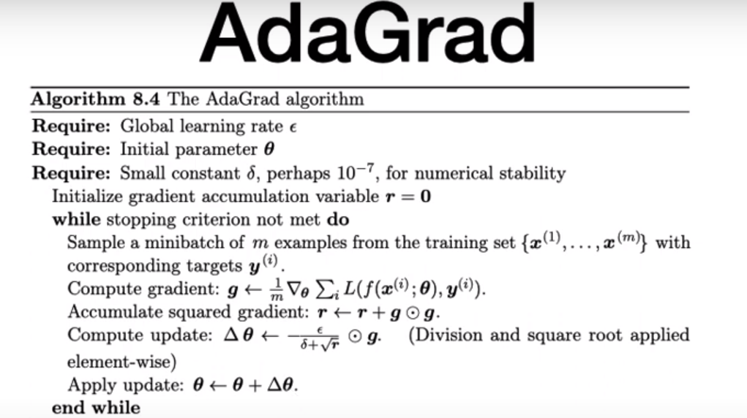

def AdaGrad(X,y,num_iterations):
# Hyperparameters
X_new_train = np.c_[np.ones((X.shape[0], 1)), X]
learning_rate = 0.1
epsilon = 1e-8 # Small constant to avoid division by zero in AdaGrad
num_iterations = 100
theta = np.random.randn(X_new_train.shape[1])
# theta

print(theta)

[-0.51076602 -0.67133257 0.08579206 0.62453671 -1.04085572 -0.61120837 1.82653555]

# X_new_train = np.c_[np.ones((X.shape[0], 1)), X]
n=X_new_train.shape[0]
batch_size=30
grad_squared = np.zeros_like(theta)
# grad_squared

print(grad_squared)

[0. 0. 0. 0. 0. 0. 0.]

for iteration in range(num_iterations):
for i in range(0, n, batch_size):
# Create a mini-batch
X_batch = X_new_train[i:i + batch_size]
y_batch = y[i:i + batch_size]
X_batch_T=np.transpose(X_batch)
gradients = 2 / len(X_batch) * X_batch_T.dot(X_batch.dot(theta) - y_batch)
# Update the squared gradient accumulator
grad_squared += gradients**2
# Update the parameters using AdaGrad update rule
theta -= (learning_rate / (np.sqrt(grad_squared) + epsilon)) * gradients
return theta

First, based on the range of our data, we create small batches according to the batch_size, and then we perform the theta (θ) computation on these batches.
For example, if i = 0 and batch_size = 10:

batch_size=10
X_batch = X_new_train[0:0 + batch_size]
y_batch = y[0:0 + batch_size]
print('X_batch=',X_batch)
print('y_batch',y_batch)

X_batch= [[ 1. -0.30919471 0.81132919 0.46433261 0.57937612 1.41018962
0.11128749]
[ 1. -0.32405062 0.65872413 0.48503189 0.65370608 1.41018962
0.11531789]
[ 1. -0.12580097 0.81132919 -0.99151667 0.1426876 1.19309847
0.11781674]
[ 1. -0.44238569 0.50611908 0.46203269 0.74661853 1.41018962
0.12160531]
[ 1. -0.34710291 0.50611908 0.02504791 0.65370608 1.41018962
0.1224114 ]
[ 1. -0.33480836 0.60785578 0.44133341 0.64441484 1.19309847
0.12362052]
[ 1. -0.48131844 1.11653931 0.21364134 0.65370608 -0.04914528
0.12410416]
[ 1. -0.38859702 0.81132919 0.46893245 0.66299733 -0.04914528
0.12507146]
[ 1. 0.00739001 0.45525072 0.06414655 0.65370608 -0.04914528
0.12934368]
[ 1. 0.27940698 -0.0534328 0.23664054 0.83953099 -0.04914528
0.12813456]]

y_batch : [ 9.47222222 9.35555556 9.37777778 8.28888889 8.75555556 9.22222222
7.73333333 8.77222222 10.82222222 13.77222222]

epsilon

(np.sqrt(grad_squared) + epsilon)

In SGD, the update direction has high variance, and the path taken by mini-batch gradients tends to oscillate around the convergence point.
The momentum method uses the history of past gradients to smooth the update process and reduce these oscillations.
The update process in momentum is defined as follows:



In the above formula, α (alpha) is called the momentum parameter, which is a value between 0 and 1.
ε (epsilon) represents the learning rate.
This formula computes a weighted average of $v$.
Therefore, θ (theta) becomes the previous θ plus v.
In other words, v is computed by combining the learning rate multiplied by the gradient with an exponentially weighted average of past gradients. In other terms, all gradients from the beginning of the training process up to the current step are taken into account in the weight update, but their influence decreases exponentially over time.
In other words, past gradients contribute to the current update, but with exponentially decaying weights.
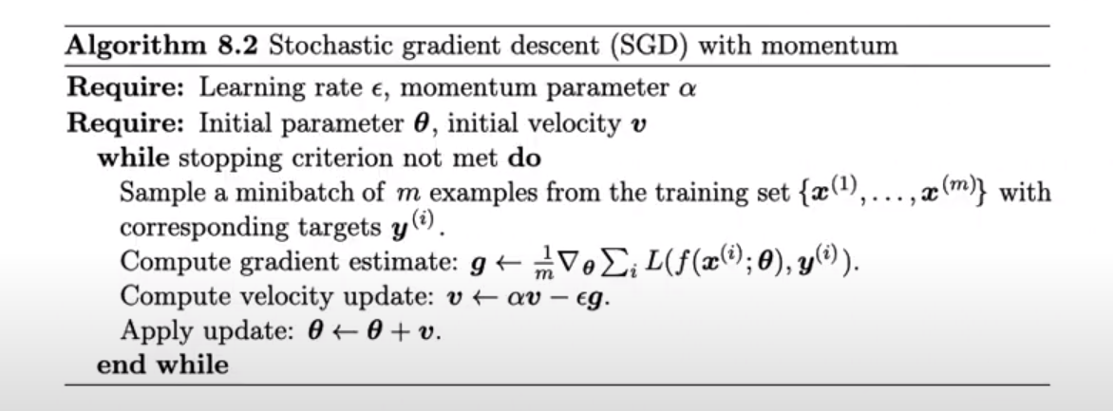

def linear_regression_sgd_momentum(X, y, learning_rate=0.01, momentum_factor=0.9, num_epochs=100):

X_new_train = np.c_[np.ones((X.shape[0], 1)), X]
m=X_new_train.shape[0]
n=X_new_train.shape[1]
theta = np.random.randn(X_new_train.shape[1])
momentum = np.zeros_like(theta)
batch_size=32

for epoch in range(num_epochs):
permutation = np.random.permutation(m)
X_shuffled = X_new_train[permutation]
y_shuffled = y[permutation]
for i in range(0, m, batch_size):
X_batch = X_shuffled[i:i + batch_size]
y_batch = y_shuffled[i:i + batch_size]
X_batch_T=np.transpose(X_batch)
gradients = 2 / len(X_batch) * X_batch_T.dot(X_batch.dot(theta) - y_batch)
# Update the momentum term
momentum = momentum_factor * momentum + learning_rate * gradients
theta -= momentum
return theta
We defined a function with inputs X_train and y_train.
- Momentum factor = 0.9
- Learning rate = 0.01
Then we normalized X_train and added a bias column (a column of ones). After that, we initialized the required model parameters.
Next, we randomly select a mini-batch from our dataset.
Random data selection
The selection of random samples is performed as follows:

permutation = np.random.permutation(m)
X_shuffled = X_new_train[permutation]
y_shuffled = y[permutation]
print(permutation)

[75713 18499 2844 ... 27716 63100 63285]
[49025 35732 22630 ... 53933 56033 15328]
[74428 7125 5274 ... 68070 28132 55418]
[67137 31847 68703 ... 22343 15334 50673]
[51263 64767 76694 ... 29466 72175 19925]
[23409 43142 62457 ... 55559 10592 42660]
[67492 10818 5426 ... 5992 55330 23216]
[ 6595 12083 60470 ... 5074 2543 15425]
[11786 52719 30498 ... 45583 73142 16023]
[40156 23525 22989 ... 37540 39511 52901]
[54800 9723 10844 ... 15996 63851 41714]
[29476 45499 75575 ... 58399 17677 28725]
[ 8186 24600 22793 ... 46546 58018 41359]
[31709 33936 42164 ... 28118 36756 69955]
[ 4187 51710 31260 ... 33174 66785 70398]
[27997 19472 64661 ... 43341 75510 25289]
[48301 16999 63002 ... 34151 16849 54241]
[30691 45964 76635 ... 3996 3398 1730]
[49603 40816 66220 ... 21661 44158 14551]
[61812 29458 38856 ... 51692 75727 29819]
[19466 31047 26098 ... 46052 2817 43144]
[14844 49333 28565 ... 22727 63139 67586]
[40221 43197 19107 ... 62231 53640 40994]
[52103 4533 28833 ... 8687 61516 30421]
[51372 17402 35728 ... 23539 59961 39863]
...
[12781 5250 65789 ... 46012 25011 33360]
[76725 30126 10617 ... 47367 37141 51133]
[ 3611 7900 55233 ... 39638 69763 28639]
[ 6948 60147 20959 ... 73924 59280 64744]

print('X_shuffled',X_shuffled)
print('y_shuffled',y_shuffled)

X_shuffled: [[ 1. 0.27684561 0.20090896 ... 0.85811348 0.27247123
0.08355833]
[ 1. 1.19381429 -1.78295678 ... -0.18250598 -0.04914528
0.08380015]
[ 1. 0.3967175 -1.1216682 ... 0.56079363 -0.04914528
0.08646022]
...
[ 1. -1.46437034 -0.76558973 ... -1.55761027 0.27247123
0.25331882]
[ 1. 0.38391067 0.20090896 ... 0.86740472 1.47853312
0.11451181]
[ 1. 1.41306714 -1.17253655 ... 0.56079363 -0.04914528
0.10983654]]
y_shuffled: [13.74444444 23.68888889 15.04444444 ... 1.20555556 14.90555556
26.06666667]

X_batch = X_shuffled[i:i + batch_size]
y_batch = y_shuffled[i:i + batch_size]

gradients = 2 / len(X_batch) * X_batch_T.dot(X_batch.dot(theta) - y_batch)
# Update the momentum term

momentum = momentum_factor * momentum + learning_rate * gradients

theta -= momentum

8 :
In this section, using two libraries—statsmodels and scikit-learn—we obtained the results of two regression models. We then evaluated their predictions using coefficient estimation and MSE (Mean Squared Error).
According to the outputs, both models show similar predictive accuracy and produce nearly identical results. The estimated coefficients are the same, and the Mean Squared Error (MSE) values are equal. This indicates that both models have learned the same relationship between the independent variables and the target variable.

